
S-101 Value Added Roadmap
April 2016

- Introduction

S-101 is a new Product Specification for Electronic Navigational Chart data sets based on the overarching S-100 framework. Future S-101 compliant ENCs are aimed to succeed, and finally replace S-57 compliant ENCs as official chart data for ECDIS. The development of S-101 as currently undertaken by the S-101 Project Team under the IHO’s S-100 Working Group reflects the experience and stakeholder feedback gained over a number of years with regard to some limitations of S-57 compliant ENCs. S-101 compliant ENCs do not constitute a radical reengineering of the S-57 concept. S-101 retains most of the features of S-57 but improves those elements of S-57 which can benefit from a more flexible framework compliant with current ISO geospatial standards, emerging spatial data infrastructure requirements and modern geoinformation technology, including e-navigation. The S-101 development is intended to provide the base chart layer for the implementation of e-navigation. Its full potential will be realized as other data providing communities of the maritime domain such as aids to navigation, vessel traffic services, oceanography and meteorology, etc. adopt the concept and develop interoperable products and services.

The intention of this roadmap is to provide an estimated timescale of events (Figure 1) in the development, test and implementation of S-101. The sequence of activities is supported by a more detailed account of the various processes and impacts which are anticipated to have an effect on the various stakeholders. The timescales involved are very much dependent on available resources.

Section 2 provides a detailed account of all the processes involved in the development and testing of S-101, its environment and the transition from S-57 ENCs into products of the new format, its surrounding IHO, IMO and IEC standardization environment such as S-52, S-58, S-64, IMO ECDIS Performance Standards and IEC 61174 including participation of affected OEMs.

Section 3 provides details of the inner construction of S-101, its impact on regular production of ENCs and their processing along the chain from production via dissemination and use in an ECDIS in particular.

Section 4 provides a general discussion about the implications and impacts for other stakeholders who are involved with ECDIS, type approval, data production, validation and distribution, etc.

Without question, one of the key enablers to the introduction of S-101 is the identification and implementation of any changes required to the IMO Performance Standards for ECDIS and other associated standards. The regulatory process associated with the implementation of S-100 based products and services is currently under consideration by HSCC as part of the elaboration of a “Master Plan for the development and implementation of S-100.”

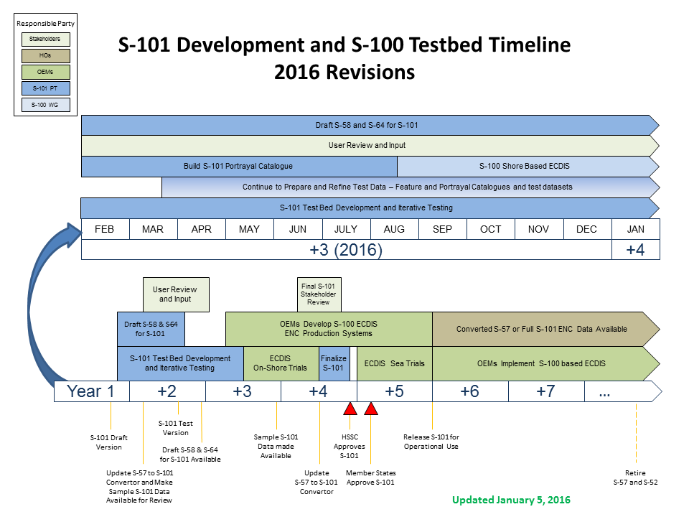

Figure 1 - Detailed Timeline
- S-101 Roadmap

  - S-101 First Draft

Projected Date | Completed Date
October 2013 | April 2014

This version, will be the basis for an extensive testing programme. As described in section 3 there are many new concepts which need to be proved and S-101 will undoubtedly change throughout this period before a stable version can be published for stakeholder evaluation. This first draft should be considered the baseline version needed for testing and will contain the first draft of the specification and draft editions of all the various catalogues required for testing: feature, portrayal, alerts / indications and agency codes.

Risk / Hazard | Mitigating measure / Impact | Comment
Delay in development of S-100 2.0.0 | Postponement of the availability of S-101 First Draft | Currently the lack of the portrayal component will probably delay the draft by up to 6 months.
Draft S-101 Product Specification not completed by October 2013 | Delay start of initial testing until Portrayal is considered stable and there is a baseline feature catalogue | There is enough information to begin test preparation – strategy, framework, some test cases.
Lack of Resources to build the next iteration of the Feature Catalogue | KHOA have graciously volunteered to assist the S-101 Project Team in the building of the Feature Catalogue | The lack of a complete feature catalogue builder prior to KHOA stepping in prevented the S-101 baseline feature catalogue from being built. This also contributed to the delay in the official first draft of S-101
Limited availability of resources to develop portrayal rules for new or modified S-101 features and attributes (which became "stabilized" in July 2013). | Use US Navy development laboratory resources to create initial draft of rules
Incorporating new changes from the S-52 PresLib4.0 into the new S-101 specification may cause additional delays. | Proceed with testbed and incorporate changes into S-101and testbed as resources permit

S-101 is a multi-part product specification when put together will form the basis for the creation and display of Electronic Navigational Charts. The major components of S-101 are:

- S-101 Main
- S-101 Data Classification and Encoding Guide
- S-101 8211 Annex
- S-101 Feature Catalogue
- S-101 Portrayal Catalogue
- S-57 to S-101 convertor
- S-101 Implementation Guidance

In order for S-101 to be at a stage for the S-101 Project Team to start testing the following components must be near or at completion.

- S-101 Main
- S-101 Data Classification and Encoding Guide
- S-101 8211 Annex
- S-101 Feature Catalogue
- S-101 Portrayal Catalogue
- S-57 to S-101 convertor

The S-101 Project Team maintains a risk register that assesses the status of each component of S-101. The risk register can be found on the S-100 Test Bed Website.

  - Initial Test Bed [2013 – 2015]

The first test bed will be a relatively simple viewer which is capable of importing and portraying data. It will facilitate the ability to import new feature and portrayal catalogues and provide functionality to change the display based on some of the parameters which users can change which affect the display. Examples include the safety contour and depths, day / night environments, etc.
The initial intention is to seek voluntary support from the OEM community to create viewers and it would be preferable if there are more than one test beds available. Obviously any OEM who participates will gain an early insight into the mechanisms involved.

It is anticipated that this phase of testing will be completed by the third quarter of 2015, but only if all the elements are stable and user evaluation and satisfaction has been achieved.

It is important to understand that this test bed will be S-100 based, capable of testing other product specifications which can be either supplementary to S-101 ENCs or another type of GIS application.
The outcome of testing will also enable a more detailed impact study as prescribed by IHO Resolution 2/2007 and a clearer indication given of the consequence and effect on the various stakeholders involved in the eventual introduction of S-101.

Risk or hazard | Mitigating measure / Impact | Comment
Lack of voluntary support | Will require funding through IHO resources | Although it is preferable to have more than one test bed the actual cost of producing a IHO owned version may not be huge. Most free ENC viewers now available could be re-configured to support S-101.

The following diagram represents the overarching S-100 test bed of which the testing of S-101 is an integral piece.

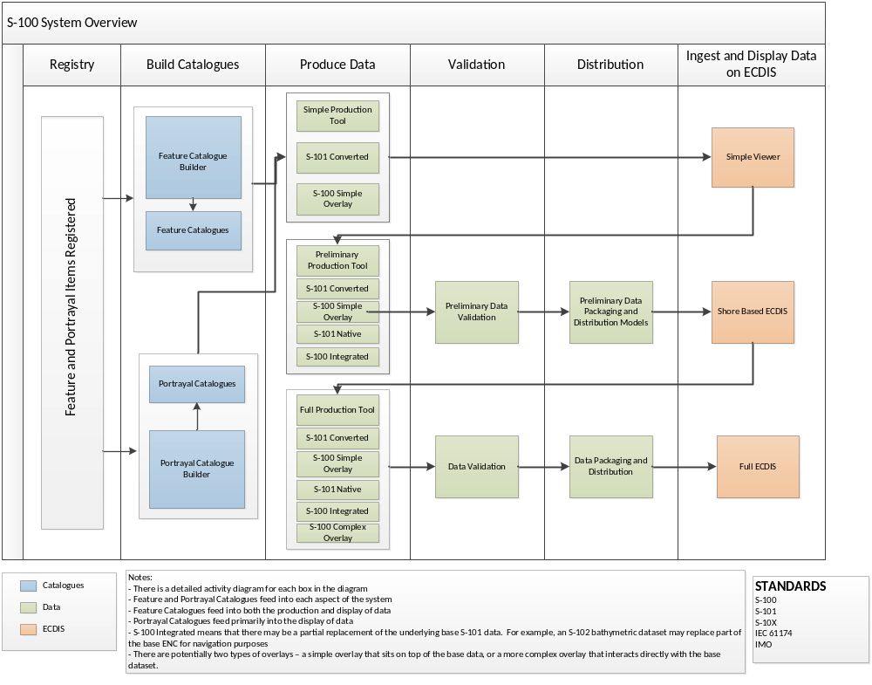Figure 2 - S-100 High Level System Overview

In order for the S-101 Project Team to manage the complexity of the S-100 test bed it has been split into nine phases. These are shown in figure 4 and follow for a logical progression from catalogue creation to use within ECDIS.

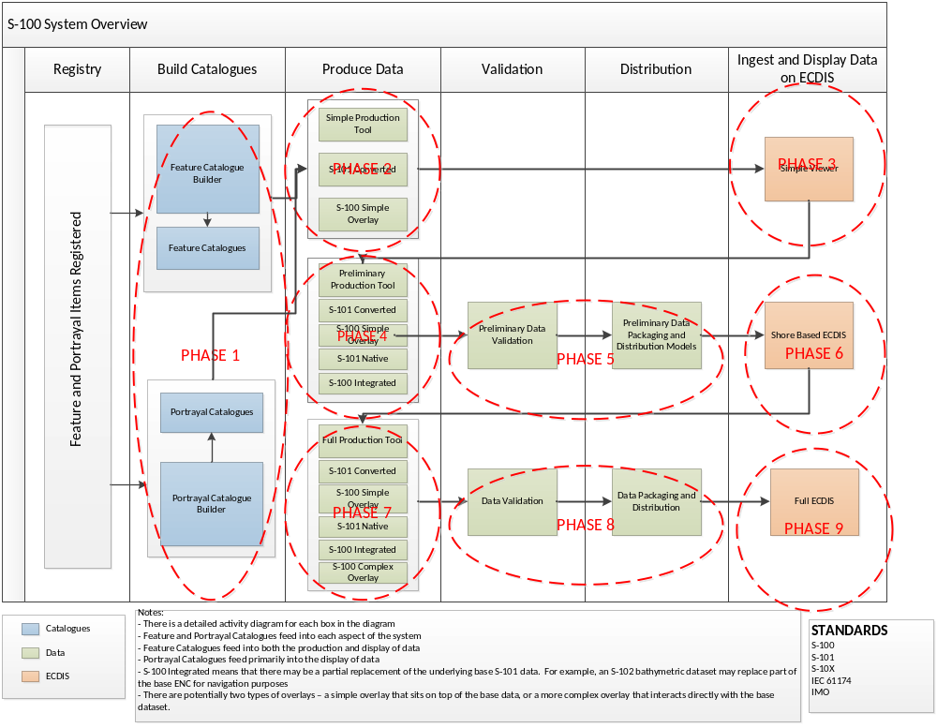
Figure 3 - S-100 Test Bed w/phases
Breaking out the testing through phases allows for the iterative development of future ECDIS as a system by gradually expanding requirements and test bed. At a high level the phases are as follows:

Phase 1: Feature and Portrayal Catalogue Generation. This phase concentrates on the feature and portrayal catalogue builders and the generation of catalogues to support the S-101 product specification and S-10X overlays.

Phase 2: Simple Production Tool. This phase deals with creating S-101 ENCs by using the S-57 convertor. In addition, it will also look to create an S-100 simple overlay file for use in testing.

Phase 3: Simple Viewer. This phase creates a simple viewer that will ingest feature and portrayal catalogues, along with an S-101 dataset to validate if the dataset displays according to what is defined in the portrayal catalogue. At this phase S-101 updates will not be tested.

Phase 4: Preliminary Production Tool. This phase deals with creating a tool that can edit and produce S-101 data and updates. In addition, there may be a secondary tool that will have the ability to produce S-10X data that is meant to be integrated within an S-101 dataset.

Phase 5: Preliminary Data Validation and Distribution. This phase will put in place draft data validation rules and test data packaging and distribution models.

Phase 6: Shore-Based ECDIS. This phase deals with the creation and testing of several shore based ECDIS.

Phase 7 – 9: Full Production Tool, Data Validation, Distribution, and Full ECDIS. These final three phases deal with the full system testing and implementation of S-100 and S-101.

    - S-57 to S-101 Converter

The converter has been developed by ESRI and partly funded by NOAA and will be freely available once it has been officially handed over to the IHO. It will be mostly open source code except where proprietary coding algorithms have been used in which case these will be provided as DLLs. One example is the complex process of determining the relationship between certain features and their surrounding depth which will populate one of the new attributes.

The converter will play an important part in the testing phase to validate its capability during the transition to a full specification S-101. Full specification S-101 datasets for testing will be created by using software designed to add new features and functionality to existing converted S-57 data.
Currently the converter has been successfully tested on approximately 90% of the S-101 content model and will be completed once all the new or remodelled features and attributes have been finalized.
Currently it is anticipated that the converter will handle most of the new S-101 functionality including geometry, complex attributes and some of the new feature types such as lights.

It obviously cannot convert elements which do not exist in the S-57 data such as Information Types and some of the new features such as Bridge Spans and Pilot Districts.

As the S-101 testing progresses there will be periodic updates to the convertor to reflect any changes that may have occurred.

One important aspect of the testing will be to determine the optimal process for converting data in the production/validation/distribution chain. Figure 2 outlines the various possible options.

Full specification S-101 V 1.0.0 ENCs can only be produced through the use of a fully S-101 compliant production system.

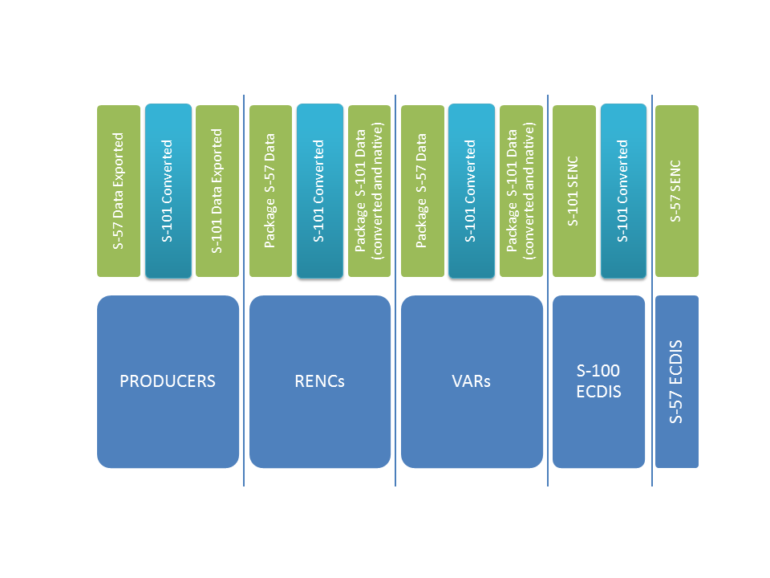
Figure 2 – Options for Converting Data

As can be seen from the above figure there are many points where S-57 data could be converted to S-101 data. One of the key aims of testing these processes is to ascertain whether there will be a need for ECDIS to have a duel fuel S-57/S-101 ENC capability. In order to simplify the process the aim must be that with the converter available along all stages of the production/validation/distribution chain an S-101 compatible ECDIS will not need an S-57 ENC capability.

One key factor which could define where conversion takes place is the update process. Updates (ER profile) have a definitive relationship to their parent ENCs by means of record identifiers and it may be the case, during testing, that this will only be possible to maintain at the point of production.

Risk or hazard | Mitigating measure / Impact | Comment
Update conversion capability | If testing proves an inability to create updates, re-issuing full cells will be the only interim option | Update support will be considered for the next iteration of development by Esri
HOs delay a move to a full specification S-101 production systems | Detrimental to the end user experience. | This particularly applies to Information Types which were conceived to alleviate the over use of caution areas which cause serious issues with the Alerts and Indications users have to contend with
Convertor is not updated to the latest iteration of the S-101 feature catalogue | Ensure that NOAA and ESRI will continue to support the convertor development. | This endeavour has been funded in partnership by NOAA and ESRI.

  - S-58 and S-64 [ 2016?]

New draft editions of both of these standards will be developed for S-101, but there is still a need for discussion about how they will be configured. It is conceivable that each could be split into two parts, part 1 for S-57 and part 2 for S-101. Alternatively both could be annexes of S-101 with the possibility that new annexes could be published independently without a change to the main S-101 version number as is currently the case with the S-57 Annex A ‘Use of the Object Catalogue’. Currently ENCs can be produced and distributed without any embedded tag that they have been validated. A method is being investigated for inclusion in the new version of S-58 whereby datasets will be tagged as being valid to a certain level. This will probably be based on similar methods currently used in the S-63 standard.

The new edition 3.0 of S-64 will form the basis of a new version of IEC 61174 and will contain the more rigorous and comprehensive tests; such tests are currently being developed for S-57 ECDIS. .
Final versions will be published in parallel with S-101 V 1.0.0

Risk or hazard | Mitigating measure / Impact | Comment
No perceived risk anticipated | N/A | Only relatively minor changes to the current version of S-58 and S-64 are anticipated.

  - S-63

Currently discussions are taking place between the S-100 Working Group and the Data Protection Working Group (DPSWG) to subsume parts of S-63 into S-100. This would better facilitate its use by any S-100 based product specification requiring security and/or encryption. This would be the case for S-101 and while not included in the scope of the initial test bed, would be available in the final draft of S-101 for the OEM review and use at the on shore ECDIS test phase. S-101 already contains an extended Exchange Catalogue which includes all of the fields required in the S-63 supplementary text file. A move to a more up to date method of using Digital Signatures is also being discussed.

Risk or hazard | Mitigating measure | Comment
DPSWG does not provide adequate input into S-101 and S-100 for the proper encryption mechanism | DPSWG focuses on providing the S-100 Working Group the correct information. | encryption is not needed until OEM Implementation

  - OEM Review [2014 – 2016]

Many stakeholders acting as expert contributors have been involved in the development of S-101, however once a relatively stable version of S-101 has been established during the testing phase this will be distributed to the various manufacturers involved in all processes creating, delivering and using the data. Draft new editions of S-58 and S-64, for use with S-101, will be made available during this period. Results of this review will be fed back into the main testing process and new iterations of the draft S-101 developed. Also during this period consideration will be given to the revision of IMO Performance Standards applicable to ECDIS and other e-navigation systems and associated IEC standards (in particular IEC61174).

Risk or hazard | Mitigating measure / Impact | Comment
S-101 is not broadly reviewed by the Stakeholder community | Ensure that there is a communication/outreach plan to gather stakeholder feedback

  - IHO/IEC/IMO Coordination [2014-2018]

While S-101 is moving through the test beds, IHO, IEC and the IMO need to coordinate on how S-100 based standards and S-10X products will be incorporated into IMO performance standards and IEC test standards.

Risk or hazard | Mitigating measure / Impact | Comment
S-100 and S-10X specifications are not incorporated into relevant IMO and IEC publications | This would prevent OEMs from implementing S-100 based ECDIS as S-101 would not be authorized for primary navigation.

  - HO and RENC Familiarization [2015 -2017]

After S-101 has gone through its test bed phase stage, IHO Resolution 2/2007 requires that a further impact study is made. As a result of the testing and impact study a new draft version of S-101 will be made available to stakeholders giving them the opportunity to begin assessing the requirements for the transition to producing S-101 ENCs. Thought will also be given to producing a simple check list which will highlight key impact requirements such as training, tools, distribution, etc.

Risk or hazard | Mitigating measure | Comment
S-101 does not have a clear framework for implementation/familiarization | IHO develop a draft implementation/familiarization plan

  - OEM Implementation [2016 – 2017]

It is intended that once a relatively stable version of the draft version of S-101 is published, ECDIS OEMs, production software and validation tool manufacturers will start to develop their systems in order to contribute to the trials which follow.

This will also be an opportunity for data producers to help test new software and become familiar with the new content and structure of S-101 as described in section 3. Any data produced can be utilised in the trials described in 2.7 and 2.9.

Risk or hazard | Mitigating measure | Comment
OEMs will opt to wait for a final edition of S-101 | IHO provides assurances that the only major changes that will happen at this point are new versions of the catalogue
OEMs need a business case for implementation | IHO and other standards setting organization need to provide other S-100 based products for S-100 to be viable | A new ENC product specification is not enough for OEMs to invest in new standards; they need other S-100 products that work with S-101. e.g Weather, Ice, Surface Currents, Nautical Publications

  - ECDIS On Shore Trials [2015 – 2016]

Based on the commitments to S-100 based technology expressed by many stakeholders, it is anticipated that at least one and possibly more S-100 enabled ECDIS will be available for the trials. All aspects of the process will be tested extensively including - data production, validation and distribution, ECDIS type approval and functionality, extensive user involvement, particularly training establishments. A dual fuel regime will test the capabilities and any issues with distributing both S-57 and S-101 ENC datasets. Special emphasis in testing is given to new functionality and new features of S-101 ENCs beyond the capabilities of S-57 datasets and, in particular, to the new machine readable catalogues for Feature, Portrayal, Alerts and Indications which are for the first time inherent part of the data delivery. Among these tests are those dedicated to proper display of the charted content in combination with operational user setting of special relevance. Test plans for systematic testing for each of those features have to be developed and ideally be conducted under supervision of type approval authorities.

Risk or hazard | Mitigating measure / Impact | Comment
OEMs will opt to wait for a final edition of S-101 | IHO provides assurances that the only major changes that will happen at this point are new versions of the catalogue
OEMs need a business case for implementation | IHO and other standards setting organization need to provide other S-100 based products for S-100 to be viable | A new ENC product specification is not enough for OEMs to invest in new standards; they need other S-100 products that work with S-101. e.g Weather, Ice, Surface Currents, Nautical Publications

  - S-101 Final Draft [2016]

During the second half of 2016 a thorough stakeholder review will culminate in a paper to the HSSC seeking endorsement of version 1.0.0 and a recommendation to seek IHO Member States’ approval to publish.
This version will contain a caveat stating that S-101 is still not available for across the board implementation and will be only used for testing until an announcement is made about a final implementation date through the IHB.

Risk or hazard | Mitigating measure / Impact | Comment
IHO Member States do not approve S-101 | IHO communicates a clear transition timeline and plan

  - ECDIS Sea Trials [2017]

This will be a similar process to the on shore trials, but will emulate a real time environment. Special attention is given to update services and interoperability with data sets of other domains, equally based on S-100 framework and assigned to future Maritime Service Portfolios of the e-navigation environment.

Risk or hazard | Mitigating measure / Impact | Comment
OEMs need a business case for implementation | IHO and other standards setting organization need to provide other S-100 based products for S-100 to be viable | A new ENC product specification is not enough for OEMs to invest in new standards, they need other S-100 products that work with S-101. e.g Weather, Ice, Surface Currents, Nautical Publications

  - S-101 Released for full implementation [2018]

At this point S-101 will be launched for full use. Those OEMs who have not started to develop systems facilitating S-100 based technology should consider doing so. It is difficult to judge when there will be full uptake of S-101 in every vessel mandated to carry ECDIS unless IMO strengthen the requirement for owners to upgrade to the latest standard. Alternatively this could be as a consequence of the cessation of S-57 ENC production.

Risk or hazard | Mitigating measure / Impact | Comment
IHO MS do not move to full S-101 ENCs | IHO will need to establish a sunset on S-57

- S-101 ENC – New Content

S-101 ENCs will eventually become the basic electronic navigation chart for use as official data in ECDIS or as component in new e-navigation environment. Since it provides enhanced options of its elements, its maintenance and compatibility it has the potential to improve the content and functionality of all applications making use of such data sets. The S-101 Project Team have hosted two S-101 Stakeholder Workshops attended by a variety of interested parties covering the whole domain of electronic navigation. Many of the new concepts which are being introduced have either evolved through, or improved by the discussions held during the workshops. The following items are as included in the first draft of S-101, but may be subject to change and or refinement during the testing phase. For a more detailed account of the following please refer to the latest draft of S-101.

It is important to recognize that the provisional content described in this section will undergo rigorous testing both from a technical perspective and also taking into consideration the implication for all the various stakeholders.

  - Features and Attributes

The main differences between the S-57 ENC Object and Attribute catalogues and the S-101 Feature catalogue are as follows:
- A Feature catalogue is now unique to the individual product specification. Currently the S-57 catalogue is designed as one fits all.
- S-100 based feature catalogues are the equivalent to an application schema. Therefore all features are pre-bound to their attributes.
- The S-101 feature catalogue will contain other constraints such as feature types, geometric primitives and mandatory status of attributes.

Impact on data production systems – This will make it easier to develop S-100 based production systems which can produce and maintain different products. Machine readable feature catalogues which are updateable will provide manufacturers with the opportunity to create “plug and play” systems.

Impact on data producers – This is an important change in practical terms as it will make encoding easier, reduce training needs and reduce errors. The ‘Data Classification and Encoding Guide (DCEG)’, comparable to the existing ‘Use of object catalogue’ for S-57 ENCs, will standardise the use of features for S-101 compliant encoding.

Impact on validating S-57 converted data – None, where there is not a direct mapping to S-101, validation tools will still find any errors.

The majority of features and attributes in S-101 have been inherited from the S-57 ENC object and attributes catalogues and remain unchanged; however the following are some examples demonstrating either improved functionality and or the end user experience.

    - Complex Attributes

These are described first because they have a significant influence on the restructuring of some of the features that will change in S-101. Complex attributes are a significant improvement to enhance S-101 applicability. It provides the ability to either replace multiple attributes or break down attributes into new sub-attributes.

For example we currently use structured text for certain attributes which consist of character strings constrained to set formats. In S-101 each element of the formatted string will be a sub-attribute. One of the more complicated formats is that of tidal stream information, the following diagram demonstrates a more logical and efficient structure.

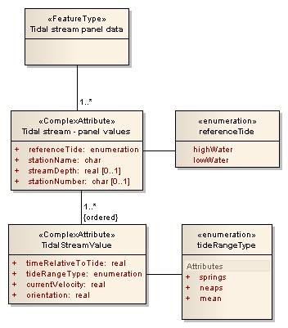

Impact on data production systems – Changes to software will be required to implement the new structure.

Impact on data producers – Minimal, the actual information remains the same it will just be entered in a different way. It should also reduce the likelihood of formatting errors. Fundamentally most if not all current production systems, whether data base or file based, do not hold data being prepared in the S-57 format. It is at the export stage when it is converted to ISO/IEC 8211 encoded data. Therefore a production system could be configured to export either the S-57 or S-101 version of ISO/IEC 8211 data.
Impact on validating S-57 converted data – None, there is a direct mapping to S-101.

  - Lights Features

There will be a separate feature type for the four main categories of lights – All Round, Sector, Fog Detector, and Air Obstruction. This will actually simplify both the encoding and portrayal of lights. For example a light with 2 or more sectors is currently encoded as one feature per light sector. In S-101 the single light feature will have sectors encoded as complex attributes.

Impact on data production systems – Changes to software will be required to implement the new structure.

Impact on data producers – Minimal, in fact it will reduce the complexity of encoding of all lights and in particular sector lights.

Impact on validating S-57 converted data – None, there is a direct mapping to S-101.

  - Update Feature

Currently one of the biggest problems users have is ascertaining what changes have been made after an update has been applied to the data. The ECDIS just does not have enough information to properly depict or highlight what are commonly important changes.
The new feature has been included to enable a user to clearly see what changes have been applied to a data set either by way of a notice to mariner or any other future mechanism which may emerge, including any features which may have been deleted. If necessary the text of the change can be included with all source references and dates. One of the major benefits will be that it can be included in passage planning to detect changes which may affect a chosen route. In particular temporal changes such as to a TSS can be detected.

Impact on data production systems – Changes to software will be required to implement the new feature.

Impact on data producers – It is likely, but no yet confirmed, that this new feature will replace the SORIND and SORDAT attributes, however it will enable update information held in production systems to be more easily tracked. Introducing this feature will probably incur more work for encoders, but the benefit to the end user will significantly outweigh this. Over time as production systems integrate more processes the burden may actually be reduced.

Impact on validating S-57 converted data – As this is a new feature it will only be available in full specification S-101 data. However there may be a possibility during the transition period to include this in the S-57 data being converted.

Impact on users – Significant, currently the methodology for highlighting changes is at best questionable in that it is very difficult to pin point the exact change because it is mostly based on geometry. A system should now be capable of allowing queries to find any updates.

  - Cartographic Text Feature

This new feature and its attributes provides the means to control the positioning of text in order to reduce text clutter one the most often issues raised by users. Initially it is thought to be only appropriate for point and possibly line features, the use and limitations of this new feature will become clearer during testing.

Impact on data production systems – Changes to software will be required to implement the new feature. Consideration should be given to utilizing information stored in multi-product databases.

Impact on data producers – Unless, as suggested above, existing information is re-used then encoding this feature will require extra effort which cannot be automated. However the impact on the end user will be considerable and achieving less cluttered displays should be a high priority.

Impact on validating S-57 converted data – These features can only encoded in the full spec. S-101 and therefore cannot be converted.

Impact on users – Significant, in conjunction with the use of SCAMIN it will significantly improve the user display.

  - Data Loading and Unloading

A new methodology based on producer defined display scales (minimum and maximum) has been introduced. This will simplify the process for ECDIS, giving clear and concise rules on how and when data is loaded and unloaded. The concept of navigation purpose has been restricted for use in presenting ENCs in a visual catalogue. The number of navigation purposes has also been reduced to three: port and approaches, coastal passage and ocean passage/routing.

Impact on data production systems – Minimal, only requires the addition of two new fields.

Impact on producers – Minimal, and it may be possible to introduce an algorithm to automate the encoding of the maximum and minimum scales. This will become clearer during the test phase.

Impact on validating S-57 converted data – Investigation is being undertaken to determine if the maximum and minimum scale values can be automatically generated. It may also be possible to introduce a mechanism to populate the fields during the conversion process.

Impact on users – Significant, currently there isn’t a standardized formula for loading data which has led to inconsistent and sometimes unhelpful loading strategies being utilized.

  - Scale Dependant and Independent Datasets

There has been continuous debate on the pros and cons of introducing this revolutionary concept and varied levels of support from the Member States’ attendees at TSMAD. Although the balance was more in favour of it being ultimately beneficial to both producers and end users a decision was made by members at TSMAD26 to mothball the concept for the time being. It was considered that the transition to S-101 should be kept as simple as possible and that the other benefits and advantages of moving to S-101 were already significant enough to warrant this decision.

  - Data Classification and Encoding Guide (DCEG)

The DCEG is the S-101 equivalent of the S-57 Appendix B.1 Annex A ‘Use of the Object catalogue, (Feature Object and Feature Attribute Catalogues combined)’, and will mean that encoders have all the necessary information in one place. The DCEG will undoubtedly evolve throughout the testing phases as the new features and constructs are put into practice.

- Impact on other Stakeholders

  - ECDIS and e-navigation equipment OEMs

Compared to other equipment used in support of S-101, the ECDIS will require the most change. However the overall benefits will be significant in that it will overcome the current difficulties with promulgating change and improve the user’s experience. Future ECDIS will not just be capable of handling S-101 data but should be thought of as S-100 enabled and capable of handling products interoperable to S-101 within an e-navigation environment.

The following items are some of the more major changes introduced.

    - Machine readable catalogues

Currently the intention is to provide 4 catalogues – Feature, Portrayal, Alerts and Indications and Producer Codes, although there is a possibility that Alerts and Indications could be included with portrayal. The ECDIS must be capable of importing the catalogues and updating the system, ideally not limited to S-101 ENCs but for all S-100 based data products as components of an e-navigation environment. In addition to the benefit of being able to deliver change more easily, there is potential to reduce type approval requirements to a one off test of the process.

    - Registration of S-10X Product Layers

At the request of the OEMs, it was agreed that a mechanism would be developed to register different product specifications and enhanced metadata for the ECDIS to achieve full machine readability for all S-100 based product specifications. It was noted that at a minimum the following should be part of the registration process:

- Objects and attributes associated with this S-10X product layer
- Display rules of object(s)/attribute(s) combinations including drawing order (priority, masking of shared edges, etc.) within this S-10X product layer
- Available, if any, end user selectors to control drawing of object(s)/attribute(s) combinations. Good examples from history is “viewing group layers” and “independent mariner selections” available in S-52.
- Available, if any, functionality based on object(s)/attribute(s) combinations. Good examples from history are “detection of safety contour”, “detection of navigational hazards” and “detection of area for which special condition exist”.
- Available, if any, functionality or drawing order relative to other S-10X product layers. Good example of drawing order from history is over/under radar flag in old S-52 to specify which parts of ENC charts (in future S-101 product layer) were over or under the Radar echo overlay. Good example of functionality is S-102 bathymetric layer or AML charts including skin of the earth objects (both examples can be used to replace depth information of the ENC charts).
- Available, if any, functionality or drawing based on received external data. Good example is functionality based on tidal data – either predictions or real-time measurements.

    - ISO/IEC 8211

After consultation with OEMs it has been agreed that S-101 will retain the ISO/IEC8211 encoding in a modified form which conforms to S-100.

    - Least Depth Attribute

This new attribute could equally have been described in Section 3, but it will have considerably more impact in ECDIS. Currently, during the SENC build process the system has to trawl datasets to find the relationship between features such as wrecks, obstructions, etc. and their underlying depth area. This relationship exists in the production systems and therefore in S-101 ENC in an attribute in the data which makes the trawl redundant, i.e. the functionality based on this is more robust and faster.

  - Type Approval Authorities

Recent discussions on the revision and expansion of S-64 have included the opinions of type approval authorities. This work is carried through to the requirements for S-101 and will include more comprehensive tests and accompanying test data sets. Consideration will also be given to the possibility of separating software testing from hardware where appropriate. Testing of processes will also be investigated, e.g. the process of importing test catalogues, test data and providing a default portrayal list for approval is fundamental to the concept of “plug and play”.

  - Service Providers

One of the main issues during the transition from S-57 to S-101 ENCs will be the need for a delivery process for both types of data sets. The provision of a more robust and better structured version of S-58 will increase the efficiency of the process and provide better quality control. Currently discussions are ongoing between the S-101 Project Team and DPSWG to include a revised content model of S-63 in S-100 making it more consistently available to all S-100 based products.

