DATA CONTENT AND STRUCTURE

1.1 Introduction
The Forecast Chart from KHOA has most of information which is being already developed in various other S-100 specifications. Specifications of S-101(ENC), S-102(Bathymetry), S-104(Tidal Information), S-111(Surface Current), S-112(Dynamic Water Level Data Transfer) and S-412(Weather Overlay) include information and standardize about canal, tidal height, tidal current, sea current, wave height and water temperature etc. S-126, one of those, have the properties of including about oceanic physical environment. Then, the data of flood risk is represented by the Forecast Chart by KHOA and it maybe could be covered by S-126. The development of S-126 had been progressing slowly since NIPWG4[2017], because it has
redundancy and ambiguity compared the others. However, the presentation about the direction of S-126 was announced about logical validity and combinability with others in NIPWG4 (NIPWG4-WP3-1 has the contents with S-111).

The others are also using a variety type of forecast data like grid result of model, velocity of current, sea water temperature. In addition to this, each kind has identical portrayal symbol which represents character of that efficiently.

This section discusses the application schema, which is described in UML; the feature catalogue. Features which overlap with the other products and with no overlap will be introduced.

1.2 Feature Catalogue
Table 1.1 Duplicate Feature
NIPWG Category | NIPWG Subcategory | IHO Registry Name | ALPHA CODE | IHO product
Currents, Tidal Streams and Flow | Tidal stream-flood/ebb | TidalStreamFloodEbb | TS_FEB | S-100
Ice Conditions | Ice drift | IceDrift | ICEDFT | S-411
Ice Conditions | Icebergs | BergIce | ICEBRG | S-411
Ice Conditions |  | IceArea | ICEARE | S-411
Sea Level and Tides | Sea level | LowWaterLevel | LOWATR | S-112
Sea Level and Tides | Tides | - | - | S-112
Sea Water Characteristics | Sea surface temperature | - | SSTEMP | S-412
Climate and Weather/General Conditions | Visibility | SurfaceVisibility | SURVIS | S-412
Climate and Weather/Fog and Visibility | Sea fog | - | - | -

TidalStreamFloodEbb : Approximate tidal stream rates given as discrete rate values for flood and ebb flow during springs.
With “Surface Current(S-111)”, CautionTidalStream is defined within a certain velocity of current.

IceArea : An area of ice over land or water. “IceArea” define CautionSeaIce
SurfaceVisibility : Greatest distance at which a black object of suitable dimensions can be seen and recognized against the horizon sky during daylight or could be seen and recognized during the night if the general illumination were raised to the normal daylight level. SurfaceVisibility define CautionSeaFog

<New Feature>

CautionEddy : Currents which flow in a circular motion around the center of the eddy caused by unstable and meandering currents.
CautionCoastalUpwelling : The appearance of cold seawater by upwelling in coastal area.

CautionTidalFront : Frnts is in coastal waters where tidal mixing is dominant about deep waters. In surface, temperature of coastal is lower than open sea. It is against in seabed.

Table 1.2 Definition of Mesoscale Eddy and Classification Procedure
Definition : Currents which flow in a circular motion around the center of the eddy caused by unstable and meandering currents.

Type : Warm eddy, Cold eddy
- Warm eddy : Waters are warmer than surrounding waters at the base of the thermocline near 300m and are turning clockwise(CW).
- Cold eddy : Waters are colder than surrounding waters at the base of the thermocline near 300m and are turning counterclockwise(CCW).

Geographic Range : Diameter of eddy is about 50~200 km, effect depth is about 300 m.
Range of current speed : 0.3 ~ 1.0 m/s
Duration : a few dozen days ~ more than 1 year
# Space and Time (possible) → 1 / 0
# Domain : grid data of torus (50km ~ 100km)
# Detecting closed path graph using current vector space ← Domain
# AVT <- Average Value of Temperature ← mean( Temperature( Domain ) )
# [ AVT – Temperature ( Point ) > 0 ] → Cold Eddy
# [ AVT – Temperature ( Point ) < 0 ] → Warm Eddy

Table 1.3 Definition of Coastal Upwelling and Classification Procedure
Definition : The appearance of cold seawater by upwelling in coastal area.
Machanism : Coastal upwelling was induced by Ekman transport to the offshore area by strong southerly winds. Warm water is transferred and deep cold water appears.
Location : Gijang, Uljin Ulgi, Gampo, Yeongduk, Geojae
Geographic Range : 10~30km from the offshore
Time : Jun. ~ Aug.
Note : Caution of sea fog at upwelling area
# Space and Time (possible) → 1 / 0
# Domain : grid data of torus (10km ~ 20km)
# AVT <- Average Value of Temperature ← mean( Temperature( Domain ) )
# [ AVT – Temperature ( Point ) > 10 ] → Warning
# [ AVT – Temperature ( Point ) > 5 ] → Caution

Table 1.4 Definition of Tidal Font and Classification Procedure
Definition : Fronts is in coastal waters where tidal mixing is dominant about deep waters. In surface, temperature of coastal is lower than open sea. It is against in seabed.
Condition for occurrence : Area which has steepest depth, fresh water and faster tidal currents.
Location : Daeheuksando~Jido, Taeanbando, Gyeonggiman, North Jeju, South Jeju
Geographic Range : 20~60km from the offshore
Time : Apr. ~ Nov.
Note : Caution of sea fog at area which has cold water and eddies locally by seaweed instability.
# Space and Time (possible; 20~60km from the offshore and Apr. ~ Nov.) → 1 / 0
# Domain : grid data of torus (10km ~ 20km)
# if [ max(Domain) – min(Domain) > 5 ] → Occurrence
# if [ max/2 + min/2 == point ] → Point of tidal front

1.3 Application schema
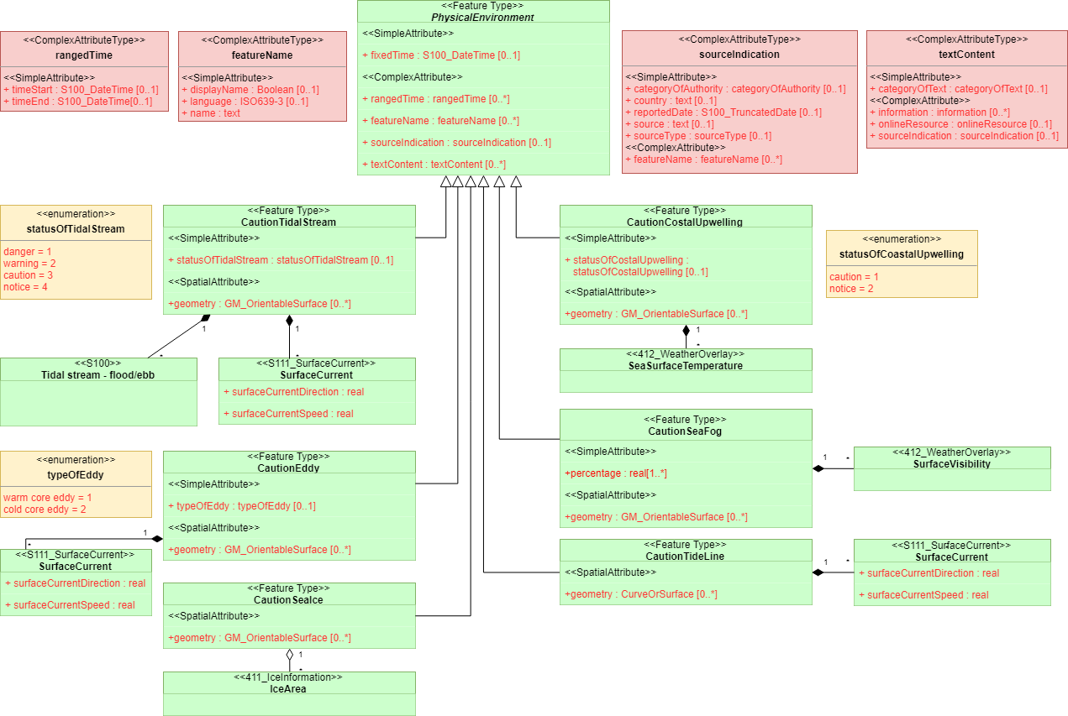
Figure 1.1 Application schema by UML

1.3.1 Feature
CautionTidalStream
Attributes
Role Name | Name | Mult | Type | Remarks
Attribute | statusOfTidalStream | [0..1] | statusOfTidalStream
Spatial Attribute | geometry | [0..*] | GM_OrientableSurface

Inherited Attributes
Role Name | Name | Mult | Type | Remarks
Attribute | fixedTime | [0..1] | S100_DateTime
Complex Attributes | RangedTime | [0..*] | rangedTime
Complex Attributes | featureName | [0..*] | featureName
Complex Attributes | sourceIndication | [0..1] | sourceIndication
Complex Attribues | textContent | [0..1] | textContent

CautionEddy
Attributes
Role Name | Name | Mult | Type | Remarks
Attribute | typeOfEddy | [0..1] | typeOfEddy
Spatial Attribute | geometry | [0..*] | GM_OrientableSurface

Inherited Attributes
Role Name | Name | Mult | Type | Remarks
Attribute | fixedTime | [0..1] | S100_DateTime
Complex Attributes | RangedTime | [0..*] | rangedTime
Complex Attributes | featureName | [0..*] | featureName
Complex Attributes | sourceIndication | [0..1] | sourceIndication
Complex Attribues | textContent | [0..1] | textContent

CautionSeaIce
Attributes
Role Name | Name | Mult | Type | Remarks
Spatial Attribute | geometry | [0..*] | GM_OrientableSurface

Inherited Attributes
Role Name | Name | Mult | Type | Remarks
Attribute | fixedTime | [0..1] | S100_DateTime
Complex Attributes | RangedTime | [0..*] | rangedTime
Complex Attributes | featureName | [0..*] | featureName
Complex Attributes | sourceIndication | [0..1] | sourceIndication
Complex Attribues | textContent | [0..1] | textContent

CautionCoastalUpwelling
Attributes
Role Name | Name | Mult | Type | Remarks
Attribute | statusOfCoastalUpwelling | [0..1] | statusOfCoastalUpwelling
Spatial Attribute | geometry | [0..*] | GM_OrientableSurface

Inherited Attributes
Role Name | Name | Mult | Type | Remarks
Attribute | fixedTime | [0..1] | S100_DateTime
Complex Attributes | RangedTime | [0..*] | rangedTime
Complex Attributes | featureName | [0..*] | featureName
Complex Attributes | sourceIndication | [0..1] | sourceIndication
Complex Attribues | textContent | [0..1] | textContent

CautionSeaFog
Attributes
Role Name | Name | Mult | Type | Remarks
Attribute | Percentage | [1..*] | real | Prob. Of occurring sea fog.
Spatial Attribute | geometry | [0..*] | GM_OrientableSurface

Inherited Attributes
Role Name | Name | Mult | Type | Remarks
Attribute | fixedTime | [0..1] | S100_DateTime
Complex Attributes | RangedTime | [0..*] | rangedTime
Complex Attributes | featureName | [0..*] | featureName
Complex Attributes | sourceIndication | [0..1] | sourceIndication
Complex Attribues | textContent | [0..1] | textContent

CautionTidalLine
Role Name | Name | Mult | Type | Remarks
Spatial Attribute | geometry | [0..*] | CurveOrSurface

Inherited Attributes
Role Name | Name | Mult | Type | Remarks
Attribute | fixedTime | [0..1] | S100_DateTime
Complex Attributes | RangedTime | [0..*] | rangedTime
Complex Attributes | featureName | [0..*] | featureName
Complex Attributes | sourceIndication | [0..1] | sourceIndication
Complex Attribues | textContent | [0..1] | textContent

1.3.2 Complex Attributes
rangedTime
Role Name | Name | Multi | Type | Remarks
Attributes | timeStart | [0..1] | S100_DateTime
Attributes | timeEnd | [0..1] | S100_DateTime

featureName
Role Name | Name | Multi | Type | Remarks
Attributes | displayName | [0..1] | Boolean
Attributes | language | [0..1] | ISO639-3
Attributes | name | [1] | text

sourceIndication
Role Name | Name | Multi | Type | Remarks
Attributes | categoryOfAuthority | [0..1] | categoryOfAuthority
Attributes | Country | [0..1] | text
Attributes | reportedDate | [0..1] | S100_TruncatedDate
Attributes | source | [0..1] | text
Attributes | sourceType | [0..1] | sourceType
Complex Attributes | featureName | [0..*] | featureName

textContent
Role Name | Name | Multi | Type | Remarks
Attributes | categoryOfText | [0..1] | categoryOfText
Complex Attributes | Information | [0..*] | Information
Complex Attributes | onlineResource | [0..1] | onlineResource
Complex Attributes | sourceIndication | [0..1] | sourceIndication

1.3.3 Enuemeration
statusOfTidalStream
Role Name | Name | Code | Remarks
Literal | danger | 1
Literal | warning | 2
Literal | caution | 3
Literal | notice | 4

Role Name | Name | Code | Remarks
Literal | warm core eddy | 1
Literal | cold core eddy | 2
typeOfEddy

statusOfCoastalUpwelling
Role Name | Name | Code | Remarks
Literal | caution | 1
Literal | notice | 2

PORTRAYAL

2.1 Introduction
Portrayal about 7 kinds of physical environment will be defined. Observation data, astronomical prediction data and real-time data is mainly represented by point symbol, if need arise, line and area fill portrayal. The physical environment like caution of tidal stream, is described by point data and like sea ice, mesoscale eddy, coastal upwelling, sea fog is described by area data. They can be described, of course, by point data. Caution of Tidal Front may be described by line symbol.

Since the physical environments are well wrapped by text information in nautical publications, we will modify text information for ECDIS. This should help to navigate by representing warning symbol in due course.

S-126(Physical Environment) was skeptical about necessity by redundancy until NIPWG 3, 2016. However, development plan was introduced with more closely other products in NIPWG 4, 2017. The S-101(ENC), S-104(Tidal Information), S-111(Surface Currents), S-411(Sea Ice) and S-412(Weather Overlay) are helpful on the sea, on the other hands, S-126(Physical Environment) can be helpful in the planning.

All recommended sizes are given assuming a minimum size ECDIS display of 270 by 270 mm or 1020 by 1020 pixels.

2.2 Display of Physical Environment at a Single Point
A point data of each physical environment can be represented by point symbol. (ex. Predicted point of strong tidal stream and observing point of sea fog)

The symbol described by point means occurrence of the physical environment at that place. Also, S-111(Surface Currents) and S-126(Physical Environment) are combined in last meeting of NIPWG 4(2017). We suggest more meaningful symbol instead of simple thing <Figure 2.3> to classify physical environment intuitionally.

2.2.1 Warning Symbol Shape
Basically circular and include characteristic of each physical environment.

It will be located at centre of portrayal domain when drawed on line or area. (centre of line or centre of gravity)

In case of sea fog, the symbol was created with reference icon, internationally using by weather charts. Three horizontal lines mean fog symbol, so we gave shape like <Figure 2.1>, foggy cloud and horizontal lines on the sea.

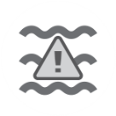
Tidal Stream | Sea Ice | Coastal Upwelling
Sea Fog | Tidal Front | Cold Eddy | Warm Eddy
Figure 2.1 Point symbol of each physical environment

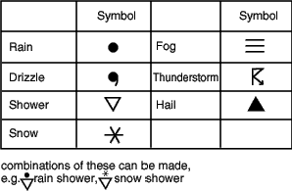
Figure 2.2 Symbol of weather charts

Figure 2.3 Simple Warning Symbol (existing)

2.2.2 Warning Symbol Size
Size of each symbol must be applied the biggest size with independency and readability. It will be fundamentally accepted 20 mm, square.

2.2.3 Text Information
The data are invisible initially, and when the cursor in ECDIS is placed on the symbol, the data will be shown. <Figure 2.4> Text information about each physical environment could be obtained by text box. In case of cautionTidalstream, it provides speed and direction of tidal current. The others are providing reasonable information The text box in Figure 2.4 requires the use of two additional colours: black for the text and box outline, and white for the interior of the box.

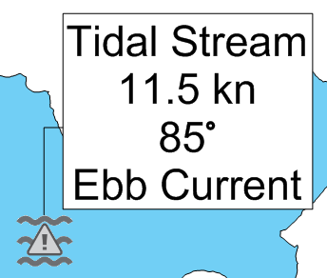
Figure 2.4 Example of Text Box

Table 2.1 Text Information of <cautionTidalStream>
Priority  Level | Text Information Displayed
1 | Speed, Direction, Flood/Ebb
2 | Data source or station name, Latitude, Longitude, Valid Date, Valid Time
3 | Uncertainty in speed, Uncertainty in direction, Uncertainty in horizontal position, Uncertainty in time

Table 2.2 Text Information of <cautionSeaIce>
Priority  Level | Text Information Displayed
1 | Type
2 | Data source or station name, Latitude, Longitude, Valid Date, Valid Time
3 | Uncertainty in horizontal position, Uncertainty in time

Table 2.4 Text Information of <cautionEddy>
Priority  Level | Text Information Displayed
1 | Type[Warm / Cold], Speed, Direction
2 | Data source or station name, Latitude, Longitude, Valid Date, Valid Time
3 | Uncertainty in speed, Uncertainty in direction, Uncertainty in horizontal position, Uncertainty in time

Table 2.5 Text Information of <cautionCostalUpwelling>
Priority  Level | Text Information Displayed
1 | Temperature, Difference
2 | Data source or station name, Latitude, Longitude, Valid Date, Valid Time
3 | Uncertainty in temperature, Uncertainty in horizontal position, Uncertainty in time

Table 2.6 Text Information of <cautionSeaFog>
Priority  Level | Text Information Displayed
1 | Visibility, Percentage
2 | Data source or station name, Latitude, Longitude, Valid Date, Valid Time
3 | Uncertainty in visibility, Uncertainty in percentage, Uncertainty in horizontal position, Uncertainty in time

Table 2.7 Text Information of <cautionTidalFront>
Priority  Level | Text Information Displayed
1 | Difference, Length
2 | Data source or station name, Latitude, Longitude, Valid Date, Valid Time
3 | Uncertainty in Difference, Uncertainty in Length, Uncertainty in horizontal position, Uncertainty in time

2.3 Display of Physical Environment in Line
The Tidal Front can be described by line portrayal since it is font. The shape of line is unique and so does not duplicate with existing line shape previously approved for use in ECDIS <Figure 2.5> The line use colour, red and blue to obtain difference of water temperatures. Since previous line symbol is almost black or magenta line, it is classified the others.

 |  | 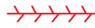
(a) Line Symbol | (b) Instability line | (c) Convergence Line | (d) Monsoon trough
Figure 2.5 Line Symbol

2.4 Display of Physical Environment in Area

In case of area fill portrayal, the physical environment will be described by dotted outline and patterned area fill. The colours are selected to be easy to understand each characteristic. For example, coastal upwelling is drawing by blue colour and environment related high water temperature is drawing by red colour. The sea fog is using gray colour.

Table 2.8 Color Table

Feature | Colour | Colour Scale Intensity
 |  | Red | Green | Blue
cautionSeaIce |  | 0 | 255 | 255
cautionEddy[warm] |  | 245 | 25 | 25
cautionEddy[cold] |  | 25 | 25 | 245
cautionCoastallUpwelling |  | 25 | 25 | 245
cautionSeaFog |  | 127 | 127 | 127

2.5 Temporal Considerations
The symbol will be shown up at selected date and time. Prediicted spring ebb currents in nautical publication is shown up at designated date and time in the publication. (Also, around designated region) Of course, extra time is given in case predicted data.

Nov. 16th 13:00 Spring Ebb Currents (predicted)
- In ENC around region, From 12:00 To 14:00, Turn up Warning TidalStream Symbol

2.6 Sample Representation
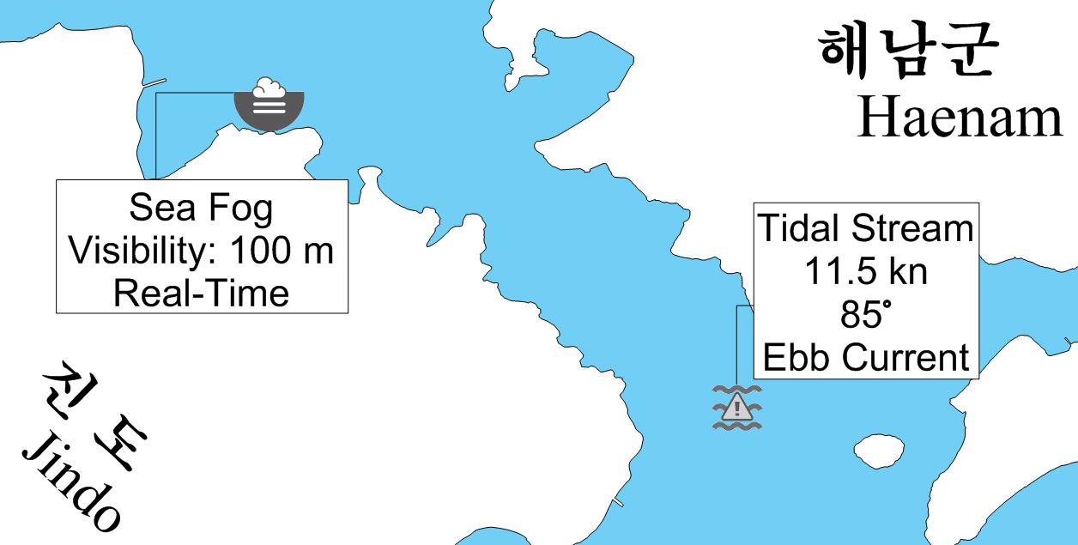
(a) Point
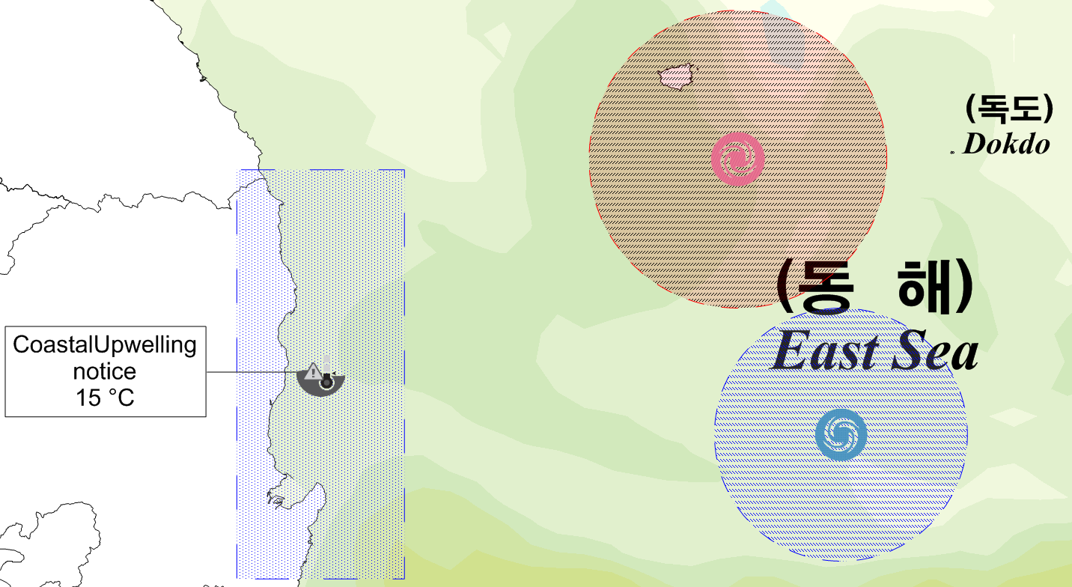
(b) Area
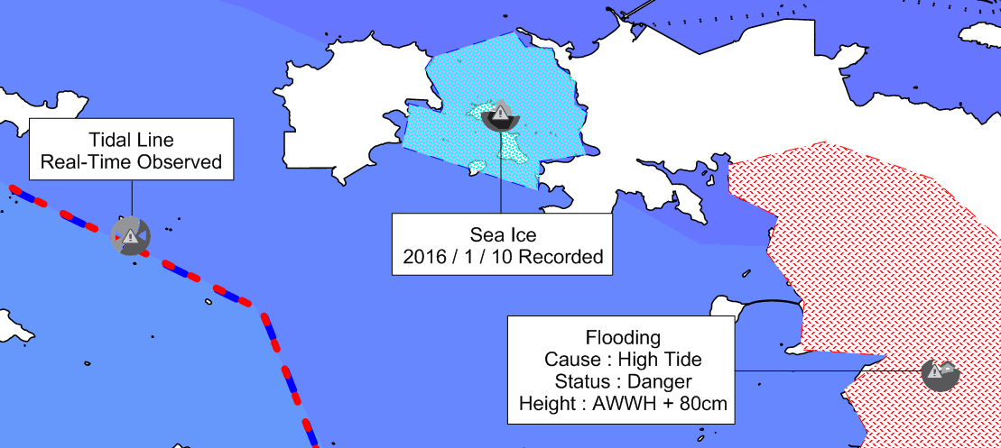
(c) Line / Area
Figure 2.6 Sample Representation with text information

