INTERNATIONAL HYDROGRAPHIC  ORGANIZATION | INTERGOVERNMENTAL OCEANOGRAPHIC  COMMISSION (of UNESCO)

UNDERSEA FEATURE NAME PROPOSAL
(Sea NOTE overleaf)

Note: The boxes will expand as you fill the form.
Name Proposed: | Rasa Ridge | Ocean or Sea: | Northwest Pacific Ocean

Geometry that best defines the feature (Yes/No) :
Point | Line | Polygon | Multiple points | Multiple lines* | Multiple polygons* | Combination of geometries*
 |  | Yes
* Geometry should be clearly distinguished when providing the coordinates below.
 | Lat. (e.g. 63°32.6’N) | Long. (e.g. 046°21.3’W)
Coordinates: | 21°40.30’N (Summit1)  21°38.90’N  21°47.83’N  21°50.68’N  21°47.11’N  21°34.62’N  21°38.90’N | 130°45.11’E (Summit 1)  130°39.34’E  130°34.16’E  130°36.66’E  130°45.94’E  130°54.50’E  130°39.34’E

Feature Description: | Maximum Depth : | 6079 m | Steepness :
Feature Description: | Minimum Depth : | 4564 m | Shape :
Feature Description: | Total Relief : | 1515 m | Dimension/Size : | 30 km×41 km

Associated Features:

Chart/Map References: | Shown Named on Map/Chart: | #6722
Chart/Map References: | Shown Unnamed on Map/Chart:
Chart/Map References: | Within Area of Map/Chart:

Reason for Choice of Name (if a person, state how associated with the feature to be named): | Named after the closest Oki-Daito Island, which is located on the Oki-Daito Ridge. Oki-Daito Island is also known as Rasa Island.

Discovery Facts: | Discovery Date: | 1996
Discovery Facts: | Discoverer (Individual, Ship): | The Japanese survey vessel “Takuyo”

Supporting Survey Data, including Track Controls: | Date of Survey: | 1996
Supporting Survey Data, including Track Controls: | Survey Ship: | The Japanese survey vessel “Takuyo”
Supporting Survey Data, including Track Controls: | Sounding Equipement: | Multibeam echo sounder  Seabeam 210A
Supporting Survey Data, including Track Controls: | Type of Navigation: | GPS
Supporting Survey Data, including Track Controls: | Estimated Horizontal Accuracy (nm): | 0.108 nm (200 m)
Supporting Survey Data, including Track Controls: | Survey Track Spacing: | 6 nm
Supporting Survey Data, including Track Controls: | Supporting material can be submitted as Annex in analog or digital form.

Proposer(s): | Name(s): | JCUFN
Proposer(s): | Date: | Sep. 10, 2015
Proposer(s): | E-mail: | ico@jodc.go.jp
Proposer(s): | Organization and Address: | Hydrographic and Oceanographic Department, Japan Coast Guard  Aomi 2-5-18,Koto-ku, Tokyo 135-0064, Japan
Proposer(s): | Concurrer (name, e-mail, organization and address):

Remarks:

NOTE : This form should be forwarded, when completed :

a) If the undersea feature is located inside the external limit of the territorial sea :-
to your "National Authority for Approval of Undersea Feature Names" (see page 2-9) or, if this does not exist or is not known, either to the IHB or to the IOC (see addresses below);

b) If at least 50 % of the undersea feature is located outside the external limits of the territorial sea :-
to the IHB or to the IOC, at the following addresses :

International Hydrographic Bureau (IHB)  4, Quai Antoine 1er  B.P. 445  MC 98011 MONACO CEDEX  Principality of MONACO  Fax: +377 93 10 81 40  E-mail: info@ihb.mc | Intergovernmental Oceanographic Commission (IOC)  UNESCO  Place de Fontenoy  75700 PARIS  France  Fax: +33 1 45 68 58 12  E-mail: info@unesco.org

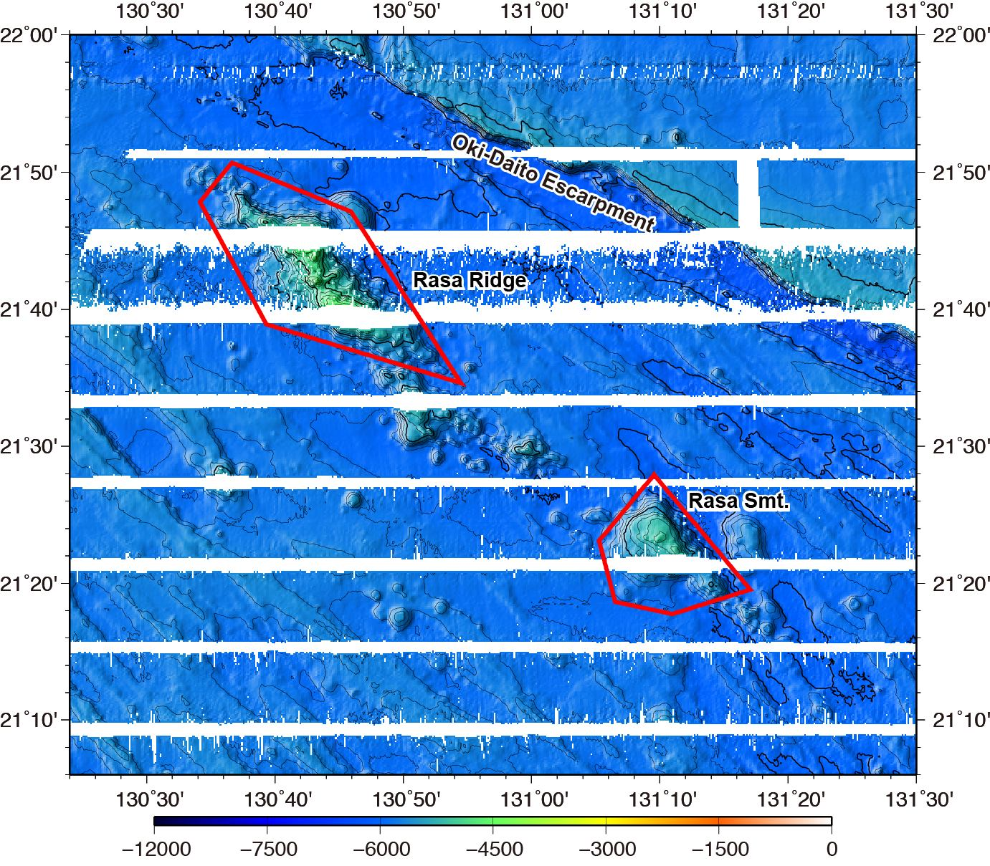

Fig. 1. Bathymetric map of the Rasa Ridge and Rasa Seamount. Contours are in 100 m.
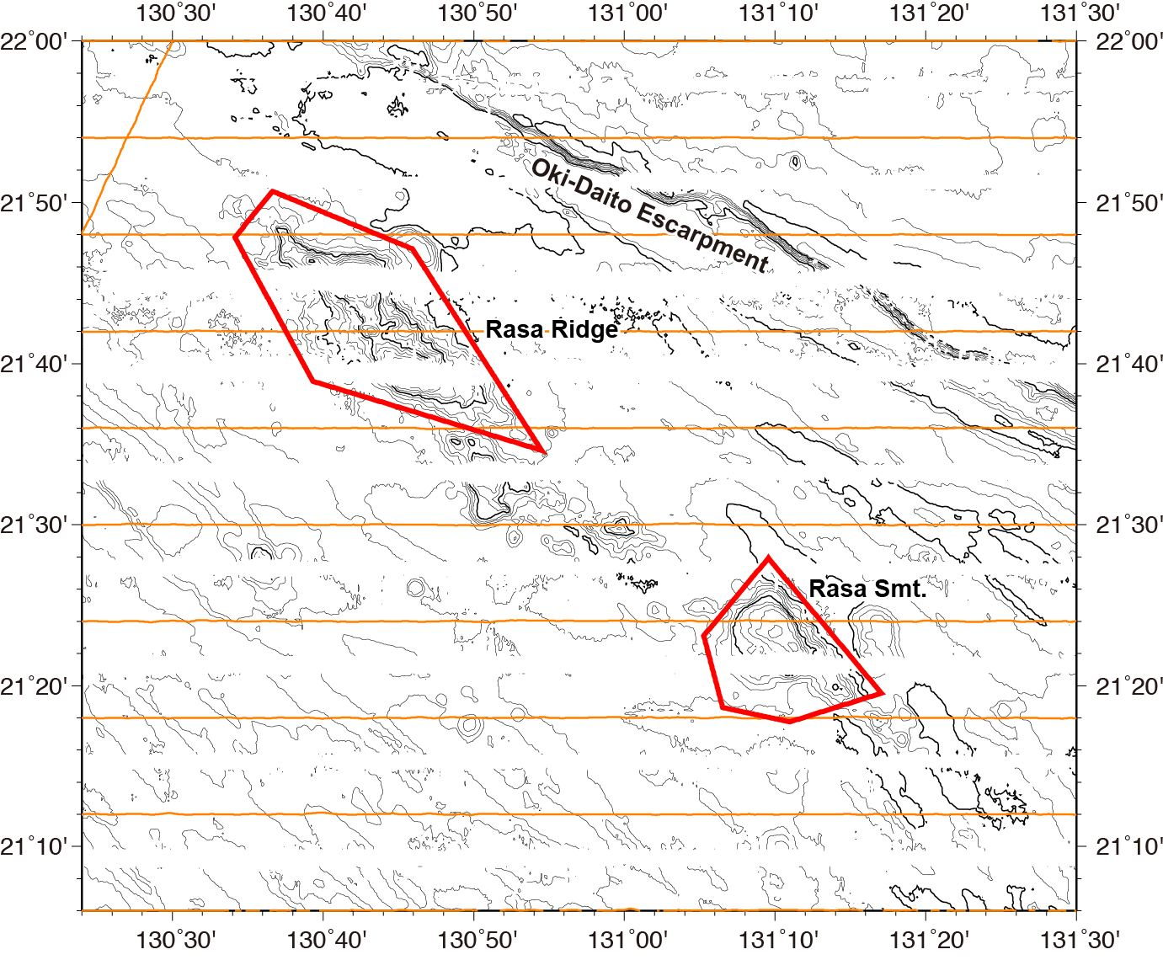

Fig. 2. Bathymetric map of the Rasa Ridge and Rasa Seamount, showing with track lines. Contours are in 100 m.

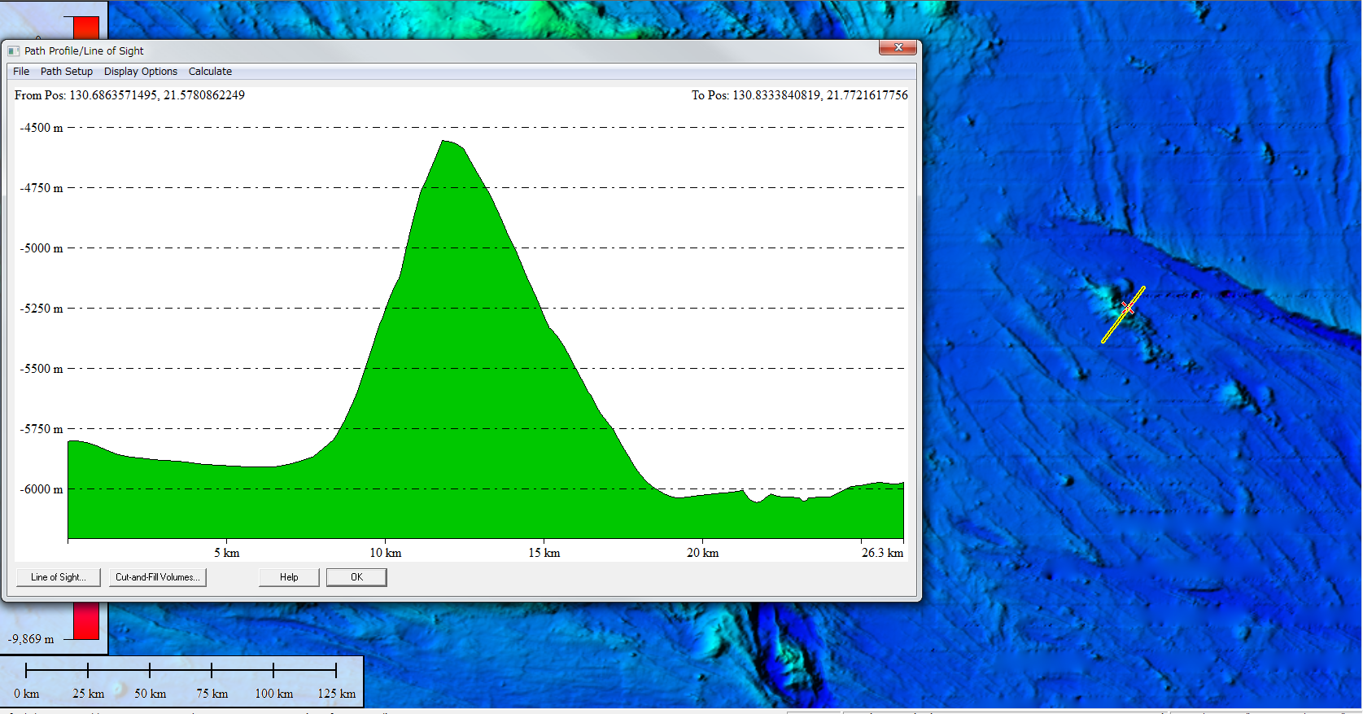

Fig. 3. Bathymetric profiles across the Rasa Ridge.

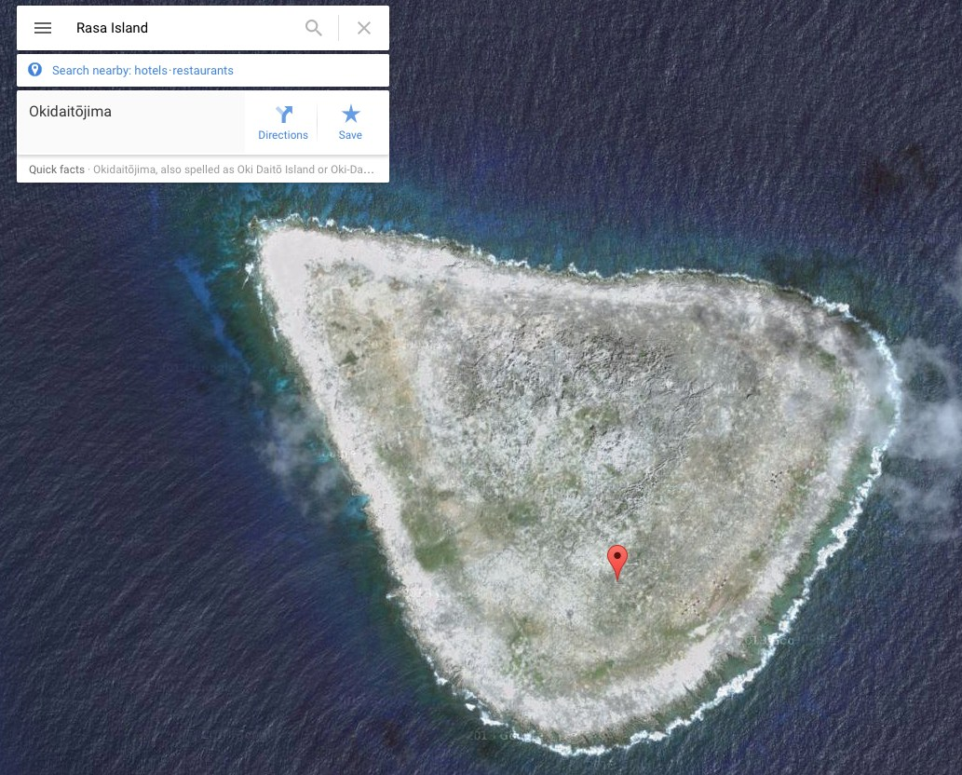

Fig. 4. Capture of a Google Earth screen for the Rasa Island, Japan.

