Example of encoded CATZOC differences in TSS encoded by 2 different producers.

ENC Country AA (AA29GOFW) and ENC Country BB (BB213053) have encoded individual parts of a common Traffic Separation Scheme.

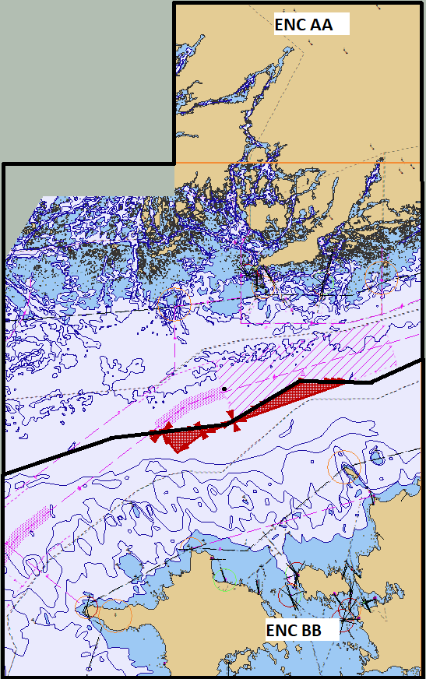

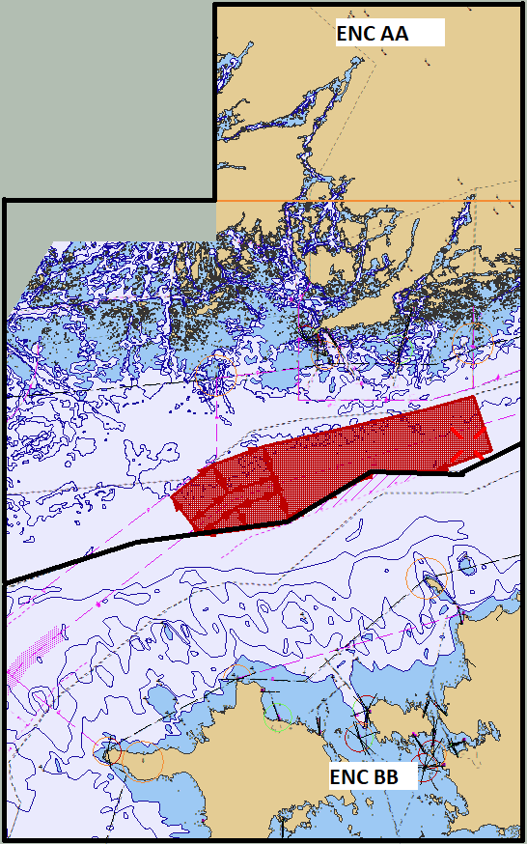

Zooming in and checking CATZOC we can see ENCAA cell has M_QUAL area with CATZOC = A1 and the ENCBB has M_QUAL area with CATZOC = A2:
