Example of encoded CATZOC differences in TSS encoded by 2 different producers.

ENCAA (AA375880) and ENCBB (BB300306) have encoded individual parts of a common Traffic Separation Scheme.

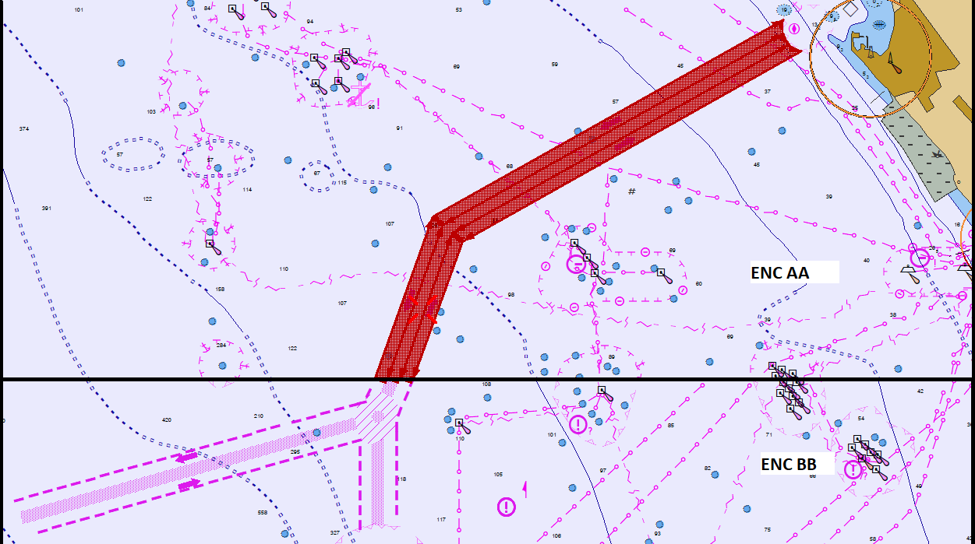

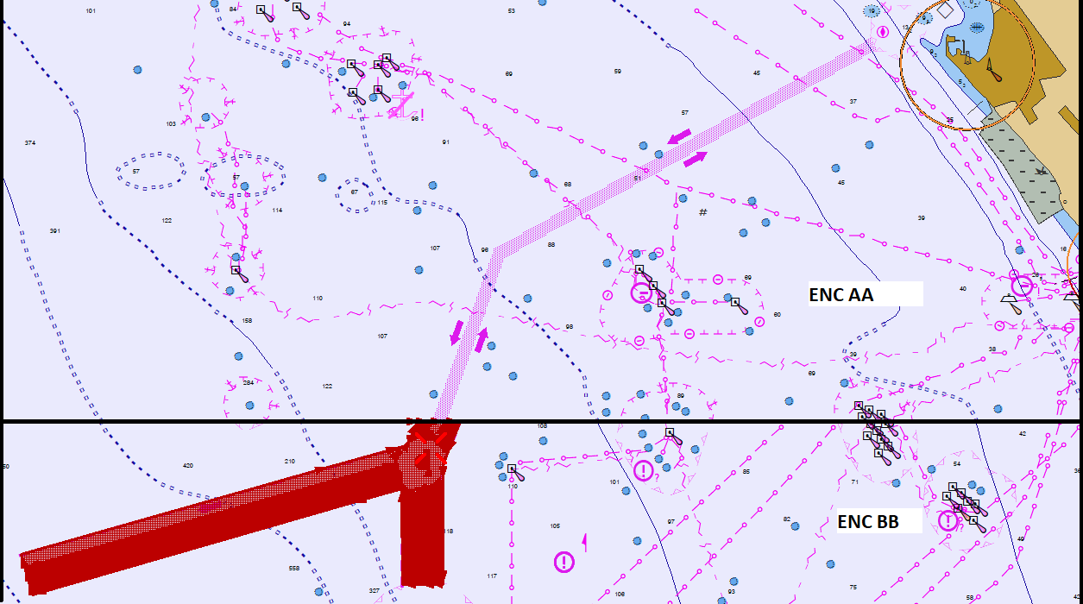

Zooming in and checking CATZOC we can see ENCAA cell has M_QUAL area with CATZOC = D and the ENCBB has M_QUAL areas with CATZOC = C and D:
