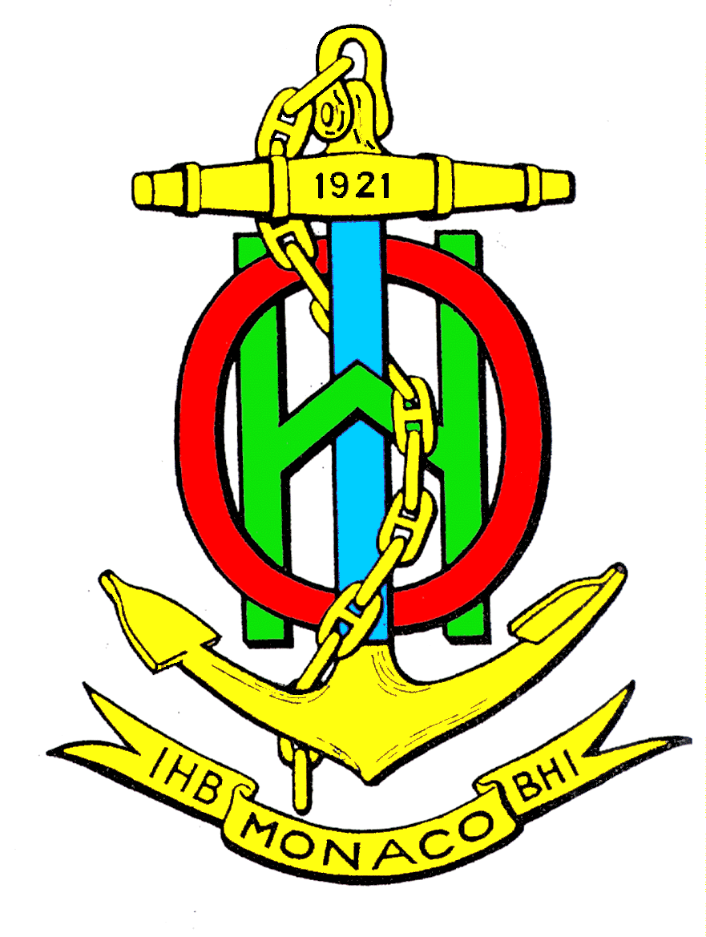

Worldwide ENC Database Working Group (WENDWG)

WENDWG4 Meeting, Niteroi, Brazil, 18-20 March 2014

Registration Form

Please complete this registration form and e-mail it to int.rel@dhn.mar.mil.br, by 18 February 2014 (copy to steve.barnett@ukho.gov.uk and alberto.neves@iho.int).

Rank or Title
Surname or Family Name
First Name
Name of Accompanying Person(s)
E-mail
Telephone
Representing (Nation, RHC, other)
Arrival | date
 | time
 | Airport
 | Flt nº
Departure | date
 | time
 | Airport
 | Flt nº
Accommodation (Hotel Name)

More information can be obtained from:
Karen Gomes, DHN International Partnering Team
Phone: +55 (21) 2189 3014
Email: int.rel@dhn.mar.mil.br

