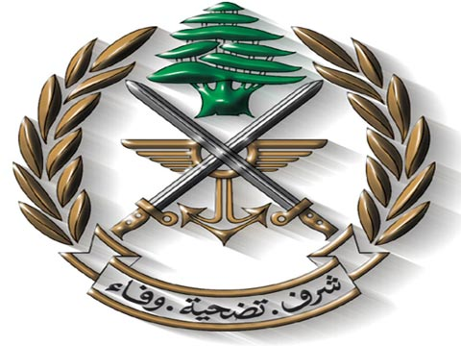
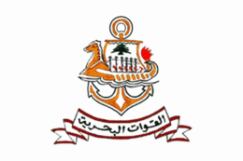

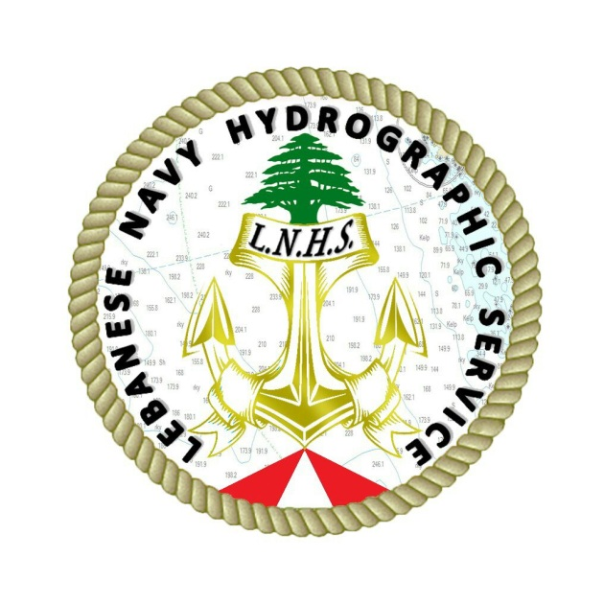

Lebanese Navy Hydrographic Service
2015 Report to the 19th MBSHC

Abbreviations

CBP Capacity building program
CNRS National Council for Scientific Research
GDGA General Directorate of Geographical Affairs
GIS Geographical Information System
IHO International Hydrographic Organization
IMO International Maritime Organization
LAF Lebanese Armed Forces
LNHS Lebanese Navy Hydrographic Service
MBSHC Mediterranean and Black Sea Hydrographic Commission
MSI Maritime Safety Information
NHC National Hydrographic Committee
NtMs Notice to Mariners
PCA Primary Charting Authority
POC Point of contact
SHOM Hydrographic and Oceanographic Service of the French Navy
SOLAS Safety of Life at Sea

Introduction
The aim of this report is to show the current situation of Hydrography in Lebanon and all the progress made since the last International Hydrographic Organization (IHO) technical team visit to Lebanon in February 2014. The report will also cover how the Lebanese Navy Hydrographic Service (LNHS) dealt with the technical visit recommendations. The capacity building needs of the LNHS are also included in the report.
Current situation
- The LNHS was established on the 1st of February 2014 and was activated on the 28th of October 2014. The LNHS is currently located in Beirut Naval Base and is directly attached to the Navy headquarters. At the moment, the service consists of:
- Chief of the LNHS: Navy surface warfare Commander without any hydrographic experience.
- One hydrographic surveyor: Navy surface warfare Lieutenant with a bachelor degree in Hydrography. Conducted a professional training in the Royal Navy and onboard HM SML Gleaner.
- 6 Petty officers and enlisted who had followed a naval training and are qualified to navigate. They have a good scientific background with universities degrees in science, computer science or management.

- On the 23rd of December 2014, the Lebanese government selected the LNHS to be the national point of contact (P.O.C) for hydrography. As well, Lebanon has started the necessary formal procedures to join the IHO.

- Since the activation date, the LNHS personnel (in the country and abroad) are still following continuous training in:
- Surveying afloat (Hydrographic science, Single and Multibeam echo sounders, planning surveys…) including practical training onboard R/V CANA.
- Surveying ashore (Geodesy, projections, tides, Global positioning systems…) including topographic equipment handling and Geographical Information System (GIS) course in the Army General Directorate of Geographical Affairs (GDGA).
- Maritime Safety Information (MSI) course (responsibilities of Lebanon as national coordinator, gathering, dealing with and reporting navigational warnings…) conducted by a French mobile team from the French Navy hydrographic service (SHOM).
- Basic and advanced hydrographic surveying courses followed by 2 officers in the Italian Navy Hydrographic institute.

- Although no surveying or cartographic capabilities are available so far, the LNHS has prepared a capacity building plan for the upcoming years and technical specifications for a full hydrographic system for shallow and deep water’s surveys.

- LNHS is currently establishing a national MSI plan as a matter of priority which will make it ready to deal with MSI and will ensure a continuous flow of exchangeable information between the national authorities, sub-regional and regional coordinators (Cyprus, NAVAREA III coordinator- Spain…). As a result, the cartographic production will be kept up to date (although the underlying surveys are old) and achieving by that the phase one of the capacity building program.

- A protocol of cooperation in hydrography, oceanography and nautical charting (training and mutual survey operations) had been discussed and is still under study between Turkey and Lebanon after a visit executed by the Chief of the LNHS and 2 Lebanese Navy officers to the Turkish Navy Office of Navigation, hydrography and Oceanography. On the other hand, another protocol of cooperation in the fields of hydrography and nautical charting is also still under study with the SHOM.

- The LNHS has started to supervise the different types of survey operations executed by national vessels in the Lebanese waters (ex. Survey launch “Jack Daniels” which conducts underwater wires and pipes inspection’s surveys) and to cooperate with them for national benefits.

- The LNHS presented a lecture titled “The National and Economical importance of the LNHS” to officers from Lebanese Armed Forces (LAF) units in order to introduce hydrography for them and to increase their awareness regarding the importance of the jobs and missions of the LNHS.

Near Future to do

- By achieving the phase one (MSI) of the capacity building program, the LNHS will be concentrating on phase two “conducting survey operations”.

- The LNHS as POC for hydrography in Lebanon is also following up the creation of a National Committee of Integrated Maritime Policy and a Navy Hydrographic Committee (NHC) where all the national maritime stakeholders will be presented.

Needs and requests
In order to develop and strengthen hydrographic capabilities and reach the internationally recognized standards, the LNHS seeks the following help and support:
- More training to gain the necessary professional experience in the different hydrographic fields. (Short courses opportunities in the fundamentals of hydrographic data gathering are available through the IHO CBP).
- MBSHC to inform NAVAREA III coordinator the relevant contact of the LNHS-MSI coordinator.
- MBSHC to support the access of Lebanon, as member, to the IHO.
- Establishing long-term tide gauges system (at least three covering the entire Lebanese coastline) to determine the different vertical datum and to monitor the tides and sea level changing.
- Procurement of survey equipment.
- Planning joint survey operations with participations of LNHS staff.

Conclusions
The LNHS has the willingness to build the national hydrographic capabilities which will contribute in a modern maritime and port infrastructure and will allow Lebanon to fulfill its international obligations in accordance with Regulations 4 and 9 of Chapter V of the SOLAS convention.
Since the last IHO technical team visit to Lebanon and the designation of the LNHS as national POC for hydrography, the Lebanese Navy is working hard to fulfill the hydrographic obligations. The recommendations of the IHO team were taken into account especially those related to phase one of the capacity building program. The cooperation and support of the MBSHC are extremely important and valuable to allow the development of the LNHS.

