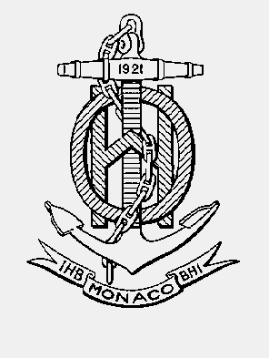

INTERNATIONAL HYDROGRAPHIC ORGANISATION HYDROGRAPHIQUE
ORGANIZATION INTERNATIONALE

CHART STANDARDIZATION & PAPER CHART WORKING GROUP
(CSPCWG)

[A Working Group of the Hydrographic Services and Standards Committee (HSSC)]

Chairman: Jeff WOOTTON  Australian Hydrographic Service  8 Station Street, Wollongong, NSW, 2500  Australia | Secretary: Andrew HEATH-COLEMAN  United Kingdom Hydrographic Office  Admiralty Way, Taunton, Somerset  United Kingdom
Tel: +61 2 4223 6508 | Tel: +44 1823 337900 ext 3656
Email: jeff.wootton@defence.gov.au | Email: andrew.coleman@ukho.gov.uk

CSPCWG Letter: 15/2014

UKHO ref: HA317/010/031-11 & HA317/010/034-12
AHS ref: fAA134047

To CSPCWG Members Date 18 December 2014

Dear Colleagues,
Subject: 11th CSPCWG Meeting, 27-30 April, in Rostock, Germany
As notified in CSPCWG Letter 06/2014, the 11th CSPCWG meeting will take place in Rostock, Germany, hosted by Bundesamt für Seeschifffahrt und Hydrographie (BSH - German Maritime and Hydrographic Agency). The meeting will commence on Monday 27 April 2015 at 0930 (0900 on other days) and is scheduled to close not later than 1500 on Thursday 30 April (planned finish 1600 on other days).
I look forward to another productive meeting, which will provide the opportunity for us to enhance our CSPCWG/NCWG activities and to discuss important issues which cannot readily be progressed by correspondence. The meeting also provides a valuable opportunity to share our knowledge, experience and practices in nautical cartography to the benefit of us all when we return to the challenges in our own hydrographic offices. Some will be renewing professional acquaintances and I hope the attendance of new members will further strengthen the CSPCWG. I encourage you to attend if you possibly can.
Following approval by HSSC, CSPCWG is to change its name to ‘Nautical Cartography Working Group’, so it will become the ‘1st NCWG meeting’ during the meeting.
CSPCWG10 Actions
I have included at Annex A the current status of the Actions from CSPCWG10. I would be grateful if you would review these and advise the Secretary as soon as possible of any updates to actions which are allocated to you, or to the WG in general.
Agenda
I have included an outline draft agenda at Annex B, which consists of our standing items, plus items we have noted during the year. Those items from WG members have the lead member nation(s) indicated in bold; please let me know as soon as possible whether you are content for these to be on the agenda. In order to maximise the value of the meeting, I encourage you to propose your own topics of interest as soon as possible. Perhaps there are subjects that you are currently reviewing within your own office, which would benefit from input from a wider viewpoint. Please note that the invitation to submit topics equally applies to those WG members who are unable to attend the meeting, provided they are accompanied by sufficiently detailed explanatory notes.
Additionally, you may consider submitting a report of any activities or issues regarding chart standardization which might be of interest to the WG (as an INF paper at item 15 at Annex B). You may also consider in advance of the meeting whether your office would like to host the next meeting (item 16 at Annex B).
CSPCWG11 papers
I have also included at Annex C the ‘Recommended format for Submission of Proposals to CSPCWG11’. It would be helpful if you could use this as a guide for your submissions. We will arrange to post meeting documents on the IHO website: go to www.iho.int and follow the links: Committees & WG / CSPCWG / Meetings. You may also find it useful to refer to submissions made to previous meetings (available in the same place) and to the guidance at Committees & WG / HSSC / Instructions for Submission of Reports and Proposals. These should be submitted at least 7 weeks before the meeting. This allows for follow-up submissions at least 3 weeks before the meeting. Follow-up submissions may:
(1) raise alternative proposals for consideration,
(2) propose substantial amendments to proposals, or
(3) provide comments from those delegates unable to attend a meeting.
Please provide all submissions to the Secretary in Microsoft Word® format.
Logistics
BSH has made a block reservation at the Radisson Blu hotel. Further details are provided in Annex D, with other helpful logistics information. Previous experience has demonstrated that it is a significant advantage to stay with the group in the same hotel.
Respond please
Please also use Annex E to advise the Secretary and host (Sylvia Spohn) of your intentions and any subjects you wish added to the agenda, whether or not you plan to attend CSPCWG11/NCWG1.
Timetable summary
In conclusion, the sequence of events requiring your action is:
As soon as possible:
- Advise the Secretary of the latest status of action items allocated to you (see Annex A).
- Advise the Secretary of subjects for the agenda (see Annex B).
As soon as possible and before 9 March 2015:
- Submit explanatory notes (ENs) for new items and any agenda items for which you are designated as lead (see Annex C).
- Advise the Secretary and Sylvia Spohn whether or not you plan to attend (see Annex E).
As soon as possible and before 27 March 2015:
- Book your room directly with the hotel. Remember to quote CSPCWG11 (see Annex D).
The meeting starts on Monday 27 April 2015 in the Deneb Room on the 5th floor of the BSH offices at Neptunallee 5, ROSTOK, 18057. This is approximately a 15 min walk from the Radisson Blu hotel along the city harbour; public (tram) transport is also possible (see Annex D). Please arrive in the conference room at 0915 on Monday (0845 on other days).

Yours sincerely,
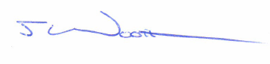
Jeff Wootton,
Chairman

Annex A: Status of CSPCWG10 actions
Annex B: Draft agenda for CSPCWG11/NCWG1
Annex C: Recommended format for Submission of Proposals to CSPCWG11/NCWG1
Annex D: Logistics Information
Annex E: CSPCWG11/NCWG1 Meeting Response Form

Annex A to CSPCWG Letter 15/2014

11th CSPWG MEETING

ACTIONS from CSPCWG10
UPDATED 17 November 2014

RETAINED ACTIONS from CSPCWG9
No | WG9  Agenda item | WG9 Action | Delegate | Status
22 | 8.5 | WG9 22: AU to continue discussion on dividing regulatory from navigation restrictions (for S-101), keeping Secretary informed, | AU
58 | 14.6 | WG9 58: AU to produce a sample INT1 register for next meeting. | AU

ACTIONS from CSPCWG10
No | WG10  Agenda item |  | WG10 Action | Delegate | Status
 | 3 |  | Secretary to produce draft report of CSPCWG10 by end of February 2014, for participants to approve.  Draft sent 18/02, final version distributed by email 06/03/14 | Secretary | Completed
 | 3 |  | All WG members to make early bids for travel budget to CSPCWG11; advise Chairman if any difficulties. | All WG members
 | 3 |  | All WG members to note agenda items for CSPCWG11 throughout the year (and forward to Secretary as they arise). Explanatory Notes may be sent before meeting calling letter. | All WG members
 | 4.1 |  | All WG members to brief their senior staff on CSPCWG views when CL inviting comments and participation in the proposed WG reorganization is issued.  CL39 dated 21 May, response by 1 July 2014 | All WG members | Time expired
 | 4.4 |  | Secretary to amend S-4 for revised definitions of aquaculture and phase of light once approved by MS (as clarification at next opportunity).  Included in S-4 Edition 4.5.0 published Oct 2014 | Secretary | Completed
 | 5 |  | IHB to amend CSPCWG TOR paragraph 2 when revision of S-4 is complete, by keeping the first two sentences only. | IHB
 | 5 |  | Secretary to propose to the WG a clarification to S-4 B-160 when revision of S-4 is complete.  Included in S-4 Edition 4.5.0 published Oct 2014. WG Letters 05 & 08/2014 refer. | Secretary | Completed
 | 6 |  | Secretary to amend paragraphs 3.1 and 4.1 of WG Procedures when revision of S-4 is complete.  Required for CSPCWG11 | Secretary
 | 7 |  | Secretary to amend Work Plan Task F to ‘maintain and extend…’ and Task G to delete ‘annual’.  Included CSPCWG10 report Annex E | Secretary | Completed
 | 8.1 | Group together | Secretary to draft revised S-4 specifications for ‘dredged / maintained areas’ for WG approval. | Secretary | In progress  WG Letters 09 & 13/2014 refer
 | 8.1 | Group together | INT1 subWG to retire I23 and amend terms for I21 and I22. | INT1 subWG | In progress  WG Letters 09 & 13/2014 refer
 | 8.2 | Group together | Devise new symbol for ‘maximum authorized draught’. | FI, DE, AU, Secretary | In progress  WG Letters 09 & 13/2014 refer
 | 8.2 | Group together | Secretary to consider whether any additional exceptions to B-141/142 are required. | Secretary | In progress  WG Letters 09 & 13/2014 refer
 | 8.2 | Group together | Consider CSPCWG Letter to enquire how widespread the concept of maximum draught is. | Chairman, IHB | In progress  WG Letters 09 & 13/2014 refer
 | 8.3 |  | Secretary to draft amendment to B-296.2 to allow (ie use may) indication of dredged / maintained / unsurveyed areas in Sources diagrams  WG Letters 10 &14/2014 refer | Secretary | Completed
 | 8.4 |  | Secretary to revise light vessel symbol (remove ‘X’) and progress to MS approval.  With JW to explore ‘old’ CL44/93 – email 16/07 | Secretary | In progress
 | 8.4 |  | INT1 subWG to retire P6; add new Light Vessel at Q32 (and amend heading to ‘Light Vessels and minor light floats’).  Await outcome Action 16 | INT1 subWG
 | 8.6 |  | Secretary to draft S-4 specification for dangerous cargo berth.  WG Letters 10 &14/2014 refer | Secretary | Completed
 | 8.6 |  | INT1 subWG to add symbol for dangerous cargo berth at F19.3.  WG Letters 10 &14/2014 refer | INT1 subWG | Completed
 | 8.7 |  | Secretary to draft S-4 specification for wind farms under construction.  WG Letters 10 &14/2014 refer | Secretary | Completed
 | 8.10 |  | Secretary to draft S-4 specification for covered berth.  WG Letters 10 &14/2014 refer. To be further considered at CSPCWG11. | Secretary | Completed
 | 8.11 |  | Secretary to amend S-4 to remove references to IQ and IVQ and advise SNPWG (for updating S-12) and MS (via CL on publication of next edition of S-4).  Included in S-4 Edition 4.5.0 published Oct 2014 and explained in CL69 | Secretary | Completed
 | 8.11 |  | INT1 subWG to remove IQ and IVQ.  INT1 producers to include in next edition. | INT1 subWG
 | 8.14 |  | CA and US (NOAA) to keep WG informed of any developments with radio-activated aids to navigation or proposals for charting. | CA, US(NOAA)
 | 9.2 |  | J Wootton to follow-up Chairman’s letter to Chairman HDWG about ED. (No further action for CSPCWG.)  NB: Not mentioned in HDWG report to HSSC | AU
 | 9.3.2 |  | Secretary to consider whether B-641.3 should be expanded (on pattern copies, to cover multiple NM blocks).  WG Letter 11/2014 refers (Response 1/01) | Secretary | In progress
 | 9.3.3 |  | Secretary to complete the example of a note which could be used instead of a (T) NM at B-633.6 (as a clarification).  Included in S-4 Edition 4.5.0 published Oct 2014 | Secretary | Completed
 | 9.4 |  | Secretary to draft addition to B-489 on how to deal with the proliferation of AIS. (Also note re non-recognition of term ‘synthetic’).  WG Letter 11/2014 refers (Response 1/01) | Secretary | In progress
 | 9.6 |  | Chairman to submit paper to HSSC6 re use of non-IHO member seals on INT charts.  HSSC6-05.5C refers | Chairman | Completed
 | 9.7 |  | J Barone to refer ‘Dataset Rating for Confidence Assessment’ paper to MSDIWG and DQWG. | US(NGA)
 | 9.9 |  | Secretary to amend S-4 as requested in CSPCWG10-09.9A, to reflect that inclusion of Racon wavelengths in ENC is allowed. Included in S-4 Edition 4.5.0 published Oct 2014 | Secretary | Completed
 | 9.10 |  | J Wootton to represent the differing positions expressed about definitions of Elevation and Height to TSMAD  NB: Not mentioned in HDWG or TSMAD report to HSSC. S-32 not amended. | Chairman
 | 10.1 |  | NO to develop a proposal for adding topographic contours to glacier depiction and provide to Secretary.  WG Letters 03, 07 & 12/14 refer | NO | Completed
 | 11.1 |  | Secretary to amend S-4 to reduce options for illuminated to the symbol or the INT abbreviation. Included in S-4 Edition 4.5.0 published Oct 2014 | Secretary | Completed
 | 11.2 |  | AU to develop initial draft of new ‘data quality’ section V for INT1. | AU | In progress
 | 13.1 |  | Develop further consideration on the future of paper charts and present a paper to CSPCWG11 at latest. | AU, CA, SE, UK | In progress
 | 14.2 |  | Chairman and Secretary to draft a revised Work Plan and forward to participants for approval.  Included in CSPCWG10 report Annex E | Chairman, Secretary | Completed
 | 15.2 |  | Secretary to draft S-4 guidance on the use of QR codes (or other technology).  WG Letter 11/2014 refers (Response 1/01) | Secretary | In progress
 | 15.3 |  | AU to present paper [on sea experience by UKHO staff – INF3] to DIPWG/TSMAD  Discussion in AOB agenda item with IK as lead at TSMAD28/DIPWG6 | AU | Completed
 | 15.4 |  | AU to forward CSPCWG10-INF4 on Ice product specification and discuss with Chairman DIPWG. | AU
 | 15.6 |  | Secretary to draft S-4 guidance about adding P&T NM reminder legend to charts.  WG Letter 11/2014 refers (Response 1/01) | Secretary | In progress
 | 15.7 |  | Secretary to draft S-4 guidance about national versions of INT2 and INT3 and consider any necessary amendment to CSPCWG Procedures.  WG Letter 11/2014 refers (Response 1/01) | Secretary | In progress
 | 16 |  | Chairman to confirm the requirement for a meeting with the WG and, if required, to arrange the details of CSPCWG11 meeting with DE.  Date confirmed by WG Letter 06/14 (w/c 27/04/15). | Chairman, DE | Completed

Annex B to CSPCWG Letter 15/2014

Draft Agenda for 11th CSPCWG MEETING
Rostock, Germany 27-30 April 2015

Please assemble at 0945 for 1000 start (Monday) and 0845 for 0900 start (other days).
Close by approximately 1600 (1500 on Thursday).

- Welcome, Introductions and Administrative Arrangements

- Approval of Agenda

- Status of Actions from CSPCWG10

- Relationship with HSSC
  - Notes from HSSC6 (Chairman)
  - Report from DIPWG (Chairman)
  - Report from TSMAD (Chairman)
  - Report from HDWG (Chairman)
  - Report from DQWG (Chairman)

- Terms of Reference
  - Change of name
  - Changes consequent on application of IHO Resolution 2/2007

- CSPCWG procedures
  - Changes consequent on application of IHO Resolution 2/2007

- CSPCWG work plan
  - Summary of progress (Sec)

- Chart content:
  - Covered berths – further considerations (AU)
  - Update on Radio-activated lights and fog signals (US, CA)
  - Bathymetry in maximum draught areas (IT)
  - Offshore accommodation vessels (UK)
  - WW1 wrecks: UNESCO convention (UK)
  - Refuge anchorage (UK)
  - Satellite derived bathymetry (UK)

- S-4
  - Superseded NMs (NZ)
  - Grouping of symbols in area limits (UK)

- Other CSPCWG publications
  - S-11 Part A
  - S-49

- INT 1 / 2 / 3
  - Report from Secretary of INT1 subWG (Sec)

- Lessons learned from Marine Incidents
  - Grounding of the Deutschland in Chile 2012

- Strategic direction
  - Future of paper charts (AU/CA/SE)

- Review of Actions and Work Plan
  - Actions
  - New items for Work Plan
  - Priorities
  - Timescales for tasks

- INF papers, reports and Any Other Business,
  - INF1: LED Lite Pipe

- Date, duration and venue of next meeting
Annex C to CSPCWG Letter xx/2014

Recommended format for Submission of Proposals to CSPCWG11
Paper for Consideration by CSPCWG
[Short descriptive title]

Submitted by: | MS or Organisation
Executive Summary: | Brief summary outlining the intention of the paper.
Related Documents: | Any relevant documents and references to the extent that they are known to the originator.
Related Projects: | Any related projects that may impact upon considerations

Introduction / Background
Introduction / Background
An introduction and any relevant background.
Analysis / Discussion
An analysis and/or discussion of the issues involved.
In analysing the issues, the following should be considered and addressed as appropriate:
is the subject addressed by the paper within the scope of IHO objectives?
is the subject of the paper within the scope of an item of the current IHO work programme?
do adequate industry standards exist?
do the benefits justify the proposed action?
are there any potential cost impacts on the maritime industry, Member States or other involved parties?
Conclusions
Any conclusions that may be drawn from the analysis/discussion.
Recommendations
Any resultant recommendations.
Justification and Impacts
Justification for any proposed action or recommendations. This should include:
identifying the benefits which would accrue from any proposed action;
identifying any resource implications resulting from the recommendations, such as the number of working group sessions, expertise, need for expert consultants, funding, etc;
identifying which HSSC working group(s) are essential to completing any proposed new work items;
the date when any proposed new work item is expected to be completed;
the proposed priority (high, medium or low);
any related activities that may impact on a proposed work item or decision.
Action required of CSPCWG
The CSPCWG is invited to:
a. endorse ……….
b. agree ………….
c. note …………...
etc.
Annex D to CSPCWG Letter xx/2014
IHO CSPCWG11/NCWG1, 27-30 April 2015
General and Logistics Information

Information for CSPCWG members attending the 11th Meeting hosted by Bundesamt für Seeschifffahrt und Hydrographie (BSH - German Maritime and Hydrographic Agency)
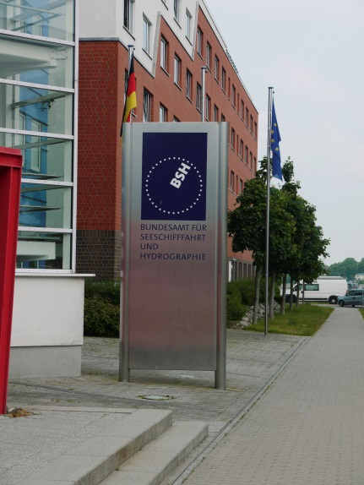

Meeting Venue:

The 11th meeting of the CSPCWG will take place in the congress room “Deneb” of the Federal Maritime and Hydrographic Agency (Bundesamt für Seeschifffahrt und Hydrographie - BSH), Neptunallee 5, 18057 Rostock, Germany. The meeting will commence at 9:30 on Monday morning and should be closed by 15:00 on Thursday.

Electrical connections and wireless broadband access for multiple users will be available for delegates' laptops.

Registration:

Please send your intention to attend the meeting by e-mail before 9 March 2015 to Sylvia Spohn (sylvia.spohn@bsh.de) and Andrew Heath-Coleman (andrew.coleman@ukho.gov.uk), using Annex E.

Lunch:

Lunch can be taken in the canteen/cafeteria of BSH on one’s own account until 1 p.m.

Accommodation:
A block reservation is made at:
Radisson Blu Hotel
Lange Straße 40
D-18055 Rostock
Germany
Phone: +49(0) 381 3750-3500
Fax: +49(0) 381 3750-3590
E-mail for booking: reservation.rostock@radissonblu.com
Website: www. radissonblu.com/hotel-rostock

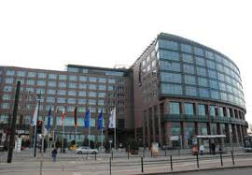

Rate for a single room is 95€ (double occupancy on request).
The rate includes Super Breakfast Buffet, use of wellness and fitness rooms and High Speed WLAN.
Reservation should be made directly with hotel by phone, fax or e-mail before 27 March 2015.
Booking reference: Please quote CSPCWG11.

The hotel is located in the city center of Rostock, 15 minutes walking to the BSH (see map on next page) or 10 minutes by tram (tram stop in front of the hotel; line no. 1 or 5 - four stops up to “Massmannstraße”) and 5 minutes walking.

City map with footpath from Radisson BLU Hotel to BSH

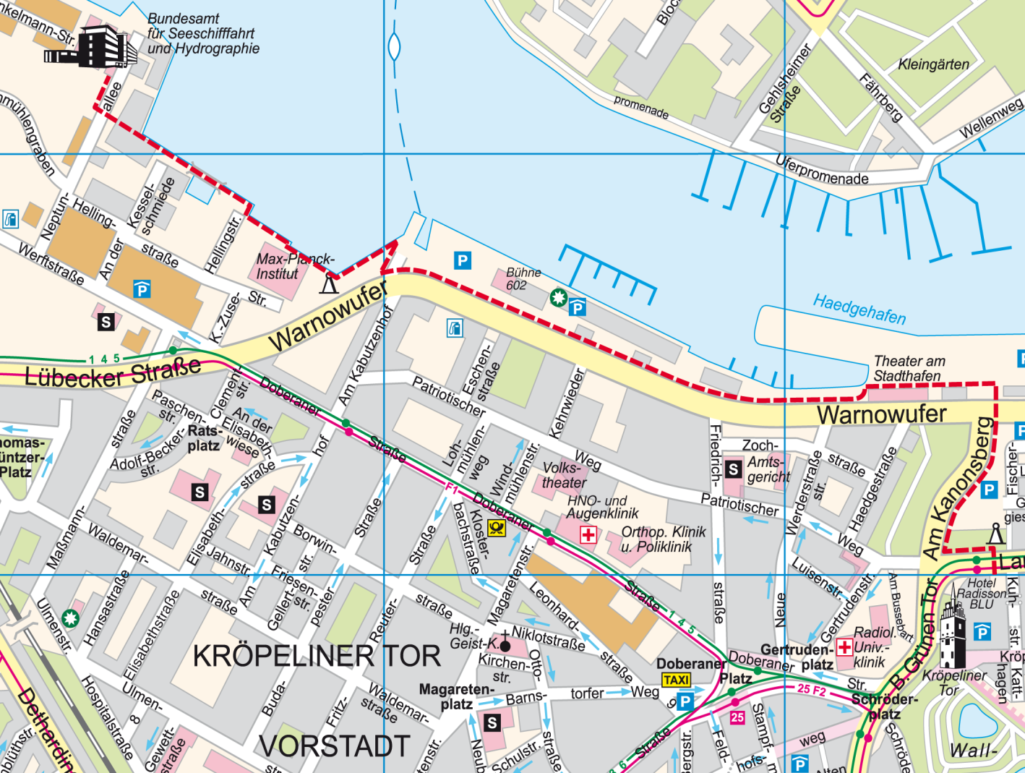

Transportation to and from the airport:

Nearest located international airports are Berlin or Hamburg.

From Hamburg airport please take the S-Bahn (S1) (suburban railway) directly to the central station – 25 minutes time to travel, runs every 10 minutes. There you get the train to Rostock.

From Berlin airport (Tegel) please take the bus named TXL to the central station. There you can take the train to Rostock.

At the central station of Rostock taxies are available or the tram on the lowest floor of the station No. 2, 5 and 6 go to the city centre. You get off at the tram stop “Kröpeliner Tor” in front of the hotel “Radisson Blu”

Tourist Information
Rostock is the largest city in the north German state Mecklenburg-Vorpommern. Rostock is on the Warnow river. The district of Warnemünde, 12 kilometres (7 miles) north of the city centre, is directly at the coast of the Baltic Sea.
Rostock is home to one of the oldest universities in the world, the University of Rostock, founded in 1419.
http://www.rostock.de/tourismus/tourist-information/

Social Program:

To be advised

Electricity - plug and socket:

Electrical voltage is 230V, 50 HZ. Plugs Type A or B

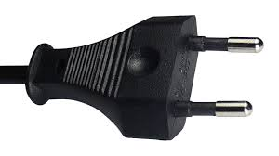

Contacts:

Assistance can be provided as needed. Anyone requiring assistance is invited to contact
Mrs. Jutta Rebetzky jutta.rebetzky@bsh.de phone no.. +49 (0) 381 4563-945
or
Mrs. Sylvia Spohn sylvia.spohn@bsh.de phone no.. +49 (0) 381 4563-767

Annex E to CSPCWG Letter 15/2014

CSPCWG10 MEETING RESPONSE FORM
(Please return to CSPCWG Secretary and copy to Sylvia Spohn, BSH
as soon as possible, not later than 9 March 2015 – DE time!)
andrew.coleman@ukho.gov.uk
sylvia.spohn@bsh.de
 |  | Yes | No
1 | Do you plan to attend CSPCWG11/NCWG1 in Rostock, Germany?
2 | Have you made a reservation at the Radisson Blu hotel?
3 | Have you any subjects to add to the agenda?

Title(s) of any additional agenda item(s) you wish to propose:

Please provide Explanatory Notes (ENs) for agenda items already allocated to you as lead and for any additional items you are proposing for the agenda. Preferably format the EN as Annex C, especially if it constitutes a new work item for the CSPCWG. ENs should be submitted by 9 March 2015. Papers submitted after that date will be taken at the discretion of the Chairman depending on time available, and usually be numbered as ‘INF’ papers.

6. Any further comments:

Name....………………………………………………………….
Member State……..……………………………………………..

