DQWG12-10.1A

12th DQWG MEETING
The Hague, 13-15 June 2017

Paper for consideration by the Data Quality Working Group (DQWG)

Review S-100 section 4C and ISO and INSPIRE standards
Submitted by: NL
Executive summary: Review S-100 section 4C and ISO and INSPIRE standards
Related documents: S_100_V2.0.0_June-2015, 211n2492_Text_for_ISO_19115-2, ISO-TC211_N3521_ISO-FDIS_19157_Geographic_informati
Related projects: S-100 development
Date 06 June 2017

Introduction / background
The DQWG was tasked by the S-100WG to review S-100 part 4C, Metadata – Data Quality. This paper describes the result of this review. One item that should be discussed is maintaining IHO standards in line with ISO when certain ISO standards reach end-of-life cycle.
The first outcome of this review is that S-100 adopts some of the ISO 19157 standard but is not complete and sometimes uses different wording for its definitions.

S_100_V2.0.0_June-2015 part 4C
This chapter contains the following information:
4c-1: Scope
4c-2: References
4c-3: Content
4c-3.1 ISO 19138 Quality Measures and UML Classes
4c-3.2 Core Metadata
Appendix 4c-A Hydrographic Quality Metadata profile, UML diagrams
Appendix 4c-B Hydrographic Quality Metadata profile Data Dictionary
Appendix 4c-C Hydrographic Quality Metadata Attribute Definitions

4c-1: Scope
No comments on this paragraph.

4c-2: References
ISO 19138, Geographic information – Quality measures is now obsolete and replaced by ISO 19157, Geographic information – Data Quality

4c-3: Content
ISO 19138 should be replaced by ISO 19157.

4c-3.1 ISO 19138 Quality Measures and UML Classes
Paragraph 3.1 states: “Additional quality measures may be described in a register of quality measures as described in ISO 19138 Annex-B.”

ISO 19157 has the following Annexes:
Annex A (normative) Abstract Test Suites
Annex B (informative) Data quality concepts and their use
Annex C (normative) Data dictionary for data quality
Annex D (normative) List of standardized data quality measures
Annex E (informative) Evaluating and reporting data quality
Annex F (informative) Sampling methods for evaluating
Annex G (normative) Data quality basic measures
Annex H (informative) Management of data quality measures
Annex I (informative) Guidelines for the use of Quality Elements
Annex J (informative) Aggregation of data quality results

The reference to ISO 19138 Annex-B is no longer valid. ISO 19157 Annex-D seems to most suitable one to be used.

4c-3.2 Core Metadata
No comments.

Appendix 4c-A Hydrographic Quality Metadata profile, UML diagrams
The present diagram in S-100 does not reflect the UML diagrams in ISO 19157, ref figure 1 page 16 and figure 2 page 17. These diagrams are shown below:

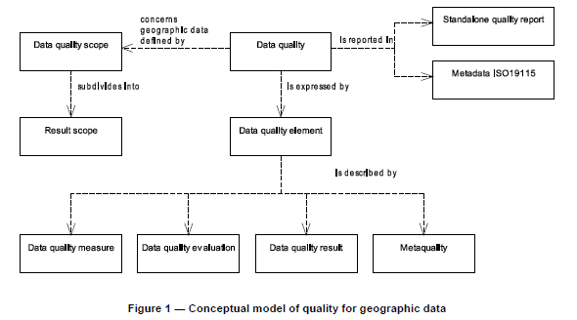

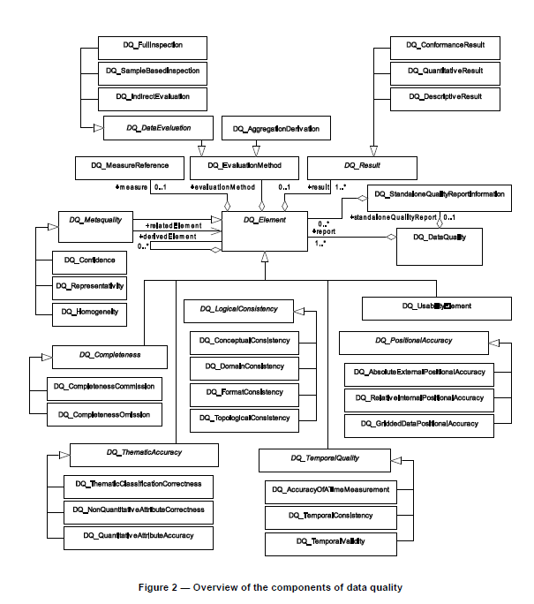

Appendix 4c-B Hydrographic Quality Metadata profile Data Dictionary
Text of S100 is compared with ISO-TC211_N3521_ISO-FDIS_19157_Geographic_Information, Annex C – Data dictionary for data quality

ISO LineNo is not present in ISO 19157

Name/role name: . A label assigned to a class or class attribute. Class names are unique within the entire data dictionary. Class attribute names are unique within a class. Role names are used to identify abstract model associations and are preceded by Role name: to distinguish them from other class attributes.*

Definition: This is the class or class attribute description*

Obligation/condition: This is a descriptor indicating whether a class or class attribute shall always be documented in the dataset or sometimes be documented (i.e. contains value(s)). This descriptor may have the following values: M (mandatory), C (conditional), or O (optional).

Maximum occurrence: Specifies the maximum number of instances the class, class attribute or association may have. Single occurrences are shown by “1”; repeating occurrences are represented by “N”. Fixed number occurrences other than one are allowed, and will be represented by the corresponding number (i.e. “2”, “3”…etc).

Data type: Specifies a set of distinct values for representing the class attributes; for example, integer, real, string, DateTime, and Boolean. The data type column is also used to define classes, stereotypes, and class associations.

Domain: For a class (shaded rows), the domain indicates the line numbers covered by class attributes and associations for that class.
For a class attribute or association, the domain specifies the values allowed or the use of free text. “Free text” indicates that no restrictions are placed on the content of the field. Integer-based codes shall be used to represent values for domains containing codelists.*

All above are taken from ISO 19157. This items marked * are different in S-100.

The table in S-100 page 140 (part 4c- Metadata – Data Quality page 5) should be renewed entirely in line with ISO 19157.

Appendix 4c-C: Hydrographic Quality Metadata Attribute Definitions
The following classes have been defined in S-100:
Class | Description
DQ_AbsoluteExternalPositionalAccuracy | Closeness of reported coordinative values to values accepted as or being true
DQ_AccuracyOfATimeMeasurement | Correctness of the temporal references of an item (reporting of error in time measurement)
DQ_CompletenessCommission | Excess data present in a data set
DQ_CompletenessOmission | This data absent from a data set
DQ_ConceptualConsistancy | Adherence to the rules of a conceptual schema
DQ_DomainConsistancy | Adherence of the values to the value domains
DQ_FormatConsistancy | Degree to which data is stored in accordance with the physical structure of the data set.
DQ_GriddedDataPositionalAccuracy | Closeness of gridded data position values to values to values accepted as or being true.
DQ_NonQuantitativeAttributeAccuracy | Correctness of non-quantitative attribute
DQ_QuantitativeAttributeAccuracy | Accuracy of a quantitative attribute
DQ_RelativeInternalPositionalAccuracy | Closeness of the relative positions of features in a dataset to their respective relative positions accepted as or being true.
DQ_TemporalConsistancy | Correctness of ordered events or sequences, if reported.
DQ_TemporalValidity | Validity of data with respect to time
DQ_ThematicClassificationCorrectness | Comparison of the classes assigned to features or their attributes to a universe of discourse
DQ_TopologicalConsistency | Measures of the topological consistency of geometric representations of features.

ISO-TC211_N3521_ISO-FDIS_19157_Geographic_Information, Annex D – List of standardized data quality measures reports:

Group | Class | Measure
Completeness | Commission | Excess item
 |  | Number of excess items
 |  | Rate of excess items
 |  | Number of duplicate features instances
 | Omission | Missing item
 |  | Number of missing items
 |  | Rate of missing items
Logical consistency | Conceptual consistency | Conceptual schema non-compliance
 |  | Conceptual schema compliance
 |  | Number of items not compliant with the rules of the conceptual schema
 |  | Number of invalid overlaps or surfaces
 |  | Non compliance rate with respect to the rules of the conceptual schema
 |  | Compliance rate with the rules of the conceptual schema
 | Domain consistency | Value domain non-compliance
 |  | Value domain conformance
 |  | Number of items not in conformance with their value domain
 |  | Value domain conformance rate
 |  | Value domain non-conformance rate
 | Format consistency | Physical structure conflicts
 |  | Physical structure conflicts number
 |  | Physical structure conflict rate
 | Topological consistency | Number of faulty point curve corrections
 |  | Rate of faulty point curve corrections
 |  | Number of missing connections due to undershoots
 |  | Number of missing connections due to overshoots
 |  | Number of invalid sliver
 |  | Number of invalid self-intersect errors
 |  | Number of invalid self-overlap errors
Positional accuracy | Absolute or external accuracy | Mean value of positional uncertainties
 |  | Bias of positions
 |  | Mean value of positional uncertainties excluding outliers
 |  | Number of positional uncertainties above a given threshold
 |  | Rate of positional errors above a given threshold
 |  | Covariance matrix
 | Vertical positional uncertainties | Linear error probable
 |  | Standard linear error
 |  | Linear map accuracy at 90% significance level
 |  | Linear map accuracy at 95% significance level
 |  | Linear map accuracy at 99% significance level
 |  | Near certainty linear error
 |  | Root mean square error
 |  | Absolute linear error at 90% significance level of biased vertical data (NATO)
 |  | Absolute linear error at 90% significance level of biased vertical data
 | Horizontal positional uncertainties | Circular standard deviation
 |  | Circular error probable
 |  | Circular map accuracy standard
 |  | Circular error at 95% significance level
 |  | Circular near certainty error
 |  | Root mean square error of planimetry
 |  | Absolute circular error at 90% significance level of biased data
 |  | Absolute circular error at 90% significance level of biased data (NATO)
 |  | Uncertainty ellipse
 |  | Confidence ellipse
 | Relative or internal accuracy | Relative vertical error
 |  | Relative horizontal error
 | Gridded data position accuracy | Use “horizontal positional uncertainties”
Temporal quality | Accuracy of a time measurement | Time accuracy at 68,3% significance level
 |  | Time accuracy at 50% significance level
 |  | Time accuracy at 90% significance level
 |  | Time accuracy at 95% significance level
 |  | Time accuracy at 99% significance level
 |  | Time accuracy at 99,8% significance level
 | Temporal consistency | Chronological error
 | Temporal validity | See “domain consistency”
Thematic accuracy | Classification correctness | Number of incorrectly classified features
 |  | Misclassification rate
 |  | Misclassification matrix
 |  | Relative misclassification matrix
 |  | Kappa coefficient
 | Non-quantative attribute correctness | Number of incorrect attribute values
 |  | Rate of correct attribute values
 |  | Rate of incorrect attribute values
 | Quantative attribute accuracy | Attribute value uncertainty at 68,3% level
 |  | Attribute value uncertainty at 50% level
 |  | Attribute value uncertainty at 90% level
 |  | Attribute value uncertainty at 95% level
 |  | Attribute value uncertainty at 99% level
 |  | Attribute value uncertainty at 99,8% level
Aggregation measures |  | Data product specification passed
 |  | Data product specification fail count
 |  | Data product specification pass count
 |  | Data product specification fail rate
 |  | Data product specification pass rate

Conclusion: S-100 has 15 quality measures defined. In ISO 19157 dictionary, 83 measures are listed. So 18% of possible measures are used. Are the remaining measures used in different context than S-100? This may need to be reconsidered.

INSPIRE standards have directly copied ISO standards and their definitions into their schema.

The DQWG is invited to:
- Note this report
- Discuss its content
- Draw a conclusion to the S-100 WG.

