DQWG13-08.1A

13th DQWG Meeting
Monaco, 15-19 January 2018

Paper for consideration by the Data Quality Working Group

Data Quality Indicators for bathymetric data on ECDIS chart display

Submitted by: Netherlands
Executive summary: Combine safety contours and quality of bathymetric data
Related documents: S-101PT / S-101WG2-11.1D MAR 17 Clean.pdf
S4 V4-6-0_ENG_April16
Related projects: Action item E from HSSC-8, S-101, IHO registry

Introduction/Background
DQWG has been tasked by HSSC to “Investigate ways of ensuring that ECDIS displays provide a clear warning or indication to the mariner on the quality of the underlying survey data, through appropriate use of the attribute CATZOC and/or improvement of the existing display capabilities (IHO Task 2.5.2).” The Nautical Cartography Working Group (NCWG) introduced a paper to DQWG at its 12th meeting (Doc. NCWG03-08.4A refers) submitted by Germany and asked the DQWG to:
- to the DQWG to revise the principles of data quality classification resulting in a less complex and more intuitive solution,
- to the ENCWG to search for more intuitive options for their symbolization.

The outcomes of the discussion during the DQWG meeting 12 are:
- The suggestion that mariners should be consulted to determine whether close cross hatching, or open cross hatching should represent the high quality or low quality end of the spectrum. DQWG view was that the natural response would be that closer cross hatching represents areas to avoid;
- Whether a system of lines, versus a tint, would possibly hide linear features, but acknowledging that this may be difficult with alternate day / night color palates;
- Suggestion that data quality should be a component of the safety depth contour, such that it shows areas considered too shallow, and also those where the data quality is too low for the vessel’s preferred data quality areas. This could be an operator set preference in the same way as other vessel parameters (including under-keel margin) can be entered into the ECDIS vessel setup.

Analysis/Discussion
The principles of data quality classification are based on the rule that an ENC data structure forms a seamless coverage of the area it depicts. This was achieved in S-52 structure by defining so-called “skin of the earth” objects. In the new S-100 structure the same condition applies: the base elements of the chart will form a seamless coverage. The main divisions of these elements are bathymetric and non-bathymetric in character. Each one of these elements has associated quality indicators. Several bathymetric coverages can share the same quality indicator. But a single bathymetric coverage may also be divided into two or more separate quality indicators.

In S-52 the quality indicator was driven by the acronym M_QUAL with attribute CATZOC. CATZOC has six different values (zones of confidence):
- A1 (6 stars)
- A2 (5 starts)
- B (4 stars)
- C (3 stars)
- D (2 stars)
- U (U)

The symbolization of these Zones of Confidence is almost the same: a triangle facing down with the number of stars inside the triangle depicting its value. The triangles are also placed horizontally across the screen at a regular interval. This method has two major drawbacks. It is difficult to interpret the value, one needs to look closely to count the numbers of stars inside the triangle. Second a triangle is depicted in a regular pattern across the screen giving no true indication of the coverage it is associated with. A triangle may be placed on the border of two coverages with different quality levels, giving poor guidance to both associated areas. In practice the CATZOC symbolization is almost always turned off in the screen display.

For S-100 new quality indicators have been developed by the DQWG. They are backward compatible with S-52 CATZOC but a new category has been added: Oceanic. The reason behind this is that 90% of all deep water areas on the globe are limited hydrographically surveyed but assumed safe for surface navigation due to its depth and little chance of anything near the surface. The following quality levels have been defined:
- Oceanic (deep water, assumed no risk to surface navigation shallower than 40m)
- 1
- 2
- 3
- 4
- 5
- Unassessed (no quality indication available)

Guidance to establish the appropriate quality level for each coverage:

Item | Option | Data quality measure | Quality level
Data assessment | 1 | assessed | 1,2,3,4 or 5
 | 2 | oceanic | oceanic
 | 3 | unassessed | unassessed
Category of temporal variation | 1 | extreme event | 5
 | 2 | likely to change | 5
 | 3 | likely to change but significant shoaling unlikely | 1,2,3,4 or 5
 | 4 | unlikely to change | 1,2,3,4 or 5
 | 5 | unassessed | unassessed
Significant features detected | 1 | yes | 1,2,3,4 or 5
 | 2 | no | 3,4 or 5
Least depth of detected features measured? | 1 | yes | 1,2,3,4 or 5
 | 2 | no | 3,4 or 5
Full seafloor coverage achieved | 1 | yes | 1,2,3,4 or 5
 | 2 | no | 2,3,4 or 5
Vertical uncertainty | 1 | < 0.5+0.01*depth | 1,2,3,4 or 5
 | 2 | < 1+0.02*depth | 2,3,4 or 5
 | 3 | < 2 + 0.05*depth | 3,4 or 5
Horizontal position uncertainty | 1 | < 5 + 0.05*depth | 1
 | 2 | < 20 | 2
 | 3 | < 50 | 3
 | 4 | < 500 | 4
 | 5 | > 500 | 5

The table should be followed from top to bottom. Only the lowest level encountered is valid. If at stage 1 the result is unassessed, the final outcome is unassessed.

Investigate ways of ensuring that ECDIS displays provide a clear warning or indication to the mariner on the quality of the underlying survey data
The challenge with data quality is to make its information useful and visible as a decision tool for the user of the chart. It needs to be intuitive, easy to use and understand. Symbolization of data quality has in the past been presented as an overlay information layer upon the base elements of the chart. To make it more useful, it could be integrated into the base elements of the chart in a similar way as depth areas and contour lines are being used as safety guidance.

For Under Keel Clearance management, the mariner can set the following items in an ECDIS display:
- Safety contour (value in meters)
- Safety sounding (value in meters)
- Shallow water (value in meters)
- Deep water (value in meters)

The result is that the contour line bordering a depth area shallower than the safety contour will be highlighted. The depth areas are depicted in the following way:
- Very light blue = deep water
- Light blue = shallower than deep water and deeper than safety contour
- Blue = shallower than safety contour and deeper than shallow water
- Dark blue = shallower than shallow water

The color portrayal is an indication of risk:
- Very light blue = no risk at all
- Light blue = safe to go
- Blue = take caution
- Dark blue = navigation at risk

This means that the depicted chart is relative to the draught of separate vessels. A small vessel will set the values lower than a deep vessel. There is a direct relation to the draught of the vessel and the depicted depth areas. This approach however assumes implicitly that all underlying bathymetric data has the same quality level and without additional quality information the values presented will be taken at face value by almost all users because symbolization of data quality is usually turned off. The challenge is to have the user turn on data quality information. This will most likely work when it helps in decision making.

The mariner wishes to avoid collision of the vessel. This can be catogorized as follows:
- Collision to other vessels (good seamanship)
- Collision to the seabed (grounding)
- Collision to significant features
- Collision to detected features

To help the mariner to avoid collision, data quality can be combined with Under Keel Clearance management. This method is demonstrated in an example with deep water = 15m, safety contour = 10m, shallow water = 5m, quality levels 1, 2 and 3.

Depth | Display | Quality Level | Comment
Deeper than 15m, shallower than 40m | Very light blue | oceanic | Area is not oceanic, should not be catogorized as such
 | Very light blue | 1 | No risk
 | Very light blue | 2 | No risk
 | Very light blue | 3 | No risk
 | Very light blue | 4 | No risk
 | Dark blue | 5 | Navigation at risk (extreme event)
 | Dark blue | unassessed | Navigation at risk
Deeper than 10m, shallower than 15m. | Light blue | oceanic | Area is not oceanic, should not be catogorized as such
 | Light blue | 1 | Safe to go (deeper than safety contour)
 | Blue | 2 | Take caution (no full seafloor coverage)
 | Blue | 3 | Take caution (significant features)
 | Dark blue | 4 | Navigation at risk (vertical accuracy)
 | Dark blue | 5 | Navigation at risk (extreme event, temporal variation of seabed)
 | Dark blue | unassessed | Navigation at risk
Deeper than 5m, shallower than 10m | Blue | oceanic | Area is not oceanic, should not be catogorized as such
 | Blue | 1 | Take caution (depth)
 | Dark blue | 2 | Navigation at risk (vertical accuracy)
 | Dark blue | 3 | Navigation at risk (too shallow)
 | Dark blue | 4 | Navigation at risk (too shallow)
 | Dark blue | 5 | Navigation at risk (too shallow)
 | Dark blue | unassessed | Navigation at risk (too shallow)
Shallower than 5m | Dark blue | oceanic | Navigation at risk (too shallow)
 | Dark blue | 1 | Navigation at risk (too shallow)
 | Dark blue | 2 | Navigation at risk (too shallow)
 | Dark blue | 3 | Navigation at risk (too shallow)
 | Dark blue | 4 | Navigation at risk (too shallow)
 | Dark blue | 5 | Navigation at risk (too shallow)
 | Dark blue | unassessed | Navigation at risk (too shallow)

This principle is demonstrated in the following figures:

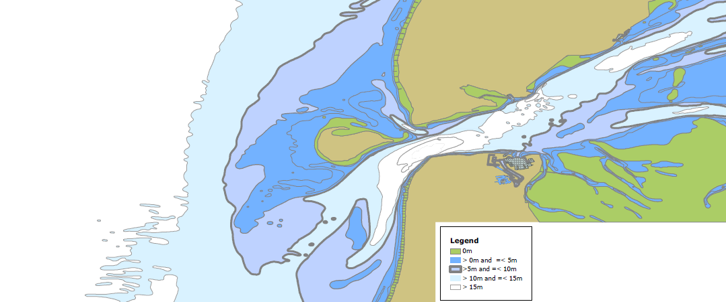
Figure 1: depth view

Figure 1 shows an area based on depth values. The waterdepth at open sea in the western part is more than 15 meters. When approaching the channel to port the depth decreases to 10-15 m and increases to more than 15 and decreases again to 10-15 m. This is the “classical view” based upon Under Keel Clearance management.

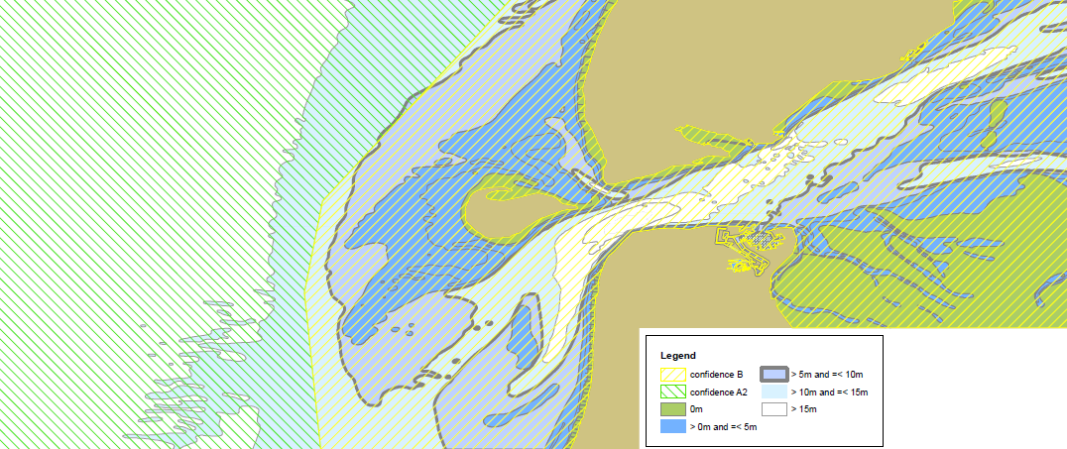
Figure 2: confidence levels

Figure 2 shows the two confidence levels available in the area. The western part has level A2 (=2), the eastern part has level B (=3). The land areas are classified as unassessed. The symbology used is for demonstration purpose only.

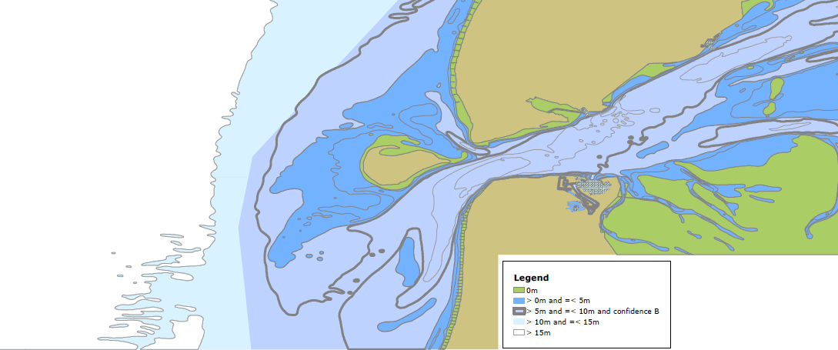
Figure 3: combination of depth and confidence level

Figure 3 shows a combination of depth and data quality of bathymetric data. The area which was initially portrayed in light blue when approaching the harbour (deeper than the safety contour value) is now portrayed as blue due to the quality level of 3. Mariners are warned to take caution in this area. By still using the safety contour highlighted, the mariner receives a clear guidance to avoid areas shallower than the safety contour, yet at the same time he recieves the signal to take caution whilst inside the safety zone due to other reasons than depth only. By simply clicking this option the mariner can make a judgement during the planning stage and return to the depth view whilst in execution of his voyage or decide to maintain the combined view.

The methodoly can be implemented under the following conditions:
- Quality of bathymetric data is usuable for decision making in depth areas shallower than the deep water value entered by the mariner. The mariner is not very concerned about objects or full seafloor coverage in waters deeper than the deep water value, otherwise he would set to value higher (=deeper).
- Quality levels to be used by default are 1, 2 and 3. This provides an indication if full seafloor coverage has been achieved, if significant features are detected and their least depth value known. Personal user input should still be allowed.
- Unassessed values for areas shallower than the deep water value entered have no meaningfull usage. The chart producer should avoid publishing such values in these areas.
- Quality values give a clear warning for areas of mobile seabed or where extreme events took place and resurvey of the area has not been completed yet.

Conclusions
There are multiple advantages of combining safety depth contours with quality of bathymetric data:
- it uses already existing symbology in place;
- there is no conflict with the existing color approach for Under Keel Clearance;
- users are already used to this color portrayal;
- there is no additional information presented on the screen;
- quality display is not mandatory but optional and simple to use;
- for IHO Member States when making the transition from S-52 to S-100, this is a good opportunity to populate ENCs with Quality of Bathymetric Data with assessed values or to set to Oceanic thus avoiding ENC’s published with Unassessed values.

There are some items that may need to be considered:
- misinterpretation of possible depths due the synoptic view of color patterns allocated to quality indicators mixed with depth ranges;
- updating Quality of Bathymetric Data values is required when new (better) bathymetry is received;
- a mixed grid solution and color patterns might be the right way to move forward, depending on the Display Mode used on ECDIS.
- this perspective is written from a producer’s point of view, feedback from the user community may be helpful for further development.

Recommendations
Evaluate the method presented to visualize data quality of bathymetric data in combination with safety contours, deep water and shallow water.

Action required of DQWG
The DQWG is invited to:
- Note and discuss this paper;
- Investigate if more documents and projects may be affected;
- Agree or not with the recommendations;
- Prepare proposals for S-100 WG, ENCWG, NCWG.

