ANNEX A

High Density (HD) ENC Production and Maintenance Guidance

Introduction
When ENCs were first introduced most HOs used their paper chart series as the source for this new vector product. Unfortunately, while enabling the relatively quick creation of ENC data, it has also led to some more unforeseen issues. One of the principle advantages of using ECDIS for navigation is that the system enables the setting of a safety contour, differentiating the safe and unsafe water. This can only accurately be achieved if the data within the ECDIS includes higher density contour intervals. Many of our ENCs today only contain the standard series of contour lines mirroring the paper chart as specified in IHO S-4 B-411. This results in some vessels having to navigate in waters indicated on the ECDIS as dangerous, when in reality the vessel is still safe and has not reached the maximum permitted water depth.
There is also an emerging requirement for Electronic Navigational Charts (ENC) covering commercial ports to include significantly larger scale and higher bathymetric content levels than any equivalent paper chart. This requirement is driven by:
- the increasing size of vessels in relation to ports and their channels; and confined waters,
- reduced under-keel depth margins as more vessel sailings are required within each tidal window,
- a fundamental shift in the way these vessels are navigated and a change in user expectations.
The preference is to meet these requirements through official S-57 / S-63 ENC rather than unofficial ‘closed’ proprietary formats. There is a concern that use of a proprietary format creates a situation whereby the ship’s Pilot has a considerably different view of the navigation situation compared to the vessel’s Master, leading to ineffective Bridge Resource Management, confusion and increased safety risk. In contrast, use of S-57 / S-63 ENC allows for access and use of the same information by all parties.

With advances in the processing of high-resolution bathymetry it is now possible to automatically create sets of supplementary contours that can directly feed into the creation of high density bathymetry ENCs. This Annex will provide HOs with survey capture, processing and production guidance to enable the effective creation of HD ENCs.

Definitions

High Density ENC (HD ENC)

An ENC product that includes bathymetry depicted with depth area intervals of 1 metre or closer within the depth range of relevance, focussed on a physically constrained waterway, and any relevant infrastructure in or affecting that area. The additional bathymetric information is incorporated in the base ENC dataset. The product may also include more detailed port infrastructure. Under the current IMO ECDIS Performance Standards, this product is suitable to be displayed and operated on any type-approved ECDIS and consequently it can be used to fulfil the IMO’s chart carriage requirements.

Bathymetric Surveys for HD ENCs
HD ENCs are of maximum benefit to the Mariner in areas where there are areas of minimal under-keel clearance.
Careful consideration must be given when planning surveys, so that the resulting data can be used to compile areas of HD bathymetry. Consult with ports, pilots etc. regarding surveys, maintenance, accuracy of infrastructure, ……
Appendix 1
Hydrographic surveys to be used in the compilation of HD bathymetric areas will in the majority of cases need to meet IHO S-44 Special Order requirements survey:
Maximum allowable Total Horizontal Uncertainty (95% confidence): | +/- 2 m
Maximum allowable Total Vertical Uncertainty (95% confidence):  A = +/- 0.25m  B = 0.0075  (see S-44 extract in Annex A) | TVU for 10m depths = +/- 0.26m  TVU for 20m depths = +/- 0.29m
Feature Detection: | Full seafloor search (able to detect features greater than 1 cubic metre in size)
The bathymetry supplied needs to be referenced to:
- WGS84. This is what ships, pilots, and ENC use. Transformation to other reference systems, and back again, increases the THU.
- A specified port tidal datum (such as “zero of the port tide gauge”, “x.xx metres below [named] benchmark” or similar). Where multiple tidal stations or nodes have been used, each should be listed to ensure accuracy is maintained through to the ENC. Simply stating “LAT” does not provide sufficient detail to replicate the tidal reference plane within the AHO. LAT within ports is frequently insufficiently defined for levels of accuracy to be maintained through to the ENC.
In cartographic terms, HD bathymetric data should only be depicted in areas categorized as CATZOC of A1 or A2.
The exception to this is where the bottom quality is mud/silt and the water column is holding significant amounts of sediment. Given these environmental conditions multibeam as a survey technique is not suited when acquiring depth information. In this situation other survey techniques may be used.
It is recommended that charting authorities consider the following criteria when developing HD ENCs
a. Ability for larger vessels to access the port.
b. Improvement to routes to avoid areas of environmental risk
c. Improvement to routes to improve traffic flow
d. Is it practical to maintain the cells once produced?

HD ENC Cell Creation
There are two options for creating HD ENCs:
- Existing cells – including additional depth contours in existing commercially available cells
HD bathymetric data can be included in any navigational purpose so long as the product is the largest scale ENC available in the area. In some cases these areas will probably require a larger compilation scale to support the extra detail provided (M_CSCL) and the way the end user will use the ENC.
Standard ENC ENC containing HD bathymetric data
The images above show the impact on the available safe water when additional contours are included.
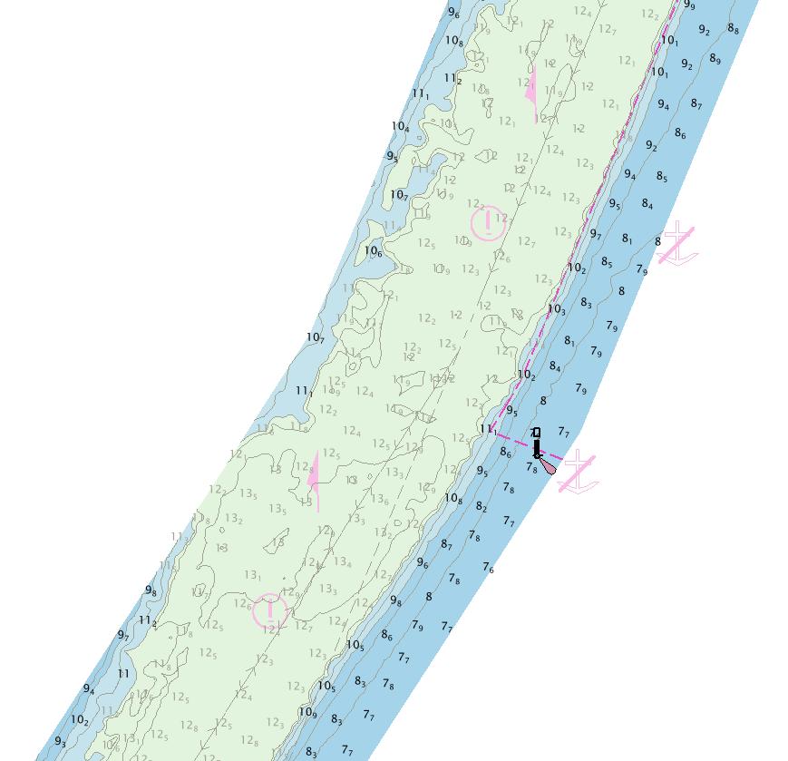
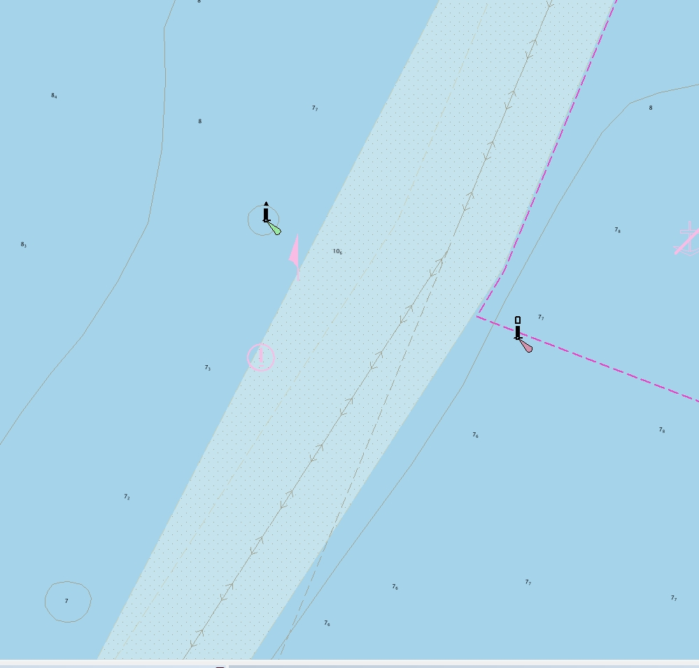
- New cells – Navigational Purpose band 6 berthing cells, standalone product (HD ENC). It is expected that the majority of HD bathymetric data will be included in new cells created in the Berthing Navigational Purpose. This approach is preferred as it simplifies the updating process.
HD ENC view
Classic Navigational Purpose 5 ENC view

Cell Size
A HD ENC cell limit will be set at 5mb but can exceed this limit if necessary

Quality of Bathymetric Data
To ensure the mariner has access to all the metadata related to the bathymetric survey the feature M_QUAL must be used. It is strongly recommended that M_SREL and the attributes POSACC, SOUACC and SUREND are also used to relay important information about the survey technique of sounding measurement (TECSOU).
CATZOC values should be A1 or A2.
Validation tests
Apply existing

Automatic Generation of Depth Contour intervals and sounding spacing
HOs are free to determine density of contours. It is recommended that a contour density of 1m is used as this represents the most useful value for the user.
For use in ECDIS HD ENC data does not need to extend from 0m > 50m, the most useful data range is between 5m to 30m.
The use of denser sounding patterns may be beneficial to support the navigation of large vessels that may still require higher accuracy than 1m contour intervals. In these cases, an evenly spaced sounding pattern (automated sounding suppression routine) is preferred over a triangular spacing. The first one is faster to generate and there’s no expectation that the mariner may sail ‘from sounding to sounding’. It is important to remember that soundings are not part of the S-52 ‘Standard’ display and they can be turned off at any moment.
Note: When DRGAREs exist within the area of HD bathymetry the use of ‘supplementary’ contours matching the design depth of dredged areas is highly recommended (i.e. 7.6m). HOs may decide to replace dredged areas with full bathymetry, in which case the limit of the dredged are and the dredged depth should be indicated using a FAIRWY object.

Setting SCAMIN on Contours
SCAMIN must be applied to the standard contours (i.e. 2, 5, 10, etc) in a way they match the values of the same contours outside the area of HD bathymetry. Depth contours having the same VALDCO must appear and disappear at the same time irrespective if they sit within or outside the HD bathymetry area.
To avoid excess clutter within the ECDIS it is recommended that SCAMIN is applied to the intermediate contours so they are either not visible or only visible at compilation scale (of the HD ENC or the M_CSCL). The decision depends on the sea bottom topography and on how close the contours are at compilation scale. Related S-58 checks (1553) can be ignored.

Setting SCAMIN on Soundings
Same as standard practice.

Managing Shoals and Deeps
The automated contouring process may generate contours that are too small to easily be displayed at compilation scaleI. It is advised that no area should be smaller than 2.75mm at compilation scale. Appropriate automated contour generation algorithms so as to avoid the creation of small shoals should be investigated.
Small deeps can be filtered out.
Examples screenshot of generalisation and enlarging of contours.

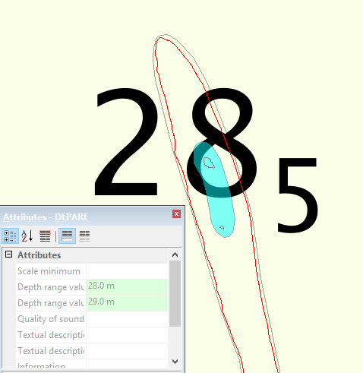
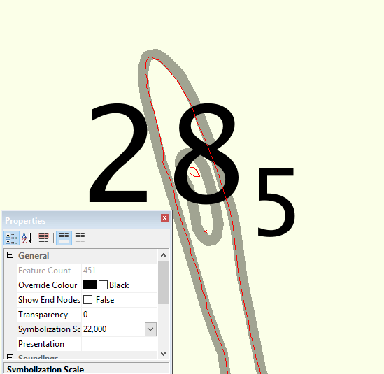

Testing
Supply to pilots and simulator for testing and feedback.

Maintenance of HD ENC cells
HD ENCs should be maintained at a minimum as is done for the regular ENC maintenance regime, however where there is a requirement to release the data more regularly this would be possible with the agreement of the RENCs.
For post-dredged surveys the HO’s should be capable of processing the data and releasing an ENC update within 2 weeks from data receipt.

