Could you please comment on the results of tests 2.2.2 and 2.2.4 from S-64 (Edition 3.0.1 - June 2015) for Identifying Automatic Chart Corrections on Mariners Demand?

Test 2.2.2. Loading sequential update
As a case in point, we took the test results after loading the update GB5X01SW.003.
The content of the update given in the Readme.txt file in clause 2.2.2 Loading of Updates of S-64 is the following:

gb5x01sw.003 Extend western limits of the prohibited entry area (delete cautionary area).
EDTN 1, UPDN 3, ISDT 20050908
According to the test description, the review should be done by setting the date range given on the corresponding screen sample.
The screen sample from S-64 with test results is reproduced at the picture below:
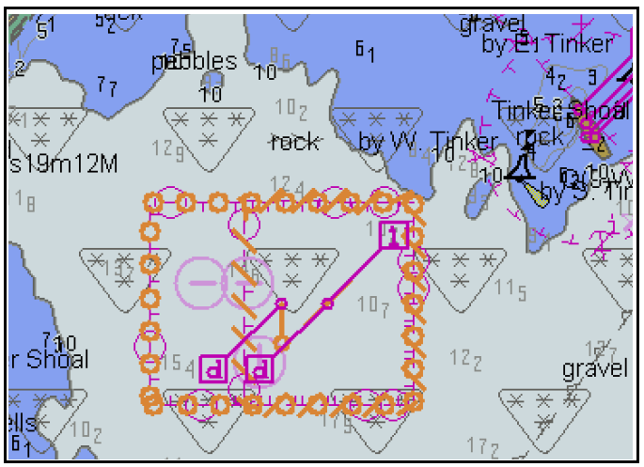
For this sample, the date range should include 8th Sep 2005.
- Definition of date range
In our opinion, the term ‘include’ is not precise. In this case, the date range may be extended to include, for example 9th May 2001. Then, updates gb5x01sw.001 and gb5x01sw.002 should also be highlighted for such extended date range.

In clause 10.4 of the Presentation library for processing date dependent ENC objects, there are strict and well-defined terms for a data range:

Display is based on date dd mm yyyy, or
Display is based on viewing date range from dd mm yyyy to dd mm yyyy

For testing processing and presentation of date dependent objects (tests 3.3.3.2 of S-64), similar setting descriptions are used:
Set viewing date = dd.mm.yyyy
or
Start viewing date= dd.mm.yyyy
End viewing date= dd.mm.yyyy

To avoid ambiguity, we suggest using the same terms for settings in the tests for Identifying Automatic Chart Corrections on Mariners Demand.

We would also like to note that in case of the presentation symbol CHDATD01 for date dependent objects (it is presented on this sample), the option ‘Select Highlight date dependent’ should be set.

In addition, the Mariner must be informed by a permanent indication on the chart display that the date has been adjusted.

- Presentation of center symbols

Three center symbols are displayed in this test. They are:
- Two symbols SY(ENTRES51) for RESARE
- SY(CTNARE51) for CTNARE

On the screen sample for test results, only one symbol for update highlighting (CHRVID01) is shown in the centre of gravity of the final object symbolization.

We don’t give the complete log of this update here, but briefly there are the following operations:
- Four instructions for geometry (Delete node, Create node, Delete Edge, Create Edge)
- Modifying the references in RESARE
- Deleting CTNARE

Could you explain why exactly these three above mentioned center symbols with only one symbol (CHRVID01) for highlighting are shown?

In our opinion, the rule listed in the corresponding clause of the presentation library is too common, whereas the sequence of update instructions can be very complex. We think that the algorithm for highlighting automatic updates should be specified in more detail to have non-contradictory test results.

- Presentation of highlighting symbol

In our previous remarks for the presentation library, we have noted that the algorithm for presentation of center symbols with predefined shifts of pivot point is obsolete and not useful for real chart objects with complex, not rectangle geometry (as it is in, e.g., ECDIS CHART 1), especially for concave polygons.

Lack of such algorithm (predefined shifted pivot point) becomes apparent over the problem with combined symbolization of several symbols in one point. For example, symbolization of the above mentioned centered symbols and symbols to superimpose them (Identifying Automatic Chart Corrections, Information symbols, etc.)
In our opinion, it is necessary to permit manufacturers to place centre symbols using their own algorithms. The corresponding remark should be added to clause 8.5.1 of the presentation library.

Test 2.2.4. Loading update of newer edition, pp.3

According to the test description, the following actions should be performed:
3. Install the following base cell:
2.2.5 Good Base Cells\ENC_ROOT\GB5X01SW.000 (edition 2); and load the following update:
2.2.4 Loading of New Update\ENC_ROOT\GB5X01SW.001 (edition 2)
4. Display installed chart.

The result of the test and objects to be highlighted after applying automatic update GB5X01SW.001 are shown on the corresponding screen sample in this test. This screen sample is reproduced (with our comments) at the picture below:
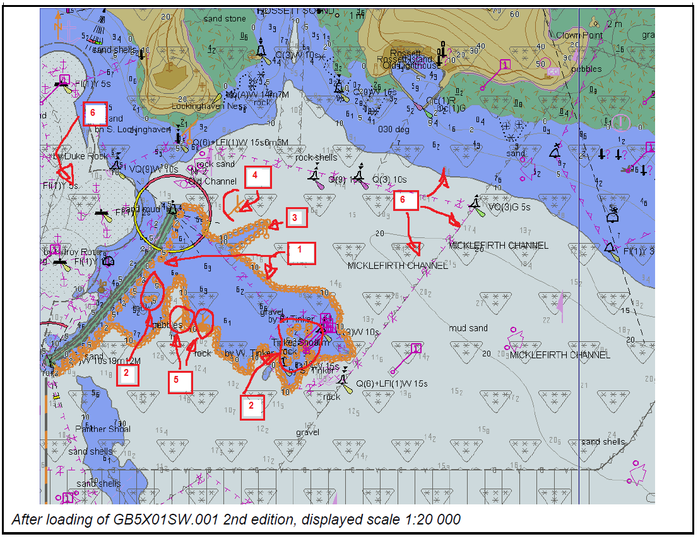
The content of the update given in Readme.txt file in clause 2.2.4 Loading of New Update of S-64 is the following:
gb5x01sw.001
Replace 12.8m sounding at: 32 31.75S, 60 56.85E with a 9.4m sounding.
Modify the 10m contour to enclose.
Because of the way that UKHO's ENC production software works, the update also deletes and re-creates a bundle of 273 soundings as well as the 10m contour, the 5-10m depth area, the 10-20m depth area, a harbour area and a meta navigational system of marks.

We don’t give here the complete log of this update, but the main changes we saw are the following:
- Creating a new 3D edge for sounding (9.4m)
- Modifying (deleting and adding) 2D points for the part of the 10m contour
- Modifying two DEPARE objects: DEPARE (DRVAL1=5m, DRVAL2=10m) and DEPARE (DRVAL1=10m, DRVAL2=20m)
- Modifying the references of M_NSYS and HRBARE objects
- Refactoring and modifying the references for several objects shared with the objects modified in p.3 DEPARE, e.g.:
- internal TG1 objects (DEPAREs, HULKS) for DEPARE (DRVAL1 =5m, DRVAL2=10m)
- DEPARE (DRVAL1 =20m, DRVAL2=30m)
- DRGARE (DRVAL1 =8.6m)
- etc.
On the corresponding screen sample for test results, the following objects, which were modified in gb5x01sw.001 update, are highlighted (see numbering in the sample given at the picture above)
- DEPARE (DRVAL1=5m, DRVAL2=10m) – see N.1
- Internal for this DEPARE TG1 objects (DEPAREs, HULKS) – see N.2
- 3D DOUNDG object – see N.3
We don’t quite understand the following identifying (highlighting):
- Modification shown at N.4. Is it modification of center symbol for M_NSYS object? Why in this case the center DIRBOY01 symbol is not shown?
- Modification shown at N.5. What are these objects that have been highlighted?
TG1 objects (DEPAREs, HULKS) inside the DEPARE (DRVAL1=5m, DRVAL2=10m) are highlighted as modified (see N.2). Then why modification of other objects whose references were also modified in this update is not shown? (All objects listed below are marked as N.6). For example:
- Modification of the following objects refactored in this update is not shown (the list it is not complete):
- Modification of DEPARE (DRVAL1=10m, DRVAL2=20m) is not shown
- Modification of HRBARE is not shown
- Modification of DEPARE (DRVAL1=20m, DRVAL2=30m) – internal for DEPARE (DRVAL1=10m, DRVAL2=20m), is not shown
- Modification of DRGARE (DRVAL1=8.6m) shared with modified DEPARE (DRVAL1=10m, DRVAL2=20m) is not shown
- etc.
We understand that Identifying of Automatic Chart Corrections applied to the geometry is a considerably more complex task (indirectly changing references of many outside objects and marking these objects as updated) than identifying the updates applied to the feature object or its attribute. However, in our opinion, a strict algorithm should be described and test results must be intelligible and non-contradictory for such kind of update.
We also consider it necessary to describe rules for Identifying of Automatic Chart Corrections in case if MASK and USAG subfields of FSPT field are set to {1} (mask) or {3} (exterior boundary, truncated by the data limit). Should the edges of the corresponding objects be highlighted in this case?
We would also like to notice that the quality of the screen sample in this particular case is too low.

