S-64 IHO TEST DATA SET DISCREPANCIES
S-64 Test reference | Description | Discrepancy | Suggestions
2.1.1 | Loading of initial datasets and indication of own ship stationary position. | New CSP LIGHT06 has changed display of all round lights with VALNMR >= 10 NM. These should be shown with circles. Picture at the test 2.1.1 shows such lights with light flare. | Make new screen shot.
2.1.2 | Checking that in the chart library the information about the cells is provided as it is given in Action section | - The Action section is having table where charts are listed, however, this table is not satisfied to the suggested by IHO S-63 edition 1.2 ENC Status Report.  - The test references to IEC 61174/4.4.1. The 4.4.1 Para of IEC 61174 is about the Contents of the SENC, there is nothing mentioned about the how the chart library should look like. | Change the table whether to the table given in IHO S-63 edition 1.2 – ENC Status Report,  OR  Change the Result content, so inspectors won’t be searching for the same table in the EUT.
2.2.4 | After loading of GB5X01SW.001 2nd edition, displayed scale 1:20 000 (screen plot) | The plot given in this test is having only one of DEPARE highlighted by Chart Corrections symbols (SY(CHRVIDz01) and SY(CHRVDEL1). Adjacent DEPARE was also changed by the update and should be highlighted. | The boundary of adjacent DEPARE should also be highlighted, see Figure 1 below  Additionally update makes changes in soundings, MNSYS, and harbor area. All of these should be highlighted
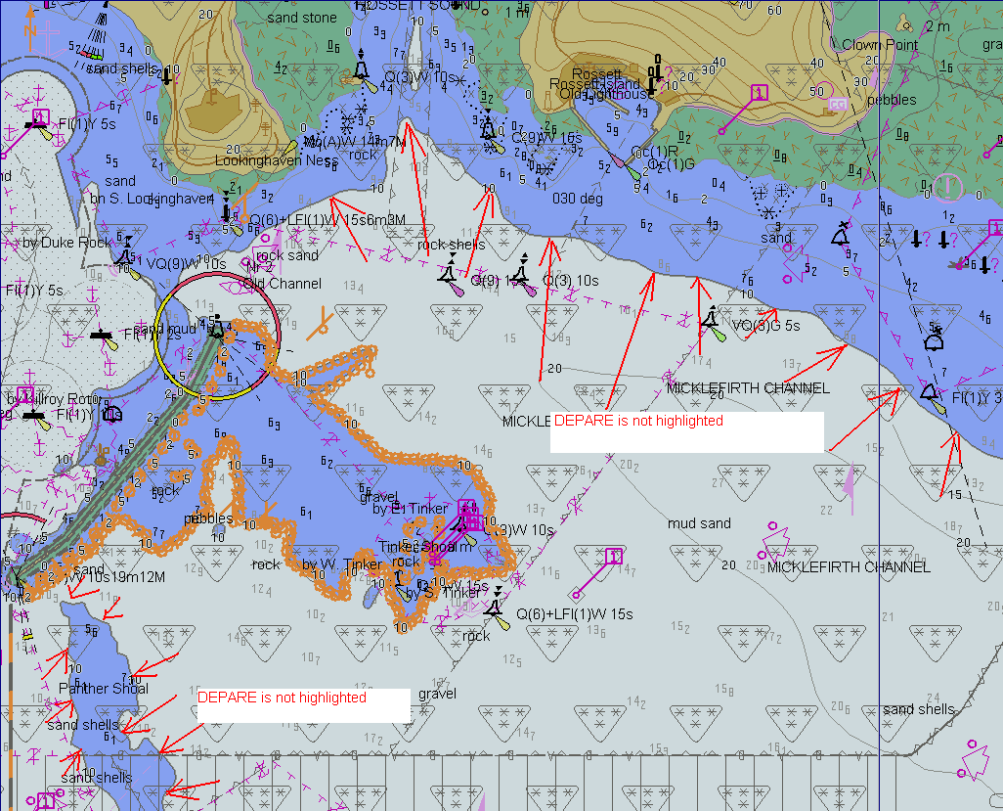
Figure 1.
2.5.7 h) | D:\IHO S-64 [S-64 V 1.2.1]\7 ENC Data Management\Test 7f\Update  Result:  The ECDIS should report the status of all ENCs loaded in accordance with S-63. It should use the issue date of the exchange set as the reference date and should display its reference date as 2nd September 2009 (the SERIAL .ENC date of the last update loaded). | Serial.ENC file contains this:  GBWK05-09 20090209UPDATE  However, in reality, the 9 February was on Monday, week 7. | Perhaps, SERIAL.ENC should be changed/fixed?
3.1.4 | Select Symbolized Boundaries  Select Simplified Point Symbols.  Buoys, beacons, aids to navigation in Standard Display | Plot for Buoys, beacons, aids to navigation is given for Paper chart Points Symbols, but in Setup it is set Simplified | Change the settings, so Setup will have:  Select Paper chart Point chart Symbols.
3.3.9 b) | Display of additional chart information symbol (INFORM).  Select Highlight info | Highlight info symbol must be shown when the INFORM attribute is given for an object (PL 4.0 - 10.6.1.1).  The point [discrepancy] is that all the given objects are having INFORM attribute, so when selecting Highlight info then the INFORM01 symbol will be turned on for all objects. | Change the image  OR  Change the chart objects, removing INFORM attribute from those which are having TXTDSC or NTXDSC, or PICREP
3.6.4 | View the object at position 32º21.100’S-61º20.650’E scale 1:5000  Results  Confirm that items 1-4 display as shown in the graphic below: | Image is showing both objects, but should show only NEWOBJ.  Lines: the CANALS object shall not be displayed because NEWOBJ overlays it (NEWOBJ priority is 6, CANALS - 2)  Areas: ADMARE – 2, NEWOBJ – 6. The ADMARE boundary is overlaid by NEWOBJ. | Change the image.  OR  Use other objects the priorities of which are higher than NEWOBJ.
3.6.8 | Unofficial data boundary display. | The discrepancy relates to the one-sided line [LC(NONHODAT] that is drawn on the boundary of the non-IHO data. The NONHODAT line is overlapped by built-up area drawn at non-official cell. This could happen if the Pres Lib drawing priorities are applied to both official and non-official data objects; in this case unofficial built-up area overlaps official data boundary. This seems to be illogical since it could lead to a case when boundary between official and non-official data is not shown at all. It is assumed that NONHODAT line should have priority over all unofficial data and should always be shown on top of unofficial data. | Change the image, so NONHODAT line will be drawn on top of object from unofficial cell

