HSSCCGxx-xx

Paper for Consideration by HSSC CG

S100WG Input into the IHO Strategic Plan

Submitted by: | S100WG
Executive Summary: | This paper presents the results of the S100WG survey regarding inputs into the IHO Strategic Plan
Related Documents: | N/A
Related Projects: | N/A

Introduction / Background
At HSSC7, the working group chairs were invited to assist in the preparation for the HSSC submission to the next International Hydrographic Conference in 2017 to update the IHO strategic plan and to provide inputs into the next five year work programme. At the last S-100WG meeting in March 2016, the chair of the S100WG reported that a survey would be sent to the working group members and expert contributors to help determine what the top priorities of the working group should be. In addition, the survey also asked some questions regarding IHO resolution 2/2007 and if any improvements can be made. This paper presents the results of this survey.

Analysis/Discussion
The survey was sent out to S100WG members and the IHO list of ECDIS manufacturers at the beginning of April and remained open for thirty days. A total of 45 individuals started the survey, although only 26 individuals responded to the entire survey. The breakdown of responses are in the table below:

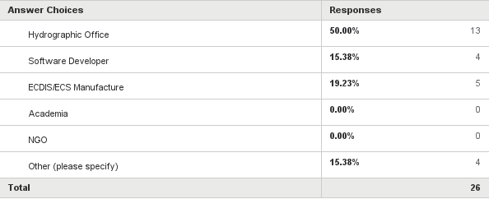

The first question in the survey asked for people to rank what parts of the S-100 Work Plan was Most Important to Least Important. The top six items that had an aggregate response being the highest priority are:

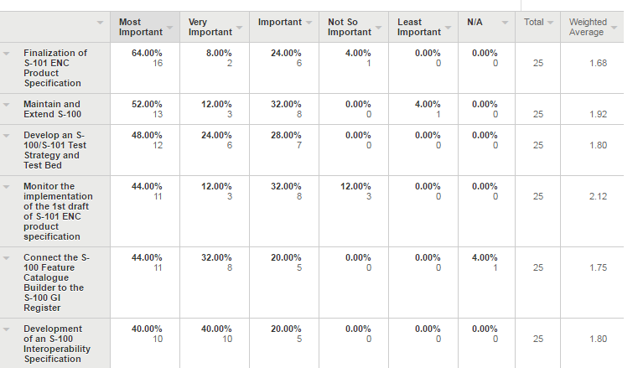

If the responses were further subdivided into user groups then the responses change slightly:

Hydrographic Offices Top Six:

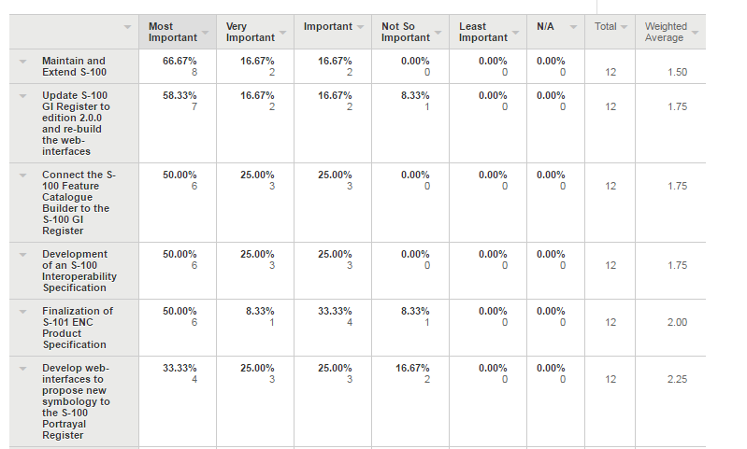

ECDIS/Software Developer Top Six:

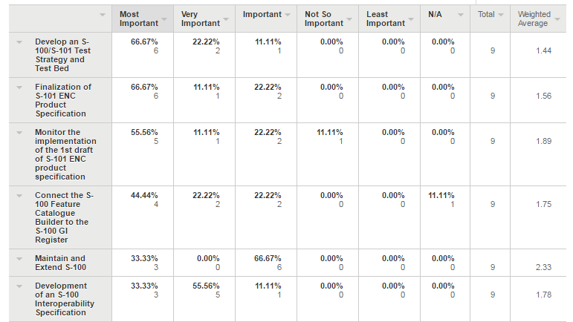

The second question asked individuals to rank what the most important product specifications are that are currently under development by IHO Working Groups. Because of the large amount of product specifications that have been assigned and the limited amount of resources, this question might help HSSC focus in on the priority products.

All Respondents:

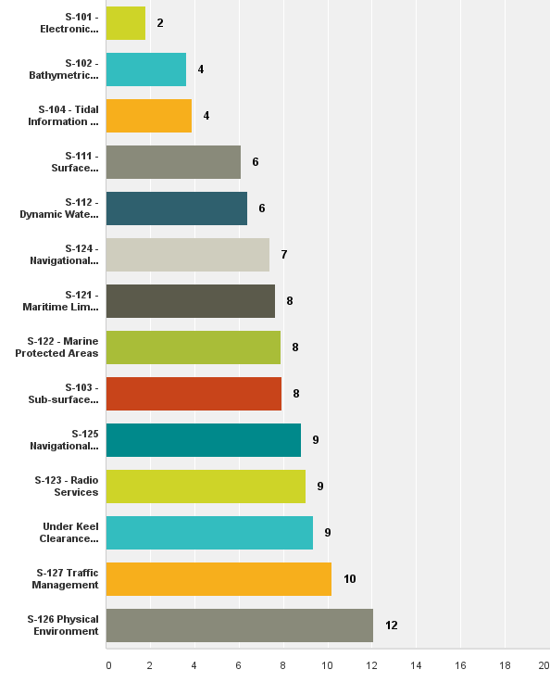
Hydrographic Offices:

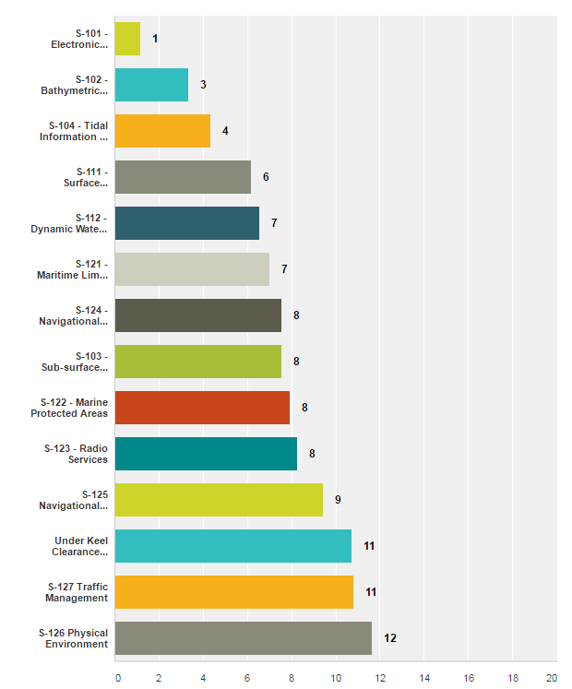

ECDIS and Software Developers:

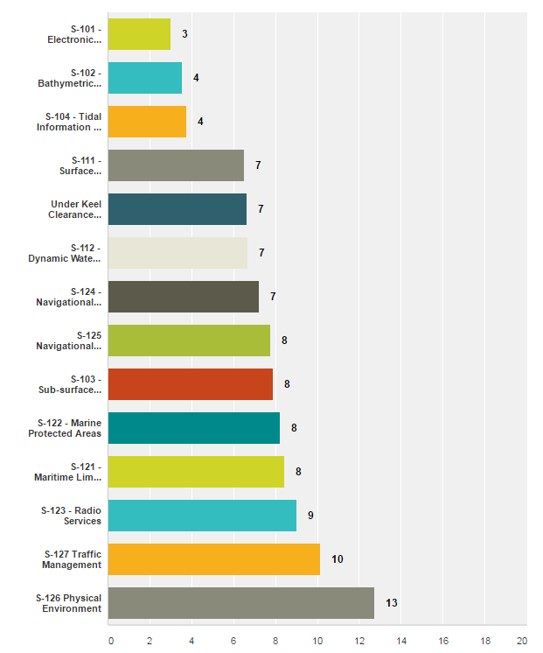
The third question asked individuals to rank the importance of non-IHO S-100 based product specifications that are under development by other organizations. The aggregate responses are:

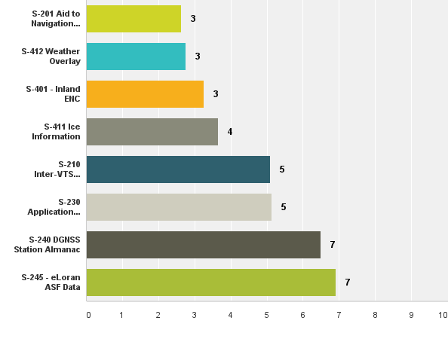

Hydrographic Offices:

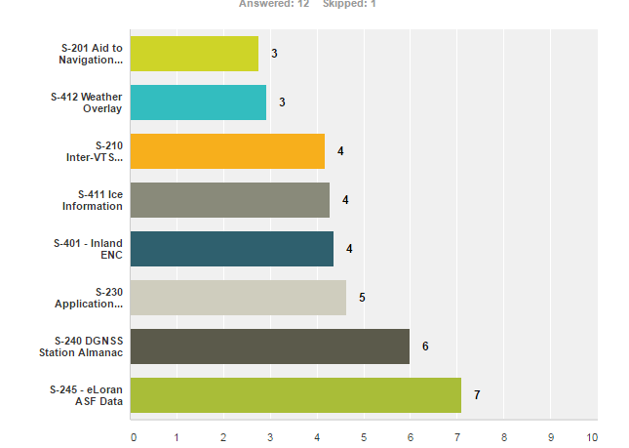

ECDIS/Software Developers:

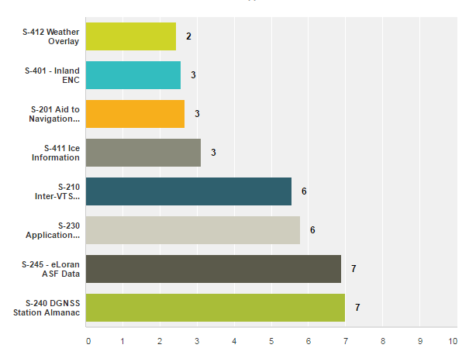

In summary, the three items in the S-100 Workplan that have overlap between the two communities are:

- Maintain and Extend S-100
- Finalize S-101
- Develop the S-100 Interoperability Specification.

As to the work on the individual product specifications, the top four were the same for each user community and then the prioritization differs.

- S-101
- S-102
- S-104
- S-111

The second part of the survey focused on IHO Resolution 2/2007. For the most part respondents felt that it adequately covers the standards development lifecycle, although the respondents that did not agree offered some comments:

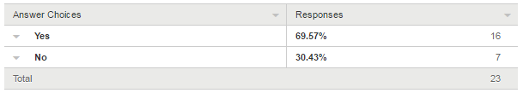

Some of the comments for suggested improvements are:

- To circumstantial for S-100, OK for Product Specs
- Emphasize transition and consequences for all stakeholders.
- Considering the growing requirements on various product specifications, it need to simplify the development life cycle
- Allow WG to process and approve revisions, not just clarifications. Adopt streamlined standards approval processes not necessarily involving circular letters.
- The evaluation of the classification of a change to a standard (new edition vice revision vice clarification) is assumed in assignment to the committee before stakeholder engagement, or perhaps with 'soft' stakeholder(s) on the committee voicing intent and relevant impact. As most changes will have commercial impact, a period of industry assessment, possibly through an RFI process, could improve the ability of the IHO to gauge impact and potential 'ripple effects' before the work program begins.
- Life cycle does not provide timeline for phases. There is no concept of time defined. For example, what does "fast-track" mean?
- Need to establish predictable lifecycle of development.

The next question asked if S-100 should be put on a timed lifecycle to provide a predictable expectation when a full new edition of S-100 would be published. The intent behind this question was to determine if the S-100 community thought this was a good idea. The results show that approximately 2/3rd of the respondents thought that S-100 should be on a timed schedule.

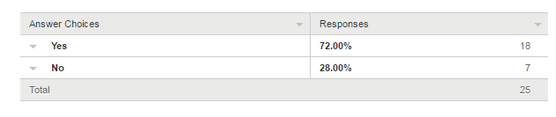

The following question asked respondents that if they answered yes to S-100 being on a timed schedule for new editions, then wat was the appropriate interval. They were giving three choices – 2,3 or 4 year cycles.

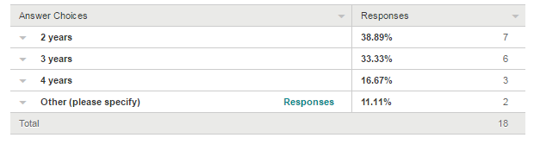

From the responses above, there was no clear indicator of what the appropriate timing between new editions of S-100 should be. In addition, one response indicated that there should be 1 year between new editions, and another response was that the S-100WG “must complete one full implementation first, i.e. S-101 then determine cycle. Best guess would be 3 year cycle at that point.

Finally the survey asked if there were any other comments questions, or concerns that should be considered by the HSSC chair group. In total there were 8 responses:

- New editions of standards should be considered as and when required.
- shipping companies require more contour lines in ENC´s
- Need to have a conscious awareness of relationships between some IHO standards today (S63, S57, S58, S65), and if/how such a relationship will be maintained with the new S10x standards and how their development will be synchronized
- in (7), I believe 3 years is a rather arbitrary number that fits the current IHO working group decision periodicity; 2 is too short for the group, and 4 is too long and likely to be offset from the IHC. New editions of S-100 should not be constrained by hardware manufacturers, and software can be updated, even with high-fidelity testing, on an annual basis. Thus, my concern is that the IHO not 'lock' the safety of navigation into a cycle of improvement that is too slow to leverage Internet of Things, the sensor 'web' in Ports, or other technologies that will impact safety of navigation. S-100 needs to be agile to adapt to these technologies, not specific hardware interfaces that are, at root, simply manifestations of software controls
- Timing. The new S-100 based specifications could take too long to implement. We would like to see the standards in full use in less than 10 years.
- IHO technical standards Maintenance Body (MB) should attempt to harmonize technical input from all contributors. MB should be run by IHO MS neutral person. Impasse should be resolved by MB and a way forward presented in timely manner. Maintenance cycle can address issues as they arise.
- S-100WG focus on development and extension of S-100 and test bed for interoperability guideline. Also provide infrastructures to develop and harmonize S-xxx PS among the domain owners.
- Consider 4 year cycle for major updates and mandatory matters (for example changes requiring update of shipboard software installations or SOLAS-related ) and 2 year cycle for non-mandatory but "if provided" harmonization matters (for example harmonization considerations).

Conclusions

It should be noted that these are just the opinions of S-100 WG members and its band of expert contributors; however, these responses should help inform the strategic direction of the IHO and the strategic plan and 5 year work programme should reflect the importance of S-100 and its various product specifications to the IHO and the greater IHO community.

Recommendations

As a result of the survey, a few preliminary recommendations can be put forward:

- A proposed amendment to IHO Resolution TR 2/2007 that takes into account some of the comments made by the responders.
- Consider implementing a timed lifecycle for S-100 to ensure a certain amount of predictability for when major extensions will be added to S-100.
- Consider applying a comprehensive timed lifecycle to all IHO S-10X product specifications. This would be in line with what is currently practiced by both IEC and ISO.

In addition, to the above recommendation, the chair of the S-100WG would like to put forth the idea that the role of the expert contributors be somehow acknowledged at the S-100WG level. If not for the work of the expert contributors and the proposals that they make to improve S-100 based on how the framework is implemented, then there would be no S-100. As it stands now, the expert contributors propose the majority of amendments to S-100 based on issues found during implementation and rely on the MS to have the technical expertise to approve or disprove these amendments.

In addition, it is also recommended that HSSC begin to start the discussion on how hydrographic offices will have to deal with the eventual transition to S-101. This should be included in the next strategic plan of the IHO. For example, there may be misconceptions that S-101 will be backward compatible. IT WILL NOT BE. Because of this, hydrographic offices may have to maintain two production systems for a period of time – or they can use the convertor to create S-101 data – but eventually they will have to migrate. This will be easier if the production system utilizes a central database to house hydrographic information – but not all HO’s have this capability or even need this capability. In addition, we do not know if the ECDIS community intends to be duel fuel. These are large question that will need to be answered as the completion date of S-101 starts to draw near.

Action Required of HSSC CG
The HSSC CG is invited to:
a. note the paper
b. discuss the survey results
c. discuss the preliminary recommendations

