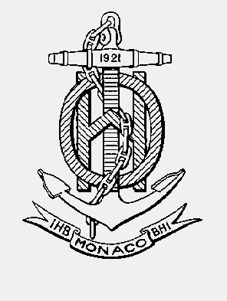

INTERNATIONAL HYDROGRAPHIC ORGANISATION HYDROGRAPHIQUE
ORGANIZATION INTERNATIONALE

NAUTICAL CARTOGRAPHY WORKING GROUP
(NCWG)

[A Working Group of the Hydrographic Services and Standards Committee (HSSC)]

Chair: Jeff WOOTTON  Australian Hydrographic Service  8 Station Street, Wollongong, NSW, 2500  Australia | Secretary: Andrew HEATH-COLEMAN  United Kingdom Hydrographic Office  Admiralty Way, Taunton, Somerset  United Kingdom
Tel: +61 2 4223 6508 | Tel: +44 1823 337900 ext 3656
Email: jeff.wootton@defence.gov.au | Email: andrew.coleman@ukho.gov.uk

NCWG Letter: 16/2015
UKHO ref: HA317/010/031-12
AHS ref: fAA161096; fAA158644; fAA156801
Date 15 December 2015

Dear Colleagues

Subject: Abbreviation ‘Accom’ (follow-up to NCWG Letter 12/2015)
Thank you to the 19 Working Group members and ESRI who responded to NCWG Letter 12/2015. All approved the adoption of a new international abbreviation ‘Accom’ to be used in association with symbol L17 when required to indicate that it is an accommodation vessel. There were no additional comments.
Consequently, this new abbreviation will be included in the list of international abbreviations in S-4 at B-122.1 and the new sentence under the L17 symbol in B-445.5 will be amended to:
‘An appropriate legend, for example: ‘Storage Tanker ’ (or equivalent) or international abbreviation, for example: ‘Accom’; ‘FSU’; ‘FSO’; ‘FPSO’ should be added adjacent to the symbol if scale allows.’
These will be included in S-4 Edition 4.6.0, currently in preparation.
There is no need to respond to this letter.
Yours sincerely,
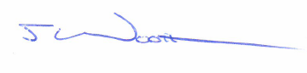
Jeff Wootton,
Chair NCWG.

