From: ENAV | ENAV18/output/14.1.21
To: PAP | 18 March 2016

LIAISON NOTE

Roles and Responsibilities of AtoN Authorities Regarding the Portrayal of AtoN on Electronic Navigational Charts (ENCs)

INTRODUCTION
This liaison note discusses the issues surrounding the portrayal of AtoN on Electronic Navigational Charts (ENCs). It will analyse the roles and responsibilities AtoN Authorities have regarding the communication of the intent of the waterway designer regarding the mariner’s use and interpretation of AtoNs as portrayed on the ENC. Purpose of this paper is to define the issues and recommend a solution to the Policy Advisory Panel for their consideration.

DETAILS
The Norwegian Coastal Administration (NCA), through the ARM Committee, has highlighted their concerns regarding presentation of visual AtoN’s on Electronic Navigational Chart (ENC) charts. Specifically, the portrayal of the International Hydrographic Office (IHO) defined “Complex Lights” on ENCs does not always reflect the desired information necessary for the mariner to use these AtoNs as intended and in a safe manner.

Discussion
The ENAV Committee reviewed the liaison note from ARM (ENAV18-9.11, formerly ARM3-11.1.3) and has dissected the topic into two principle issues which define the larger issue of the what are the Roles and Responsibilities of IALA with regard to portrayal guidance provided to Hydrographic Offices.
- Issue 1: Charting of Complex Lights on ENCs is a concern to IALA because the desired information necessary for the mariner to use these AtoNs as intended, and in a safe manner, must be appropriately portrayed. Complex Lights comprise a wide range of AtoNs which include Sector, Directional, and Leading lights where the arc of light is dissected into colours with varying intensities and characteristics. These AtoN types continue to evolve not only in their capability, but in their charting complexity as well. See example of a complex light in figure 1.
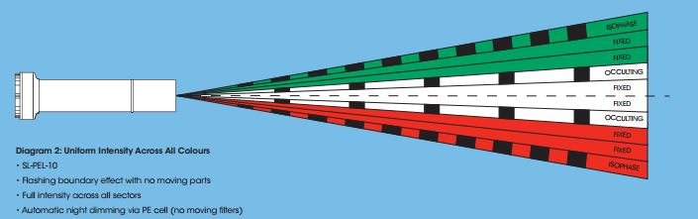
Figure 1 - Sealite Port Entry Light
- Issue 2: Prior to the wide range use of ENCs and the automation of AtoN data exchange between AtoN Authorities and their corresponding Hydrographic Offices (HOs) the waterway designer would directly communicate with the cartographer to express charting requirements yielding an appropriate portrayal of the AtoN on the paper chart. The advent of the ENC and digitized data exchange has removed this verbal exchange and a gap now exists.
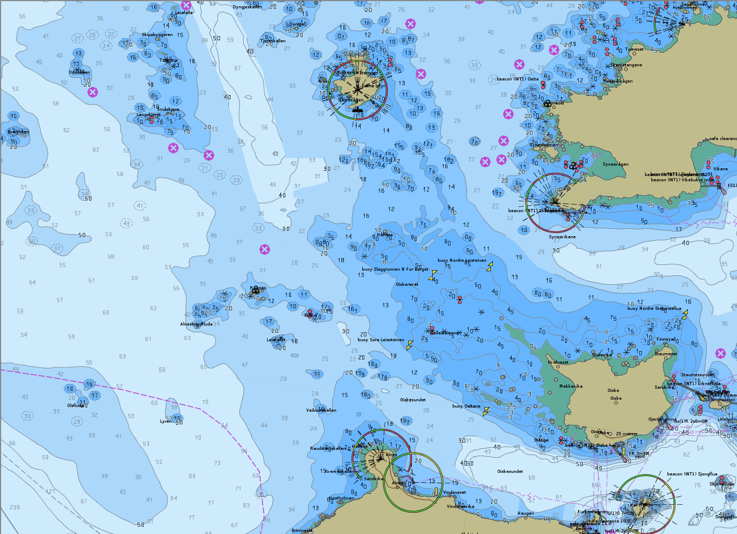
Figure 2 - Portrayal of light sectors in an ENC chart
The question for IALA that these two issues raise is: Should IALA S-2xx Product Specifications include encoding/portrayal “advice” which will inform HO Cartographers as to the intended use of an AtoN or other AtoN Authority related services to ensure appropriate portrayal?
Proposed Solution: It is not the intent of this paper to recommend that AtoN Authorities assume complete responsibility for portrayal of AtoN in an ENC, but rather provide encoding details which will assist the HO in appropriately portraying an AtoN so that the intent of the AtoN is clear to the mariner. Therefore, the recommend solution would encourage the AtoN Authority to provide encoding details consistent with the existing HOs encoding guidelines to inform rather than replace the cartographer. Examples of the encoding guidance include recommended SCAMIN values, lengths and placement of Nav Lines associated with an AtoN, etc. An example of this collaboration between an HO and an AtoN Authority can be found in the U.S. where the U.S. Coast Guard is automating AtoN data exchange with the two internal Hydrographic Offices (NOAA and USACE). The formats of these dataset files include the S-57 attributes necessary to encode the AtoN data on an ENC with minimal human interaction. These datasets adhere to both IHO and NOAA/USACE encoding guidelines and it is the intent to migrate these datasets to comply with the S-100 and S-201 standards when adopted.

ACTION REQUESTED
The PAP committee is requested to:
1. Note the concerns of the ARM committee and NCA.
2. Consider the issues and recommendation raised within this paper.
3. Determine if further guidance to members is required in terms of providing encoding guidance to their respective HO. If further guidance is needed, assign development of an IALA Guideline for AtoN S-57 and S-100 Encoding to the appropriate committee.

