NIPWG 3-26.1

Paper for Consideration by NIPWG

[S-123 - ProdSpec Radio Services - Sample data sets]

Submitted by: | France (SHOM)
Executive Summary: | Amended version of Radio Services sample data sets.
Related Documents: | - NIPWG 2-26.1  - Minutes of NIPWG 2 (Section 26)
Related Projects: | Nil

Introduction / Background

- Mapping work conducted before NIPWG 2 resulted several issues. It appeared that some sample data needed to be clarified. The new version of Sample data sets takes into account the clarifications presented during NIPWG 2.

- During NIPWG 2, Italy suggested to complete the sample data sets with information about AIS. In accordance with Action item 2/13, Italy provided information about AIS stations along the Italian coast. After analysis, it appeared that this information only related to AIS AtoN and associated base stations and were not relevant to S-123 but to S-125. Italian data have been forwarded to Finland for further consideration.
In nautical publications (Mariner's handbook, lists of Radio Signals, etc.), there are no information about AIS that might be included in the S-123;. only functions related to Anti-collision and to Aids to Navigation are described.

Action Required of NIPWG

The NIPWG is invited to:
a. note this paper.
b. provide any comment.

S-123

Sample Data Sets

RADIO SERVICES

including REFERENCE

Version 09/11/2016

MARITIME RADIO STATIONS

JUSSLAND

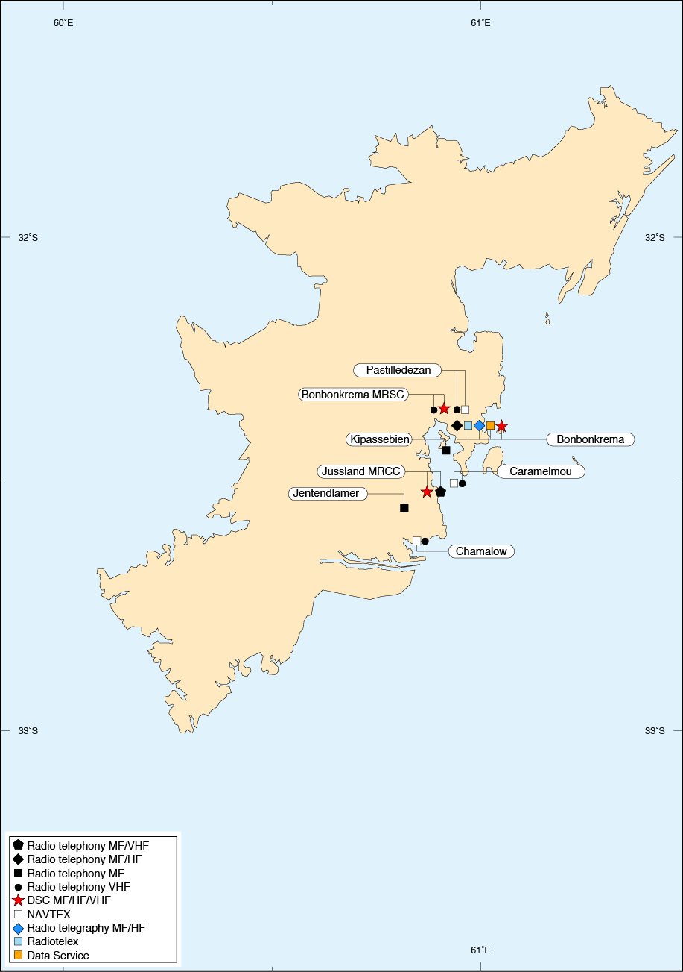

MARITIME TELEMEDICAL ASSISTANCE SERVICE (TMAS)
Usual name of centre | Jusslandcity Hospital, Jussland City
Communications | Jussland MRCC : DSC A1 A2 A3 MMSI 005742029  Bonbonkrema MRSC : DSC A1 A2 A3 MMSI 005742030  Bonbonkrema (ZZZ) : DSC A1 A2 A3 MMSI 005742031
Hospital Landlines :
 +999(0)1 23456755-59 |  |  +999(0)1 23456760
MRCC :
 +999(0)1 23456789 |  |  +999(0)1 23456788
 |  | email: mrcc.jussland@jussland.gov.js
Inmarsat C : +583 422123456  TELEX : +998 123456 |  | WEBSITE : www.jussland.mrcc.js
Associated MRCC or JRCC | MRCC JUSSLAND
Consultation Languages | Jusslandish and English
Remarks | The Maritime Search and Rescue Service is under the command of the Jusslander NAVY.  Attention is drawn to the International Code of Signals, Medical Section.

JUSSLAND MRCC
32°31′.50 S 60°54′.07 E | MMSI 005742029 | DSC VHF : Can 70  DSC MF : 2187,5 kHz  DSC HF4 : 4207,5 kHz  DSC HF6 : 6312,0 kHz  DSC HF8 : 8414,5 kHz  DSC HF12 : 12577,0 kHz  DSC HF16 : 16804,5 kHz |  | AMVER |  | Diagram page 271
 +999(0)1 23456789 |  |  |  +999(0)1 23456788
 |  |  | email: mrcc.jussland@jussland.gov.js
Inmarsat C : +583 422123456  TELEX : +998 123456 |  |  | WEBSITE : www.jussland.mrcc.js
NOTES : 1. This station does not accept public correspondence, accepting Distress, Urgency and Safety traffic only.
2. Station accepts JUSSREP messages.
VHF
 | Ch 16 |  |  |  | H24
RT (MF)
 | Transmits |  | Receives |  | Hours of watch
 | 2182 |  | 2182 |  | H24
 | 8291 |  | 8291 |  | H24

BONBONKREMA MRSC
32°21′.70 S 60°55′.90 E | MMSI 005742030 | DSC VHF : Can 70  DSC MF : 2187,5 kHz  DSC HF4 : 4207,5 kHz  DSC HF6 : 6312,0 kHz  DSC HF8 : 8414,5 kHz  DSC HF12 : 12577,0 kHz  DSC HF16 : 16804,5 kHz |  | AMVER |  | Diagram page 271
 +999(0)1 23456790 |  |  |  +999(0)1 23456789
 |  |  | email: mrsc.jussland@jussland.gov.js
NOTES : 1. This station does not accept public correspondence, accepting Distress, Urgency and Safety traffic only.
2. Station accepts JUSSREP messages.
VHF
 | Ch 16 74 |  |  |  | H24
RT (MF)
 | Transmits |  | Receives |  | Hours of watch
Kipassebien  32°26′.80 S 60°55′.70 E | 1698
 | 4508
Jentendlamer  32°33′.40 S 60°49′.50 E |  |  | 1787 |  | H24
 |  |  | 4605 |  | H24

BONBONKREMA (ZZZ) [9999]
32°23′.30 S 60°57′.20 E | MMSI 005742031 | DSC VHF : Can 70  DSC MF : 2187,5 kHz  DSC HF6 : 6312,0 kHz  DSC HF8 : 8414,5 kHz |  | AMVER |  | Diagram page 271
 +999(0)1 51365017 & 36502642 |  |  |  +999(0)1 51136501
CALL : Krema Radio |  |  | email: mickleradio@jussland.js
Inmarsat C : +583 422123457
Iridium phone : +991 621461635
TELEX : +998 441200 BBKRM
NOTES : 1. Accepts Ship’s Weather Reports adressed to CENMETEOKREM.
2. Station accepts AMVER messages.
3. Station accepts JUSSREP messages.
VHF
Chamalow | Ch 16 27 |  |  |  | 32°37′.05 S 60°52′.40 E
Caramelmou | Ch 16 |  |  |  | 32°30′.40 S 60°57′.90 E
Pastilledezan | Ch 14 16 24 33 |  |  |  | 32°21′.10 S 60°55′.04 E
NOTE : Pastlledezan in service only during the summer period (15th Oct. to 15th Mar).
DSC
 | Transmits |  | Receives |  | Hours of Watch
Public Correspondance | 2189.5 |  | 2177 |  | 2300-1500
RT (MF)
 | Transmits |  | Receives |  | Hours of Watch
 | 2182 |  | 2182 |  | 2200-1000
 | 3180 |  | 2080
RT (HF)
 | Transmits |  | Receives |  | Hours of Watch
 | 7903 |  | 7903 |  | H24
 | 7972 |  | 7972
 | 8125 |  | 8125
 | 8131 |  | 8131
 | 8140 |  | 8140
 | 8176 |  | 8176
 | 8294 |  | 8294
 | 8755 (Ch 813) |  | 8231
 | 11456 |  | 11456
 | 12359 |  | 12359 |  | H24
 | 12365 |  | 12365
TRAFFIC LISTS: 12359 kHz: 0003 0203 0803 1003 1603 1803
Radiotelex [9999]
 | Transmits |  | Receives |  | Hours of Watch
 | 2174.5 |  | 2174.5 |  | 2300-1500
 | 6317 |  | 6265 |  | 0100-0500
 | 8376.5 |  | 8376.5 |  | 2300-1500
WT (MF)
 | Transmits |  | Receives |  | Hours of Watch
 | 458 500 |  | 500 |  | 2300-1500
TRAFFIC LISTS: 458 kHz: 0000 0400 0800 1200 2300
WT (HF)
 | Transmits |  | Receives |  | Hours of Watch
 | 6337 |  | 6265.5 – 6267 |  | 0500-0600
 | 8461 |  | 8377.5 – 8380.5 |  | 0000-0100 0400-0500
 | 12970.5 |  | 12478 – 12481 |  | 0100-0200
TRAFFIC LISTS: 8461 kHz: 000 0400
Data Service (HF)
 | Dial Frequency Rx |  | Dial Frequency Tx |  | Hours
KREM10 | 8716 |  | 8716 |  | H24
KREM11 | 13078.5 |  | 13078.5 |  | On Request
KREM12 | 17198.5 |  | 17198.5
KREM13 | 22567.5 |  | 22567.5 |  | H24
Bonbonkrema provides data services in partnership with Swisscom Maritimes Communications.

MARITIME SAFETY INFORMATION SERVICES
RADIO WEATHER SERVICES AND NAVIGATIONAL WARNINGS

METEOROLOGICAL AND HYDROLOGICAL INFORMATION TRANSMITTED THROUGH THE AUTOMATIC IDENTIFICATION SYSTEM (AIS)

The Jussland Transport Agency transmits AIS messages containing meteorological and hydrological information in all sea areas within range of the Jussland AIS base stations (Signal stations, VTS, Harbour Master’s office).
The message contains weather data from the wind and water level gauges closest to the vessel receiving the messages. Receipt of the message on AIS is possible only if the AIS device contains a program with the required specification.

INTERNET WEATHER SERVICES
www.meteojussland.js | Jussland Met Office | Marine weather forecast for Jussland waters  (in English, French, and Jusslandian)

NAVTEX
J | Caramelmou | 518 kHz | 32°30′.40 S 60°57′.90 E
N | Chamalow |  | 32°37′.05 S 60°52′.40 E
D | Pastilledezan | 490 kHz | 32°21′.10 S 60°55′.04 E
Weather Bulletins
J : 0830 2030 | Storm warning, synoptic situation and development and forecast valid for 24 hours within 450 n miles of coast.
J : 0900 2100 | Storm warning, weather bulletin.
N : 1000 2200 | Storm warning, synoptic situation and development and forecast valid for 24 hours within 450 n miles of coast.
N : 1030 2230 | High sea forecast. Ice forecast.
D : 1200 2400 | Weather bulletin for coastal water.
Navigational Warning
J : 0030 0830 1230 2030 | NAVAREA VII and coastal warning.
J : 0100 0900 1300 2100 | Navigational Warning.
N : 0200 1000 1400 2200 | NAVAREA VII and coastal warning.
N : 0230 1030 1430 2230 | Navigational Warning. Ice forecast.
D : 0400 1200 1600 2400 | NAVAREA VII and coastal warning.
D : 0430 1230 1630 2400 | Navigational Warning.

BONBONKREMA MRSC |  |  |  |  | 32°21′.70 S 60°55′.90 E
 | Ch 74 | VHF
Weather Bulletins
0033 0433 0833 1233 2033 | Coastal waters forecast in English. Gale warnings for coastal waters.
0233 0633 1033 1433 1833 2233 | High seas forecast in English. Gale warnings for high seas.
On receipt | Storm warnings (High seas and coastal waters).
Navigational Warning
0033 0433 0833 1233 2033 | Navigational warnings (covering NAVTEX station service aera) after weather bulletins.

BONBONKREMA (ZZZ) [9999] |  |  | 32°23′.30 S 60°57′.20 E
A | 3180 | RT (MF) |  | Bonbonkrema | 32°23′.30 S 60°57′.20 E
B | Ch 27 | VHF |  | Chamalow | 32°37′.05 S 60°52′.40 E
 | Ch 23 |  |  | Caramelmou | 32°30′.40 S 60°57′.90 E
 | Ch 14 |  |  | Pastilledezan | 32°21′.10 S 60°55′.04 E
Weather Bulletins
A : 0750 1950 | Weather synopsis and 24 hour forecast, storm warnings (High seas and coastal waters).
A : 1303 | Weather synopsis and 48 hour forecast, storm warnings (High seas and coastal waters).
B : 0910 2110 | Weather warnings and 48 hours forecast for coastal waters.
Navigational Warning
A : 0750 1950  B : 0910 2110 | Navigational warnings after weather bulletins.

JUSSLAND RADIO |  |  | 32°30′.30 S 60°59′.00 E
A | 193 | LW |  | Jussland City
B | 1485 | MW |  | Chamalow
 | 720 |  |  | Caramelmou
 | 774 |  |  | Pastilledezan
C | 104.9 MHz | FM
Weather Bulletins
A-C : 0048 0520 LT | Gale warnings, High sea forecast, weather reports from coast stations and the coastal forecast.
A : 1201 1754 LT | Gale warnings and High sea forecast.
C : 1754 LT (Sat & Sun)

RADIO-FACSIMILE

BONBONKREMA |  |  |  |  |  | 32°23′.30 S 60°57′.20 E
 |  | 6446 |  |  |  |  |  |  | H24
 |  | 7907 |  |  |  |  |  |  | 1900-0600
 |  | 8444 |  |  |  |  |  |  | HN
Map Areas (see chartlet)
A | 1:5,000,000  32°S.60°E 32°S.65°E  34°S.60°E 34°S.65°E |  |  | B | 1:5,000,000  24°S.60°E 24°S.70°E  32°S.60°E 32°S.70°E
Schedule
A |  |  | 36 hour surface prognosis |  |  | 0700 (00) |  | 120/576
A |  |  | Sea state analysis |  |  | 0800 (06)
B |  |  | 36 hour surface prognosis |  |  | 1000 (06)
A |  |  | Surface temperature analysis / iceberg positions |  |  | 1400 (12)
B |  |  | Sea state analysis |  |  | 1500 (12)
 |  |  | Broadcast shedule (text) |  |  | 1850 |  | 90/576
 |  |  | Iceberg prognosis (text) |  |  | 2000 |  | 120/576
A |  |  | H+36 (JCMF) 925 hPa, 700 hPa relative humidity* |  |  | 2230 (12)
* Special programs for Jusslandians research vessels.

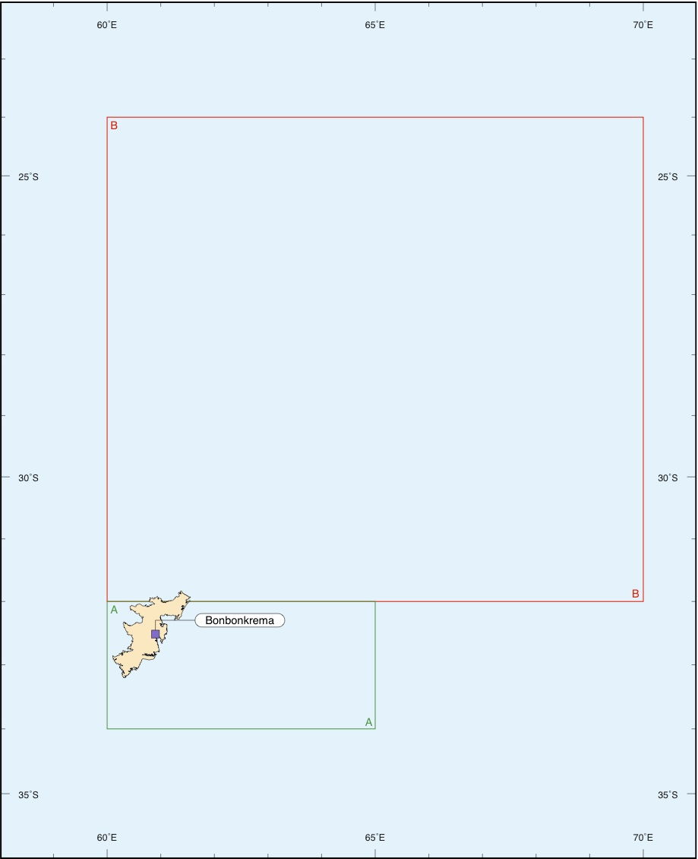
SAFETYNET

EGC SAFETYNET SYSTEM
Transmission schedule for full GMDSS service

NAVAREA | NAV information |  | METAREA | MET information
 | Coordinator | Times (UTC) |  | Issuing country | Times (UTC)
I | United Kingdom | 0530, 1730 (AOR-E) | I | United Kingdom | 0930, 2130 (AOR-E)  Warnings only on receipt (AOR-W)
II | France | 0430, 1630 (AOR-E) | II | France | 1015, 2215 (AOR-E / AOR-W)
III | Spain | 1200, 2400 & on receipt (AOR-E) | III | Greece¹ | 1000, 2200 (AOR-E)
IV | United States | 1000, 2200 (AOR-W)  (1200 Ice reports N Atlantic)  0900, 2100 (AOR-W) French West Indies  0900, 2100 (AOR-W) French Guyana | IV | United States | 0430, 1030, 1630, 2230 (AOR-W)
V | Brazil | 0030, 1230 (AOR-E) | V | Brazil | 0730, 1930 (AOR-E)
 |  |  |  |  | Coastal warnings for Amazon Basin and additional coastal areas (AOR-E)
VI | Argentina | 0200, 1400 (AOR-W) | VI | Argentina | 0230, 1730 (AOR-W)
VII | South Africa | 1940 (AOR-E / IOR)  0140, 1340 (IOR) Kerguelen Islands  0330, 1530 (IOR) Mayotte  0400, 1600 (IOR) Jussland | VII | South Africa | 0940, 1940, (AOR-E / IOR)^{2, 5}
VIII | India | 1000, 2200 (IOR)  0040, 1240 (IOR) Réunion  0330, 1530 (IOR) Mayotte | VIII (N) | India | 0900, 1800 for N of 0° (IOR)
 |  |  | VIII (S) | Mauritius / Réunion | 0130, 1330 for S of 0° (IOR)  0000³, 0600³, 1200³, 1800³ for S of 0° (IOR)
 |  |  |  | Australia | Warnings only for S of 0° and E of 90°E (IOR)
IX | Pakistan | 0800 (IOR) | IX | Pakistan | 0700 (IOR)
X | Australia | 0700, 1900 & on receipt (IOR / POR)  0140, 1340 (POR) New Caledonia | X | Australia | 1030, 2330 (IOR)
 |  |  |  |  | 1100, 2300 (POR)
 |  |  |  |  | Coastal Warnings for Bass Strait, Northern Territory & Western Australia (IOR / POR)
XI | Japan | 0005, 1205 (POR / IOR) | XI | China | 0330, 1015, 1530, 2215 (IOR)
 |  |  |  | Japan | 0230, 0830, 1430, 2030 for N of 0° (POR)  0815, 2015⁴ for S of 0° (POR)
XII | United States | 1030, 2230 (POR / AOR-W) | XII | United States | 0545, 1145, 1745, 2345 (POR / AOR-W)
XIII | Russian Federation | 0930, 2130 (POR) | XIII | Russian Federation | 0930, 2130 (POR)
XIV | New Zealand | 0900, 2100 (POR) New Zealand  0140, 1340 (POR) New Caledonia  0030, 1230 (POR) Wallis & Futuna  0250, 1450 (POR) French Polynesia | XIV | New Zealand | 0330, 0930, 1530, 2130 (POR) Warnings  0330, 1530, (POR) for Area Southern  0930, 2130 (POR) for Area Subtropic, Forties & Pacific
XV | Chile | 0210, 1410 (AOR-W) | XV | Chile | 0100, 1330 (AOR-W) for Sea Areas 1-8  1440 (AOR-W) for Sea Area 9  0345, 1845 (AOR-W) for Sea Area 10
XVI | Peru | 0500, 1700 (AOR-W) | XVI | United States | 0515, 1115, 1715, 2315 (AOR-W)
XVII | Canada | 1130, 2330 (POR) | XVII | Canada | 0300, 1500 (POR)
XVIII | Canada | 1100, 2300 (AOR-W) | XVIII | Canada | 0300, 1500 (AOR-W)
XIX | Norway | 0630, 1830 (AOR-E) | XIX | Norway | 1100, 2300 (AOR-E)
XX | Russian Federation | 0530, 1730 (IOR) | XX | Russian Federation | 0600, 1800 (IOR)
XXI | Russian Federation | 0630, 1830 (POR) | XXI | Russian Federation | 0600, 1800 (POR)

¹ Scheduled bulletins and warnings for Western Mediterranean Sea are prepared by France.
² Forecasts for areas 30°S - 50°E / 50°S - 80°E and tropical cyclone warnings are prepared by Réunion.
³ Tropical cyclone warnings (if any) issued by Réunion as an unscheduled broadcast.
⁴ Scheduled bulletins and warnings for south of the equator prepared by Australia.
⁵ Transmission via AOR-E for areas West of 20°E, transmission via IOR for areas East of 20°E.

GLOBAL MARITIME DISTRESS AND SAFETY SYSTEM (GMDSS)

SEA AREA A1

VHF DSC, LIST OF COAST STATIONS FOR SEA AREA A1

Country  Station | MMSI | Position | Range  (n miles) | Status (Associated RCCs)
(1) | (2) | (3) | (4) | (5)
Jussland
Jussland | 005742029 | 32°31′.50 S 60°54′.07 E | 50 | Operational (MRCC Jussland)
Bonbonkrema MRSC | 005742030 | 32°21′.70 S 60°55′.90 E | 50 | Operational (MRCC Jussland)
Bonbonkrema (ZZZ)  Remotely controlled stations :  Chamalow  Caramelmou  Pastilledezan | 005742031 | 32°23′.30 S 60°57′.20 E  32°37′.05 S 60°52′.40 E  32°30′.40 S 60°57′.90 E  32°21′.10 S 60°55′.04 E | 50  50  50  50 | Operational (MRCC Jussland)

SEA AREA A2

MF DSC, LIST OF COAST STATIONS FOR SEA AREA A2

Country  Station | MMSI | Position | Range  (n miles) | Status (Associated RCCs)
(1) | (2) | (3) | (4) | (5)
Jussland
Jussland | 005742029 | 32°31′.50 S 60°54′.07 E | 150 | Operational (MRCC Jussland)
Bonbonkrema MRSC | 005742030 | 32°21′.70 S 60°55′.90 E | 150 | Operational (MRCC Jussland)
Bonbonkrema (ZZZ) | 005742031 | 32°23′.30 S 60°57′.20 E | 150 | Operational (MRCC Jussland)

SEA AREAS A3/A4

HF DSC, LIST OF COAST STATIONS FOR SEA AREAS A3 AND A4

Country  Station | MMSI | Operational frequency bands |  | Status (Associated RCCs)
(1) | (2) | (3) |  | (5)
Jussland
Jussland | 005742029 | 4,6,8,12 & 16 MHz |  | Operational (MRCC Jussland)
Bonbonkrema MRSC | 005742030 | 4,6,8,12 & 16 MHz |  | Operational (MRCC Jussland)
Bonbonkrema (ZZZ) | 005742031 | 4,6,8,12 & 16 MHz |  | Operational (MRCC Jussland)

MSI

MARITIME SAFETY INFORMATION (MSI) UNDER THE GMDSS

HF NBDP MARITIME SAFETY INFORMATION BROADCAST SERVICE

BONBONKREMA (ZZZ) [9999] |  |  | 32°23′.30 S 60°57′.20 E
A | 8416.5 | RADIO-TELEX
B | 16806.5
Weather Bulletins
A : 0000 1130 | Meteorogical warnings.
B : 0030 1200
Navigational Warning
A : 0000 1130 | Navigational warnings.
B : 0030 1200

NAVAREA COORDINATORS

NAVAREA VII (South Africa)

The Hydrographer, S.A. Navy
Hydrographic Office
private Bag X1, Tokai
7966 CAPE TOWN
South Africa
Telephone : +27 21 7872408
Fax : +27 21 7872228
email : hydrosan@iafrica.com
Website : http//www.sanho.co.za

National Coordinators

COUNTRY | TELEPHONE | FACSIMILE | EMAIL | OTHER
Angola | +244 22 2449211 | +244 22 2447320 | hidroportos@netangola.com
Jussland | +999(0)1 23451111 | +999(0)1 23451112 | hidrojussland@jussland.gov.js
Mozambique | +258 1 430186 | +258 1 430185 | hidro@inahina.uem.mz
Namibia | +264 64 2082258 | +264 64 2082326 | mmandia@namport.com.na

SAR

JUSSLAND

National SAR Agency : HQ Jusslander NAVY
Adresse : Spring Place, 105 Commercial Road, Jussland City
JS5629 JUSSLAND
Tel : +999 (0)1 56489652 (Office hours only)
Fax : +999 (0)1 56894123 (Office hours only)
email : sar.response@jussland.gov.js
TeleMedical Assistance Service : The Jusslandcity Hospital provides assistance. Contact via any radiostations requesting Medico assistance.
 | Telephone +999 | Fax + 999 | Other
Jussland MRCC | (0)1 23456789 | (0)1 23456788 | Inmarsat-C : +583 422123456  TELEX : +998 123456  email : mrcc.jussland@jussland.gov.js
Bonbonkrema MRSC | (0)1 23456790 | (0)1 23456789 | email : mrsc.jussland@jussland.gov.js
Bonbonkrema (ZZZ) | (0)1 51365017  (0)1 36502642 | (0)1 51136501 | email : mickleradio@jussland.js

See http://www.navcen.uscg.gov/?pageName=DSCPublic
Weather bulletins: meteorological forecast and warnings
Commercial broadcast station
Night service only (from sunrise to sunset)
Jusslandian Prediction Model

