INTERNATIONAL HYDROGRAPHIC ORGANIZATION

OPERATIONAL PROCEDURES FOR THE ORGANIZATION AND MANAGEMENT OF THE S-100 GEOSPATIAL INFORMATION REGISTRY

Publication S-99

Annex A

Conventions and Guidelines for the Content of the IHO GI Registry

Edition 1.0.0, Xxxx 2019

Published by the
International Hydrographic Organization
4b, Quai Antoine 1er
B.P 445 - MC 98011 MONACO Cedex
Principauté de Monaco
Telefax: (+377) 93 10 81 40
E-mail: info@iho.int
Web http://www.iho.int

© Copyright International Hydrographic Organization [2019]
This work is copyright. Apart from any use permitted in accordance with the Berne Convention for the Protection of Literary and Artistic Works (1886), and except in the circumstances described below, no part may be translated, reproduced by any process, adapted, communicated or commercially exploited without prior written permission from the International Hydrographic Organization (IHO). Copyright in some of the material in this publication may be owned by another party and permission for the translation and/or reproduction of that material must be obtained from the owner.
This document or partial material from this document may be translated, reproduced or distributed for general information, on no more than a cost recovery basis. Copies may not be sold or distributed for profit or gain without prior written agreement of the IHO Secretariat and any other copyright holders.
In the event that this document or partial material from this document is reproduced, translated or distributed under the terms described above, the following statements are to be included:
“Material from IHO publication [reference to extract: Title, Edition] is reproduced with the permission of the IHO Secretariat (Permission No ……./…) acting for the International Hydrographic Organization (IHO), which does not accept responsibility for the correctness of the material as reproduced: in case of doubt, the IHO’s authentic text shall prevail. The incorporation of material sourced from IHO shall not be construed as constituting an endorsement by IHO of this product.”
“This [document/publication] is a translation of IHO [document/publication] [name]. The IHO has not checked this translation and therefore takes no responsibility for its accuracy. In case of doubt the source version of [name] in [language] should be consulted.”

The IHO Logo or other identifiers shall not be used in any derived product without prior written permission from the IHO Secretariat.

Contents

1 OVERVIEW 1
1.1 Preface 1
1.2 S-99 Annex A; Conventions and Guidelines for the Content of the IHO GI Registry - Metadata 1
1.3 Terms, Definitions and Abbreviations 1
1.3.1 Terms and Definitions 1
1.3.2 Abbreviations 1
1.4 Use of Language 1
1.5 Maintenance 2
2 CONVENTIONS AND GUIDELINES 3
2.1 Conventions 3
2.1.1 Language and Spelling 3
2.1.2 Register Item Name (Concept Register) 3
2.1.3 Alias 4
2.1.4 CamelCase 4
2.1.5 Alpha Code 4
2.1.6 Definition 4
2.1.7 Reference 4
2.1.8 Definition Source 5
2.1.9 Remarks 5
2.2 Guidelines 6
2.2.1 General 6
2.2.2 Proposals 6
2.2.2.1 Register item (concept) name 6
2.2.2.2 Alias 6
2.2.2.3 Definition 6
2.2.2.4 Distinctions 7
2.2.3 Feature Data Dictionary Considerations 7
2.2.3.1 Supertypes 7
2.2.3.2 Codelists 7

Page intentionally left blank

OVERVIEW

Preface
The “Conventions and Guidelines for the Content of the IHO GI Registry” have been developed to provide consistent, standardized instructions for the IHO Geospatial Information (GI) Registry Manager; Domain Control Bodies; Submitting Organizations; and Users when ……

S-99 Annex A; Conventions and Guidelines for the Content of the IHO GI Registry - Metadata
Note: This information uniquely identifies this Annex to S-99 and provides information about its creation and maintenance.
Title: The International Hydrographic Organization Operational Procedures for the Organization and Management of the S-100 Geospatial Information Registry, Annex A – Conventions and Guidelines for the Content of the IHO GI Registry
Version: 1.0.0
Date: Xxxx 2018
Language: English
Classification: Unclassified
Contact: International Hydrographic Organization
4b quai Antoine 1er
B.P. 445
MC 98011 MONACO CEDEX
Principauté de Monaco
Telephone: +377 93 10 81 00
Fax: +377 93 10 81 40
URL: www.iho.int
Identifier: S-99 Annex A
Maintenance: Changes to S-99 Annex A; Conventions and Guidelines for the Content of the IHO GI Registry are coordinated by the IHO Secretariat and must be made available via the IHO web site.

Terms, Definitions and Abbreviations

Terms and Definitions
definition 1
definition
definition 2
definition
…….

Abbreviations
ABB1 Abbreviation

Use of Language
Within this document:
“Must” indicates a mandatory requirement;
“Should” indicates an optional requirement, that is the recommended process to be followed, but is not mandatory;
“May” means “allowed to” or “could possibly”, and is not mandatory.

Maintenance
…..

INTRODUCTION

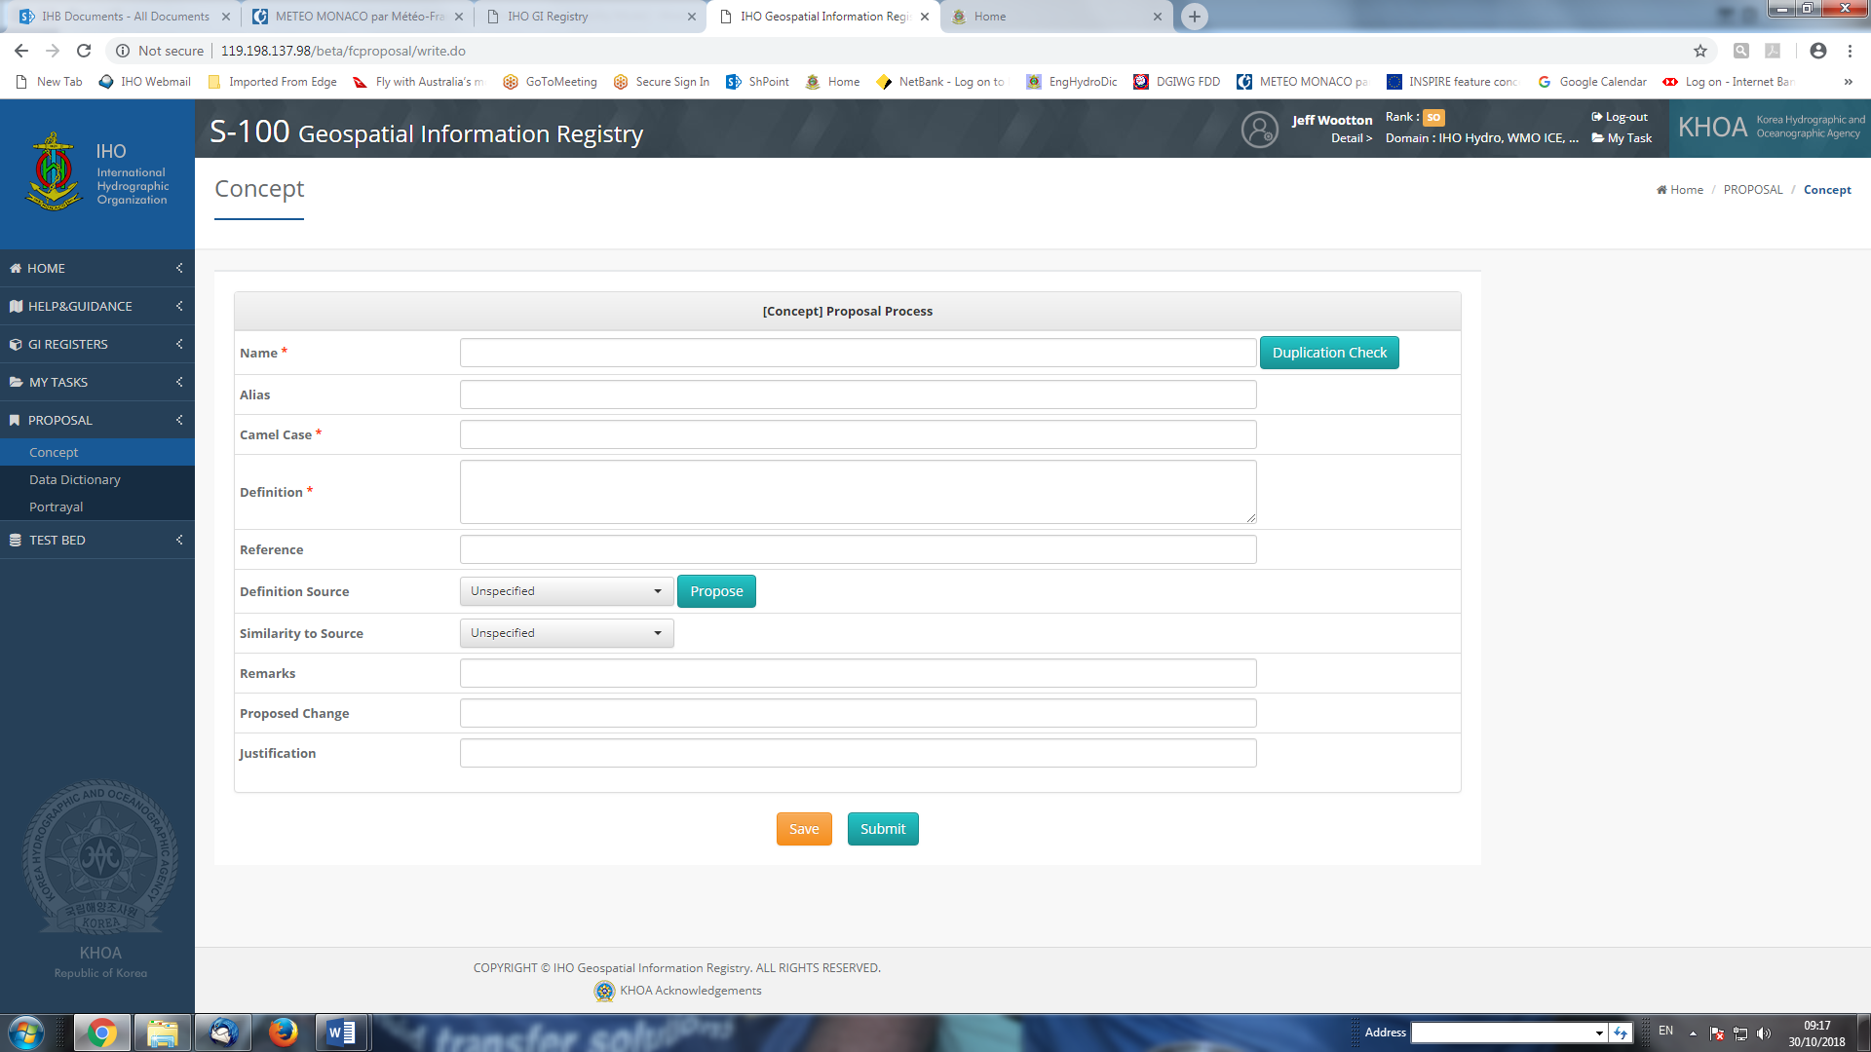

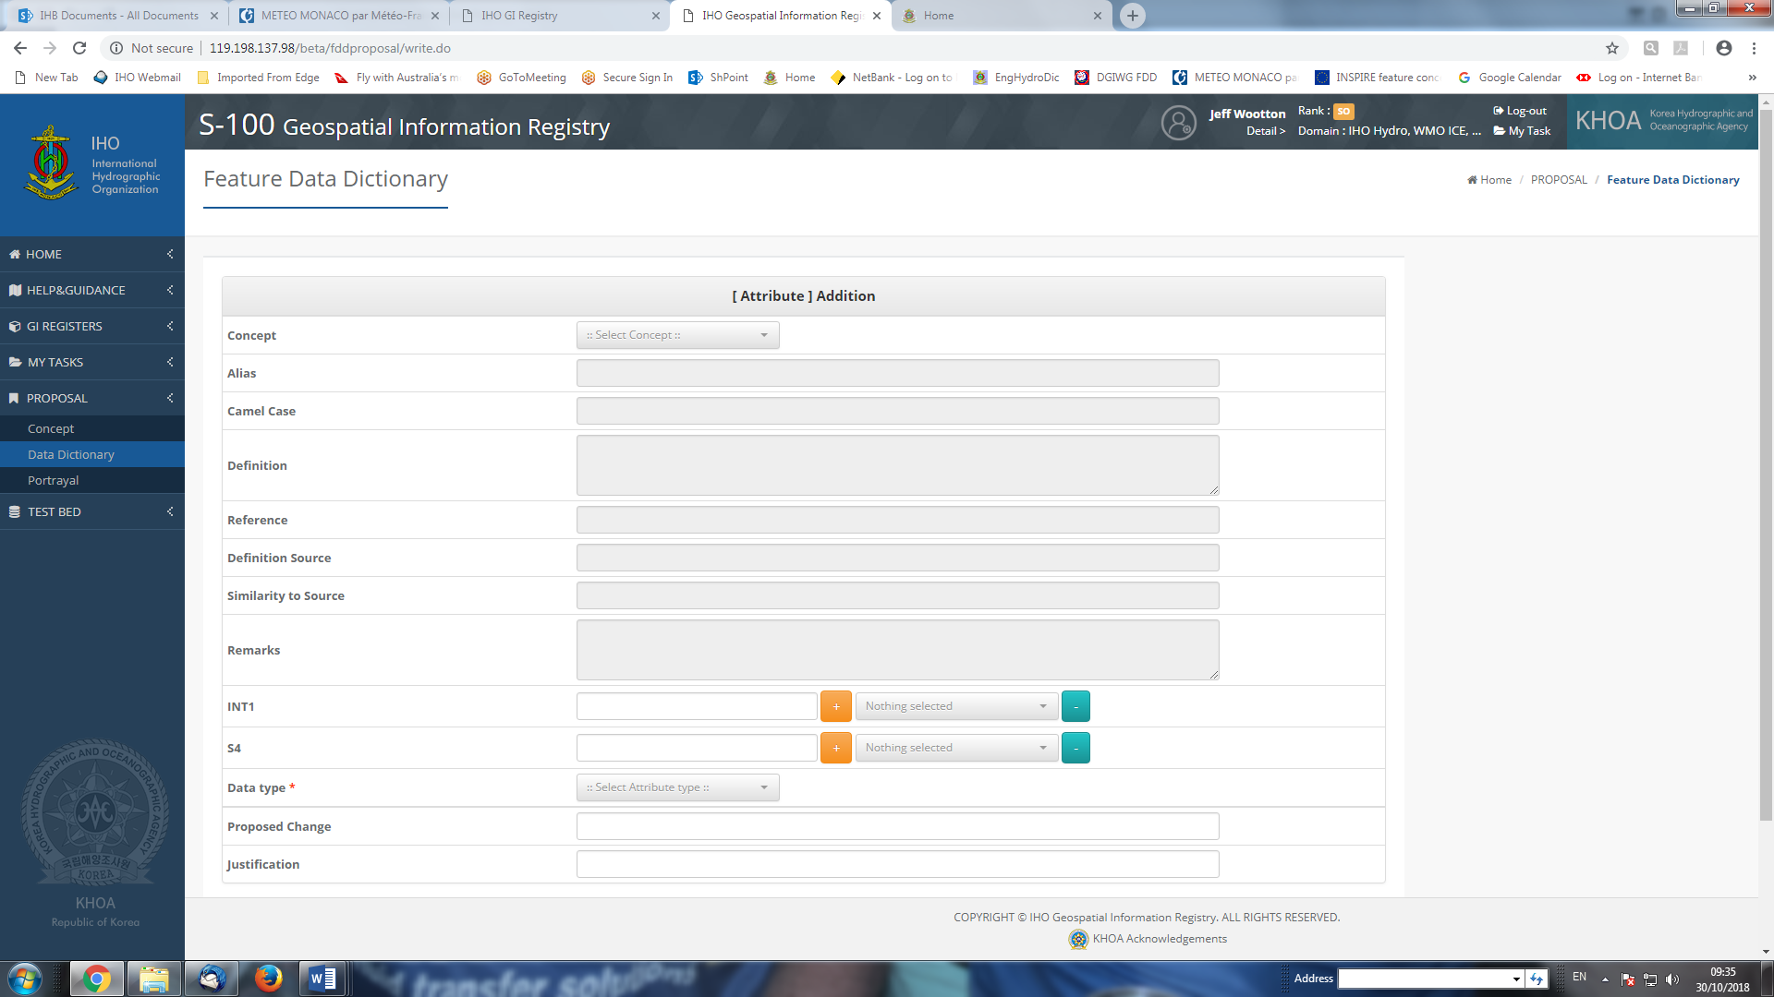

CONVENTIONS AND GUIDELINES

Conventions

Language and Spelling
The language of the IHO GI Registry is English. All concepts, terminology and definitions must be in accordance with the English language and spelling as defined in the Oxford English Dictionary, unless otherwise specified in these Conventions.

Register Item Name
The Item Name field is used to provide the “primary” name (or term) for the concept in the IHO GI Registry Registers. This name is linked as the primary term for a concept to its definition by a unique identifier assigned in the Register, and if considered to be specific to hydrography, will also provide via the unique identifier the equivalent entry in the IHO Dictionary (S-32).
A fundamental convention for the Register Item Name (as described in ISO Standards) is that there must not be any two (or more) concepts in the Register that have the same (or can be considered to have the same) definition.

Concept Register
The following conventions apply for the name of all item names (or terms) proposed to the IHO GI Registry Concept Register:
- The concept name must be as “generic” as possible with regard to its relevance to hydrography. Specializations more suited to specific implementations in Application Schema should be included in the Data Dictionary Register (see clause X.X). When developing a proposal for the Concept Register, proposers must consider that the concept may be used for other S-100 based Product Specifications. Where possible the concept should be able to be used in a Product Specification using the registered Item Name, without a requirement to propose an alternate “secondary” name (or alias – see clause X.X).
- The name must be concise. Every effort must be taken to avoid being too descriptive when selecting an item name. This supports the intended generic nature of the name as described in the above bullet.
- Where a concept can be considered to be a “sub-classification” of a particular “theme”, the term identifying the “theme” should be the first part of the Item Name. For instance, “buoys” and “beacons” have been used as “themes” in the Concept Register, resulting in all registered items that are part of these “themes” beginning with the word “Buoy” (for example Buoy Cardinal”) or “Beacon” (for example “Beacon Isolated Danger”).
- Similar to the above, descriptive terms (for instance “direction of”; “size of”) should not be used at the start of an item name.
- Only alphanumeric characters (A-Z; a-z; 0-9) and the special characters “.” and “_” are allowable for Concept Register item names. All other characters are prohibited. [What about accented letters? Lexical level??]
- All names must have each word included in the name commencing with an upper case character A-Z. [What about prepositions – “of” etc? Is there an ISO convention for this?]
- Unless generally internationally accepted as such (for instance, if a non-English term is the internationally recognized term used; or the term is an internationally recognized name in a national language), a non-English term cannot be used as the Item Name for a concept.
- In relation to the above point, however, the units of measure for the “physical characteristic” must not be included in the item name. This is to allow application across Domains where different units of measurement may be used. The units of measurement should either be included as part of the metadata for the dataset or encoded in the Feature Catalogue (that is, specified at the Product Specification level) or modelled as an attribute bound to an application of the concept in the modelling (that is at the Feature Data Dictionary level).
- “Category of” and “Value of”: Need to define the conventions for naming these concepts in the Concept Register – either Category of …../Value of ….. or …..Category/….. Value.
- Note inconsistencies in the FCD where in some cases the number is used and in others the spelling of the number is used. Requires a convention.
- Use of acronyms in names? There should not be a combination of both acronym and full term in an Item Name. The best known term should be used as the Item name with the alternative listed as an Alias. For instance: Item Name = LANBY; Alias = Large Automatic Navigational Buoy.

Codelist Register
The following conventions apply for the name of all item names (or terms) proposed to the IHO GI Registry Concept Register:
- Where an item(s) to be registered corresponds to an established classification or identification code (for example Metarea numbers; Beaufort Force values; IUCN Code), the value of the code must be registered as the Item Name. The “meaning” (or what may be interpreted as the definition) of the value must not be included in the Item Name; the meaning will be incorporated in the Feature Catalogue through the identification of the Codelist in the Register as a Classification Type.

Data Dictionary Register
The following conventions apply for the name of all item names (or terms) included in the IHO GI Registry Data Dictionary Register:
- Where an item is adopted from the Concept Register without any change (that is, same definition), the Item Name must not be changed.
- Where a concept is a specialization intended to define a physical characteristic (attribute) of a phenomenon, the characteristic (for instance “distance”, “height”, “weight”) should be included as an extension of the Concept Register Item Name, which must be included unchanged. For instance, a concept such as “Surface Visibility” may have various characteristics that need to be specifically identified. If it is required to include an item that is intended to identify the maximum distance of surface visibility that has been measured at a location, the corresponding derived Item Name should be “Surface Visibility Distance”.

Alias
The Alias field is used to define alternate names for the concept. This may be required for IHO Registry user communities that require a variant of the “primary” name registered as the “Item Name” (see clause X.X above) in the Concept Register in their Product Specification.
All values populated in the Alias field must conform to the definition for the “primary” Item Name – the Alias must not be used to extend, sub-define or sub-classify the Concept Register definition in a Domain of the Feature Data Dictionary Register.
A term cannot be listed as an alias against a registered item if that term has itself been registered as a discrete item.
The Alias field must not be used to provide a translation of the Item Name into a non-English language.
Can an acronym (for instance ODAS) be included as an Alias (possible alternative is in Remarks?)?

CamelCase
The camelCase identifier must be structured according to the conventions provided in S-100 clause 2a-4.2.3. See also S-97 Part A, clause 5.1.2.

Concept Register
Within the Concept Register, all camelCase must commence with a lower case letter, with the first letter of each following word commencing with an upper case character.
EXAMPLES: categoryOfSeaArea; lightAllAround; seamount.

Codelist Register
Within the Codelist Register, the camelCase for the parent attribute must commence with a lower case letter, with the first letter of each following word commencing with an upper case character.
For enumerated values, the camelCase must commence with a lower case letter or a numeral. In the majority of cases, a numeral should only be used if the enumerated list is itself a coded classification list that is numeric or begins with a numeral.

Data Dictionary Register
For the Data Dictionary Register, each Domain must have the camelCase for each assigned type structured as follows:
- Feature and Information types: The first letter of each word must commence with an upper case letter. EXAMPLES: LightAllAround; Seamount.
- Attributes (Simple and Complex): The first letter of the camelCase must commence with a lower case letter, with the first letter of each following word commencing with an upper case character. EXAMPLES: categoryOfSeaArea; lightAllAround; seamount.
- Codelists: The first letter of the camelCase must commence with a lower case letter, with the first letter of each following word commencing with an upper case character. EXAMPLES: categoryOfSchedule.
- Enumerated and Codelist identifiers: The first letter of the camelCase must commence with a lower case letter, with the first letter of each following word commencing with an upper case character. EXAMPLES: seamount; windTurbine; beaufortForce7.
The following additional conventions apply for the name of all camelCase proposed to the IHO GI Registry Concept Register:
- There must be a direct correlation between the camelCase and the Register Item Name in the Concept Register. That is, the camelCase must essentially be the equivalent of the Item Name, but structured in the camelCase format. For example, Depth Area –> depthArea is acceptable, however Strips And Patches –> iceStrips is not acceptable.
- Use of numbers within camelCase needs to be clarified.

Alpha Code
The Alpha Code must be structured according to the conventions provided in S-100 clause 2a-4.2.16.
The following conventions apply for the name of all Alpha Codes proposed to the IHO GI Registry Concept Register:
- Alpha Codes must include at least 6 characters and a maximum 12 characters.

Definition
- There must be a direct correlation between the definition for a registered item and the item name. Where the item name is generic, the definition for that item must also be suitably generic. Item names that are specific to an application must have the definition relevant to that application.
- The term (item name) being defined must not be included as the introductory phrase for the definition. For example, the definition for the term Depth Area must not commence with “A depth area is …”. Similarly, definitions must not include reference to other Register fields for the item, such as camelCase and AlphaCode; and must not imply a direct relationship to other registered items such as inclusion of implied modelling.
- Standard punctuation convention must be applied to all definitions. For instance, all definitions must end with the appropriate punctuation (generally a full-stop).
- Where possible, definitions must avoid inclusion of units of measure.

Definition Source
Wherever possible, the authority for the definition of a concept should be included, using the Definition Source field.
Before preparing a submission to add a new item to the Concept Register, a check should be conducted on the predefined list of sources to ensure that authority for the definition for the new concept is listed in the predefined “drop down” list. Where the authority is not included in the predefined list, the proposer should submit an additional proposal to have the authority included.
Need a clear distinction here between the “Reference” field and the “Definition source” field.

Definition Reference
Need a clear distinction here between the “Reference” field and the “Definition source” field.

Remarks
Within the Concept Register, the Remarks field must be restricted to general information about the concept. There should be no inference of binding (for example for a specific Product Specification) at the geometry or feature level; or any “guidance” on implementation (encoding) of the concept, specific to a Product Specification(s).
- A possible exception to this rule is where a concept does not conform to what would be considered to be the “normal or general accepted convention” as implied for the Item Name. For instance, the concept “Date Variable” may, given that the name includes the word “Date”, be considered to be used as a Date type (attribute) when implemented in Product Specifications. However, the definition describes this concept as being a recurring day that is not fixed in the Gregorian calendar, thus excluding this concept from being applied as a Date type (?????). In this case the Remarks may include a reference to the intended type (in this case Text rather than Date) and an example (e.g. “Fourth Thursday in November”).
Where the item is used in a Product Specification, the application of the concept specific to the product may be expanded on in the Remarks field in the relevant Domain of the Feature Data Dictionary Register. This may be done, for instance, to include guidance specific to the modelling of the concept (and rules for use of the concept) within the Product Specification. However, the Remarks field must not be used to supplement or amend the definition of the concept as defined in the Concept Register.

Guidelines

General
- All items registered in the Concept Register must not carry any implied relationship to bindings within a Product Specification (Feature Data Dictionary Register).
- Modelers must consider, when developing their Data Dictionary, the understanding of concepts by the end user that can be derived from the context (binding) in which the concept is used, as distinct from creating new Aliases that may not be required.
- Although there are fields within the Concept Register proposal form that are optional, every effort should be made to populate these fields with relevant values when preparing proposals for submission.
- [Add a decision making flow (e.g. diagram) outlining the steps to take when determining whether it is appropriate to make a proposal??]

Proposals

Register item (concept) name
Names for items in the IHO GI Registry Concept Register must be as product neutral and concise as possible.
- Need to work out a hierarchy of allowable concept registration, i.e. should a concept be registered at the very generic level only in the Concept Register (e.g. Light), then Aliases for “sub-usage” derived from this in the FDD Register (e.g. Light All Around, Light Sectored, ….). If this is the case how is this going to work for definitions? Suggest that this should be based on the “hydrographically relevant” aspect, i.e. if the concept has a usage or characteristic that is distinct (by definition) in regard to its application in hydrography (or a hydrographically relevant field), it should be registered at the Concept Register level. If this is agreed, need to make sure that clear distinctions are made in the Concept Register (by definitions?) so that there is no perception of the “same” concept being registered multiple times with a different name.
- When determining how specific a proposed item name is to be, consideration must be made as to whether there will be any likelihood that the concept can be utilized by other user communities. If it is known that a concept will only be used by a single community (that is, the proposing community), then there can be some latitude in the specificity of the item name.
  - Example: The “Sector Extension” simple attribute (S-101) is intended only to improve the display of sector lights in ECDIS. This is unlikely to be required by any other S-100 based Product Specifications, and can therefore be named specifically for that purpose.
- When considering the Item Name, and it is likely that the name will include multiple words, a check of the Concept Register should be done to see if there are similar or related concepts already registered so as to be consistent with the syntax of the name in the proposal in addition to the guidance included in the Conventions at clause X.X. This is so that there is as much consistency as possible in the naming of features in the Register.
Examples:
Good: Beaufort 01; Beaufort Force 1 Bad: Beaufort 01 – 01-03 Knots Light Air
Proposal type: Addition; Supersession; Retirement.

Alias
When considering whether an item (concept) required for a S-100 based Product Specification can be included as an Alias to an already registered item in the Concept Register, the primary field to use in the assessment is the Definition field. The Alias field can only be used where the definition of the registered item in the Concept Register is suitable for the application of the concept in a Product Specification.
Examples:
Item Name: Radio Calling In Point Alias: Radio Reporting Point; Radio Way Point
Proposal type: Supersession.

Definition
There must be alignment between the specificity of the item being defined (item name) and its definition.
- The amount of detail that can be included in the definition for a registered item is dependent on how specific the item name is. A generic item name must have a similarly generic definition. However where an item name is very specific (that is, used by a single user community and modelled in a single way), then the definition may be very specific. For instance, such a specific definition may include information such as units of measurement.
Examples:
Proposal type: Clarification.

Distinction
In general, a check is (must be) conducted within the Concept Register for items already registered that may satisfy the requirement before a proposal for a new item in the Register is developed. It is recommended that when conducting this check, a list is made of similar items in the Register that do not (quite) satisfy the requirement. This list can then be used as suggested distinctions within the proposal for the new item.
Proposal type: Clarification(?).

Feature Data Dictionary Register Considerations

Supertypes

[Consider that a good criterion for determining whether something should be proposed as a Supertype is the requirement for a concept (item) to have more than “one level” of definition. For instance, in S-57 the different types of buoy and beacon all had a separate definition for “buoy” or “beacon” before the definition for the “type” of buoy or beacon for the object class itself. From this perspective this is an indication that there should be a Supertype defined for “Buoy” and “Beacon”, which would also mean that these would be registered as concepts in the Concept Register.]

Codelists
The following factors must be taken into consideration when deciding whether to model an attribute as type Codelist:
- Where it is possible to model as an enumerated attribute type, then it should be modelled thus. Considerations include:
  - Is the list of values to be assigned to the attribute a fixed list (that is, not likely to change)? If so, then the attribute should be modelled as en enumerated attribute type. If the list is likely to be extended regularly to meet the requirements of different user communities, then consideration should be given to modelling as a Codelist type attribute.
  - Is there an intended impact on the end-user system performance (for example ECDIS)? If new required values are intended to impact on the performance of the end user system, for example portrayal or alarms/indications, then Codelist type should not be used.
  - [Could we have a “register” for allowable (agreed) text strings that can be populated for the “other: [something]” Codelist value (open enumeration and open dictionary Codelists)?]

Numeric Attribute Specification and Restrictions
[RM: Ideally, numeric attributes which are restricted in some way (e.g., must be non-negative, must have only 1 place after the decimal point, etc.) should have constraints encoded.
Ideally, attributes that measure quantities should have UoM and quantity specification encoded.
Constraints and UoMs are potentially useful for validation and display (and perhaps computations – maybe alerts and indications?).]

Enumerate Register Considerations

Enumerated Value Code Number
The Enumerated Value Code Number is a unique positive integer value that is assigned to each enumerate value that is bound to an enumerated or Codelist attribute type. All possible enumerate values that may be assigned to the enumerated attribute must be included in the Enumerate Register – in general a subset of these values will be used in the application of the enumerated attribute in a Product Specification.
There is no implied relationship between the integer number assigned to the enumerated value and the value itself, therefore there is no requirement to attempt to align a number with its value. However, where this may be considered to be advantageous, and is technically feasible (for instance the enumerated values are themselves a numbered (or assigned code) list of values), alignment may be proposed.
Values will generally be assigned in ascending numerical order commencing with the Code Number 1. Where a new value is proposed, the next available Code Number is to be used.
The use of the value 0 is prohibited.
Where an “unknown” or “undefined” value is to be included in the list, this must be assigned the Code Number 255.

Page intentionally left blank

