INTERNATIONAL HYDROGRAPHIC ORGANIZATION

MARITIME LIMITS AND BOUNDARIES
PRODUCT SPECIFICATION

IHO Publication S-121

Annex A
Data Classification and Encoding Guide

Version 1.0.0 – February 2019
Proposed revision as per comments
29 July 2019

Published by the
International Hydrographic Organization
4b quai Antoine 1er
Principauté de Monaco
Tel: (377) 93.10.81.00
Fax: (377) 93.10.81.40
E-mail: info@iho.int
Web: www.iho.int

© Copyright International Hydrographic Organization 2019
This work is copyright. Apart from any use permitted in accordance with the Berne Convention for the Protection of Literary and Artistic Works (1886), and except in the circumstances described below, no part may be translated, reproduced by any process, adapted, communicated or commercially exploited without prior written permission from the International Hydrographic Organization (IHO). Copyright in some of the material in this publication may be owned by another party and permission for the translation and/or reproduction of that material must be obtained from the owner.
This document or partial material from this document may be translated, reproduced or distributed for general information, on no more than a cost recovery basis. Copies may not be sold or distributed for profit or gain without prior written agreement of the IHO Secretariat and any other copyright holders.
In the event that this document or partial material from this document is reproduced, translated or distributed under the terms described above, the following statements are to be included:
“Material from IHO publication [reference to extract: Title, Edition] is reproduced with the permission of the IHO Secretariat (Permission No ……./…) acting for the International Hydrographic Organization (IHO), which does not accept responsibility for the correctness of the material as reproduced: in case of doubt, the IHO’s authentic text shall prevail. The incorporation of material sourced from IHO shall not be construed as constituting an endorsement by IHO of this product.”
“This [document/publication] is a translation of IHO [document/publication] [name]. The IHO has not checked this translation and therefore takes no responsibility for its accuracy. In case of doubt the source version of [name] in [language] should be consulted.”
The IHO Logo or other identifiers shall not be used in any derived product without prior written permission from the IHO Secretariat.

Document Control
Changes to this document are coordinated by the IHO S-121 Project Team (S-121PT) which is a subsidiary group of the S-100 Working Group (S-100WG). New editions of this document will produced in coordination with the S-121 Product Specification, and will be made available on the IHO web site.
Edition Number | Date | Author | Purpose
Draft Edition 1.0.0 | April 2018 | S-121PT | Approved by HSSC 10 under the new review cycle for testing. (Reference; HSSC10/16)
Draft Edition 1.0.1 | January 2019 | S-121PT | Minor revision after S-121 Project Team meeting December 2017, including , the addition of the code list “Interpolation Type” in Fig 3 Section 3.1. and the addition of an information object “S121_AdditionalSpatialInformationType” to support alignment with the S-100 Spatial Attribute.
Edition 1.0.0 | February 2019 | IHO Sec | Revised format and structure.
Proposed revision  Edition 1.0.0 | Jul 2019 | S-121PT | Proposed revision as per comments

Overview
This document is part of the Product Specification for S-121. It is a description of all the features, attributes, enumerations and enumeration values that may be required to create an S-121 compliant dataset. This document describes the various feature types and their relations and provides extensive tables describing each feature, attribute, enumeration and enumeration value in detail.

TABLE OF CONTENTS

Overview iii
1 Introduction 1
2 Feature Types 1
3 Attribute Types 8
3.1 MLB Location Objects and Attributes 9
3.2 MLB Limit Objects and Attributes 10
3.3 MLB Zone Objects and Attributes 11
3.4 MLB Space Objects and Attributes 12
3.5 MLB Generic Feature Objects and Defining Attributes 13
3.6 State Specific Feature Objects and Attributes 14
4 Feature Catalogue Entries 15
4.1 S121 Location Feature Objects 15
4.1.1 Limit Point 15
4.1.2 Baseline Point 15
4.1.3 Boundary Point 16
4.1.4 Contributing Point 16
4.2 S-121 Limit Feature Objects 17
4.2.1 Baseline 17
4.2.2 Normal Baseline 17
4.2.3 Straight Baseline 18
4.2.4 Archipelagic Baseline 18
4.2.5 Low Tide Elevation Baseline 19
4.2.6 Mouths of Rivers Baseline 19
4.2.7 Bay Baseline 20
4.2.8 Port Baseline 20
4.2.9 Reef Baseline 21
4.2.10 Boundary 21
4.2.11 International Boundary 22
4.2.12 Outer Limit of the Territorial Sea 22
4.2.13 Outer Limit of the Contiguous Zone 23
4.2.14 Outer Limit of the Exclusive Economic Zone 23
4.2.15 Outer Limit of the Continental Shelf 24
4.2.16 Outer Limit Of The Exclusive Economic Zone 24
4.2.17 Outer Limit of the Roadstead 25
4.2.18 Construction Line 25
4.3 S-121 Zone Feature Objects 26
4.3.1 Archipelagic Waters 26
4.3.2 Contiguous Zone 26
4.3.3 Continental Shelf 27
4.3.4 Exclusive Economic Zone 27
4.3.5 High Sea 28
4.3.6 Internal Water 28
4.3.7 Roadstead 29
4.3.8 Territorial Sea 29
4.3.9 The Area 30
4.4 S-121 MLB Generic Feature Objects 30
4.4.1 Location 30
4.4.2 Limit 31
4.4.3 Zone 31
4.4.4 Space 32
4.5 S-121 State Specific Objects 32
4.5.1 Outer Limit of the Inland Water 32
4.5.2 Outer Limit of the Coastal Water 33
4.5.3 Inland Water 33
4.5.4 Coastal Water 34
4.5.5 Overlap Zone 34
4.5.6 Joint Management Zone 35
4.5.7 Strait 35
4.6 S-121 Information Objects 36
4.6.1 Basic Administrative Unit 36
4.6.2 Right 36
4.6.3 Responsibility 36
4.6.4 Restriction 37
4.6.5 S121 Party 37
4.6.6 S121 Group Party 38
4.6.7 Source 38
4.6.8 Governance 39
4.7 S-121 Attributes 39
4.7.1 Label 39
4.7.2 Name 39
4.7.3 Legal Status Type 40
4.7.4 Context 40
4.7.5 Releasability Type 41
4.7.6 Start Lifespan 41
4.7.7 End Lifespan 41
4.7.8 Collection 42
4.7.9 Reference Number 42
4.7.10 Governance Title 42
4.7.11 Governance Description 43
4.7.12 Date Approved 43
4.7.13 Date Considered 43
4.7.14 Date Introduced 44
4.7.15 Basic Administrative Unit Name 44
4.7.16 Basic Administrative Unit Type 44
4.7.17 Basic Administrative Unit Context 45
4.7.18 Right Restriction Responsibility Description 45
4.7.19 MA Right Restriction Responsibility Share 46
4.7.20 Right Restriction Responsibility Share Check 46
4.7.21 Right Restriction Responsibility Time Specification 46
4.7.22 Right Type 47
4.7.23 Responsibility Type 47
4.7.24 Restriction Type 47
4.7.25 Party Required 48
4.7.26 Party Name 48
4.7.27 Party Role 49
4.7.28 Party Type 49
4.7.29 Party Group Type 49
4.7.30 Party Share 50
4.7.31 Original Location 50
4.7.32 Official Location 50
4.7.33 Common Location 51
4.7.34 Global Location 51
4.7.35 WGS84 Location 52
4.7.36 Volume Vertical Position 52
4.7.37 Volume Vertical Extent 52
4.7.38 Textual Position 53
4.7.39 Reference System 53
4.7.40 Interpolation Role 54
4.7.41 Location Object Type 54
4.7.42 Point Type 54
4.7.43 Limit Object Type 55
4.7.44 Arc Geometry Type 55
4.7.45 Zone Object Type 55
4.7.46 Jurisdiction Domain Type 56
4.7.47 Area Value 56
4.7.48 Reference Point 57
4.7.49 Surface Relation 57
4.7.50 Space Object Type 57
4.7.51 Volume Value 58
4.7.52 Type 58
4.7.53 Volume Size 59
4.7.54 Area Size 59
4.7.55 Source Administrative Date Stamp 59
4.7.56 Source Authoritative Date 60
4.7.57 Source Document Type 60
4.7.58 Source Availability Status 61
4.7.59 Administrative Source Type 61
4.7.60 Spatial Source Type 61
4.7.61 Source Type 62
4.7.62 Source Reference 62
4.7.63 Source Quality 62
4.7.64 Source Submission Date 63
4.7.65 Source External Archive Identifier 63
4.7.66 Source Registration Date 64
4.7.67 Source Document Name 64
4.7.68 Source Online Resource 64
4.7.69 Source Registry Number 65
4.7.70 Acceptance 65
4.7.71 Data 65
4.7.72 Extraction 66
4.7.73 Recordation 66
4.7.74 Submission 67
4.7.75 Online Resource Linkage URL 67
4.7.76 Online Resource Protocol 67
4.7.77 Online Resource Application Profile 68
4.7.78 Online Resource Name 68
4.7.79 Online Resource Description 68
4.7.80 Online Resource Function 69
4.8 S-121 Data Types 69
4.8.1 Area Value 69
4.8.2 Volume Value 70
4.8.3 Location Reference 70
4.8.4 Online Resource 70
4.9 S-121 Type Lists 71
4.9.1 Location Type List 71
4.9.2 Limit Type List 71
4.9.3 Zone Type List 72
4.9.4 Space Type List 72
4.9.5 Legal Status Type List 72
4.9.6 Jurisdiction Domain Type List 73
4.9.7 Releasability Type List 73
4.9.8 Arc Geometry Type List 74
4.9.9 Spatial Source Type List 74
4.9.10 Administrative Source Type List 74
4.9.11 Party Type List 75
4.9.12 Party Group Type List 75
4.9.13 Basic Administrative Unit Type List 75
4.9.14 Legal Status Type List 76
4.9.15 Restriction Type List 76
4.9.16 Right Type List 76
4.9.17 Responsibility Type List 77
4.9.18 LA Availability Status Type 77
4.9.19 LA Surface Relation Type 78
4.9.20 LA Volume Type 78
4.9.21 LA Area Type 78
4.9.22 LA Interpolation Type 79
4.9.23 LA Point Type 79
4.9.24 CI_OnlineFunctionCode 79
4.10 S-121 Listed Values 80
4.10.1 -- Legal Status Type List 80
4.10.2 -- Releasability Type List 82
4.10.3 -- LA_SurfaceRelationType 83
4.10.4 -- Basic Administrative Unit Type List 84
4.10.5 -- Location Type List 84
4.10.6 -- Limit Type List 86
4.10.7 -- Zone Type List 91
4.10.8 -- Space Type List 94
4.10.9 -- Interpolation Type List 94
4.10.10 -- Point Type List 95
4.10.11 -- Arc Geometry Type List 96
4.10.12 -- Jurisdiction Domain Type List 96
4.10.13 -- Administrative Source Type List 98
4.10.14 -- Spatial Source Type List 99
4.10.15 -- Party Type List 102
4.10.16 -- Party Group Type List 103
4.10.17 -- Restriction Type List 104
4.10.18 -- Right Type List 106
4.10.19 -- Responsibility Type List 108
4.10.20 -- LA Availability Status Type 108
4.10.21 -- LA Area Type 110
4.10.22 -- LA Volume Type 111

Introduction
This document has been developed to provide consistent, standardized instructions for encoding S-121 data.
The conceptual model defines four generic feature types Location, Limit, Zone, or a Space. From these generic S-121 features types any S-121 feature may be defined. This provides great flexibility, and allows any required feature to be developed by specializing the generic features.
When used in a data set an feature may be represented using a geometry type (Point, Curve/Line, Surface/Area). For a “Space” feature the geometric representation may be as a Surface/Area with an elevation attribute.

Feature Types
A set of predefined feature types have been established for Marine Limits and Boundaries. The stereotype <MLB> (Maritime Limits and Boundaries) is used to identify the MLB Feature Types and Defining Objects.
Figure 1 illustrates the relationship of the feature types to the defining objects. The information contained in the defining features’ attributes is included in the Feature Catalogue.

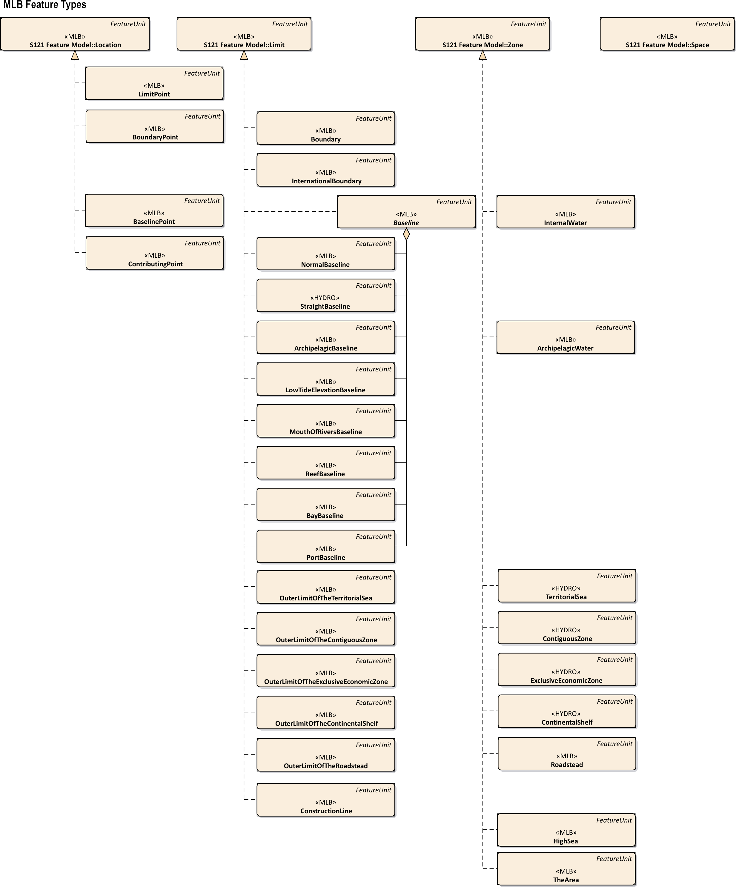
Figure 1 – MLB Features
The “location” feature types are:
Limit Point - A limit point is point on the outer limit of a maritime zone.
Baseline Point – A baseline point is a point on a baseline.
Boundary Point – A boundary point is a point on a boundary .
Contributing Point - A point, used for computation .
The “limit” feature types are:
Boundary - A delimitation line between two or more entities,.
International Boundary - A delimitation between two or more States .
Baseline (Articles 5, 6, 7, 9, 10, 11, 13, 14 and 47 of UNCLOS) – A baseline is a line from which the breadth of the territorial sea, and other maritime zones is measured..
Normal Baseline (Article 5of UNCLOS)

Straight Baselines (Articles 7of UNCLOS)

Archipelagic Baseline (Article 47 of UNCLOS)

Low-Tide Elevations (Article 13 of UNCLOS)
Mouths of Rivers (Article 9 of UNCLOS)
Reefs (Article 6 of UNCLOS)
Bays (Article 10 of UNCLOS)
Ports (Article 11 of UNCLOS)
Outer Limit of the Territorial Sea (Articles 3, 4 and 15 of UNCLOS)
Outer Limit of the Contiguous Zone (Article 33 of UNCLOS)
Outer Limit of the Exclusive Economic Zone (Article 57 and 74 of UNCLOS)
Outer Limit of the Continental Shelf (Article 76 and 83 of UNCLOS)
Outer Limit of the Roadstead (Article 12 of UNCLOS) - The outer limit of a roadstead.

Construction Line – An arc used for constructing "Limit" or "Boundary" typically linking to a "Contributing Point".
The “zone” feature types are:
Internal Waters (Article 8 of UNCLOS) –
Archipelagic Waters (Article 49 of UNCLOS) –Archipelagic waters are waters enclosed by the archipelagic baselines drawn in accordance with Article 47.
Territorial Sea (Part II, Sections 1-3, of UNCLOS)
Contiguous Zone (Part II, Section 4, of UNCLOS)
Exclusive Economic Zone (Part V of UNCLOS)
Continental Shelf (Part VI of UNCLOS)
Roadsteads (Article 12 of UNCLOS)
High Seas (Part VII of UNCLOS)
The Area (Part XI of UNCLOS)
.

Attribute Types
The Rights, Restrictions, Responsibility and Party structure effectively provides attributes to the S-121 feature types by reference.
The S121_FeatureUnit is a feature type and may take on any of the feature attributes described in the Feature Concept Dictionary Register. Specific attributes are bound to specific features in the Product Specification. Figure 2 shows S121_FeatureUnit and its attributes.
The S121_FeatureUnit also has five built-in attributes. These are:
fuID: The Feature Unit Identifier allows reference to information objects using the “Oid” (Object ID) attribute. The “Oid” comprises a unique character string and a namespace identifier which is also a unique character string. An example might be "Limit-1" where "Limit" is the namespace and "1" is the unique id within that namespace.
label: The attribute label provides a short textual identifier of the feature unit. For features registered in the Feature Context Dictionary this is the full textual Feature Type Name. This attribute is mandatory because it is used as part of the human readable textual encoding.
name: The name of the feature, i.e. the 6-character code or CamelCase code identifying the feature type (as defined in the Feature Concept Dictionary). The definition, and isAbstract of the feature are recorded in the Feature Concept Dictionary so do not need to be included in attributes.

context: This attribute describes the administrative aspects of the feature object.
releasabilityType: This attribute is optionally used to differentiate between releasability status for particular features.
In addition, there are three attributes inherited through the S121_VersionedObject structure. These are:
startLifespan: start time of a specific instance version.
endLifespan: optional end time of a specific instance version.
collection: the data set or series to which the data belongs.
Other thematic and spatial attributes are by reference.
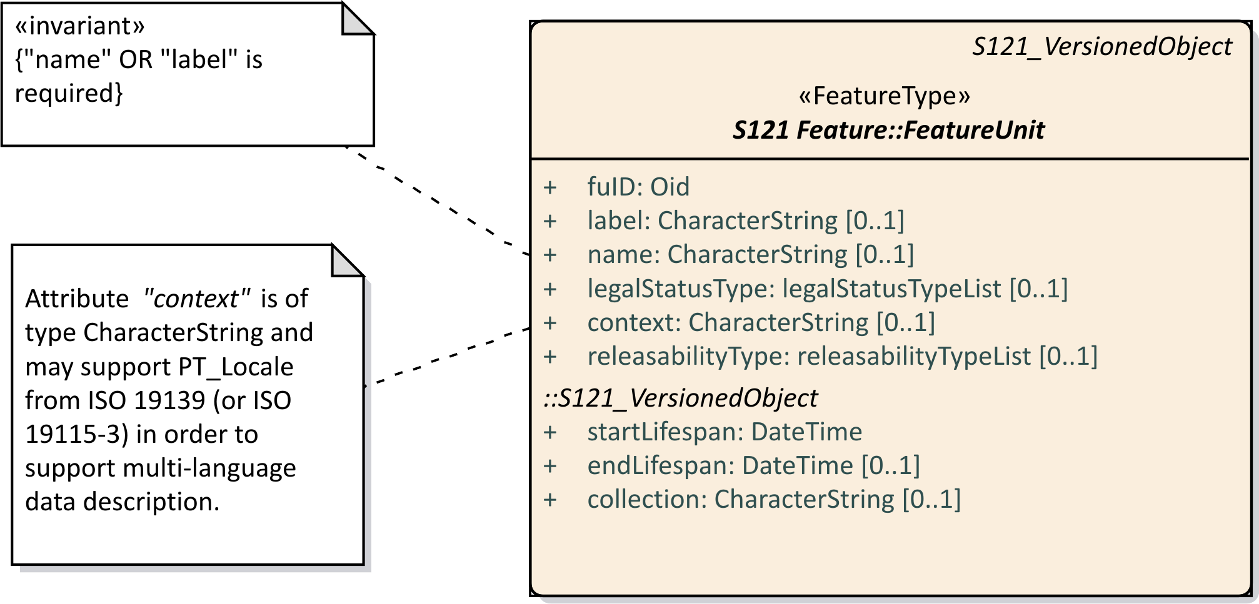

Figure 2 –Feature Unit Attributes for an S121_Feature

MLB Location Objects and Attributes
The S121 MLB Location Objects may take on any of the feature attributes described in the Feature Concept Dictionary Register. In addition, the S-121 MLB Location Objects inherit the attributes from S121_FeatureUnit: fuID, label, name, context and releasabilityType as well as the three versioning attributes, beginLifespanVersion, endLifespanVersion and collection.
The attribute locationObjectType from the codelist locationTypeList identifies which Feature Unit Limit Object type this object refers to based on the Feature Catalogue.
The attribute interpolationType from the codelist interpolationTypeList identifies the role of point in the structure of a "Straight" line or curve.
The attribute pointType from the codelist originTypeList identifies the type of the point.
Figure 3 shows MLB Location Objects and attributes.

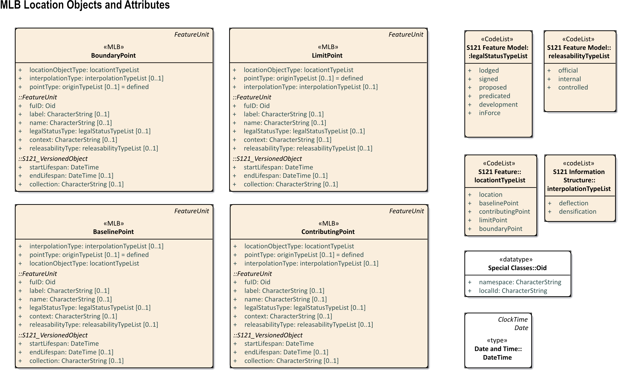
Figure 3 – MLB Location Objects and Attributes

MLB Limit Objects and Attributes
****** All the diagrams in this Annex will be regenerated when the model is revised. ****
The S121 MLB Limit Objects may take on any of the feature attributes described in the Feature Concept Dictionary Register. In addition, the S-121 MLB Limit Objects inherit the attributes from S121_FeatureUnit: fuID, label, name, context and releasabilityType and the versioning attributes, beginLifespanVersion, endLifespanVersion and collection.
The feature objects Baseline, NormalBaseline, StraightBaseline, ArchipelagicBaseline, LowTideElevationBaseline, MouthOfRiverBaseline, BayBaseline, ReefBaseline, PortBaseline, Boundary, InternationalBoundary, OuterLimitOfTheTerritorialSea, OuterLimitOfTheContiguousZone, OuterLimitOfTheExclusiveEconomicZone, OuterLimitOfTheContinentalShelf, OuterLimitOfThe Roadstead, and ConstructionLine may optionally take on the attribute arcGeometryType from the codelist arcGeometryTypeList which identifies the type of computation used to define an arc (line).
With respect to the feature objects Boundary and International Boundary: In accordance with articles 74, 75, 83, and 84 of UNCLOS, information on maritime boundaries, such as information about the delimitation of exclusive economic zones and continental shelves between states, may be provided for S-121 only when an agreement is reached between relevant states.
The attribute limitObjectType from the codelist limitTypeList identifies which Feature Unit Limit Object type this object refers to based on the Feature Catalogue.
The Figure 4 shows MLB Limit Objects and attributes.

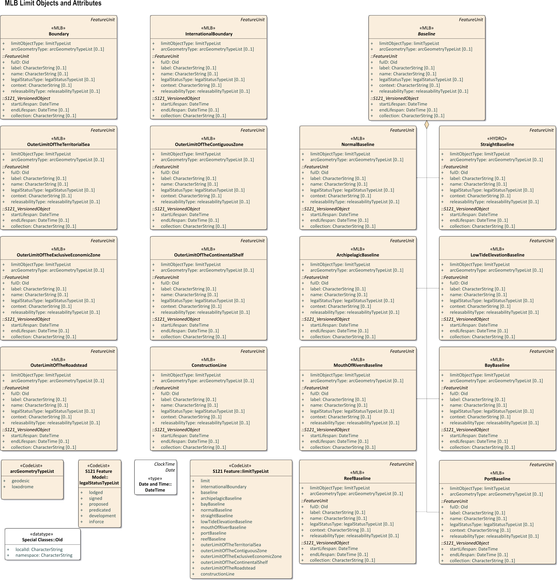
Figure 4 – MLB Limit Objects and Attributes

MLB Zone Objects and Attributes
The S121 MLB Zone Objects may take on any of the feature attributes described in the Feature Concept Dictionary Register. In addition the S121 MLB Zone Objects inherit the attributes from S121_FeatureUnit: fuID, label, name, context and releasabilityType and the versioning attributes, beginLifespanVersion, endLifespanVersion and collection.
The attribute zoneObjectType from the codelist zoneTypeList which identifies which Feature Unit Zone Object type this object refers to based on the Feature Ccatalogue.
The S121 MLB Zone Objects may optionally take on the attribute jurisdictionDomain from the codelist jurisdictionDomainTypeList which defines the vertical juridical domain of the object.
The Figure 5 shows MLB Zone Objects and attributes.

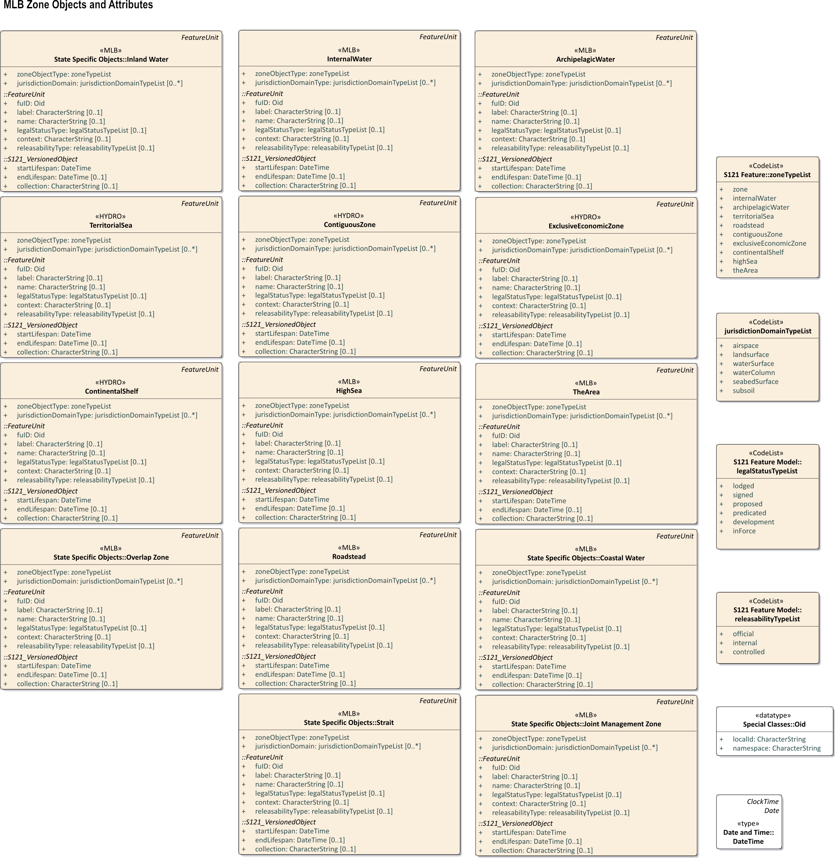
Figure 5 – MLB Zone Objects and Attributes

MLB Space Objects and Attributes
There no MLB Space objects defined. Any Space object will need to be generated from the generic object Space and registered in the Feature Catalogue for a particular product.

MLB Generic Feature Objects and Defining Attributes
There are four generic feature object types, Location, Limit, Zone and Space. These objects serve as the root objects for all of the registered Feature Types. However these four objects may also be instantiated and specialized where there is a need to construct as special object type. Figure 6 illustrates the relationship of the generic feature objects and defining attributes.

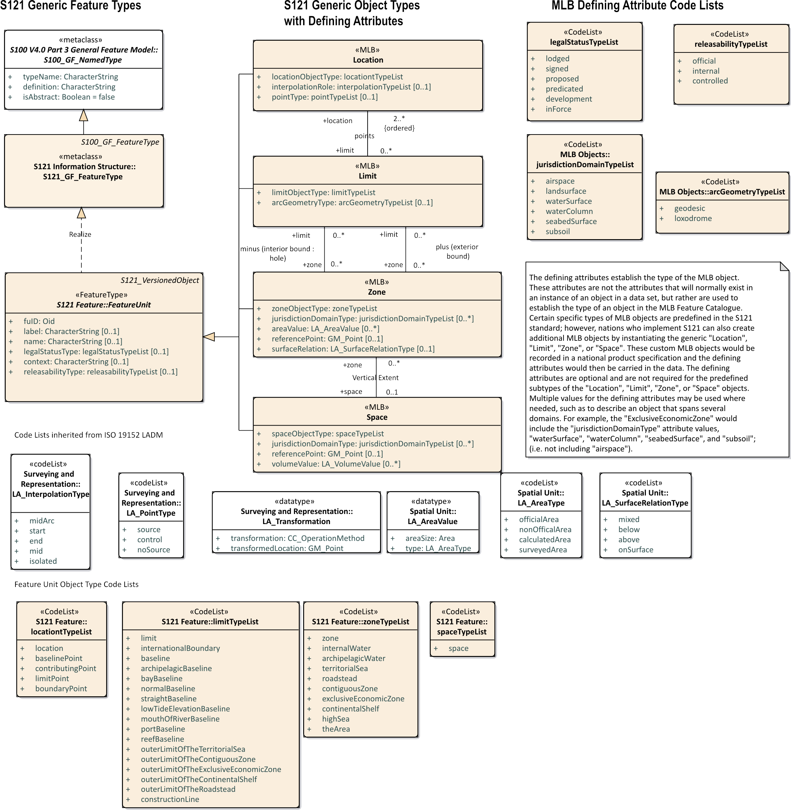
Figure 6 – MLB Generic Feature Objects and Defining Attributes

Optional Feature Objects and Attributes
In addition to the Maritime Limit and Boundaries feature types based on UNCLOS users may establish additional Feature Objects and associated attributes. These features behave in the same way as any of the other MLB objects. The difference is that they are completely optional. ****** Note to editor: Remove all State Specific Objects in section 3.6 and in the associated tables. Search the document for the mention of "State Specific" ******

Feature Catalogue Entries
The objects and attributes identified for use in the S-121 Product Specification are described in conformance with the IHO Geospatial Information (GI) Registry.
****** These tables will be generated from the Feature Catalogue ****

S121 Location Feature Objects

Limit Point
Item Type | Feature
Domain | MLB
AlphaCode | LIMPNT
Name | Limit Point
Alias | MA_LimitPoint
CamelCase | LimitPoint
Use Type | Geographic; Administrative
Definition | A limit point is point on the outer limit of a maritime zone.
Reference
Definition Source
Similarity to Source
Int1
S4
Recommended Attributes | locationObjectType, pointType, interpolationType, label, name, context and releasabilityType, beginLifespanVersion, endLifespanVersion, collection
Distinguishing Features | "BaselinePoint", "BoundaryPoint", "ContributingPoint"
Remarks | A point typically associated with only one party.
Permitted Primitives | P

Baseline Point
Item Type | Feature
Domain | MLB
AlphaCode | BASEPT
Name | Baseline Point
Alias | MA_BaselinePoint
CamelCase | BaselinePoint
Use Type | Administrative
Definition | A point on a "Baseline" from which the breadths of the "TerritorialSea", and other maritime zones are measured.
Reference
Definition Source
Similarity to Source
Int1
S4
Recommended Attributes | locationObjectType, pointType, interpolationType, label, name, context and releasabilityType, beginLifespanVersion, endLifespanVersion, collection
Distinguishing Features | "LimitPoint", "BoundaryPoint", "ContributingPoint"
Remarks | Can be any point that makes up a "Baseline".
Permitted Primitives | P

Boundary Point
Item Type | Feature
Proposal Type | Addition
Domain | MLB
AlphaCode | BDNPNT
Name | Boundary Point
Alias | MA_BoundaryPoint
CamelCase | BoundaryPoint
Use Type | Administrative
Definition | A point on a "Boundary" line between two or more entities.
Reference
Definition Source
Similarity to Source
Int1
S4
Recommended Attributes | locationObjectType, pointType, interpolationType, label, name, context and releasabilityType, beginLifespanVersion, endLifespanVersion, collection
Distinguishing Features | "BaselinePoint", "LimitPoint", "ContributingPoint"
Remarks | A point associated with more than one party.
Permitted Primitives | P

Contributing Point
Item Type | Feature
Proposal Type | Addition
Domain | MLB
AlphaCode | CNTPNT
Name | Contributing Point
Alias | MA_ContributingPoint
CamelCase | ContributingPoint
Use Type | Administrative
Definition | A point, typically a BaselinePoint, used for the computation of a maritime "Limit" or "Boundary" object.
Reference
Definition Source
Similarity to Source
Int1
S4
Recommended Attributes | locationObjectType, pointType, interpolationType, label, name, context and releasabilityType, beginLifespanVersion, endLifespanVersion, collection
Distinguishing Features | "BaselinePoint", "LimitPoint", "BoundaryPoint"
Remarks
Permitted Primitives | P

S-121 Limit Feature Objects

Baseline
Item Type: | Feature
Proposal Type: | Addition
Domain: | MLB
AlphaCode: | BASELN
Name: | Baseline
Alias: | MA_Baseline
CamelCase: | Baseline
Use Type: | Administrative
Definition: | See the legal reference provided.
Reference: | UNCLOS: Articles 5, 6, 7, 9, 10, 11, 13, 14 and 47;
IHO-S32: | 390
Definition Source: | UNCLOS "CI_Citation"; IHO S-32, 5th Ed. "CI_Citation
Similarity to Source: | by reference
Int1:
S4:
Recommended Attributes: | limitObjectType, arcGeometryType, label, name, context and releasabilityType, beginLifespanVersion, endLifespanVersion, collection
Distinguishing Features: | "Baseline", "ArchipelagicBaseline", "NormalBaseline", "StraightBaseline", "LowTideElevationBaseline", "MouthOfRiverBaseline", "BayBaseline", "ReefBaseline", "PortBaseline"
Remarks:
Permitted Primitives: | L

Normal Baseline
Item Type: | Feature
Proposal Type: | Addition
Domain: | MLB
AlphaCode: | NORBLN
Name: | Normal Baseline
Alias: | MA_NormalBaseline
CamelCase: | NormalBaseline
Use Type: | Administrative
Definition: | See the legal reference provided.
Reference: | UNCLOS: Articles 5, 6 and 13
Definition Source: | UNCLOS "CI_Citation"
Similarity to Source: | by reference
Int1:
S4:
Recommended Attributes: | limitObjectType, arcGeometryType, label, name, context and releasabilityType, beginLifespanVersion, endLifespanVersion, collection
Distinguishing Features: | "Baseline", "ArchipelagicBaseline", "NormalBaseline", "StraightBaseline", "LowTideElevationBaseline", "MouthOfRiverBaseline", "BayBaseline", "ReefBaseline", "PortBaseline"
Remarks:
Permitted Primitives: | L

Straight Baseline
Item Type: | Feature
Proposal Type: | Unspecified
Domain: | HYDRO
AlphaCode: | STSLNE
Name: | Straight Baseline
Alias: | MA_StraightBaseline
CamelCase: | StraightBaseline
Use Type: | Administrative
Definition: | See the legal reference provided.
Reference: | IHO-S32: 390;
IHO-S32: | 393;
Definition Source: | IHO S-32, 5th Ed. "CI_Citation
Similarity to Source:
Int1: | N42
S4: | 440.4
Recommended Attributes: | limitObjectType, arcGeometryType, label, name, context and releasabilityType, beginLifespanVersion, endLifespanVersion, collection
Distinguishing Features: | "Baseline", "ArchipelagicBaseline", "NormalBaseline", "StraightBaseline", "LowTideElevationBaseline", "MouthOfRiverBaseline", "BayBaseline", "ReefBaseline", "PortBaseline"
Remarks:
Permitted Primitives: | L

Archipelagic Baseline
Item Type: | Feature
Proposal Type: | Addition
Domain: | MLB
AlphaCode: | ARCBLN
Name: | Archipelagic Baseline
Alias: | MA_ArchipelagicBaseline
CamelCase: | ArchipelagicBaseline
Use Type: | Administrative
Definition: | See the legal reference provided.
Reference: | UNCLOS: Article 47
Definition Source: | UNCLOS "CI_Citation"
Similarity to Source: | by reference
Int1:
S4:
Recommended Attributes: | limitObjectType, arcGeometryType, label, name, context and releasabilityType, beginLifespanVersion, endLifespanVersion, collection
Distinguishing Features: | "Baseline", "ArchipelagicBaseline", "NormalBaseline", "StraightBaseline", "LowTideElevationBaseline", "MouthOfRiverBaseline", "BayBaseline", "ReefBaseline", "PortBaseline"
Remarks:
Permitted Primitives: | L

Low Tide Elevation Baseline
Item Type: | Feature
Proposal Type: | Addition
Domain: | MLB
AlphaCode: | LTEBLN
Name: | Low Tide Elevation Baseline
Alias: | MA_LowTideElevationBaseline
CamelCase: | LowTideElevationBaseline
Use Type: | Administrative
Definition: | See the legal reference provided.
Reference: | UNCLOS: Article 13
Definition Source: | UNCLOS "CI_Citation"
Similarity to Source: | by reference
Int1:
S4:
Recommended Attributes: | limitObjectType, arcGeometryType, label, name, context and releasabilityType, beginLifespanVersion, endLifespanVersion, collection
Distinguishing Features: | "Baseline", "ArchipelagicBaseline", "NormalBaseline", "StraightBaseline", "LowTideElevationBaseline", "MouthOfRiverBaseline", "BayBaseline", "ReefBaseline", "PortBaseline"
Remarks:
Permitted Primitives: | L

Mouths of Rivers Baseline
Item Type: | Feature
Proposal Type: | Addition
Domain: | MLB
AlphaCode: | MRVBLN
Name: | Mouths of Rivers Baseline
Alias: | MA_MouthsOfRiversBaseline
CamelCase: | MouthsOfRiversBaseline
Use Type: | Administrative
Definition: | See the legal reference provided.
Reference: | UNCLOS: Article 9
Definition Source: | UNCLOS "CI_Citation"
Similarity to Source: | by reference
Int1:
S4:
Recommended Attributes: | limitObjectType, arcGeometryType, label, name, context and releasabilityType, beginLifespanVersion, endLifespanVersion, collection
Distinguishing Features: | "Baseline", "ArchipelagicBaseline", "NormalBaseline", "StraightBaseline", "LowTideElevationBaseline", "MouthsOfRiversBaseline", "BayBaseline", "ReefBaseline", "PortBaseline"
Remarks:
Permitted Primitives: | L

Bay Baseline
Item Type: | Feature
Proposal Type: | Addition
Domain: | MLB
AlphaCode: | BAYBLN
Name: | Bay Baseline
Alias: | MA_BayBaseline
CamelCase: | BayBaseline
Use Type: | Administrative
Definition: | See the legal reference provided.
Reference: | UNCLOS: Article 10
Definition Source: | UNCLOS "CI_Citation"
Similarity to Source: | by reference
Int1:
S4:
Recommended Attributes: | limitObjectType, arcGeometryType, label, name, context and releasabilityType, beginLifespanVersion, endLifespanVersion, collection
Distinguishing Features: | "Baseline", "ArchipelagicBaseline", "NormalBaseline", "StraightBaseline", "LowTideElevationBaseline", "MouthOfRiverBaseline", "BayBaseline", "ReefBaseline", "PortBaseline"
Remarks:
Permitted Primitives: | L

Port Baseline
Item Type: | Feature
Proposal Type: | Addition
Domain: | MLB
AlphaCode: | PRTBLN
Name: | Port Baseline
Alias: | MA_PortBaseline
CamelCase: | PortBaseline
Use Type: | Administrative
Definition: | See the legal reference provided.
Reference: | UNCLOS: Article 11
Definition Source: | UNCLOS "CI_Citation"
Similarity to Source: | by reference
Int1:
S4:
Recommended Attributes: | limitObjectType, arcGeometryType, label, name, context and releasabilityType, beginLifespanVersion, endLifespanVersion, collection
Distinguishing Features: | "Baseline", "ArchipelagicBaseline", "NormalBaseline", "StraightBaseline", "LowTideElevationBaseline", "MouthOfRiverBaseline", "BayBaseline", "ReefBaseline", "PortBaseline"
Remarks:
Permitted Primitives: | L

Reef Baseline
Item Type: | Feature
Proposal Type: | Addition
Domain: | MLB
AlphaCode: | REFBLN
Name: | Reef Baseline
Alias: | MA_ReefBaseline
CamelCase: | ReefBaseline
Use Type: | Administrative
Definition: | See the legal reference provided.
Reference: | UNCLOS: Article 6
Definition Source: | UNCLOS "CI_Citation"
Similarity to Source: | by reference
Int1:
S4:
Recommended Attributes: | limitObjectType, arcGeometryType, label, name, context and releasabilityType, beginLifespanVersion, endLifespanVersion, collection
Distinguishing Features: | "Baseline", "ArchipelagicBaseline", "NormalBaseline", "StraightBaseline", "LowTideElevationBaseline", "MouthOfRiverBaseline", "BayBaseline", "ReefBaseline", "PortBaseline"
Remarks:
Permitted Primitives: | L

Boundary
Item Type: | Feature
Proposal Type: | Addition
Domain: | MLB
AlphaCode: | BNDARY
Name: | Boundary
Alias: | MA_Boundary
CamelCase: | Boundary
Use Type: | Administrative
Definition: | A delimitation line between two or more entities, determined by agreement or through a third-party dispute settlement mechanism.
Reference: | UNCLOS: Article 74, 75, 83, 84
Definition Source:
Similarity to Source:
Int1:
S4:
Recommended Attributes: | limitObjectType, arcGeometryType, label, name, context and releasabilityType, beginLifespanVersion, endLifespanVersion, collection
Distinguishing Features:
Remarks: | In accordance with articles 74, 75, 83, and 84 of UNCLOS, information on maritime boundaries, such as information about the delimitation of exclusive economic zones and continental shelves between states, may be provided for S-121 only when an agreement is reached between relevant states.
Permitted Primitives: | L

International Boundary
Item Type: | Feature
Proposal Type: | Addition
Domain: | MLB
AlphaCode: | INTBND
Name: | International Boundary
Alias: | MA_InternationalBoundary
CamelCase: | InternationalBoundary
Use Type: | Administrative
Definition: | An delimitation between two or more coastal States with adjacent or opposite coasts, determined by agreement or through a third-party dispute settlement mechanism.
Reference:
Definition Source:
Similarity to Source:
Int1:
S4:
Recommended Attributes: | limitObjectType, arcGeometryType, label, name, context and releasabilityType, beginLifespanVersion, endLifespanVersion, collection
Distinguishing Features:
Remarks: | In accordance with articles 74, 75, 83, and 84 of UNCLOS, information on maritime boundaries, such as information about the delimitation of exclusive economic zones and continental shelves between states, may be provided for S-121 only when an agreement is reached between relevant states.
Permitted Primitives: | L

Outer Limit of the Territorial Sea
Item Type: | Feature
Proposal Type: | Addition
Domain: | MLB
AlphaCode: | TESLIM
Name: | Outer Limit Of The Territorial Sea
Alias: | MA_OuterLimitOfTheTerritorialSea
CamelCase: | OuterLimitOfTheTerritorialSea
Use Type: | Administrative
Definition: | See the legal reference provided.
Reference: | UNCLOS: Articles 3, 4and 15
Definition Source: | UNCLOS "CI_Citation"
Similarity to Source: | by reference
Int1:
S4:
Recommended Attributes: | limitObjectType, arcGeometryType, label, name, context and releasabilityType, beginLifespanVersion, endLifespanVersion, collection
Distinguishing Features: | ""OuterLimitOfTheContiguousZone", "OuterLimitOfTheExclusiveEconomicZone", "OuterLimitOfTheContinentalShelf", "OuterLimitOfTheRoadstead"
Remarks:
Permitted Primitives: | L

Outer Limit of the Contiguous Zone
Item Type: | Feature
Proposal Type: | Addition
Domain: | MLB
AlphaCode: | CZOLIM
Name: | Outer Limit Of The Contiguous Zone
Alias: | MA_OuterLimitOfTheContiguousZone
CamelCase: | OuterLimitOfTheContiguousZone
Use Type: | Administrative
Definition: | See the legal reference provided.
Reference: | UNCLOS: Article 33
Definition Source: | UNCLOS "CI_Citation"
Similarity to Source: | by reference
Int1:
S4:
Recommended Attributes: | limitObjectType, arcGeometryType, label, name, context and releasabilityType, beginLifespanVersion, endLifespanVersion, collection
Distinguishing Features: | "OuterLimitOfTheTerritorialSea", "OuterLimitOfTheExclusiveEconomicZone", "OuterLimitOfTheContinentalShelf", "OuterLimitOfTheRoadstead"
Remarks:
Permitted Primitives: | L

Outer Limit of the Exclusive Economic Zone
Item Type: | Feature
Proposal Type: | Addition
Domain: | MLB
AlphaCode: | EEZLIM
Name: | Outer Limit Of The Exclusive Economic Zone
Alias: | MA_OuterLimitOfTheExclusiveEconomicZone
CamelCase: | OuterLimitOfTheExclusiveEconomicZone
Use Type: | Administrative
Definition: | See the legal reference provided.
Reference: | UNCLOS: Article 57 and 74
Definition Source: | UNCLOS "CI_Citation"
Similarity to Source: | by reference
Int1:
S4:
Recommended Attributes: | limitObjectType, arcGeometryType, label, name, context and releasabilityType, beginLifespanVersion, endLifespanVersion, collection
Distinguishing Features: | "OuterLimitOfTheTerritorialSea", "OuterLimitOfTheContiguousZone", ", "OuterLimitOfTheContinentalShelf", "OuterLimitOfTheRoadstead"
Remarks:
Permitted Primitives: | L

Outer Limit of the Continental Shelf
Item Type: | Feature
Proposal Type: | Addition
Domain: | MLB
AlphaCode: | CSOLIM
Name: | Outer Limit Of The Continental Shelf
Alias: | MA_OuterLimitOfTheContinentalShelf
CamelCase: | OuterLimitOfTheContinentalShelf
Use Type: | Administrative
Definition: | See the legal reference provided.
Reference: | UNCLOS: Article 76 and 83
Definition Source: | UNCLOS "CI_Citation"
Similarity to Source: | by reference
Int1:
S4:
Recommended Attributes: | limitObjectType, arcGeometryType, label, name, context and releasabilityType, beginLifespanVersion, endLifespanVersion, collection
Distinguishing Features: | "OuterLimitOfTheTerritorialSea", "OuterLimitOfTheContiguousZone", "OuterLimitOfTheExclusiveEconomicZone", "OuterLimitOfTheRoadstead"
Remarks:
Permitted Primitives: | L

Outer Limit of the Roadstead
Item Type: | Feature
Proposal Type: | Addition
Domain: | MLB
AlphaCode: | RDSLIM
Name: | Outer Limit Of The Roadstead
Alias: | MA_OuterLimitOfTheRoadstead
CamelCase: | OuterLimitOfTheRoadstead
Use Type: | Administrative
Definition: | See the legal reference provided.
Reference: | UNCLOS: Article 12
Definition Source: | UNCLOS "CI_Citation"
Similarity to Source: | by reference
Int1:
S4:
Recommended Attributes: | limitObjectType, arcGeometryType, label, name, context and releasabilityType, beginLifespanVersion, endLifespanVersion, collection
Distinguishing Features: | "OuterLimitOfTheTerritorialSea", "OuterLimitOfTheContiguousZone", "OuterLimitOfTheExclusiveEconomicZone", "OuterLimitOfTheContinentalShelf",
Remarks:
Permitted Primitives: | L

Construction Line
Item Type: | Feature
Proposal Type: | Addition
Domain: | MLB
AlphaCode: | CONLIN
Name: | Construction Line
Alias: | MA_ConstructionLine
CamelCase: | ConstructionLine
Use Type: | Administrative
Definition: | An arc of used for constructing "Limit" or "Boundary" typically linking to a "ContributingPoint".
Reference:
Definition Source:
Similarity to Source:
Int1:
S4:
Recommended Attributes: | limitObjectType, arcGeometryType, label, name, context and releasabilityType, beginLifespanVersion, endLifespanVersion, collection
Distinguishing Features:
Remarks:
Permitted Primitives: | L

S-121 Zone Feature Objects

Archipelagic Waters
Item Type: | Feature
Proposal Type: | Addition
Domain: | MLB
AlphaCode: | ARCWTR
Name: | Archipelagic Waters
Alias: | MA_ArchipelagicWaters
CamelCase: | ArchipelagicWaters
Use Type: | Administrative
Definition: | See the legal reference provided.
Reference: | UNCLOS: Article 47
Definition Source: | UNCLOS "CI_Citation"
Similarity to Source: | by reference
Int1:
S4:
Recommended Attributes: | zoneObjectType, jurisdictionDomainType, label, name, context and releasabilityType, beginLifespanVersion, endLifespanVersion, collection
Distinguishing Features: | "TerritorialSea", "ContiguousZone", "ExclusiveEconomicZone", "ContinentalShelf", "TheArea", "Roadstead"
Remarks:
Permitted Primitives: | A

Contiguous Zone
Item Type: | Feature
Proposal Type: | Unspecified
Domain: | HYDRO
AlphaCode: | CONZNE
Name: | Contiguous Zone
Alias: | MA_ContiguousZone
CamelCase: | ContiguousZone
Use Type: | Administrative
Definition: | See the legal reference provided.
Reference: | UNCLOS: Part II, Section 4;
IHO-S32: | 993
Definition Source: | UNCLOS "CI_Citation"; IHO S-32, 5th Ed. "CI_Citation
Similarity to Source: | by reference
Int1: | N44
S4: | 440.6
Recommended Attributes: | zoneObjectType, jurisdictionDomainType, label, name, context and releasabilityType, beginLifespanVersion, endLifespanVersion, collection
Distinguishing Features: | "ArchipelagicWater", "TerritorialSea", "ExclusiveEconomicZone", "ContinentalShelf", "TheArea", "Roadstead"
Remarks:
Permitted Primitives: | A

Continental Shelf
Item Type: | Feature
Proposal Type: | Unspecified
Domain: | HYDRO
AlphaCode: | COSARE
Name: | Continental Shelf
Alias: | MA_ContinentalShelf
CamelCase: | ContinentalShelf
Use Type: | Administrative
Definition: | See the legal reference provided.
Reference: | UNCLOS: Part VI
Definition Source: | UNCLOS "CI_Citation"
Similarity to Source: | by reference
Int1: | N 46
S4: | 440.8
Recommended Attributes: | zoneObjectType, jurisdictionDomainType, label, name, context and releasabilityType, beginLifespanVersion, endLifespanVersion, collection
Distinguishing Features: | "ArchipelagicWater", "TerritorialSea", "ContiguousZone", "ExclusiveEconomicZone", "TheArea", "Roadstead" , "HighSea"
Remarks:
Permitted Primitives: | A

Exclusive Economic Zone
Item Type: | Feature
Proposal Type: | Unspecified
Domain: | HYDRO
AlphaCode: | EXEZNE
Name: | Exclusive Economic Zone
Alias: | MA_ExclusiveEconomicZone
CamelCase: | ExclusiveEconomicZone
Use Type: | Administrative
Definition: | See the legal reference provided.
Reference: | UNCLOS: Part V;
IHO-S32:1723
Definition Source: | UNCLOS "CI_Citation"; IHO S-32, 5th Ed. "CI_Citation
Similarity to Source: | by reference
Int1: | N47
S4: | 440.9
Recommended Attributes: | zoneObjectType, jurisdictionDomainType, label, name, context and releasabilityType, beginLifespanVersion, endLifespanVersion, collection
Distinguishing Features: | ArchipelagicWater, "TerritorialSea", "ContiguousZone", "ContinentalShelf", "TheArea", "Roadstead"
Remarks:
Permitted Primitives: | A

High Seas
Item Type: | Feature
Proposal Type: | Addition
Domain: | MLB
AlphaCode: | HIGHSE
Name: | High Seas
Alias: | MA_HighSeas
CamelCase: | HighSeas
Use Type: | Administrative
Definition: | See the legal reference provided.
Reference: | UNCLOS: Part VII
Definition Source: | UNCLOS "CI_Citation"
Similarity to Source: | by reference
Int1:
S4:
Recommended Attributes: | zoneObjectType, jurisdictionDomainType, label, name, context and releasabilityType, beginLifespanVersion, endLifespanVersion, collection
Distinguishing Features: | "ArchipelagicWater", "TerritorialSea", "ContiguousZone", "ExclusiveEconomicZone", "ContinentalShelf", "TheArea", "Roadstead"
Remarks:
Permitted Primitives: | A

Internal Waters
Item Type: | Feature
Proposal Type: | Addition
Domain: | MLB
AlphaCode: | INTWTR
Name: | Internal Waters
Alias: | MA_InternalWaters
CamelCase: | InternalWaters
Use Type: | Administrative
Definition: | See the legal reference provided.
Reference: | UNCLOS: Article 8;
IHO-S32: | 2484
Definition Source: | UNCLOS "CI_Citation"; IHO S-32, 5th Ed. "CI_Citation
Similarity to Source: | by reference
Int1:
S4:
Recommended Attributes: | zoneObjectType, jurisdictionDomainType, label, name, context and releasabilityType, beginLifespanVersion, endLifespanVersion, collection
Distinguishing Features:
Remarks:
Permitted Primitives: | A

Roadstead
Item Type: | Feature
Proposal Type: | Addition
Domain: | MLB
AlphaCode: | RDSZNE
Name: | Roadstead
Alias: | MA_Roadstead
CamelCase: | Roadstead
Use Type: | Administrative
Definition: | See the legal reference provided.
Reference: | UNCLOS: Article 12
Definition Source: | UNCLOS "CI_Citation"
Similarity to Source: | by reference
Int1:
S4:
Recommended Attributes: | zoneObjectType, jurisdictionDomainType, label, name, context and releasabilityType, beginLifespanVersion, endLifespanVersion, collection
Distinguishing Features: | "ArchipelagicWater", "TerritorialSea", "ContiguousZone", "ExclusiveEconomicZone", "ContinentalShelf", "TheArea"
Remarks:
Permitted Primitives: | A

Territorial Sea
Item Type: | Feature
Proposal Type: | Unspecified
Domain: | HYDRO
AlphaCode: | TESARE
Name: | Territorial Sea
Alias: | MA_TerritorialSea
CamelCase: | TerritorialSea
Use Type: | Administrative
Definition: | See the legal reference provided.
Reference: | UNCLOS: Part II, Sections 1-3;
IHO-S32: | 5360
Definition Source: | UNCLOS "CI_Citation"; IHO S-32, 5th Ed. "CI_Citation
Similarity to Source: | by reference
Int1: | N43
S4: | 440.5
Recommended Attributes: | zoneObjectType, jurisdictionDomainType, label, name, context and releasabilityType, beginLifespanVersion, endLifespanVersion, collection
Distinguishing Features: | "ArchipelagicWater", "ContiguousZone", "ExclusiveEconomicZone", "ContinentalShelf", "TheArea", "Roadstead"
Remarks:
Permitted Primitives: | A

The Area
Item Type: | Feature
Proposal Type: | Addition
Domain: | MLB
AlphaCode: | SBAREA
Name: | The Area
Alias: | MA_TheArea
CamelCase: | TheArea
Use Type: | Administrative
Definition: | See the legal reference provided.
Reference: | UNCLOS: Part XI;
IHO-S32: | 227
Definition Source: | UNCLOS "CI_Citation"; IHO S-32, 5th Ed. "CI_Citation
Similarity to Source: | by reference
Int1:
S4:
Recommended Attributes: | zoneObjectType, jurisdictionDomainType, label, name, context and releasabilityType, beginLifespanVersion, endLifespanVersion, collection
Distinguishing Features: | ArchipelagicWater, "TerritorialSea", "ContiguousZone", "ExclusiveEconomicZone", "ContinentalShelf", "Roadstead"
Remarks:
Permitted Primitives: | A

S-121 MLB Generic Feature Objects

Location
Item Type: | Feature
Domain: | MLB
AlphaCode: | MLOCTN
Name: | Location
Alias: | MA_Location
CamelCase: | Location
Use Type: | Geographic; Administrative
Definition: | An object that defines and attributes a point in space.
Reference:
Definition Source:
Similarity to Source:
Int1:
S4:
Recommended Attributes: | locationObjectType, interpolationRule, pointType, label, name, context and releasabilityType, beginLifespanVersion, endLifespanVersion, collection
Distinguishing Features: | "Limit", "Zone", "Space"
Remarks:
Permitted Primitives: | P

Limit
Item Type: | Feature
Domain: | MLB
AlphaCode: | MLBLIM
Name: | Limit
Alias: | MA_Limit
CamelCase: | Limit
Use Type: | Geographic; Administrative
Definition: | An object that defines any limit or boundary either relating to terrestrial, marine or both environments.
Reference:
Definition Source:
Similarity to Source:
Int1:
S4:
Recommended Attributes: | limitObjectType, arcGeometryType, label, name, context and releasabilityType, beginLifespanVersion, endLifespanVersion, collection
Distinguishing Features: | "Location", "Zone", "Space"
Remarks:
Permitted Primitives: | P,L

Zone
Item Type: | Feature
Domain: | MLB
AlphaCode: | MAZONE
Name: | Zone
Alias: | MA_Zone
CamelCase: | Zone
Use Type: | Geographic; Administrative
Definition: | An object that defines an area which is logically delimited by instances of "Limit".
Reference:
Definition Source:
Similarity to Source:
Int1:
S4:
Recommended Attributes: | zoneObjectType, jurisdictionDomainType, referencePoint, areaValue, surfaceRelationType, label, name, context and releasabilityType, beginLifespanVersion, endLifespanVersion, collection
Distinguishing Features: | "Location", "Limit", "Space"
Remarks:
Permitted Primitives: | P,L,A

Space
Item Type: | Feature
Domain: | MLB
AlphaCode: | MSPACE
Name: | Space
Alias: | MA_Space
CamelCase: | Space
Use Type: | Geographic; Administrative
Definition: | An object that defines a volume which is logically delimited by instances of "Zone".
Reference:
Definition Source:
Similarity to Source:
Int1:
S4:
Recommended Attributes: | spaceObjectType, jurisdictionDomainType, referencePoint, volumeValue, label, name, context and releasabilityType, beginLifespanVersion, endLifespanVersion, collection
Distinguishing Features: | "Location", "Limit", "Zone"
Remarks: | A "Space" is an object of 2 dimensions with a height description located in 2 or 3 dimensional "Space". This is sometimes called 2 1/2 dimensions. A "Space" has the same geometry as a "Zone" with the attributes of vertical position. The vertical position may be explicit numerical attributes of height above a reference or a textual description.
Permitted Primitives: | P,L,A

S-121 Information Objects

Basic Administrative Unit
Item Type: | Information
Domain: | MLB
AlphaCode: | BAUNIT
Name: | Basic Administrative Unit
Alias: | MA_BasicAdministrativeUnit
CamelCase: | basicAdministrativeUnit
Definition: | An information object to which (one or more) unique and homogeneous "Right", "Responsibility" or "Restriction" are associated. It is an information object since it does not directly take on spatial attributes.
Reference: | ISO 19152
Definition Source: | ISO 19152:2012 clause 4.1.2
Similarity to Source: | specialization
Int1:
S4:
Remarks:

Right
Item Type: | Information
Domain: | MLB
AlphaCode: | MARGHT
Name: | Right
Alias: | MA_Right
CamelCase: | right
Definition: | An action, activity or class of actions that a system participant may perform on or using an associated resource.
Reference: | ISO 19152
Definition Source: | ISO 19152:2012 clause 4.1.2
Similarity to Source: | specialization
Int1:
S4:
Remarks: | Realized from ISO 19152 LADM "LA_Right" which stereotypes this object as a "featureType". Since it is not a feature in the same sense as the term feature is used in IHO S100, the stereotype has been removed. For the S121 code lists have been specialized to the marine environment. They can be referenced as objects from the attributes associated with an S100 Feature Object. Used in this way an information object such as an "Right" is a shared attribute by reference.

Responsibility
Item Type: | Information
Domain: | MLB
AlphaCode: | MARSPN
Name: | Responsibility
Alias: | MA_Responsibility
CamelCase: | responsibility
Definition: | A formal or informal obligation to do something.
Reference: | ISO 19152
Definition Source: | ISO 19152:2012 clause 6.4.5
Similarity to Source: | specialization
Int1:
S4:
Remarks: | Realized from ISO 19152 LADM "LA_Responsibility" which stereotypes this object as a "featureType". Since it is not a feature in the same sense as the term feature is used in IHO S100, the stereotype has been removed. For the S121 code lists have been specialized to the marine environment. They can be referenced as objects from the attributes associated with an S100 Feature Object. Used in this way an information object such as an "Responsibility" is a shared attribute by reference.

Restriction
Item Type: | Information
Domain: | MLB
AlphaCode: | MARSTN
Name: | Restriction
Alias: | MA_Restriction
CamelCase: | restriction
Definition: | A formal or informal entitlement to refrain from doing something.
Reference: | ISO 19152
Definition Source: | ISO 19152:2012 clause 6.4.4
Similarity to Source: | specialization
Int1:
S4:
Remarks: | Realized from ISO 19152 LADM "LA_Restriction" which stereotypes this object as a "featureType". Since it is not a feature in the same sense as the term feature is used in IHO S100, the stereotype has been removed. For the S121 code lists have been specialized to the marine environment. They can be referenced as objects from the attributes associated with an S100 Feature Object. Used in this way an information object such as an "Restriction" is a shared attribute by reference. Out of the RRR objects, it is the only one that does not require a relation with Party, since restrictions can apply to all.

S121 Party
Item Type: | Information
Domain: | MLB
AlphaCode: | MAPART
Name: | Party
Alias: | MA_Party
CamelCase: | party
Definition: | A person or organisation or group that plays a role in a rights transaction.
Reference: | ISO 19152
Definition Source: | ISO 19152:2012 clause 6.3.1
Similarity to Source: | specialization
Int1:
S4:
Remarks: | Realized from ISO 19152 LADM "LA_Party" which stereotypes this object as a "featureType". Since it is not a feature in the same sense as the term feature is used in IHO S100, the stereotype has been removed. LA_GroupParty describes any number of parties, forming together a distinct entity, with each party registered. Since LA_GroupParty is a subtype of LA_Party this is described as a single class "Party" that includes an conditional attribute "partyGroupTypeList" that defines the type of a group party.

S121 Group Party
Item Type: | Information
Domain: | MLB
AlphaCode: | MAGPRT
Name: | Group Party
Alias: | MA_GroupParty
CamelCase: | groupParty
Definition: | A group of two or more parties that plays a role in a rights transaction that plays a role in a rights transaction.
Reference: | ISO 19152
Definition Source: | ISO 19152:2012 clause 6.3.2
Similarity to Source: | specialization
Int1:
S4:
Remarks: | Realized from ISO 19152 LADM "LA_GroupParty" which stereotypes this object as a "featureType". Since it is not a feature in the same sense as the term feature is used in IHO S100, the stereotype has been removed. LA_GroupParty describes any number of parties, forming together a distinct entity, with each party registered. Since LA_GroupParty is a subtype of LA_Party this is described as a single class "Party" that includes an conditional attribute "partyGroupTypeList" that defines the type of a group party.

Source
Item Type: | Information
Domain: | MLB
AlphaCode:
Name: | Source
Alias:
CamelCase: | Source
Definition: | Descriptive documentation that supports, complement or describes the associated object. Document providing information on which associated object is based.
Reference: | ISO 19152
Definition Source: | ISO 19152:2012 clause 4.1.3.1 and 6.2.4
Similarity to Source: | specialization
Int1:
S4:
Remarks: | Realized from ISO 19152 LADM "LA_Source" which stereotypes this object as a "featureType". Since it is not a feature in the same sense as the term feature is used in IHO S100, the stereotype has been removed. The "Source" objects are shared attributes by reference.

Governance
Item Type: | Information
Domain: | MLB
AlphaCode: | GOVERN
Name: | Governance
Alias: | MA_Goverance
CamelCase: | Governance
Definition: | A description of the context information from a proclamation, law or treaty document.
Reference:
Definition Source:
Similarity to Source:specialization
Int1:
S4:
Remarks: | Governance information defines title, reference number, date and other associated information linked to the particular proclamation, law and treaty documents to support the provision of specific description or interpretation that is applicable to the selected set of features.

S-121 Attributes

Label
Item Type: | Simple Attribute
Domain: | MLB
AlphaCode: | MAFLAB
Name: | Label
Alias: | MA_Label
CamelCase: | label
Data Type: | CharacterString
Definition: | A short textual identifier of the feature or information object.
Reference:
Definition Source:
Similarity to Source:
Int1:
S4:
Remarks: | For features or information objects registered in the Feature Context Dictionary this is the full textual Feature / Information Object Type Name. This attribute is mandatory because it is used as part of the human readable textual encoding.
Quantity Specifications:

Name
Item Type: | Simple Attribute
Domain: | MLB
AlphaCode: | MANAME
Name: | Name
Alias: | MA_Name
CamelCase: | name
Data Type: | CharacterString
Definition: | The name of the feature or information object
Reference:
Definition Source:
Similarity to Source:
Int1:
S4:
Remarks:
Quantity Specifications:

**** Note: This needs to be reflected in the model ****

Context
Item Type: | Simple Attribute
Domain: | MLB
AlphaCode: | MACONT
Name: | Context
Alias: | MA_Context
CamelCase: | context
Data Type: | CharacterString
Definition: | This attribute describes the administrative aspects of the feature object.
Reference:
Definition Source:
Similarity to Source:
Int1:
S4:
Remarks:
Quantity Specifications:

Releasability Type
Item Type: | Simple Attribute
Domain: | MLB
AlphaCode: | MARELT
Name: | Releasability Type
Alias: | MA_ReleasabilityType
CamelCase: | releasabilityType
Data Type: | releasabilityTypeList
Definition: | This attribute is used to differentiate between releasability status for particular features or information objects.
Reference:
Definition Source:
Similarity to Source:
Int1:
S4:
Remarks:
Quantity Specifications:

Start Lifespan
Item Type: | Simple Attribute
Proposal Type:
Domain: | MLB
AlphaCode: | STAVER
Name: | Start Lifespan
Alias: | MA_beginLifespanVersion
CamelCase: | startLifespan
Data Type: | DateTime
Definition: | Start time of a specific instance version.
Reference: | ISO 19152
Definition Source: | ISO 19152:2012
Similarity to Source: | specialization
Int1:
S4:
Remarks: | The start time/date is mandatory.
Quantity Specifications:

End Lifespan
Item Type: | Simple Attribute
Proposal Type:
Domain: | MLB
AlphaCode: | ENDVER
Name: | End Lifespan
Alias: | MA_EndLifespanVersion
CamelCase: | endLifespan
Data Type: | DateTime
Definition: | End time of a specific instance version.
Reference: | ISO 19152
Definition Source: | ISO 19152:2012
Similarity to Source: | specialization
Int1:
S4:
Remarks: | The end time/date is optional and when missing indicates that the version is current.
Quantity Specifications:

Collection
Item Type: | Simple Attribute
Domain: | MLB
AlphaCode:
Name: | Collection
Alias: | MA_Collection
CamelCase: | collection
Data Type:
Definition: | This attribute identifies the data set or series to which the data belongs.
Reference:
Definition Source:
Similarity to Source:
Int1:
S4:
Remarks: | Each nation or organization creating data needs to identify the data. It is expected that the State name should be used when depositing.
Quantity Specifications:

Reference Number
Item Type: | Simple Attribute
Domain: | MLB
AlphaCode: | GORFNB
Name: | Reference Number
Alias:
Data Type:
CamelCase: | referenceNumber
Definition: | An attribute describing the reference number of the source reference.
Reference:
Definition Source:
Similarity to Source:
Int1:
S4:
Remarks:

Governance Title
Item Type: | Simple Attribute
Domain: | MLB
AlphaCode: | GOVTIT
Name: | Governance Title
Alias:
Data Type:
CamelCase: | governanceTitle
Definition: | The title of the source reference.
Reference:
Definition Source:
Similarity to Source:
Int1:
S4:
Remarks:

Governance Description
Item Type: | Simple Attribute
Domain: | MLB
AlphaCode: | GOVDES
Name: | Governance Description
Alias:
Data Type:
CamelCase: | governanceDescription
Definition: | A character string attribute containing the description of the governance statement.
Reference:
Definition Source:
Similarity to Source:
Int1:
S4:
Remarks: | This attribute contains the block or blocks of text that may act as a preamble to the source document.

Date Approved
Item Type: | Simple Attribute
Domain: | MLB
AlphaCode:
Name: | Date Approved
Alias:
CamelCase: | dateApproved
Data Type:
Definition: | The date at which the source statement or document was approved by the appropriate governing body.
Reference:
Definition Source:
Similarity to Source:
Int1:
S4:
Remarks:
Quantity Specifications:

Date Considered
Item Type: | Simple Attribute
Domain: | MLB
AlphaCode:
Name: | Date Considered
Alias:
CamelCase: | dateConsidered
Data Type:
Definition: | The date at which the source statement or document was considered by the appropriate governing body.
Reference:
Definition Source:
Similarity to Source:
Int1:
S4:
Remarks:
Quantity Specifications:

Date Introduced
Item Type: | Simple Attribute
Domain: | MLB
AlphaCode:
Name: | Date Introduced
Alias:
CamelCase: | dateIntroduced
Data Type:
Definition: | The date at which the source statement or document was introduced.
Reference:
Definition Source:
Similarity to Source:
Int1:
S4:
Remarks:
Quantity Specifications:

Basic Administrative Unit Name
Item Type: | Simple Attribute
Domain: | MLB
AlphaCode: | MABAUN
Name: | Basic Administrative Unit Name
Alias: | MA_BAUnitName
CamelCase: | basicAdministrativeUnitName
Data Type:
Definition: | Optional name for an instance of a "BasicAdministrativeUnit".
Reference: | ISO 19152
Definition Source: | ISO 19152:2012 clause 6.4.1
Similarity to Source: | specialization
Int1:
S4:
Remarks:
Quantity Specifications:

Basic Administrative Unit Type
tem Type: | Simple Attribute
Domain: | MLB
AlphaCode: | MABAUT
Name: | Basic Administrative Unit Type
Alias: | MA_BAUnitType
CamelCase: | basicAdministrativeUnitType
Data Type:
Definition: | The use type of a "BasicAdministrativeUnit".
Reference: | ISO 19152
Definition Source: | ISO 19152:2012 clause 6.4.1
Similarity to Source: | specialization
Int1:
S4:
Remarks:
Quantity Specifications:

Basic Administrative Unit Context
Item Type: | Simple Attribute
Domain: | MLB
AlphaCode: | MABAUC
Name: | Basic Administrative Unit Context
Alias: | MA_BAUnitContext
CamelCase: | basicAdministrativeUnitContext
Data Type:
Definition: | Description of the context for an instance of a "BasicAdministrativeUnit".
Reference:
Definition Source:
Similarity to Source:
Int1:
S4:
Remarks:
Quantity Specifications:

Right Restriction Responsibility Description
Item Type: | Simple Attribute
Proposal Type:
Domain: | MLB
AlphaCode: | MARRRD
Name: | Right Restriction Responsibility Description
Alias: | MA_RRRDescription
CamelCase: | rightRestrictionResponsibilitiesDescription
Data Type:
Definition: | Description regarding the "Right", "Restriction" or "Responsibility".
Reference: | ISO 19152
Definition Source: | ISO 19152:2012 clause 6.4.2
Similarity to Source:rstyled
Int1:
S4:
Remarks:
Quantity Specifications:

Right Restriction Responsibility Share
Item Type: | Simple Attribute
Proposal Type:
Domain: | MLB
AlphaCode: | MARSHR
Name: | Right Restriction Responsibility Share
Alias: | MA_RRRShare
CamelCase: | rightRestrictionResponsibilitiesShare
Data Type:
Definition: | A share in an instance of a subclass of a Right, Restriction or Responsibility.
Reference: | ISO 19152
Definition Source: | ISO 19152:2012 clause 6.4.2
Similarity to Source:specialization
Int1:
S4:
Remarks:
Quantity Specifications:

Right Restriction Responsibility Share Check
Item Type: | Simple Attribute
Proposal Type:
Domain: | MLB
AlphaCode: | MARSHC
Name: | Right Restriction Responsibility Share Check
Alias: | MA_RRRShareCheck
CamelCase: | rightRestrictionResponsibilitiesShareCheck
Data Type:
Definition: | Boolean indicating whether the constraint is applicable.
Reference: | ISO 19152
Definition Source: | ISO 19152:2012 clause 6.4.2
Similarity to Source: | specialization
Int1:
S4:
Remarks:
Quantity Specifications:

Right Restriction Responsibility Time Specification
Item Type: | Simple Attribute
Proposal Type:
Domain: | MLB
AlphaCode: | MARRRT
Name: | Right Restriction Responsibility Time Specification
Alias: | MA_RRRtimeSpec
CamelCase: | rightRestrictionResponsibilitiesTimeSpec
Data Type:
Definition: | Operational use of a right in time sharing.
Reference: | ISO 19152
Definition Source: | ISO 19152:2012 clause 6.4.2
Similarity to Source:specialization
Int1:
S4:
Remarks:
Quantity Specifications:

Right Type
Item Type: | Simple Attribute
Proposal Type:
Domain: | MLB
AlphaCode: | MARIGT
Name: | Right Type
Alias: | MA_RightType
CamelCase: | rightType
Data Type:
Definition: | The type of the right.
Reference: | ISO 19152
Definition Source: | ISO 19152:2012 clause 6.4.3
Similarity to Source: | specialization
Int1:
S4:
Remarks:
Quantity Specifications:

Responsibility Type *** in the model make this an open list rather than an enumerated list ****
Item Type: | Simple Attribute
Proposal Type:
Domain: | MLB
AlphaCode: | MAREST
Name: | Responsibility Type
Alias: | MA_ResponsibilityType
CamelCase: | responsibilityType
Data Type:
Definition: | The type of the responsibility.
Reference: | ISO 19152
Definition Source: | ISO 19152:2012 clause 6.4.5
Similarity to Source:specialization
Int1:
S4:
Remarks:
Quantity Specifications:

Restriction Type
Item Type: | Simple Attribute
Proposal Type:
Domain: | MLB
AlphaCode: | MARSTT
Name: | Restriction Type
Alias: | MA_RestrictionType
CamelCase: | restrictionType
Data Type:
Definition: | The type of the restriction.
Reference: | ISO 19152
Definition Source: | ISO 19152:2012 clause 6.4.9
Similarity to Source:specialization
Int1:
S4:
Remarks:
Quantity Specifications:

Party Required
Item Type: | Simple Attribute
Proposal Type:
Domain: | MLB
AlphaCode: | MAPREQ
Name: | Party Required
Alias: | MA_PartyRequired
CamelCase: | partyRequired
Data Type:
Definition: | Indicates whether a party is required for the registration of the restriction.
Reference: | ISO 19152
Definition Source: | ISO 19152:2012 clause 6.4.4
Similarity to Source: | specilization
Int1:
S4:
Remarks:
Quantity Specifications:

Party Name
Item Type: | Simple Attribute
Domain: | MLB
AlphaCode: | MAPNAM
Name: | Party Name
Alias: | MA_PartyName
CamelCase: | partyName
Data Type: | CharacterString
Definition: | The name of the party
Reference: | ISO 19152
Definition Source: | ISO 19152:2012 clause 6.3.1
Similarity to Source: | identical
Int1:
S4:
Remarks:
Quantity Specifications:

Party Role
Item Type: | Simple Attribute
Domain: | MLB
AlphaCode: | MAPROL
Name: | Party Role
Alias: | MA_PartyRole
CamelCase: | partyRole
Data Type:
Definition: | The role of the party
Reference: | ISO 19152
Definition Source: | ISO 19152:2012 clause 6.3.1
Similarity to Source: | identical
Int1:
S4:
Remarks:
Quantity Specifications:

Party Type
Item Type: | Simple Attribute
Domain: | MLB
AlphaCode: | MAPTYP
Name: | Party Type
Alias: | MA_PartyType
CamelCase: | partyType
Data Type: | Party Type List
Definition: | The type of party
Reference: | ISO 19152
Definition Source: | ISO 19152:2012 clause 6.3.1
Similarity to Source: | identical
Int1:
S4:
Remarks:
Quantity Specifications:

Party Group Type
Item Type: | Simple Attribute
Domain: | MLB
AlphaCode:
Name: | Party Group Type
Alias: | MA_PartyGroupType
CamelCase: | partyGroupType
Data Type:
Definition: | The type of "partyGroup".
Reference: | ISO 19152
Definition Source: | ISO 19152:2012 clause 6.3.2
Similarity to Source: | identical
Int1:
S4:
Remarks:
Quantity Specifications:

Party Share
Item Type: | Simple Attribute
Domain: | MLB
AlphaCode:
Name: | Party Share
Alias: | MA_PartyShare
CamelCase: | partyShare
Data Type: | Fraction
Definition: | The fraction of the whole.
Reference: | ISO 19152
Definition Source:
Similarity to Source:
Int1:
S4:
Remarks:
Quantity Specifications:

Original Location
Item Type: | Simple Attribute
Domain: | MLB
AlphaCode: | MAORGL
Name: | Original Location
Alias: | MA_OriginalLocation
CamelCase: | originalLocation
Data Type:
Definition: | Reference location of a point when it was first established
Reference:
Definition Source:
Similarity to Source:
Int1:
S4:
Remarks: | This includes a description of the point as a textual string, so that the exact representation of the point may be maintained in terms of degrees and decimal degrees, or degrees, minutes and seconds, or other description. In the case of the original location this may be a description of meets and bounds or whatever is included in the treaty or other original document. A reference system (CRS) shall be included where available. Often a CRS is not available for original locations derived from very old treaties.
Quantity Specifications:

Official Location
Item Type: | Simple Attribute
Domain: | MLB
AlphaCode: | MAOFFL
Name: | Official Location
Alias: | MA_OfficialLocation
CamelCase: | officialLocation
Data Type:
Definition: | Official reference of the point.
Reference:
Definition Source:
Similarity to Source:
Int1:
S4:
Remarks: | This is the official description of the point in a textual form, so that the exact representation of the point may be maintained in terms of degrees and decimal degrees, or degrees, minutes and seconds, or other description. A reference system (CRS) shall be included where available. A CRS is required, but it may only be included in the base text and therefore only included by reference through a Source object.
Quantity Specifications:

Common Location
Item Type: | Simple Attribute
Domain: | MLB
AlphaCode: | MACOML
Name: | Common Location
Alias: | MA_CommonLocation
CamelCase: | commonLocation
Data Type:
Definition: | Common reference location of point in a datum that is defaulted to the other points in the dataset.
Reference:
Definition Source:
Similarity to Source:
Int1:
S4:
Remarks:
Quantity Specifications:

Global Location
Item Type: | Simple Attribute
Domain: | MLB
AlphaCode: | MAGLOL
Name: | Global Location
Alias: | MA_GlobalLocation
CamelCase: | globalLocation
Data Type:
Definition: | Global reference to a point in a world global datum such ITRF2000.
Reference:
Definition Source:
Similarity to Source:
Int1:
S4:
Remarks:
Quantity Specifications:

WGS84 Location
Item Type: | Simple Attribute
Domain: | MLB
AlphaCode: | MAWGSL
Name: | WGS84 Location
Alias: | MA_wgs84Location
CamelCase: | wgs84Location
Data Type:
Definition: | Reference to a point in global datum WGS84.
Reference:
Definition Source:
Similarity to Source:
Int1:
S4:
Remarks: | This attribute is optional but it is requested for data deposited with DOALOS.
Quantity Specifications:

Volume Vertical Position
Item Type: | Simple Attribute
Domain: | MLB
AlphaCode: | MAVPOS
Name: | Volume Vertical Position
Alias: | MA_VerticalPosition
CamelCase: | volumeVerticalPosition
Data Type:
Definition: | A reference point used to establish a bound for the vertical extent of a volume.
Reference:
Definition Source:
Similarity to Source:
Int1:
S4:
Remarks: | GM_Point geometry as per IHO S100 Part 7 Spatial Schema, defining a reference from which to measure vertical extent.
Quantity Specifications:

Volume Vertical Extent
Item Type: | Simple Attribute
Domain: | MLB
AlphaCode: | MAVEXT
Name: | Volume Vertical Extent
Alias: | MA_verticalExtent
CamelCase: | volumeVerticalExtent
Data Type:
Definition: | The vertical extent of a volume established as a distance measured against a vertical position reference point.
Reference:
Definition Source:
Similarity to Source:
Int1:
S4:
Remarks: | Vertical extent is given in the units established through units of measure.
Quantity Specifications:

Textual Position
Item Type: | Simple Attribute
Domain: | MLB
AlphaCode: | MATXTP
Name: | Textual Position
Alias: | MA_TextualPosition
CamelCase: | textualPosition
Data Type:
Definition: | A point coordinate values in a textual form
Reference:
Definition Source:
Similarity to Source:
Int1:
S4:
Remarks:
Quantity Specifications:

Reference System
Item Type: | Simple Attribute
Domain: | MLB
AlphaCode: | MALCRS
Name: | Reference System
Alias: | MA_ReferenceSystem
CamelCase: | referenceSystem
Data Type:
Definition: | The attribute "ReferenceSystem" allows a CoordinateReferencingSystem (CRS) to optionally be specified at the "spatialAttributeTypeList" level.
Reference:
Definition Source:
Similarity to Source:
Int1:
S4:
Remarks: | In many other S100 based products the CRS is only defined at the metadata level and applies for the whole data set; however, in S121 it is necessary to detail it right down to the specific instances of geometry since treaty points and lines may come from different sources such as different treaties that may use different CRS.
Quantity Specifications:

Interpolation Role
Item Type: | Simple Attribute
Domain: | MLB
AlphaCode: | MAINTP
Name: | Interpolation Role
Alias: | MA_ Interpolation Role
CamelCase: | interpolationRole
Data Type: | interpolationTypeList
Definition: | The role of point in the structure of a "Straight" line or curve.
Reference: | ISO 19152
Definition Source: | ISO 19152:2012 clause 6.6.1
Similarity to Source: | identical
Int1:
S4:
Remarks:
Quantity Specifications:

Location Object Type
Item Type: | Simple Attribute
Domain: | MLB
AlphaCode: | MALOBT
Name: | Location Object Type
Alias: | MA_LocationObjectType
CamelCase: | locationObjectType
Data Type: | locationTypeList
Definition: | This attribute identifies which Feature Unit Location Object type this object refers to based on the feature catalogue.
Reference:
Definition Source:
Similarity to Source:
Int1:
S4:
Remarks:
Quantity Specifications:

Point Type
Item Type: | Simple Attribute
Domain: | MLB
AlphaCode: | MAPNTT
Name: | Point Type
Alias: | MA_PointType
CamelCase: | pointType
Data Type: | pointTypeList
Definition: | The type of point.
Reference: | ISO 19152
Definition Source: | ISO 19152:2012 clause 6.6.1
Similarity to Source: | identical
Int1:
S4:
Remarks:
Quantity Specifications:

Limit Object Type
Item Type: | Simple Attribute
Domain: | MLB
AlphaCode: | MALIMT
Name: | Limit Object Type
Alias: | MA_Limit Object Type
CamelCase: | limitObjectType
Data Type: | limitTypeList
Definition: | This attribute identifies which Feature Unit LimitObject type this object refers to based on the feature calatlogue.
Reference:
Definition Source:
Similarity to Source:
Int1:
S4:
Remarks:
Quantity Specifications:

Arc Geometry Type
Item Type: | Simple Attribute
Domain: | MLB
AlphaCode: | MAARTP
Name: | Arc Geometry Type
Alias: | MA_ArcGeometryType
CamelCase: | arcGeometryType
Data Type: | arcGeometryTypeList
Definition: | Type of computation used to define an arc (line).
Reference:
Definition Source:
Similarity to Source:
Int1:
S4:
Remarks:
Quantity Specifications:

Zone Object Type
Item Type: | Simple Attribute
Domain: | MLB
AlphaCode: | MAZONT
Name: | Zone Object Type
Alias: | MA_ZoneObjectType
CamelCase: | zoneObjectType
Data Type: | zoneTypeList
Definition: | This attribute identifies which Feature Unit Zone Object type this object refers to based on the feature catalogue.
Reference:
Definition Source:
Similarity to Source:
Int1:
S4:
Remarks:
Quantity Specifications:

Jurisdiction Domain Type
Item Type: | Simple Attribute
Domain: | MLB
AlphaCode: | MAJDOM
Name: | Jurisdiction Domain Type
Alias: | MA_JurisdictionDomainType
CamelCase: | jurisdictionDomainType
Data Type: | jurisdictionDomainTypeList
Definition: | Defines the vertical jurisdictional domain of the object delimited.
Reference:
Definition Source:
Similarity to Source:
Int1:
S4:
Remarks:
Quantity Specifications:

Area Value
Item Type: | Simple Attribute
Domain: | MLB
AlphaCode: | MAAREA
Name: | Area Value
Alias: | MA_AreaValue
CamelCase: | areaValue
Data Type: | LA_AreaValue
Definition: | The area value.
Reference: | ISO 19152
Definition Source: | ISO 19152:2012 clause 6.5.1
Similarity to Source: | identical
Int1:
S4:
Remarks:
Quantity Specifications:

Reference Point
Item Type: | Simple Attribute
Domain: | MLB
AlphaCode: | MAREFP
Name: | Reference Point
Alias: | MA_ReferencePoint
CamelCase: | referencePoint
Data Type: | GM_Point
Definition: | The coordinates of a point inside the spatial unit
Reference: | ISO 19107 and S-100
Definition Source: | ISO 19152:2012 clause 6.5.1
Similarity to Source: | identical
Int1:
S4:
Remarks:
Quantity Specifications:

Surface Relation
Item Type: | Simple Attribute
Domain: | MLB
AlphaCode: | MASURR
Name: | Surface Relation
Alias: | MA_SurfaceRelation
CamelCase: | surfaceRelation
Data Type: | LA_SurfaceRelationType
Definition: | Relationship to surface.
Reference: | ISO 19152
Definition Source: | ISO 19152:2012 clause 6.5.1
Similarity to Source: | generalization
Int1:
S4:
Remarks:
Quantity Specifications:

Space Object Type
Item Type: | Simple Attribute
Domain: | MLB
AlphaCode: | MASPOT
Name: | Space Object Type
Alias: | MA_SpaceObjectType
CamelCase: | spaceObjectType
Data Type: | spaceTypeList
Definition: | This attribute identifies which Feature Unit Space Object type this object refers to based on the feature catalogue.
Reference:
Definition Source:
Similarity to Source:
Int1:
S4:
Remarks:
Quantity Specifications:

Volume Value
Item Type: | Simple Attribute
Domain: | MLB
AlphaCode: | MASUUR
Name: | Volume Value
Alias: | MA_VolumeValue
CamelCase: | volumeValue
Data Type: | LA_VolumeValue
Definition: | The volume of the 3D spatial unit
Reference: | ISO 19152
Definition Source: | ISO 19152:2012 clause 6.5.1
Similarity to Source: | identical
Int1:
S4:
Remarks:
Quantity Specifications:

Type
Item Type: | Simple Attribute
Domain: | MLB
AlphaCode: | MATYPE
Name: | Type
Alias: | MA_Type
CamelCase: | type
Data Type: | LA_VolumeType or LA_AreaType
Definition: | Indicates the type of area or volume provided
Reference: | ISO 19152
Definition Source: | ISO 19152:2012 clause 6.5.7
Similarity to Source: | generalization
Int1:
S4:
Remarks: | This attribute is derived directly from ISO 19152 and is used in classes derived from ISO 19152. In S-121 this attribute is used in the two classes LA_VolumeValue and LA_AreaValue and relates to the two attribute data types LA_VolumeType and LA_AreaType respectively. Sine the term “type” is such a generic word, the meaning of this attribute must be constrained to only the S-121 MLB namespace.
Quantity Specifications:

Volume Size
Item Type: | Simple Attribute
Domain: | MLB
AlphaCode: | MAVSIZ
Name: | Volume Size
Alias: | MA_VolumeSize
CamelCase: | volumeSize
Data Type: | volume
Definition: | Indicates the value of the volume
Reference: | ISO 19152
Definition Source: | ISO 19152:2012 clause 6.5.7
Similarity to Source: | generalization
Int1:
S4:
Remarks: | This attribute is derived directly from ISO 19152 and is used in classes derived from ISO 19152. The datatype “volume” is derived from ISO 19103 (basic types).
Quantity Specifications:

Area Size
Item Type: | Simple Attribute
Domain: | MLB
AlphaCode: | MAASIZ
Name: | Area Size
Alias: | MA_AreaSize
CamelCase: | areaSize
Data Type: | area
Definition: | Indicates the value of the area
Reference: | ISO 19152
Definition Source: | ISO 19152:2012 clause 6.5.7
Similarity to Source: | generalization
Int1:
S4:
Remarks: | This attribute is derived directly from ISO 19152 and is used in classes derived from ISO 19152. The datatype “area” is derived from ISO 19103 (basic types).
Quantity Specifications:

Source Administrative Date Stamp
Item Type: | Simple Attribute
Domain: | MLB
AlphaCode: | MASASD
Name: | Source Administrative Date Stamp
Alias: | MA_SourceAdministrativeDateStamp
CamelCase: | sourceAdministrativeDateStamp
Data Type: | DateTime
Definition: | The moment that the event represented by the instance of "Source" is further processed.
Reference: | ISO 19152
Definition Source: | ISO 19152:2014 clause 6.2.4
Similarity to Source: | specialization
Int1:
S4:
Remarks: | This is the moment of "endLifespan" of old instances, and the moment of "startLifespan" of new instances.
Quantity Specifications:

Source Authoritative Date
Item Type: | Simple Attribute
Domain: | MLB
AlphaCode: | MAACPT
Name: | Source Authoritative Date
Alias: | MA_SourceAuthoritiveDate
CamelCase: | sourceAuthoritiveDate
Data Type: | DateTime
Definition: | The date of force of law of the "Source" by an authority.
Reference: | ISO 19152
Definition Source: | ISO 19152:2014 clause 6.2.4
Similarity to Source: | specialization
Int1:
S4:
Remarks:
Quantity Specifications:

Source Document Type
Item Type: | Simple Attribute
Domain: | MLB
AlphaCode: | MASODT
Name: | Source Document Type
Alias: | MA_SourceDocumentType
CamelCase: | sourceDocumentType
Data Type: | CharacterString
Definition: | The type of document
Reference: | ISO 19152; ISO 19115
Definition Source:
Similarity to Source:
Int1:
S4:
Remarks: | In ISO 19152 the equivalent attribute takes its value from ISO 19115 metadata from the class CI_PresentationFormCode. This part of the ISO metadata standard is not included in S100 part 4 metadata. Therefore a free form character string is provided as the data type.
Quantity Specifications:

Source Availability Status
Item Type: | Simple Attribute
Domain: | MLB
AlphaCode: | MASLSS
Name: | Source Availability Status
Alias: | MA_SourceAvailabilityStatus
CamelCase: | sourceAvailabilityStatus
Data Type: | LA_AvailableStatusType
Definition: | The availability status of source document.
Reference: | ISO 19152
Definition Source: | ISO 19152 clause 6.2.4
Similarity to Source:restyled
Int1:
S4:
Remarks: | The code list is taken directly for ISO 19152.
Quantity Specifications:

Administrative Source Type
Item Type: | Simple Attribute
Domain: | MLB
AlphaCode: | MAASTY
Name: | Administrative Source Type
Alias: | MA_AdministrativeSourceType
CamelCase: | administrativeSourceType
Data Type: | administrativeSourceTypeList
Definition: | The type of administrative "Source" document
Reference: | ISO 19152
Definition Source:
Similarity to Source:
Int1:
S4:
Remarks:
Quantity Specifications:

Spatial Source Type
Item Type: | Simple Attribute
Domain: | MLB
AlphaCode: | MASSTY
Name: | Spatial Source Type
Alias: | MA_SpatialSourceType
CamelCase: | spatialSourceType
Data Type: | spatialSourceTypeList
Definition: | The type of spatial "Source" document
Reference:
Definition Source:
Similarity to Source:
Int1:
S4:
Remarks:
Quantity Specifications:

Source Type
Item Type: | Simple Attribute
Domain: | MLB
AlphaCode: | MASTYP
Name: | Source Type
Alias: | MA_SourceType
CamelCase: | sourceType
Data Type: | CharacterString
Definition: | The type of "Source" document
Reference:
Definition Source:
Similarity to Source:
Int1:
S4:
Remarks: | Allows for generic sources other than "spatialSourceType" or "adminstrativeSourceType".
Quantity Specifications:

Source Reference
Item Type: | Simple Attribute
Domain: | MLB
AlphaCode: | MASOUR
Name: | Source Reference
Alias: | MA_SourceReference
CamelCase: | sourceReference
Data Type: | S121_ResponsibleParty
Definition: | The responsible party of the "Source".
Reference: | ISO 19152
Definition Source: | ISO 19152:2012 clause 6.2.4
Similarity to Source:restyled
Int1:
S4:
Remarks:
Quantity Specifications:

Source Quality
Item Type: | Simple Attribute
Domain: | MLB
AlphaCode: | MASODQ
Name: | Source Quality
Alias: | MA_SourceQuality
CamelCase: | sourceQuality
Data Type: | DQ_Element
Definition: | The quality of the "Source".
Reference: | ISO 19152
Definition Source: | ISO 19152:2012 clause 6.2.4
Similarity to Source:restyled
Int1:
S4:
Remarks: | This attribute value type is inherited directly from ISO 19115 Metadata and the code list values are described in the ISO document. S100 also used DQ_Element directly from ISO 19115.
The DQ_Element attributes are: | "nameOfMeasure", "measureIdentification", "measureDescription", "evaluationMethodType", "evaluationMethodDescription", "evaluationProcedure", "dateTime", "result".
Quantity Specifications:

Source Submission Date
Item Type: | Simple Attribute
Domain: | MLB
AlphaCode: | MASOSU
Name: | Source Submission Date
Alias: | MA_SourceSubmissionDate
CamelCase: | sourceSubmissionDate
Data Type: | DateTime
Definition: | The date of submission of the "Source" by a party
Reference: | ISO 19152
Definition Source: | ISO 19152:2012 clause 6.2.4
Similarity to Source:restyled
Int1:
S4:
Remarks:
Quantity Specifications:

Source External Archive Identifier
Item Type: | Simple Attribute
Proposal Type:
Domain: | MLB
AlphaCode: | MAEXAI
Name: | Source External Archive Identifier
Alias: | MA_ExternalArchiveID
CamelCase: | sourceExternalArchiveIdentifier
Data Type: | ExtArchive
Definition: | The identifier of a "Source" in an external registration.
Reference: | ISO 19152
Definition Source: | ISO 19152:2012 clause 6.2.4
Similarity to Source:restyled
Int1:
S4:
Remarks: | The code list is taken directly for ISO 19152.
Quantity Specifications:

Source Registration Date
Item Type: | Simple Attribute
Domain: | MLB
AlphaCode: | MASORC
Name: | Source Registration Date
Alias: | MA_SourceRecordation
CamelCase: | sourceRecordation
Data Type: | DateTime
Definition: | The date of registration (recordation) of the "Source" by registering authority
Reference: | ISO 19152
Definition Source:
Similarity to Source:
Int1:
S4:
Remarks:
Quantity Specifications:

Source Document Name
Item Type: | Simple Attribute
Proposal Type:
Domain: | MLB
AlphaCode: | MASODN
Name: | Source Document Name
Alias: | MA_SourceDocumentName
CamelCase: | sourceDocumentName
Data Type: | CharacterString
Definition: | Name of the document that defines the object - for example the document (legislation, treaty, title
Reference:
Definition Source:
Similarity to Source:
Int1:
S4:
Remarks:
Quantity Specifications:

Source Online Resource
Item Type: | Simple Attribute
Domain: | MLB
AlphaCode: | MASURL
Name: | Source Online Resource
Alias: | MA_SourceOnlineResource
CamelCase: | sourceOnlineResource
Data Type: | onlineResource
Definition: | URL - this is official the URL (or equivalent online resource) where the document is distributed.
Reference: | ISO 19115
Definition Source:
Similarity to Source:
Int1:
S4:
Remarks:
Quantity Specifications:

Source Registry Number
Item Type: | Simple Attribute
Proposal Type:
Domain: | MLB
AlphaCode: | MASORN
Name: | Source Registry Number
Alias: | MA_SourceRegistryNumber
CamelCase: | sourceRegistryNumber
Data Type: | CharacterString
Definition: | Unique official identifier of the record in a registry.
Reference:
Definition Source:
Similarity to Source:
Int1:
S4:
Remarks: | For example, in states with registers of legislative instruments, versioning is controlled by the registry ID.
Quantity Specifications:

Acceptance
Item Type: | Simple Attribute
Proposal Type:
Domain: | MLB
AlphaCode: | MAACCPT
Name: | Acceptance
Alias: | MA_Acceptance
CamelCase: | acceptance
Data Type: | DateTime
Definition: | the date of force of law of the source by the authority
Reference: | ISO 19152
Definition Source: | ISO 19152:2012 clause Annex K.10
Similarity to Source: | identical
Int1:
S4:
Remarks: | This attribute is derived directly from the ExArchive class of ISO 19152. Since the term is so generic it should be restricted to the meaning within the MLB context.
Quantity Specifications:

Data
Item Type: | Simple Attribute
Proposal Type:
Domain: | MLB
AlphaCode: | MADATA
Name: | Data
Alias: | MA_ExternalArchiveData
CamelCase: | data
Data Type: | CharacterString
Definition: | The content of the source
Reference: | ISO 19152
Definition Source: | ISO 19152:2012 clause Annex K.10
Similarity to Source: | identical
Int1:
S4:
Remarks: | This attribute is derived directly from the ExArchive class of ISO 19152. Since the term is so generic it should be restricted to the meaning within the MLB context. The data may include multilingual text per ISO 19115 Annex J (Localization)
Quantity Specifications:

Extraction
Item Type: | Simple Attribute
Proposal Type:
Domain: | MLB
AlphaCode: | MAEXTR
Name: | Extraction
Alias: | MA_ExternalArchiveExtraction
CamelCase: | extraction
Data Type: | DateTime
Definition: | The date the source was consulted
Reference: | ISO 19152
Definition Source: | ISO 19152:2012 clause Annex K.10
Similarity to Source: | identical
Int1:
S4:
Remarks: | This attribute is derived directly from the ExArchive class of ISO 19152. Since the term is so generic it should be restricted to the meaning within the MLB context.
Quantity Specifications:

Recordation
Item Type: | Simple Attribute
Proposal Type:
Domain: | MLB
AlphaCode: | MARECR
Name: | Recordation
Alias: | MA_ExternalArchiveRecordation
CamelCase: | recordation
Data Type: | DateTime
Definition: | The date of registration (recordation) of the source by registering authority.
Reference: | ISO 19152
Definition Source: | ISO 19152:2012 clause Annex K.10
Similarity to Source: | identical
Int1:
S4:
Remarks: | This attribute is derived directly from the ExArchive class of ISO 19152. Since the term is so generic it should be restricted to the meaning within the MLB context.
Quantity Specifications:

Submission
Item Type: | Simple Attribute
Proposal Type:
Domain: | MLB
AlphaCode: | MASUBM
Name: | Submission
Alias: | MA_ExternalArchiveSubmission
CamelCase: | submission
Data Type: | DateTime
Definition: | The date of submission of the source by a party.
Reference: | ISO 19152
Definition Source: | ISO 19152:2012 clause Annex K.10
Similarity to Source: | identical
Int1:
S4:
Remarks: | This attribute is derived directly from the ExArchive class of ISO 19152. Since the term is so generic it should be restricted to the meaning within the MLB context.
Quantity Specifications:

Online Resource Linkage URL
Item Type: | Simple Attribute
Proposal Type:
Domain: | MLB
AlphaCode: | MARURL
Name: | Online Resource Linkage URL
Alias: | MA_OnlineResourceLinkageURL
CamelCase: | onlineResourceLinkageURL
Data Type: | CharacterString
Definition: | Universal Resource Locator (URL) of the online resource.
Reference: | ISO 19115
Definition Source:
Similarity to Source:
Int1:
S4:
Remarks:
Quantity Specifications:

Online Resource Protocol
Item Type: | Simple Attribute
Proposal Type:
Domain: | MLB
AlphaCode: | MARPRO
Name: | Online Resource Protocol
Alias: | MA_Online Resource Protocol
CamelCase: | onlineResourceProtocol
Data Type: | CharacterString
Definition: | Protocol used by the online resource.
Reference: | ISO 19115
Definition Source:
Similarity to Source:
Int1:
S4:
Remarks:
Quantity Specifications:

Online Resource Application Profile
Item Type: | Simple Attribute
Proposal Type:
Domain: | MLB
AlphaCode: | MAAPPR
Name: | Online Resource Application Profile
Alias: | MA_OnlineResourceApplicationProfile
CamelCase: | onlineResourceApplicationProfile
Data Type: | CharacterString
Definition: | Application Profile of the online resource.
Reference: | ISO 19115
Definition Source:
Similarity to Source:
Int1:
S4:
Remarks:
Quantity Specifications:

Online Resource Name
Item Type: | Simple Attribute
Proposal Type:
Domain: | MLB
AlphaCode: | MAOLNM
Name: | Online Resource Name
Alias: | MA_OnlineResourceName
CamelCase: | onlineResourceName
Data Type: | CharacterString
Definition: | Name of the online resource.
Reference: | ISO 19115
Definition Source:
Similarity to Source:
Int1:
S4:
Remarks:
Quantity Specifications:

Online Resource Description
Item Type: | Simple Attribute
Proposal Type:
Domain: | MLB
AlphaCode: | MAORDS
Name: | Online Resource Description
Alias: | MA_OnlineResourceDescription
CamelCase: | onlineResourceDescription
Data Type: | CharacterString
Definition: | Universal Resource Locator (URL) of the online resource.
Reference: | ISO 19115
Definition Source:
Similarity to Source:
Int1:
S4:
Remarks:
Quantity Specifications:

Online Resource Function
Item Type: | Simple Attribute
Proposal Type:
Domain: | MLB
AlphaCode: | MAORFN
Name: | Online Resource Function
Alias: | MA_OnlineResourceFunction
CamelCase: | onlineResourceFunction
Data Type: | CI_OnlineFunctionCode
Definition: | Function of the online resource.
Reference: | ISO 19115
Definition Source:
Similarity to Source:
Int1:
S4:
Remarks:
Quantity Specifications: | The code list CI_OnlineFunctionCode is derived from ISO 19115 metadata.

S-121 Data Types

Area Value
Item Type: | Data Type
Domain: | MLB
AlphaCode: | LAARAV
Name: | LA_AreaValue
Alias: | Area Value
CamelCase: | areaValue
Data Type:
Definition: | Area of the 2D object
Reference: | ISO19152:2012
Definition Source: | ISO19152:2012 clause 6.5.7
Similarity to Source: | Specialization
Int1:
S4:
Remarks: | Derived directly from ISO 19152
Quantity Specifications:

Volume Value
Item Type: | Data Type
Domain: | MLB
AlphaCode: | LAVOLV
Name: | LA_VolumeValue
Alias: | Volume Value
CamelCase: | volumeValue
Data Type:
Definition: | Volume of the 3D object
Reference: | ISO19152:2012
Definition Source: | ISO19152:2012 clause 6.5.7
Similarity to Source: | Specialization
Int1:
S4:
Remarks: | Derived directly from ISO 19152
Quantity Specifications:

Location Reference
Item Type: | Data Type
Domain: | MLB
AlphaCode: | MALORE
Name: | Location Reference
Alias:
CamelCase: | locationReference
Data Type:
Definition: | This data type provides information about a point location.
Reference:
Definition Source:
Similarity to Source:
Int1:
S4:
Remarks:
Quantity Specifications:

Online Resource
Item Type: | Data Type
Domain: | MLB
AlphaCode: | MAOLRS
Name: | Online Resource
Alias: | MA_OnlineResource
CamelCase: | onlineResource
Data Type:
Definition: | This data type provides describes an online resource.
Reference: | ISO_19115
Definition Source:
Similarity to Source:
Int1:
S4:
Remarks:
Quantity Specifications: | Online Resource derives from the ISO 19115 metadata standard.

S-121 Type Lists

Location Type List
Item Type: | Code List
Proposal Type: | Addition
Domain: | MLB
Name: | Location Type List
Alias: | MA_LocationTypeList
CamelCase: | locationTypeList
Code List Type: | open enumeration
URI:
Encoding:
Definition: | This code list describes categories of "LocationType" that have a common characteristic related to the administrative aspects of the marine environment. In effect this list consist of all S121 features under the location type classes.
Reference:
Definition Source:
Similarity to Source:
Int1:
S4:
Remarks: | The code list is registered in the Feature Concept Dictionary as listed values and can be extended as needed.

Limit Type List
Item Type: | Code List
Proposal Type: | Addition
Domain: | MLB
Name: | Limit Type List
Alias: | MA_LimitTypeList
CamelCase: | limitTypeList
Code List Type: | open enumeration
URI:
Encoding:
Definition: | This code list describes categories of "LimitType" that have a common characteristic related to the administrative aspects of the marine environment. In effect this list consist of all S121 feature unit limit type classes.
Reference:
Definition Source:
Similarity to Source:
Int1:
S4:
Remarks: | The code list is registered in the Feature Concept Dictionary as listed values and can be extended as needed.

Zone Type List
Item Type: | Code List
Proposal Type: | Addition
Domain: | MLB
Name: | Feature Unit Type List
Alias: | MA_featureUnitTypeList
CamelCase: | featureUnitTypeList
Code List Type: | open enumeration
URI:
Encoding:
Definition: | This code list describes categories of "ZoneType" that have a common characteristic related to the administrative aspects of the marine environment. In effect this list consist of all S121 feature unit zone type classes.
Reference:
Definition Source:
Similarity to Source:
Int1:
S4:
Remarks: | The code list is registered in the Feature Concept Dictionary as listed values and can be extended as needed.

Space Type List
Item Type: | Code List
Proposal Type: | Addition
Domain: | MLB
Name: | Space Type List
Alias: | MA_SpaceTypeList
CamelCase: | spaceTypeList
Code List Type: | open enumeration
URI:
Encoding:
Definition: | This code list describes categories of "SpaceType" that have a common characteristic related to the administrative aspects of the marine environment. In effect this list consist of all S121 feature unit space type classes.
Reference:
Definition Source:
Similarity to Source:
Int1:
S4:
Remarks: | The code list is registered in the Feature Concept Dictionary as listed values and can be extended as needed.

*** to be reflected in the model ***

Jurisdiction Domain Type List
Item Type: | Code List
Domain: | MLB
Associated Attribute: | jurisdictionDomainType
Name: | Jurisdiction Domain Type List
Alias: | MA_JurisdictionDomainTypeList
CamelCase: | jurisdictionDomainTypeList
Code List Type: | open enumeration
URI:
Encoding:
Definition: | Defines the vertical juridical domain of the object delimited, based on a breakdown of vertical jurisdictions used in UNCLOS.
Reference:
Definition Source:
Similarity to Source:
Int1:
S4:
Remarks: | Any particular object may span more than one jurisdiction domain.

Releasability Type List
Item Type: | Code List
Domain: | MLB
Associated Attribute: | releasabilityType
Name: | Releasability Type List
Alias: | MA_ReleasabilityTypeList
CamelCase: | releasabilityTypeList
Code List Type: | Open Enumeration
URI:
Encoding:
Definition: | A list of value providing a releasability status for the "FeatureUnit" described.
Reference:
Definition Source:
Similarity to Source:
Int1:
S4:
Remarks:

Arc Geometry Type List
Item Type: | Code List
Domain: | MLB
Associated Attribute: | arcGeometryType
Name: | Arc Geometry Type List
Alias: | MA_ArcGeometryTypeList
CamelCase: | arcGeometryTypeList
Code List Type: | open enumeration
URI:
Encoding:
Definition: | This code list describes the category of lines or arcs that can be represented on the surface of the ellipsoid.
Reference:
Definition Source:
Similarity to Source:
Int1:
S4:
Remarks:

Spatial Source Type List
Item Type: | Code List
Domain: | MLB
Name: | Spatial Source Type List
Alias: | MA_SpatialSourceTypeList
CamelCase: | spatialSourceTypeList
Code List Type: | open enumeration
URI:
Encoding:
Definition: | Category of "spatialSourceType".
Reference: | ISO 19152
Definition Source: | ISO 19152:2012 clause 6.6.6
Similarity to Source:
Int1:
S4:
Remarks:

Administrative Source Type List
Item Type: | Code List
Domain: | MLB
Associated Attribute: | administrativeSourceType
Name: | Administrative Source Type List
Alias: | MA_AdministrativeSourceTypeList
CamelCase: | administrativeSourceTypeList
Code List Type: | open enumeration
URI:
Encoding:
Definition: | Category of "administrativeSourceType".
Reference: | ISO 19152
Definition Source:
Similarity to Source:
Int1:
S4:
Remarks: | The code list includes: "internationalAgreement", "domesticLegislativeInstrument", "domesticAdministration".

Party Type List
Item Type: | Code List
Domain: | MLB
Name: | Party Type List
Alias: | MA_PartyTypeList
CamelCase: | partyTypeList
Code List Type: | open enumeration
URI:
Encoding:
Definition: | This code list describes categories of "partyType".
Reference: | ISO 19152
Definition Source: | ISO 19152:2012 clause 6.3.1
Similarity to Source: | specialization
Int1:
S4:
Remarks: | The code list is registered in the Feature Concept Dictionary as listed values and as such can be expanded to include all party types.

Party Group Type List
Item Type: | Code List
Domain: | MLB
Name: | Party Group Type List
Alias: | MA_PartyGroupTypeList
CamelCase: | partyGroupTypeList
Code List Type: | open enumeration
URI:
Encoding:
Definition: | This code list describes categories of "partyGroupType".
Reference: | ISO 19152
Definition Source: | ISO 19152:2012 clause 6.3.2
Similarity to Source: | specialization
Int1:
S4:
Remarks: | The code list is registered in the Feature Concept Dictionary as listed values and as such can be expanded to include all administrative types.

Basic Administrative Unit Type List
Item Type: | Code List
Domain: | MLB
Name: | Basic Administrative Unit Type List
Alias: | MA_ basicAdministrativeUnitTypeList
CamelCase: | basicAdministrativeUnitTypeList
Code List Type: | open enumeration
URI:
Encoding:
Definition: | Categories of "basicAdministrativeUnitType".
Reference:
Definition Source:
Similarity to Source:
Int1:
S4:
Remarks: | The code list includes: "maritimeLimitsAndBoundaries".

**** Remove from model - this was a duplicate ***

Restriction Type List
Item Type: | Code List
Domain: | MLB
Associated Attribute: | restrictionType
Name: | Restriction Type List
Alias: | MA_RestrictionTypeList
CamelCase: | restrictionTypeList
Code List Type: | open enumeration
URI:
Encoding:
Definition: | Category of "restrictionType"
Reference: | ISO 19152
Definition Source: | ISO 19152:2012 clause 6.4.9
Similarity to Source:specialization
Int1:
S4:
Remarks: | The code list includes: "timeBasedRestriction", "passageRestriction", "accessRestriction", "useRestriction","jurisdictionRestriction", "resourceRestriction".

Right Type List
Item Type: | Code List
Domain: | MLB
Name: | Right Type List
Alias: | MA_RightTypeList
CamelCase: | rightTypeList
Code List Type: | open enumeration
URI:
Encoding:
Definition: | Category of "rightType"
Reference:
Definition Source:
Similarity to Source:
Int1:
S4:
Remarks: | The code list includes: "sovereignty", "sovereignRight", "accessRight", "harvestRight", "easementRight".

Responsibility Type List
Item Type: | Code List
Domain: | MLB
Associated Attribute: | responsibilityType
Name: | Responsibility Type List
Alias: | MA_ResponsibilityTypeList
CamelCase: | responsibilityTypeList
Code List Type: | open enumeration
URI:
Encoding:
Definition: | Category of "responsibilityType".
Reference:
Definition Source:
Similarity to Source:
Int1:
S4:
Remarks:

LA Availability Status Type
Item Type: | Code List
Domain: | MLB
Associated Attribute: | sourceAvailabilityStatus
Name: | LA Availability Status Type
Alias: | MAAVST
CamelCase: | LA_AvailabilityStatusType
Code List Type: | open enumeration
URI:
Encoding:
Definition: | Category of " sourceAvailabilityStatus ".
Reference: | ISO 19152
Definition Source: | ISO 19152:2012 clause 6.4.9
Similarity to Source: | specialization
Int1:
S4:
Remarks: | Derived directly from the ISO 19152 standard. Values are “archiveConverted”, archiveDestroyed”, archiveIncomplete”, “archiveUnknown”, “docAvailable”.

LA Surface Relation Type
Item Type: | Code List
Domain: | MLB
Associated Attribute: | MASURT
Name: | LA Surface Relation Type
Alias: | MA_surfaceRelationType
CamelCase: | surfaceRelationType
Code List Type: | open enumeration
URI:
Encoding:
Definition: | This data type provides information about the relationship to the surface.
Reference: | ISO 19152
Definition Source: | ISO 19152 clause 6.5.8
Similarity to Source: | identical
Int1:
S4:
Remarks: | This codelist is taken directly from ISO 19152

LA Volume Type
Item Type: | Code List
Domain: | MLB
Associated Attribute: | MAVOLT
Name: | LA Volume Type
Alias: | MA_volumeType
CamelCase: | volumeType
Code List Type: | open enumeration
URI:
Encoding:
Definition: | Description of the type of volume.
Reference: | ISO 19152
Definition Source: | ISO 19152 clause 6.5.8
Similarity to Source: | generalization
Int1:
S4:
Remarks: | This codelist is taken directly from ISO 19152

LA Area Type
Item Type: | Code List
Domain: | MLB
Associated Attribute: | MAARTY
Name: | LA Area Type
Alias: | MA_areaType
CamelCase: | areaType
Code List Type: | open enumeration
URI:
Encoding:
Definition: | Description of the type of volume.
Reference: | ISO 19152
Definition Source: | ISO 19152 clause 6.5.8
Similarity to Source: | generalization
Int1:
S4:
Remarks: | This codelist is taken directly from ISO 19152

LA Interpolation Type
Item Type: | Code List
Domain | ISO 19152
Associated Attribute: | arcGeometry
Name | Arc Interpolation Type
Alias | MA_InterpolationTypeList
Definition | Interpolation Types
camelCaseCode | LA_InterpolationType
Remarks | This code list derives directly from ISO 19152
Use Type | Marine Administrative Domain
Code List Type | Closed Enumeration (midArc, start, end, mid, isolated)
URI
Encoding
References | ISO 19152

LA Point Type
Item Type: | Code List
Domain | ISO 19152
Associated Attribute: | pointType
Name | Point Type
Alias | MA_PointType
Definition | Point Types.
camelCaseCode | LA_PointType
Remarks | This code list derives directly from ISO 19152
Use Type | Marine Administrative Domain
Code List Type | Closed Enumeration (source, control, noSource)
URI
Encoding
References | ISO 19152

CI_OnlineFunctionCode
Item Type: | Code List
Domain: | MLB
Associated Attribute: | ronlineResourceFunction
Name: | CI_OnlineFunctionCode
Alias: | MA_CI_OnlineFunctionCode
CamelCase: | onlineFunctionCode
Code List Type: | open enumeration
URI:
Encoding:
Definition: | Function performed by the resource
Reference: | ISO 19115
Definition Source:
Similarity to Source:
Int1:
S4:
Remarks: | Derived directly from the ISO 19115 standard. Values are “download”, information”, offlineAccess”, “order”, “search”.

S-121 Listed Values

-- Releasability Type List

Official
Item Type: | Code List Value
Domain: | MLB
Associated Attribute: | releasabilityTypeList
Name: | Official
Alias:
CamelCase: | official
Definition: | Describes a "FeatureUnit" that can be officially released.
Reference:
Definition Source:
Similarity to Source:
Int1:
S4:
Remarks:

Internal
Item Type: | Code List Value
Domain: | MLB
Associated Attribute: | releasabilityTypeList
Name: | Internal
Alias:
CamelCase: | internal
Definition: | Describes a "FeatureUnit" that can only be released internally
Reference:
Definition Source:
Similarity to Source:
Int1:
S4:
Remarks:

Controlled
Item Type: | Code List Value
Domain: | MLB
Associated Attribute: | releasabilityTypeList
Name: | Controlled
Alias:
CamelCase: | controlled
Definition: | Describes a "FeatureUnit" that bears security restrictions.
Reference:
Definition Source:
Similarity to Source:
Int1:
S4:
Remarks:

-- LA_SurfaceRelationType

Mixed
Item Type: | Code List Value
Domain: | MLB
Associated Attribute: | LA_surfaceRelationType
Name: | Mixed
Alias:
CamelCase: | mixed
Definition: | Relationship of spatial unit to surface. Mixed relationship.
Reference:
Definition Source:
Similarity to Source:
Int1:
S4:
Remarks:

Below
Item Type: | Code List Value
Domain: | MLB
Associated Attribute: | LA_surfaceRelationType
Name: | Below
Alias:
CamelCase: | below
Definition: | Relationship of spatial unit to surface. Below Surface.
Reference:
Definition Source:
Similarity to Source:
Int1:
S4:
Remarks:

Above
Item Type: | Code List Value
Domain: | MLB
Associated Attribute: | LA_surfaceRelationType
Name: | Above
Alias:
CamelCase: | above
Definition: | Relationship of spatial unit to surface. Above surface.
Reference:
Definition Source:
Similarity to Source:
Int1:
S4:
Remarks:

On Surface
Item Type: | Code List Value
Domain: | MLB
Associated Attribute: | LA_surfaceRelationType
Name: | On Surface
Alias:
CamelCase: | onSurface
Definition: | Relationship of spatial unit to surface. On surface.
Reference:
Definition Source:
Similarity to Source:
Int1:
S4:
Remarks:

-- Basic Administrative Unit Type List

Maritime Limits and Boundaries
Item Type: | Code List Value
Domain: | MLB
Associated Attribute: | basicAdministrativeUnitTypeList
Name: | Maritime Limits and Boundaries
Alias:
CamelCase: | MaritimeLimitsAndBoundaries
Definition: | Administrative Unit relates to "Maritime Limits and Boundaries"
Reference:
Definition Source:
Similarity to Source:
Int1:
S4:
Remarks:

-- Location Type List

Location
Item Type: | Code List Value
Domain: | MLB
Associated Attribute: | locationTypeList
Name: | Location
Alias:
CamelCase: | location
Definition: | Identifier that a Feature Unit is of type generic Location
Reference:
Definition Source:
Similarity to Source:
Int1:
S4:
Remarks:

Baseline Point
Item Type: | Code List Value
Domain: | MLB
Associated Attribute: | locationTypeList
Name: | Baseline Point
Alias:
CamelCase: | baselinePoint
Definition: | Identifier that a Feature Unit is of type Baseline Point
Reference:
Definition Source:
Similarity to Source:
Int1:
S4:
Remarks:

Contributing Point
Item Type: | Code List Value
Domain: | MLB
Associated Attribute: | locationTypeList
Name: | Contributing Point
Alias:
CamelCase: | contributingPoint
Definition: | Identifier that a Feature Unit is of type Contributing Point
Reference:
Definition Source:
Similarity to Source:
Int1:
S4:
Remarks:

Limit Point
Item Type: | Code List Value
Domain: | MLB
Associated Attribute: | locationTypeList
Name: | Limit Point
Alias:
CamelCase: | limitPoint
Definition: | Identifier that a Feature Unit is of type Limit Point
Reference:
Definition Source:
Similarity to Source:
Int1:
S4:
Remarks:

Boundary Point
Item Type: | Code List Value
Domain: | MLB
Associated Attribute: | locationTypeList
Name: | Boundary Point
Alias:
CamelCase: | boundaryPoint
Definition: | Identifier that a Feature Unit is of type Boundary Point
Reference:
Definition Source:
Similarity to Source:
Int1:
S4:
Remarks:

-- Limit Type List

Limit
Item Type: | Code List Value
Domain: | MLB
Associated Attribute: | limitTypeList
Name: | Limit
Alias:
CamelCase: | limit
Definition: | Identifier that a Feature Unit is of type generic Limit
Reference:
Definition Source:
Similarity to Source:
Int1:
S4:
Remarks:

International Boundary
Item Type: | Code List Value
Domain: | MLB
Associated Attribute: | limitTypeList
Name: | International Boundary
Alias:
CamelCase: | internationalBoundary
Definition: | Identifier that a Feature Unit is of type International Boundary
Reference:
Definition Source:
Similarity to Source:
Int1:
S4:
Remarks:

Baseline
Item Type: | Code List Value
Domain: | MLB
Associated Attribute: | limitTypeList
Name: | Baseline
Alias:
CamelCase: | baseline
Definition: | Identifier that a Feature Unit is of type Baseline
Reference:
Definition Source:
Similarity to Source:
Int1:
S4:
Remarks:

Archipelagic Baseline
Item Type: | Code List Value
Domain: | MLB
Associated Attribute: | limitTypeList
Name: | Archipelagic Baseline
Alias:
CamelCase: | archipelagicBaseline
Definition: | Identifier that a Feature Unit is of type Archipelagic Baseline
Reference:
Definition Source:
Similarity to Source:
Int1:
S4:
Remarks:

Bays
Item Type: | Code List Value
Domain: | MLB
Associated Attribute: | limitTypeList
Name: | Bays
Alias:
CamelCase: | baysBaseline
Definition: | Identifier that a Feature Unit is of type Bays baseline
Reference:
Definition Source:
Similarity to Source:
Int1:
S4:
Remarks:

Normal Baseline
Item Type: | Code List Value
Domain: | MLB
Associated Attribute: | limitTypeList
Name: | Normal Baseline
Alias:
CamelCase: | normalBaseline
Definition: | Identifier that a Feature Unit is of type Normal Baseline
Reference:
Definition Source:
Similarity to Source:
Int1:
S4:
Remarks:

Straight Baselines
Item Type: | Code List Value
Domain: | MLB
Associated Attribute: | limitTypeList
Name: | Straight Baselines
Alias:
CamelCase: | straightBaselines
Definition: | Identifier that a Feature Unit is of type Straight Baselines
Reference:
Definition Source:
Similarity to Source:
Int1:
S4:
Remarks:

Low-Tide Elevations
Item Type: | Code List Value
Domain: | MLB
Associated Attribute: | limitTypeList
Name: | Low-Tide Elevations
Alias:
CamelCase: | lowTideElevationsBaseline
Definition: | Identifier that a Feature Unit is of type Low-Tide Elevations baseline
Reference:
Definition Source:
Similarity to Source:
Int1:
S4:
Remarks:

Mouths of Rivers
Item Type: | Code List Value
Domain: | MLB
Associated Attribute: | limitTypeList
Name: | Mouths of Rivers
Alias:
CamelCase: | mouthsOfRiversBaseline
Definition: | Identifier that a Feature Unit is of type Mouths of Rivers baseline
Reference:
Definition Source:
Similarity to Source:
Int1:
S4:
Remarks:

Ports
Item Type: | Code List Value
Domain: | MLB
Associated Attribute: | limitTypeList
Name: | Ports
Alias:
CamelCase: | portsBaseline
Definition: | Identifier that a Feature Unit is of type Portsbaseline
Reference:
Definition Source:
Similarity to Source:
Int1:
S4:
Remarks:

Reefs
Item Type: | Code List Value
Domain: | MLB
Associated Attribute: | limitTypeList
Name: | Reefs
Alias:
CamelCase: | reefsBaseline
Definition: | Identifier that a Feature Unit is of type Reefs baseline
Reference:
Definition Source:
Similarity to Source:
Int1:
S4:
Remarks:

Outer Limit of the Territorial Sea
Item Type: | Code List Value
Domain: | MLB
Associated Attribute: | limitTypeList
Name: | Outer Limit of the Territorial Sea
Alias:
CamelCase: | outerLimitOfTheTerritorialSea
Definition: | Identifier that a Feature Unit is of type Outer Limit of the Territorial Sea
Reference:
Definition Source:
Similarity to Source:
Int1:
S4:
Remarks:

Outer Limit of the Contiguous Zone
Item Type: | Code List Value
Domain: | MLB
Associated Attribute: | limitTypeList
Name: | Outer Limit of the Contiguous Zone
Alias:
CamelCase: | outerLimitOfTheContiguousZone
Definition: | Identifier that a Feature Unit is of type Outer Limit of the Contiguous Zone
Reference:
Definition Source:
Similarity to Source:
Int1:
S4:
Remarks:

Outer Limit of the Exclusive Economic Zone
Item Type: | Code List Value
Domain: | MLB
Associated Attribute: | limitTypeList
Name: | Outer Limit of the Exclusive Economic Zone
Alias:
CamelCase: | outerLimitOfTheExclusiveEconomicZone
Definition: | Identifier that a Feature Unit is of type Outer Limit of the Exclusive Economic Zone
Reference:
Definition Source:
Similarity to Source:
Int1:
S4:
Remarks:

Outer Limit of the Continental Shelf
Item Type: | Code List Value
Domain: | MLB
Associated Attribute: | limitTypeList
Name: | Outer Limit of the Continental Shelf
Alias:
CamelCase: | outerLimitOfTheContinentalShelf
Definition: | Identifier that a Feature Unit is of type Outer Limit of the Continental Shelf
Reference:
Definition Source:
Similarity to Source:
Int1:
S4:
Remarks:

Outer Limit of the Roadstead
Item Type: | Code List Value
Domain: | MLB
Associated Attribute: | limitTypeList
Name: | Outer Limit of the Roadstead
Alias:
CamelCase: | outerLimitOfTheRoadstead
Definition: | Identifier that a Feature Unit is of type Outer Limit of the Roadstead
Reference:
Definition Source:
Similarity to Source:
Int1:
S4:
Remarks:

Construction Line
Item Type: | Code List Value
Domain: | MLB
Associated Attribute: | limitTypeList
Name: | Construction Line
Alias:
CamelCase: | constructionLine
Definition: | Identifier that a Feature Unit is of type Construction Line
Reference:
Definition Source:
Similarity to Source:
Int1:
S4:
Remarks:

-- Zone Type List

Zone
Item Type: | Code List Value
Domain: | MLB
Associated Attribute: | zoneTypeList
Name: | Zone
Alias:
CamelCase: | zone
Definition: | Identifier that a Feature Unit is of type generic Zone
Reference:
Definition Source:
Similarity to Source:
Int1:
S4:
Remarks:

Internal Waters
Item Type: | Code List Value
Domain: | MLB
Associated Attribute: | zoneTypeList
Name: | Internal Waters
Alias:
CamelCase: | internalWaters
Definition: | Identifier that a Feature Unit is of type Internal Waters
Reference:
Definition Source:
Similarity to Source:
Int1:
S4:
Remarks:

Archipelagic Waters
Item Type: | Code List Value
Domain: | MLB
Associated Attribute: | zoneTypeList
Name: | Archipelagic Waters
Alias:
CamelCase: | archipelagicWaters
Definition: | Identifier that a Feature Unit is of type Archipelagic Waters
Reference:
Definition Source:
Similarity to Source:
Int1:
S4:
Remarks:

Territorial Sea
Item Type: | Code List Value
Domain: | MLB
Associated Attribute: | zoneTypeList
Name: | Territorial Sea
Alias:
CamelCase: | territorialSea
Definition: | Identifier that a Feature Unit is of type Territorial Sea
Reference:
Definition Source:
Similarity to Source:
Int1:
S4:
Remarks:

Roadsteads
Item Type: | Code List Value
Domain: | MLB
Associated Attribute: | zoneTypeList
Name: | Roadsteads
Alias:
CamelCase: | roadsteads
Definition: | Identifier that a Feature Unit is of type Roadstead
Reference:
Definition Source:
Similarity to Source:
Int1:
S4:
Remarks:

Contiguous Zone
Item Type: | Code List Value
Domain: | MLB
Associated Attribute: | zoneTypeList
Name: | Contiguous Zone
Alias:
CamelCase: | contiguousZone
Definition: | Identifier that a Feature Unit is of type Contiguous Zone
Reference:
Definition Source:
Similarity to Source:
Int1:
S4:
Remarks:

Exclusive Economic Zone
Item Type: | Code List Value
Domain: | MLB
Associated Attribute: | zoneTypeList
Name: | Exclusive Economic Zone
Alias:
CamelCase: | exclusiveEconomicZone
Definition: | Identifier that a Feature Unit is of type Exclusive Economic Zone
Reference:
Definition Source:
Similarity to Source:
Int1:
S4:
Remarks:

Continental Shelf
Item Type: | Code List Value
Domain: | MLB
Associated Attribute: | zoneTypeList
Name: | Continental Shelf
Alias:
CamelCase: | continentalShelf
Definition: | Identifier that a Feature Unit is of type Continental Shelf
Reference:
Definition Source:
Similarity to Source:
Int1:
S4:
Remarks:

High Seas
Item Type: | Code List Value
Domain: | MLB
Associated Attribute: | zoneTypeList
Name: | High Seas
Alias:
CamelCase: | highSeas
Definition: | Identifier that a Feature Unit is of type High Seas
Reference:
Definition Source:
Similarity to Source:
Int1:
S4:
Remarks:

The Area
Item Type: | Code List Value
Domain: | MLB
Associated Attribute: | zoneTypeList
Name: | The Area
Alias:
CamelCase: | theArea
Definition: | Identifier that a Feature Unit is of type The Area
Reference:
Definition Source:
Similarity to Source:
Int1:
S4:
Remarks:

-- Space Type List

Space
Item Type: | Code List Value
Domain: | MLB
Associated Attribute: | spaceTypeList
Name: | Space
Alias:
CamelCase: | space
Definition: | Identifier that a Feature Unit is of type generic Space
Reference:
Definition Source:
Similarity to Source:
Int1:
S4:
Remarks:

-- Interpolation Type List

Deflection
Item Type: | Code List Value
Domain: | MLB
Associated Attribute: | interpolationTypeList
Name: | Deflection
Alias:
CamelCase: | deflection
Definition: | A turning point along a line.
Reference:
Definition Source:
Similarity to Source:
Int1:
S4:
Remarks:

Densification
Item Type: | Code List Value
Domain: | MLB
Associated Attribute: | interpolationTypeList
Name: | Densification
Alias:
CamelCase: | Densification
Definition: | Describes a location that densifies a line to ensure the geometry of a feature is correctly represented.
Reference:
Definition Source:
Similarity to Source:
Int1:
S4:
Remarks:

-- Point Type List

Defined
Item Type: | Code List Value
Domain: | MLB
Associated Attribute: | pointTypeList
Name: | Defined
Alias:
CamelCase: | defined
Definition: | Describes a "Location" that is derived from a legislative document or other definitive sources.
Reference:
Definition Source:
Similarity to Source:
Int1:
S4:
Remarks:

Computed
Item Type: | Code List Value
Domain: | MLB
Associated Attribute: | pointTypeList
Name: | Computed
Alias:
CamelCase: | computed
Definition: | Describes a location that is computed in accordance with the definition described in the source through proper geodetic calculations; for example, the intersection of two arcs over an ellipsoidal surface. A point may be established to support construction computations.
Reference:
Definition Source:
Similarity to Source:
Int1:
S4:
Remarks:

-- Arc Geometry Type List

Geodesic
Item Type: | Code List Value
Domain: | MLB
Associated Attribute: | arcGeometryTypeList
Name: | Geodesic
Alias:
CamelCase: | geodesic
Definition: | Describes a path of shortest distance along the surface of an ellipsoid
Reference:
Definition Source:
Similarity to Source:
Int1:
S4:
Remarks:

Loxodrome
Item Type: | Code List Value
Domain: | MLB
Associated Attribute: | arcGeometryTypeList
Name: | Loxodrome
Alias:
CamelCase: | loxodrome
Definition: | Describes an arc crossing all meridians of longitude at the same angle; a path with constant bearing.
Reference:
Definition Source:
Similarity to Source:
Int1:
S4:
Remarks:

-- Jurisdiction Domain Type List

Airspace
Item Type: | Code List Value
Domain: | MLB
Associated Attribute: | jurisdictionDomainTypeList
Name: | Airspace
Alias:
CamelCase: | airspace
Definition: | Describes a space in the air above the "landSurface" or "waterSurface".
Reference:
Definition Source:
Similarity to Source:
Int1:
S4:
Remarks:

Land Surface
Item Type: | Code List Value
Domain: | MLB
Associated Attribute: | jurisdictionDomainTypeList
Name: | Land Surface
Alias:
CamelCase: | landSurface
Definition: | Describe the interface between "subsoil" and "airspace"
Reference:
Definition Source:
Similarity to Source:
Int1:
S4:
Remarks:

Water Surface
Item Type: | Code List Value
Domain: | MLB
Associated Attribute: | jurisdictionDomainTypeList
Name: | Water Surface
Alias:
CamelCase: | waterSurface
Definition: | Describe the interface between the "airspace" and "waterColumn"
Reference:
Definition Source:
Similarity to Source:
Int1:
S4:
Remarks:

Water Column
Item Type: | Code List Value
Domain: | MLB
Associated Attribute: | jurisdictionDomainTypeList
Name: | Water Column
Alias:
CamelCase: | waterColumn
Definition: | Describes a space from the "seabedSurface" up to the "waterSurface".
Reference:
Definition Source:
Similarity to Source:
Int1:
S4:
Remarks:

Seabed Surface
Item Type: | Code List Value
Domain: | MLB
Associated Attribute: | jurisdictionDomainTypeList
Name: | Seabed Surface
Alias:
CamelCase: | seabedSurface
Definition: | Describes the interface between the "waterColumn" and the "subsoil", submerged land surface found under the oceans.
Reference:
Definition Source:
Similarity to Source:
Int1:
S4:
Remarks:

Subsoil
Item Type: | Code List Value
Domain: | MLB
Associated Attribute: | jurisdictionDomainTypeList
Name: | Subsoil
Alias:
CamelCase: | subsoil
Definition: | Describes a space below the "landSurface" and the "seabedSurface".
Reference:
Definition Source:
Similarity to Source:
Int1:
S4:
Remarks:

-- Administrative Source Type List

International Agreement
Item Type: | Code List Value
Domain: | MLB
Associated Attribute: | administrativeSourceTypeList
Name: | International Agreement
Alias:
CamelCase: | internationalAgreement
Definition: | Describes an international agreement for example: Treaty, Agreement, MOU (Memorandum of Understanding), Exchange of letters.
Reference:
Definition Source:
Similarity to Source:
Int1:
S4:
Remarks:

Domestic Legislative Instrument
Item Type: | Code List Value
Domain: | MLB
Associated Attribute: | administrativeSourceTypeList
Name: | Domestic Legislative Instrument
Alias:
CamelCase: | domesticLegislativeInstrument
Definition: | Defines a source describing a primary and secondary legislative processes and domestic implementations of treaties.
Reference:
Definition Source:
Similarity to Source:
Int1:
S4:
Remarks:

Domestic Administrative
Item Type: | Code List Value
Domain: | MLB
Associated Attribute: | administrativeSourceTypeList
Name: | Domestic Administrative
Alias:
CamelCase: | domesticAdministrative
Definition: | Defines a source that is based under a legislative framework by the authority given under domestic legislation; for example, petroleum permits.
Reference:
Definition Source:
Similarity to Source:
Int1:
S4:
Remarks:

-- Spatial Source Type List

Field Sketch
Item Type: | Code List Value
Domain: | MLB
Associated Attribute: | spatialSourceTypeList
Name: | Field Sketch
Alias:
CamelCase: | fieldSketch
Definition: | Source data collected from hydrographer's or mapper's field sketch
Reference: | ISO 19152
Definition Source:
Similarity to Source:
Int1:
S4:
Remarks:

GNSS Survey
Item Type: | Code List Value
Domain: | MLB
Associated Attribute: | SpatialSourceTypeList
Name: | GNSS Survey
Alias:
CamelCase: | gnssSurvey
Definition: | Source data collected from GNSS satellite positioning
Reference: | ISO 19152
Definition Source:
Similarity to Source:
Int1:
S4:
Remarks:

Relative Measurement
Item Type: | Code List Value
Domain: | MLB
Associated Attribute: | SpatialSourceTypeList
Name: | Relative Measurement
Alias:
CamelCase: | relativeMeasurement
Definition: | Source data collected based on relative measurement
Reference: | ISO 19152
Definition Source:
Similarity to Source:
Int1:
S4:
Remarks:

Orthographic Photo
Item Type: | Code List Value
Domain: | MLB
Associated Attribute: | SpatialSourceTypeList
Name: | Orthographic Photo
Alias:
CamelCase: | orthoPhoto
Definition: | Source data collected base on "Orthographic Photo"
Reference: | ISO 19152
Definition Source:
Similarity to Source:
Int1:
S4:
Remarks:

Satellite Imagery
Item Type: | Code List Value
Domain: | MLB
Associated Attribute: | SpatialSourceTypeList
Name: | Satellite Imagery
camelCaseCode: | SatelliteImagery
Definition: | Source data collected base on "Satellite Imagery".
Reference: | ISO 19152
Definition Source:
Similarity to Source:
Int1:
S4:
Remarks:

Topographic Map
Item Type: | Code List Value
Domain: | MLB
Associated Attribute: | SpatialSourceTypeList
Name: | Topographic Map
Alias:
CamelCase: | topographicMap
Definition: | Source data collected base on "Topographic Map" data
Reference: | ISO 19152
Definition Source:
Similarity to Source:
Int1:
S4:
Remarks:

LiDAR Survey
tem Type: | Code List Value
Domain: | MLB
Associated Attribute: | SpatialSourceTypeList
Name: | LiDAR Survey
Alias:
CamelCase: | lidarSurvey
Definition: | Source data collected from a "LiDAR Survey".
Reference:
Definition Source:
Similarity to Source:
Int1:
S4:
Remarks:

Video
Item Type: | Code List Value
Domain: | MLB
Associated Attribute: | SpatialSourceTypeList
Name: | Video
Alias:
CamelCase: | video
Definition: | Source data collected base on "Video" information.
Reference: | ISO 19152
Definition Source:
Similarity to Source:
Int1:
S4:
Remarks:

Hydrographic Chart
Item Type: | Code List Value
Domain: | MLB
Associated Attribute: | SpatialSourceTypeList
Name: | Hydrographic Chart
Alias:
CamelCase: | hydrographicChart
Definition: | Source data collected base on "Hydrographic Chart" data.
Reference:
Definition Source:
Similarity to Source:
Int1:
S4:
Remarks:

-- Party Type List

International Organisation
Item Type: | Code List Value
Domain: | MLB
Associated Attribute: | partyTypeList
Name: | International Organisation
Alias:
CamelCase: | internationalOrganisation
Definition: | Identifies party as being an International Organization.
Reference:
Definition Source:
Similarity to Source:
Int1:
S4:
Remarks:

State Country
Item Type: | Code List Value
Domain: | MLB
Associated Attribute: | partyTypeList
Name: | StateCountry
Alias:
CamelCase: | stateCountry
Definition: | Identifies party as being a State or Country.
Reference:
Definition Source:
Similarity to Source:
Int1:
S4:
Remarks:

Province State
Item Type: | Code List Value
Proposal Type:
Domain: | MLB
Associated Attribute: | partyTypeList
Name: | Province State
Alias:
CamelCase: | provinceState
Definition: | Identifies party as being a province or state.
Reference:
Definition Source:
Similarity to Source:
Int1:
S4:
Remarks:

Non Natural Person
Item Type: | Code List Value
Domain: | MLB
Associated Attribute: | partyTypeList
Name: | Non Natural Person
Alias:
CamelCase: | nonNaturalPerson
Definition: | Identifies party as being a non-natural person such as a corporation.
Reference:
Definition Source:
Similarity to Source:
Int1:
S4:
Remarks:

Natural Person
Item Type: | Code List Value
Proposal Type:
Domain: | MLB
Associated Attribute: | partyTypeList
Name: | Natural Person
Alias:
CamelCase: | naturalPerson
Definition: | Defines a natural person
Reference:
Definition Source:
Similarity to Source:
Int1:
S4:
Remarks:

-- Party Group Type List

Agreement
Item Type: | Code List Value
Proposal Type:
Domain: | MLB
Associated Attribute: | groupPartyTypeList
Name: | Agreement
Alias:
CamelCase: | agreement
Definition: | The resulting group consists of parties related to an agreement.
Reference: | ISO 19152
Definition Source:
Similarity to Source:
Int1:
S4:
Remarks:

Association
Item Type: | Code List Value
Domain: | MLB
Associated Attribute: | partyGroupTypeList
Name: | Association
Alias:
CamelCase: | association
Definition: | The resulting group is an association.
Reference: | ISO 19152
Definition Source:
Similarity to Source:
Int1:
S4:
Remarks:

Condominium
Item Type: | Code List Value
Domain: | MLB
Associated Attribute: | partyGroupTypeList
Name: | Condominium
Alias:
CamelCase: | condominium
Definition: | The resulting group is a condominium.
Reference:
Definition Source:
Similarity to Source:
Int1:
S4:
Remarks:

-- LA Availability Status Type

Archive Converted
Item Type: | Code List Value
Domain: | MLB
Associated Attribute: | LA_AvailabilityStatusType
Name: | Archive Converted
Alias:
CamelCase: | archiveConverted
Definition: | Source archive has been converted.
Reference:
Definition Source:
Similarity to Source:
Int1:
S4:
Remarks:

Archive Destroyed
Item Type: | Code List Value
Domain: | MLB
Associated Attribute: | LA_AvailabilityStatusType
Name: | Archive Destroyed
Alias:
CamelCase: | archiveDestroyed
Definition: | Source archive has been destroved.
Reference:
Definition Source:
Similarity to Source:
Int1:
S4:
Remarks:

Archive Incomplete
Item Type: | Code List Value
Domain: | MLB
Associated Attribute: | LA_AvailabilityStatusType
Name: | Archive Incomplete
Alias:
CamelCase: | archiveIncomplete
Definition: | Source archive I incomplete.
Reference:
Definition Source:
Similarity to Source:
Int1:
S4:
Remarks:

Archive Unknown
Item Type: | Code List Value
Domain: | MLB
Associated Attribute: | LA_AvailabilityStatusType
Name: | Archive Unknown
Alias:
CamelCase: | archiveUnknown
Definition: | Source archive is unknown.
Reference:
Definition Source:
Similarity to Source:
Int1:
S4:
Remarks:

Document Available
Item Type: | Code List Value
Domain: | MLB
Associated Attribute: | LA_AvailabilityStatusType
Name: | Document Available
Alias:
CamelCase: | docAvailable
Definition: | Source document is available.
Reference:
Definition Source:
Similarity to Source:
Int1:
S4:
Remarks:

-- LA Area Type

Official Area
Item Type: | Code List Value
Domain: | MLB
Associated Attribute: | LA_AreaType
Name: | Official Area
Alias:
CamelCase: | officialArea
Definition: | Area has been officially established.
Reference:
Definition Source:
Similarity to Source:
Int1:
S4:
Remarks:

Non Official Area
Item Type: | Code List Value
Domain: | MLB
Associated Attribute: | LA_AreaType
Name: | Non-official Area
Alias:
CamelCase: | nonOfficialArea
Definition: | Area has not been officially established.
Reference:
Definition Source:
Similarity to Source:
Int1:
S4:
Remarks:

Calculated Area
Item Type: | Code List Value
Domain: | MLB
Associated Attribute: | LA_AreaType
Name: | Calculated Area
Alias:
CamelCase: | calculatedArea
Definition: | Area has been established through a calculation.
Reference:
Definition Source:
Similarity to Source:
Int1:
S4:
Remarks:

Surveyed Area
Item Type: | Code List Value
Domain: | MLB
Associated Attribute: | LA_AreaType
Name: | Surveyed Area
Alias:
CamelCase: | surveyedArea
Definition: | Area has been established through use of a survey technique.
Reference:
Definition Source:
Similarity to Source:
Int1:
S4:
Remarks:

-- LA Volume Type

Official Volume
Item Type: | Code List Value
Domain: | MLB
Associated Attribute: | LA_VolumeType
Name: | Official Volume
Alias:
CamelCase: | officialVolume
Definition: | Volume has been officially established.
Reference:
Definition Source:
Similarity to Source:
Int1:
S4:
Remarks:

Non Official Volume
Item Type: | Code List Value
Domain: | MLB
Associated Attribute: | LA_VolumeType
Name: | Non-official Volume
Alias:
CamelCase: | nonOfficialVolume
Definition: | Volume has not been officially established.
Reference:
Definition Source:
Similarity to Source:
Int1:
S4:
Remarks:

Calculated Volume
Item Type: | Code List Value
Domain: | MLB
Associated Attribute: | LA_VolumeType
Name: | Calculated Volume
Alias:
CamelCase: | calculatedVolume
Definition: | Volume has been established through a calculation.
Reference:
Definition Source:
Similarity to Source:
Int1:
S4:
Remarks:

Surveyed Volume
Item Type: | Code List Value
Domain: | MLB
Associated Attribute: | LA_VolumeType
Name: | Surveyed Volume
Alias:
CamelCase: | surveyedVolume
Definition: | Volume has been established through use of a survey technique.
Reference:
Definition Source:
Similarity to Source:
Int1:
S4:
Remarks:

