CHAPTER 5

INDIAN OCEAN
AND ITS SUB-DIVISIONS

CHARTLET-INDEX
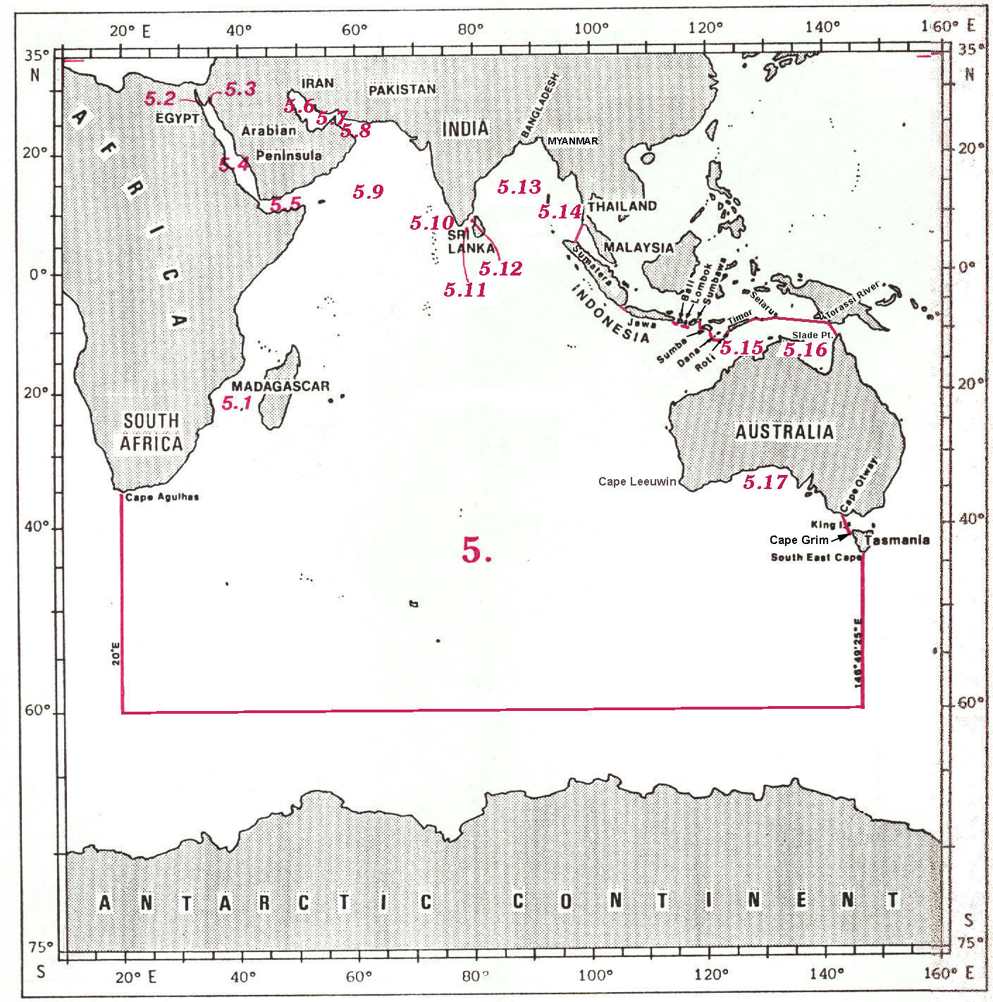
INDIAN OCEAN

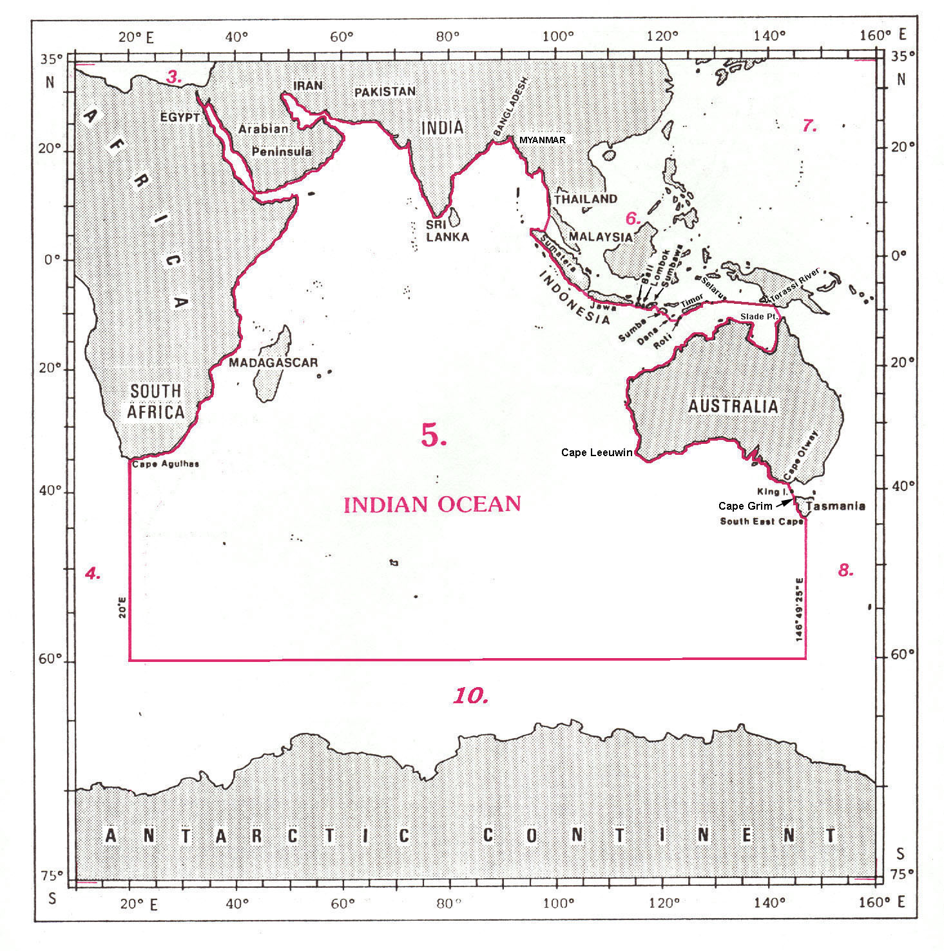

5. INDIAN OCEAN

The limits of the Indian Ocean are the following:

On the West and the North:
From Cape Agulhas (34°50’S - 20°00’E), the southern extremity of Africa, northward and eastward, along the eastern coast of Africa and the southern coast of Asia, to Lem1 Phra Chao (7°46’N - 98°19’E), on the western coast of Thailand.

On the Northeast and East:
From Lem Phra Chao southwestward, a line to Tanjung2 Jamboaye (5°15’N - 97°30’E), on the north western coast of Sumatera, (the common limit with the South China and Eastern Archipelagic Seas, see 6.)
thence from Tanjung1 Jamboaye northwestward, southwestward and southeastward along the north eastern, northern and southwestward coasts of Sumatera, to Tanjung Cukusaleman (5°57’S - 104°35’E), the southern extremity of this island;
thence from Tanjung Cukusaleman southwestward, a line to Tanjung Guha Kolak (6°50’S - 105°15’E), the southwestern extremity of Jawa;
thence from Tanjung Guha Kolak eastward, along the southern coast of Jawa, to Tanjung¹ Bantenan (8°46’S - 114°32’E), the southeastern extremity of this island;
thence from Tanjung Bantenan eastward, a line to the southern extremity of the Bukitbadung peninsula (8°51’S - 115°07’E), the southern point of Bali;
thence from the southern point of Bali eastward, a line to Tanjung Sedihing (8°49’S - 115°36’E), the south eastern extremity of Pulau2 Nusa Penida;
thence from Tanjung Sedihing eastward, a line to Tanjung Batu Gendang (8°50’S - 115°51’E), the southwestern extremity of Pulau Lombok;
thence from Tanjung Batu Gendang eastward, along the southern coast of Lombok, to Tanjung Ringgit (8°52’S - 116°36’E), an eastern extremity in the south of this island;
thence from Tanjung Ringgit southward, a line to Tanjung Mangkun (9°01’S - 116°44’E), the southwestern extremity of Pulau Sumbawa;
thence from Tanjung Mangkun eastward, along the southern coast of Sumbawa, to Tanjung Toro Doro (8°54’S - 118°30’E);
thence from Tanjung Toro Doro southward, a line to Tanjung Karosso (9°33’S - 118°56’E), the western extremity of Sumba;
thence from Tanjung Karosso southeastward, along the southern coast of Sumba, to Tanjung Ngunju (10°19’S - 120°27’E), the southern extremity of this island;
thence from Tanjung Ngunju southeastward, a line to Pulau Dana (10°50’S - 121°17’E);
thence from Pulau Dana eastward, a line to Tanjung Boa (10°56’S - 122°51’E), the southwestern extremity of Pulau Roti;
thence from Tanjung Boa northeastward, along the southeastern coast of Roti, to Tanjung Pukuatu (10°25’S - 123°22’E), the northern extremity of this island;
thence from Tanjung Pukuatu northeastward, a line to Tanjung Oisina (10°21’S - 123°27’E), the western extremity of Timor (the common limit with the Sawu Sea, see 6.13);
thence from Tanjung Oisina northeastward, along the southern coast of Timor, to Tanjung Sewirara (8°23’S - 127°17’E) the eastern extremity of this island;
thence from Tanjung Sewirara northeastward, a line to Tanjung Tut Pateh (8°13’S - 127°36’E), the western extremity of Pulau Leti;
thence from Tanjung Tut Pateh eastward, along the northern coast of Leti, to Tanjung Supurmela (8°12’S – 127°45’E), the eastern extremity of this island;
thence from Tanjung Supurmela northward, a line to Tanjung Yaulu (8°07’S – 127°46’E), the western extremity of Pulau Moa;
thence from Tanjung Yaulu eastward, along the northern and eastern coasts of Moa, to Moanga (8°12’S – 128°04’E), the northeastern extremity of this island;
thence from Moanga eastward, a line to the northwestern extremity of Pulau Lakor (8°12’S – 128°06’E);
thence from the northwestern extremity of Lakor eastward, along the northern coast of this island, to Tanjung Nyadora (8°16'S - 128°14'E), the southeastern extremity thereof;
thence from Tanjung Nyadora eastward, a line to the southern extremity of Pulau Meatij Miarang (8°20’S - 128°30’E);
thence from the southern extremity of Meatij Miarang eastward, a line to Tanjung Oftiau (8°21'S - 130°47'E), the southern extremity of Pulau Selaru (the common limit with the Banda Sea, see 6.15);
and thence from Tanjung Oftiau southeastward, a line to the mouth of the Torassi River (9°07'S – 141°01'E), on the southern coast of New Guinea.

On the East and South East:
From the mouth of the Torassi River southeastward, a line to Slade Point (10°59’S - 142°08’E), on the northern coast of Australia;
thence from Slade Point, southward, westward, northward, westward and generally southwestward, along the northern, north western and westerly coasts of Australia, to Cape Leeuwin (34°22’S - 115°08’E), the southwestern extremity of Australia;
thence from Cape Leeuwin eastward, along the southern coast of Australia, to Cape Otway (38°51’S - 143°31’E), the southern point of the western coast of the Australian State of Victoria;
thence from Cape Otway southward, a line to Cape Wickham (39°34’S - 143°57’E), the northern point of King Island;
thence from Cape Wickham southward, along the western coast of King Island, to Stokes Point (40°09’S - 143°55’E), the southern point of this island;
thence from Stokes Point southeastward, a line to Cape Grim (40°41’S - 144°41’E), on the northern part of the western coast of Tasmania;
thence from Cape Grim, generally southward and southeastward, along the western and southern coasts of Tasmania, to South East Cape (43°38’S - 146°49’E), the southern point of this island;
and thence from South East Cape southward, along the meridian of 146°49’E, to position 60°00'S – 146°19'E (the common limit with the South Pacific Ocean, see 8.)

On the South
From position 60°00’S - 146°49’E westward, along the parallel of 60°S, to position 60°00’S - 20°00’E (the meridian of Cape Agulhas) (the common limit with the Southern Ocean, see 10.)

On the SouthWest:
From position 60°00’S - 20°00’E northward, along the meridian of 20°E, to Cape Agulhas (34°50’S - 20°00’E), the point of commencement (the common limit with the South Atlantic Ocean, see 4.)

Note: See reservation by Australia in Appendix A.

MOZAMBIQUE CHANNEL

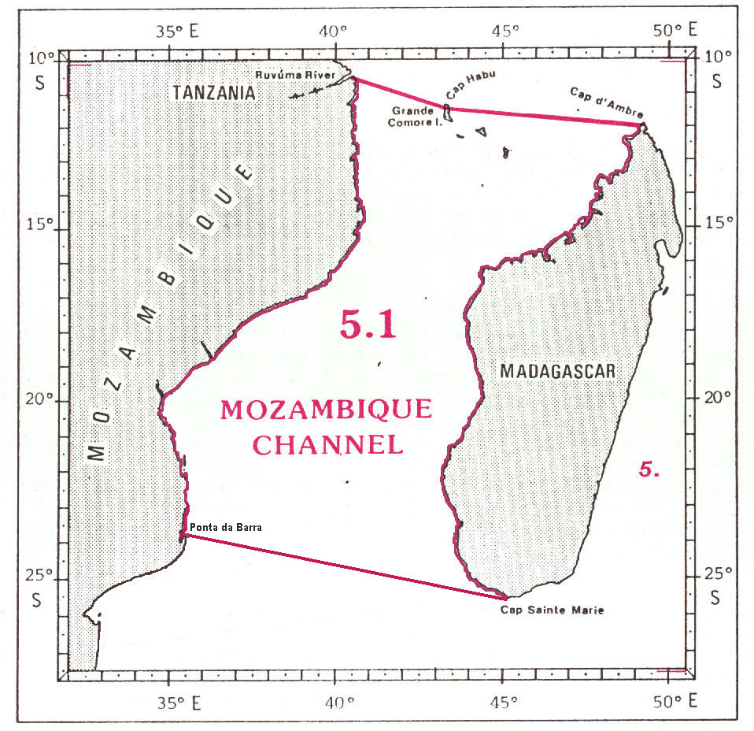

5.1 MOZAMBIQUE CHANNEL

The limits of the Mozambique Channel, the wide passage situated on the eastern coast of Africa between the coasts of Mozambique and Madagascar, are the following:

On the North:
A line joining the mouth of Ruvúma River (10°28’S - 40°26’E), the frontier between Tanzania and Mozambique, southeastward to Cap1 Habu (11°22’S - 43°23’E), on the northern coast of Grande Comore Island;
and thence from Cap Habu eastward, a line to Cap d’Ambre (11°57’S - 49°16’E), the northern extremity of Madagascar.

On the East:
From Cap d’Ambre southward, along the western coast of Madagascar, to Cap Sainte Marie (25°36’S - 45°09’E), the southern extremity of this island.

On the South:
A line joining Cap Sainte Marie westward to Ponta2 da Barra (23°47’S - 35°32’E), in Mozambique.

On the West:
From Ponta da Barra northward, along the coast of Mozambique, to the mouth of Ruvúma River (10°28’S - 40°26’E).

GULF OF SUEZ and GULF OF AQABA

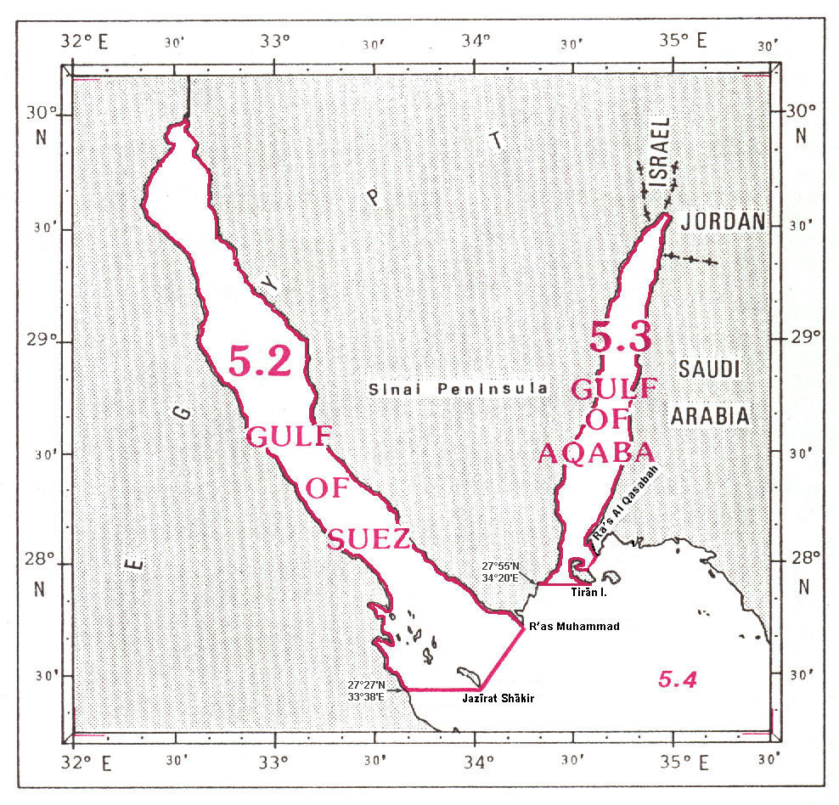

5.2 GULF OF SUEZ

The Gulf of Suez is situated northwestward and adjacent to the Red Sea, bounded by the coasts of Africa and Sinai Peninsula (Egypt). Its southern limit with the Red Sea (in the Strait of Gûbal) is the following:

A line joining R'as1 Muhammad (27°44’N - 34°15’E), the southern extremity of the Sinai Peninsula, southwestward to the southern point of Jazīrat Shākir (27°27’N - 34°02’E);
and thence from the southern point of Jazīrat Shākir westward, along the parallel of 27°27’N, to the coast of Africa, in Egypt at position 27°27'N - 33°38'E.

5.3 GULF OF AQABA

The Gulf of Aqaba is situated northeastward and adjacent to the Red Sea, bounded by the coasts of Sinai Peninsula and Arabian Peninsula. Its southern limit with the Red Sea (in the Strait of Tírán) is the following:

A line joining Ra's al Qaşabah (28°02’N - 34°37’E), in Saudi Arabia, southwestward to position 27°58’N – 34°35’E on the coast of Tirān Island;
thence from this position, generally westward and southeastward, along the northern, western and southern coasts of Tirān Island, to its southwestern extremity (27°55’N - 34°33’E);
and thence from the southwestern extremity of Tirān Island westward, along the parallel of 27°55’N, to the coast of Sinai Peninsula, in Egypt, at position 27°55' - 34°20'E.
RED SEA and GULF OF ADEN

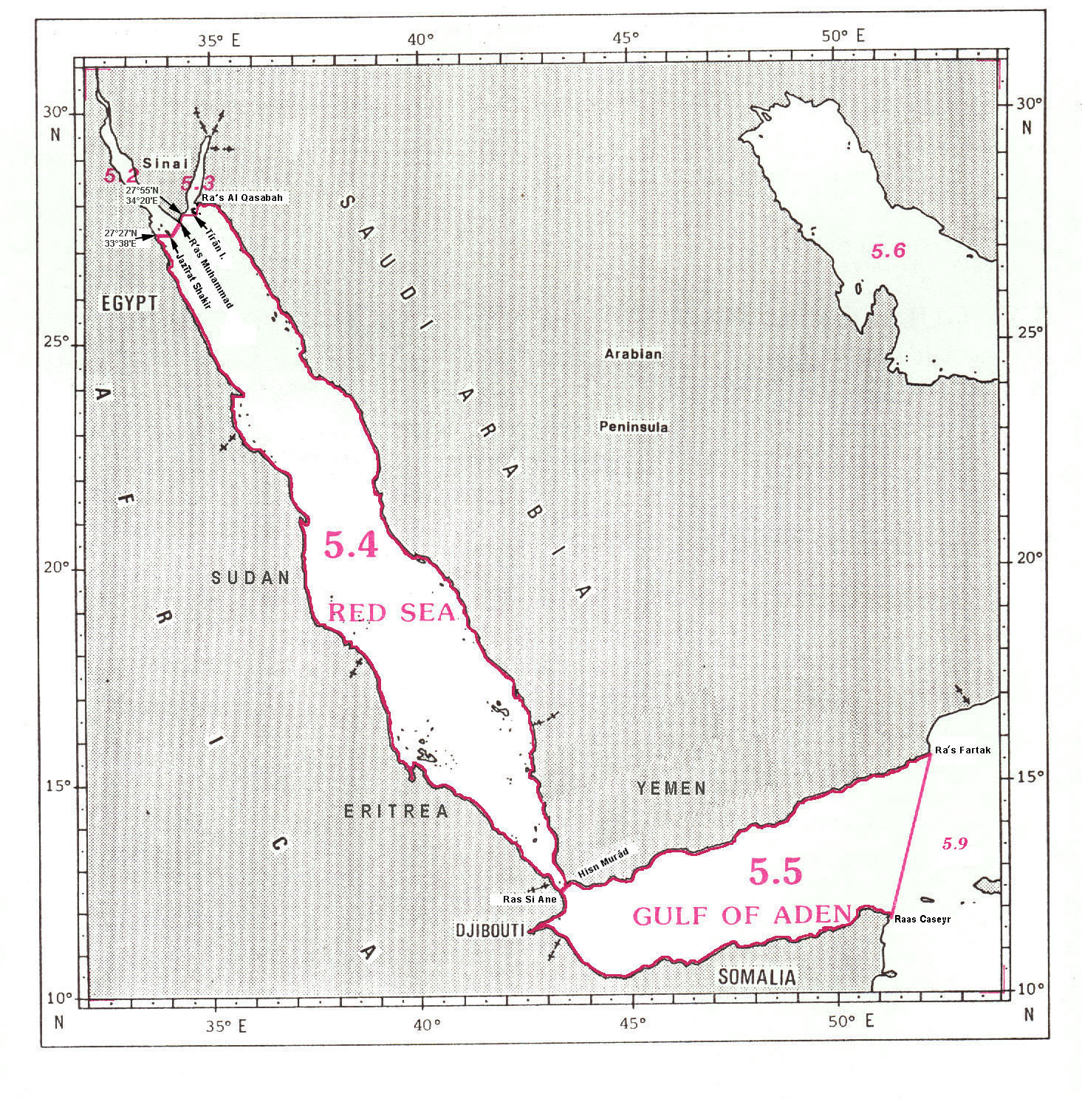
5.4 RED SEA

The limits of the Red Sea, situated between the coasts of Africa and the Arabian Peninsula, are the following:

On the North:
A line joining position 27°27'N - 33°38'E on the coast of Africa, in Egypt, eastward, along the parallel of 27°27’N, to the southern extremity of Jazīrat Shākir (27°27’N - 34°02’E);
thence from the southern extremity of Jazīrat Shākir northeastward, a line to Ras1 Muhammad (27°44’N - 34°15’E), the southern extremity of the Sinai Peninsula (the common limit with the Gulf of Suez, see 5.2);
thence from Ras Muhammad northeastward, along the southern coast of the Sinai Peninsula, to position 27°55’N - 34°20'E;
thence from this position eastward, along the parallel of 27°55’N, to the southwestern extremity of Tirān Island (27°55’N - 34°33’E);
thence from the southwestern extremity of Tírān Island, generally northwestward, along the eastern coast of this island, to position 27°58’N - 34°35’E, on the northeastern coast thereof;
and thence a line joining this position northeastward to Ra's al Qaşabah (28°02’N - 34°37’E), in Saudi Arabia (the common limit with the Gulf of Aqaba, see 5.3).

On the East:
From Ra's al Qaşabah southeastward, along the coast of the Arabian Peninsula, to Hisn2 Murád (12°40’N - 43°30’E), on the southern coast of Yemen.

On the South:
A line joining Hisn Murád southwestward to Ras Si Ane (12°29’N - 43°19’E), in Djibouti (the common limit with the Gulf of Aden, see 5.5).

On the West:
From Ras Si Ane northwestward, along the coast of Africa, to position 27°27'N - 33°38'E, in Egypt.

5.5 GULF OF ADEN

The limits of the Gulf of Aden, a wide strait linking the Red Sea and the Arabian Sea, are the following:

On the North:
From Hisn Murad (12°40’N - 43°30’E) eastward, along the southern coast of Yemen, to Ras¹ Fartak (15°38’N - 52°14’E).

On the East:
A line joining Ras Fartak southwestward to Ras Caseyr (11°50’N - 51°17’E), in Somalia (the common limit with the Arabian Sea, see 5.9).

On the South and the West:
From Ras Caseyr westward and northward, along the coasts of Somalia and Djibouti, to Ras¹ Si Ane (12°29’N - 43°19’E), in Djibouti.

On the Northwest:
A line joining Ras Si Ane northeastward to Hisn Murad (12°40’N - 43°30’E), in Yemen (the common limit with the Red Sea, see 5.4).
PERSIAN GULF, STRAIT OF HORMUZ, GULF OF OMAN and ARABIAN SEA

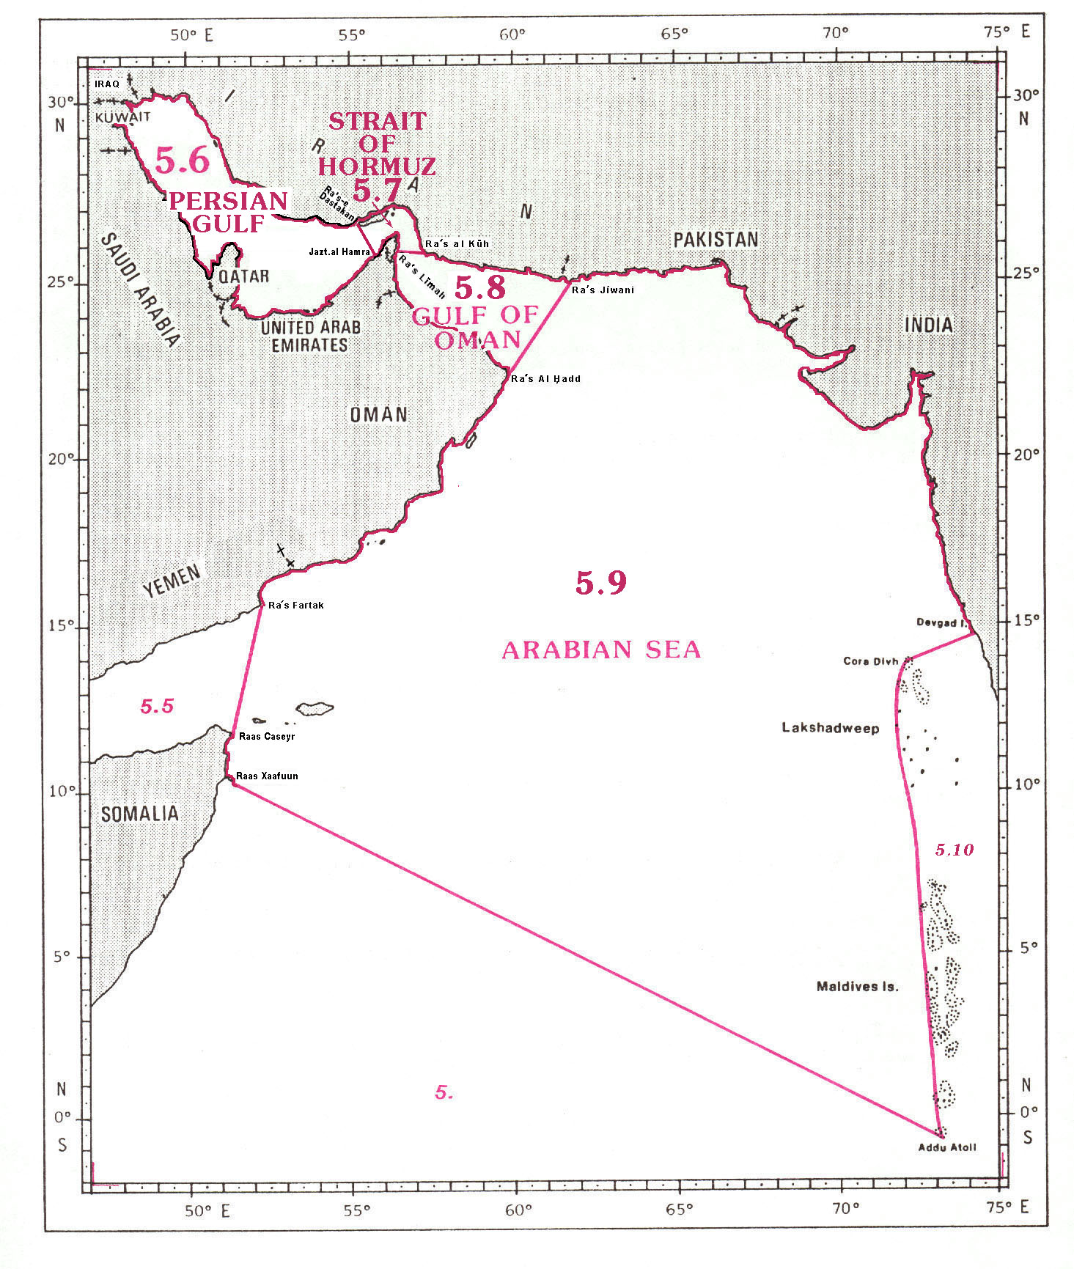

5.6 PERSIAN GULF

The Persian Gulf is bounded by the coasts of Oman, United Arab Emirates, Qatar, Saudi Arabia, Kuwait, Iraq and Iran. Its southeastern limit with the Strait of Hormuz is the following:

A line joining Ra's1-e Dastakan (26°33'N – 55°17'E) in Iran, southward to Jaztal Hamra lighthouse (25°44'N – 55°48'E), in the United Arab Emirates (the common limit with the Strait of Hormuz, see 5.7).

5.7 STRAIT OF HORMUZ

The Strait of Hormuz links the Persian Gulf with the Gulf of Oman, lying between Iran and Oman. It has the following limits:

On the West:
A line joining Ra's-e Dastakan (26°33'N – 55°17'E) in Iran, southward to Jaztal Hamra lighthouse (25°44'N – 55°48'E), in the United Arab Emirates (the common limit with the Persian Gulf, see 5.6).

On the East:
A line joining Ra's Līmah (25°27'N – 56°28'E), in Oman, eastward to Ra's al Kūh (25°48'N – 57°18'E), in Iran (the common limit with the Arabian Sea, see 5.9).

5.8 GULF OF OMAN

The limits of the Gulf of Oman, a wide strait linking the Persian Gulf and the Arabian Sea, are the following:

On the North:
A line joining Ra's Līmah (25°57’N - 56°28’E), in Oman, eastward to Ra’s al Kūh (25°48’N - 57°18’E), in Iran (the common limit with the Strait of Hormuz, see 5.7)
and thence from Ra's al Kūh eastward, along the coasts of Iran and Pakistan, to Ra’s Jíwani (25°01’N - 61°44’E), in Pakistan.

On the East:
A line joining Ra’s Jíwani southwestward to Ra’s al H,add (22°32'N – 59°48'E), in Oman (the common limit with the Arabian Sea, see 5.9).

On the South and the West:
From Ra’s al H,add northwestward, along the coasts of Oman and the United Arab Emirates, to Ra’s
Līmah (25°57’N - 56°28’E), in Oman.

5.9 ARABIAN SEA

The limits of the Arabian Sea, situated in the northern part of the Indian Ocean, are the following:

On the North and the East:
From Ra’s Jíwani (25°01’N - 61°44’E), in Pakistan, eastward and southward, along the coasts of Pakistan and India, to Devgad Island (14°49’N - 74°04’E), off the western coast of India;
thence from Devgad Island southwestward, a line to Cora Divh (13°42’N - 72°10’E);
and thence from Cora Divh southward, along the western side of the Lakshadweep and Maldives Islands, to the southern extremity of Addu Atoll (0°42’S - 73°10’E) (the common limit with the Lakshadweep Sea, see 5.10).

On the South:
A line joining the southern extremity of Addu Atoll, in the Maldives Islands, northwestward to Raas Xaafuun (10°26’N - 51°25’E), in Somalia.

On the West:
From Raas Xaafuun northward, along the coast of Somalia, to Raas Caseyr (11°50’N - 51°17’E);
thence from Raas Caseyr northeastward, a line to Ra’s Fartak (15°38’N - 52°14’E), in Yemen (the common limit with the Gulf of Aden, see 5.5).;
thence from Ra’s Fartak northeastward, along the coasts of Yemen and Oman, to Ra’s al H,add(22°32’N - 59°48’E), in Oman;
and thence from Ra’s al H,add, northeastward, a line to Ra’s Jíwani (25°01'N– 61°44'E), in Pakistan (the common limit with the Gulf of Oman, see 5.7).
LAKSHADWEEP SEA, GULF OF MANNAR,
PALK STRAIT and PALK BAY

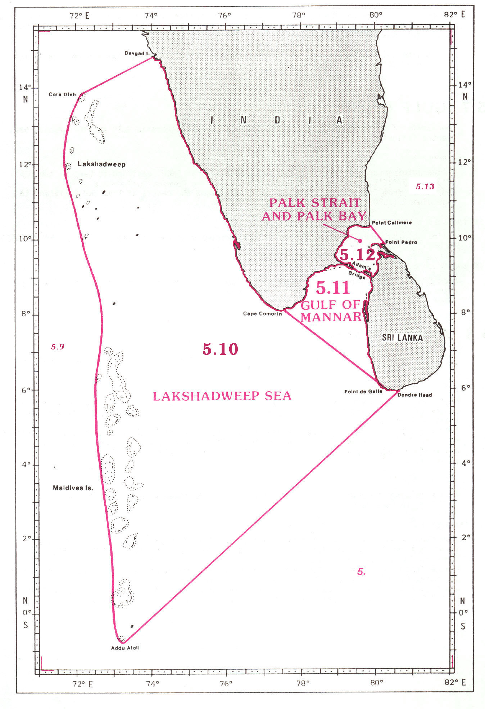

5.10 LAKSHADWEEP SEA

The limits of the Lakshadweep Sea, bounded by the Lakshadweep and Maldives Islands on the West, and by the southwestern coasts of India and Sri Lanka on the East, are the following:

On the West:
A line joining Devgad Island (14°49’N - 74°04’E), off the western coast of India, southwestward to Cora Divh (13°42’N - 72°10’E);
and thence from Cora Divh southward, along the western side of Lakshadweep and Maldives Islands, to the southern extremity of Addu Atoll (0°42’S - 73°10’E) (the common limit with the Arabian Sea, see 5.9).

On the South:
A line joining the southern extremity of Addu Atoll northeastward to Dondra Head (5°55’N - 80°35’E), the southern extremity of Sri Lanka.

On the East:
From Dondra Head northwestward, along the southwestern coast of Sri Lanka, to Point de Galle (6°02’N - 80°13’E);
thence from Point de Galle northwestward, a line to Cape Comorin (8°05’N - 77°33’E), the southern extremity of India (the common limit with the Gulf of Mannar, see 5.11);
and thence from Cape Comorin northwestward, along the western coast of India, to Devgad Island (14°49’N - 74°04’E).

5.11 GULF OF MANNAR

The Gulf of Mannar is situated eastward and adjacent to the Lakshadweep Sea and is bounded by the coast of India on the northwest and by the coast of Sri Lanka on the East. It has the following limit:

On the North:
From Cape Comorin (8°05'N – 77°33'E), the southern point of India, northeastward, along the coast of India, to the westward end of Adam's Bridge (9°10'N – 79°26'E).

On the East:
From the westward end of Adam's Bridge, along the southern side of the Bridge to position 9°06'N – 79°42'E, on the northwest coast of Sri Lanka;
and thence from this position southward, along the western coast of Sri Lanka, to Point de Galle (6°02'N – 80°13'E) (the common limit with Palk Strait and Palk Bay, see 5.12).

On the West:
From Point de Galle, in Sri Lanka, northwestward to Cape Comorin (8°05'N – 77°33'E), in India (the common limit with the Lakshadweep Sea, see 5.10).

5.12 PALK STRAIT AND PALK BAY

The Palk Strait and Palk Bay are situated southwestward and adjacent to the Bay of Bengal and are bounded by the coast of India on the northwest and by the northwestern coast of Sri Lanka on the southeast. It has the following limits:

On the South:
From Point Pedro (9°50'N – 80°15'E), the northern extremity of Sri Lanka, generally southwestward, along the northern coast of Sri Lanka, to position 9°06'N – 79°42'E;
and thence from this position, along the northern side of Adam's Bridge, to position 9°10'N – 79°26'E, the westward end thereof (the common limit with the Gulf of Mannar, see 5.11).

On the North:
From the westward end of Adam's Bridge northeastward, along the coast of India, to Point Calimere (10°18'N – 79°53'E);
and thence from Point Calimere southeastward, a line to Point Pedro (9°50'N – 80°15'E), the northern extremity of Sri Lanka (the common limit with the Bay of Bengal, see 5.13).

BAY OF BENGAL

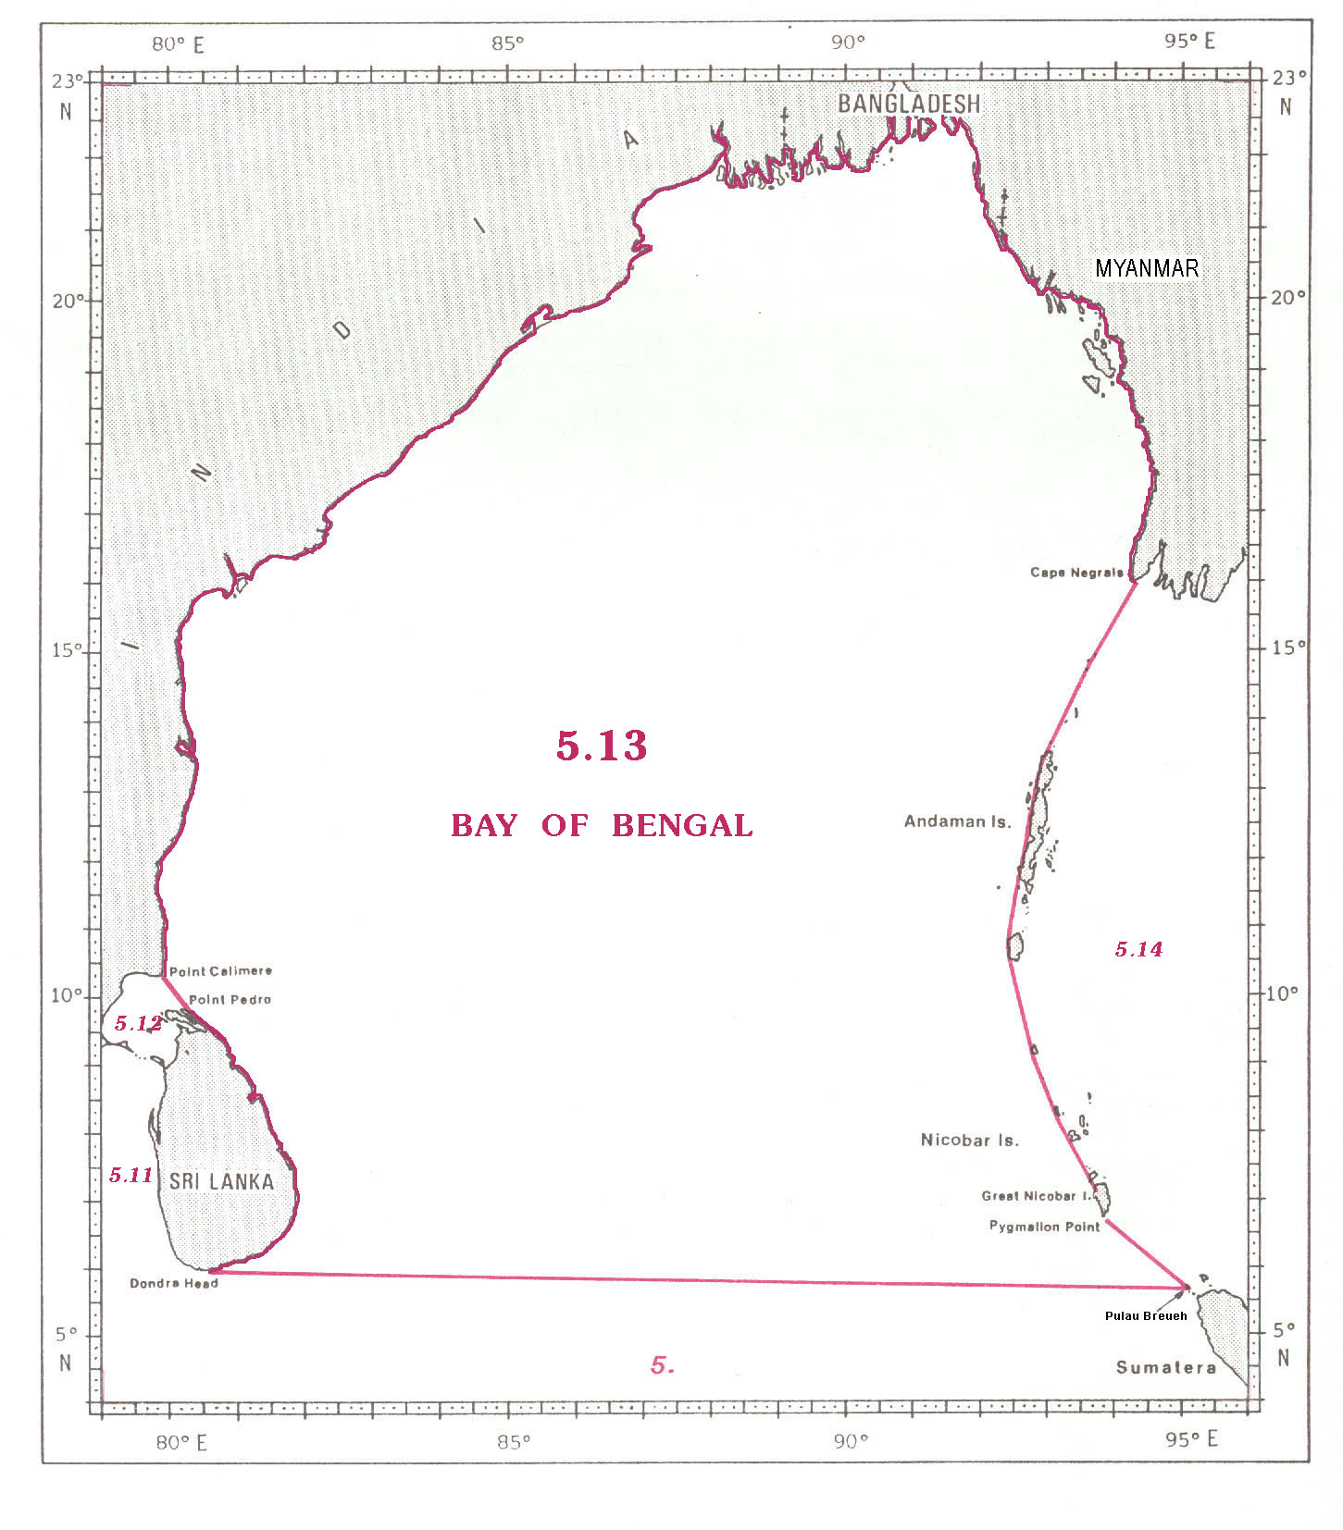
5.13 BAY OF BENGAL

The limits of the Bay of Bengal, situated in the northern part of the Indian Ocean, between the coasts of Sri Lanka, India, Bangladesh, Myanmar and the western side of Andaman and Nicobar Islands, are the following:

On the West and the North
From Dondra Head (5°55’N - 80°35’E), the southern extremity of Sri Lanka, northward, along the eastern coast of this island, to Point Pedro (9°50’N - 80°15’E), the northern extremity thereof;
thence from Point Pedro northwestward, a line to Point Calimere (10°18’N - 79°53’E), on the coast of India (the common limit with the Palk Strait and Palk Bay, see 5.12);
and thence from Point Calimere, in India, along the coasts of India, Bangladesh and Myanmar, to Cape Negrais (16°03’N - 94°12’E), in Myanmar.

On the East:
A line joining Cape Negrais, in Myanmar, southward, along the western coasts of the Andaman and Nicobar Island, to Pygmalion Point (6°45’N - 93°50’E), the southern extremity of Great Nicobar Island - in such a way that all the narrow waters between these islands lie to the eastward and are therefore excluded from the Bay of Bengal;
and thence from Pygmalion Point southeastward, a line to the northern extremity of Pulau1 Breueh (5°45’N - 95°02’E), off the northwestern extremity of Sumatera (the common limit with the Andaman Sea, see 5.14).

On the South:
A line joining the northern extremity of Pulau Breueh westward to Dondra Head (5°55’N - 80°35’E), the southern extremity of Sri Lanka.
ANDAMAN SEA

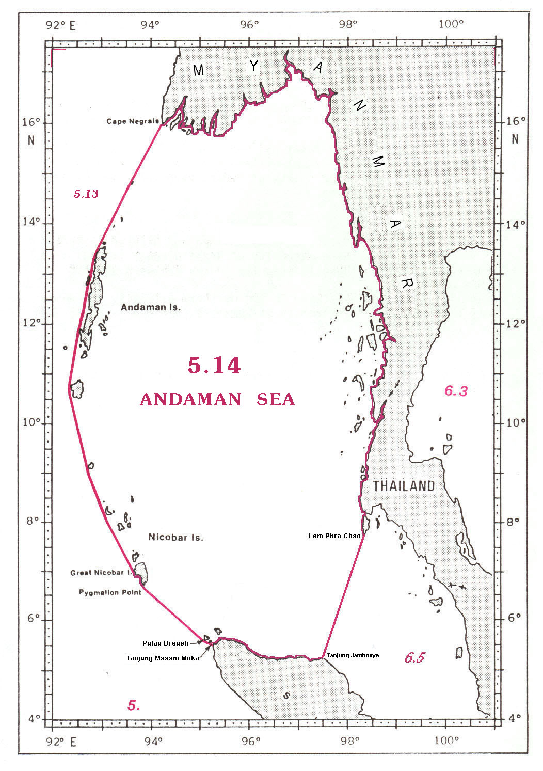

5.14 ANDAMAN SEA

The limits of the Andaman Sea, situated between the Andaman and Nicobar Islands and the coasts of Myanmar and Thailand, are the following:

On the North and the East:
From Cape Negrais (16°03’N - 94°12’E), in Myanmar, eastward and southward, along the coasts of Myanmar and Thailand, to Lem1 Phra Chao (7°46’N - 98°19’E), on the western coast of Thailand.

On the South:
A line joining Lem Phra Chao southwestward to Tanjung2 Jamboaye (5°15’W – 97°30’E) on the north eastern coast of Sumatera (the common limit with the Malacca Strait, see 6.5);
thence from Tanjung Jamboaye northwestward, along the northern coast of Sumatera, to Tanjung Masam Muka (5°35’N - 95°14’E);
and thence from Tanjung Masam Muka northwestward, a line to the northern extremity of Pulau3 Breueh (5°45’N - 95°02’E), off the northwestern coast of Sumatera.

On the West
A line joining the northern extremity of Pulau Breueh northwestward to Pygmalion Point (6°45’N - 93°50’E), the southern extremity of Great Nicobar Island;
and thence from Pygmalion Point northward, along the western coasts of the Nicobar and Andaman Islands, to Cape Negrais (16°03’N - 94°12’E), on the coast of Myanmar - in such a way that all the narrow waters between these islands are included in the Andaman Sea (the common limit with the Bay of Bengal, see 5.13).

TIMOR SEA and JOSEPH BONAPARTE GULF

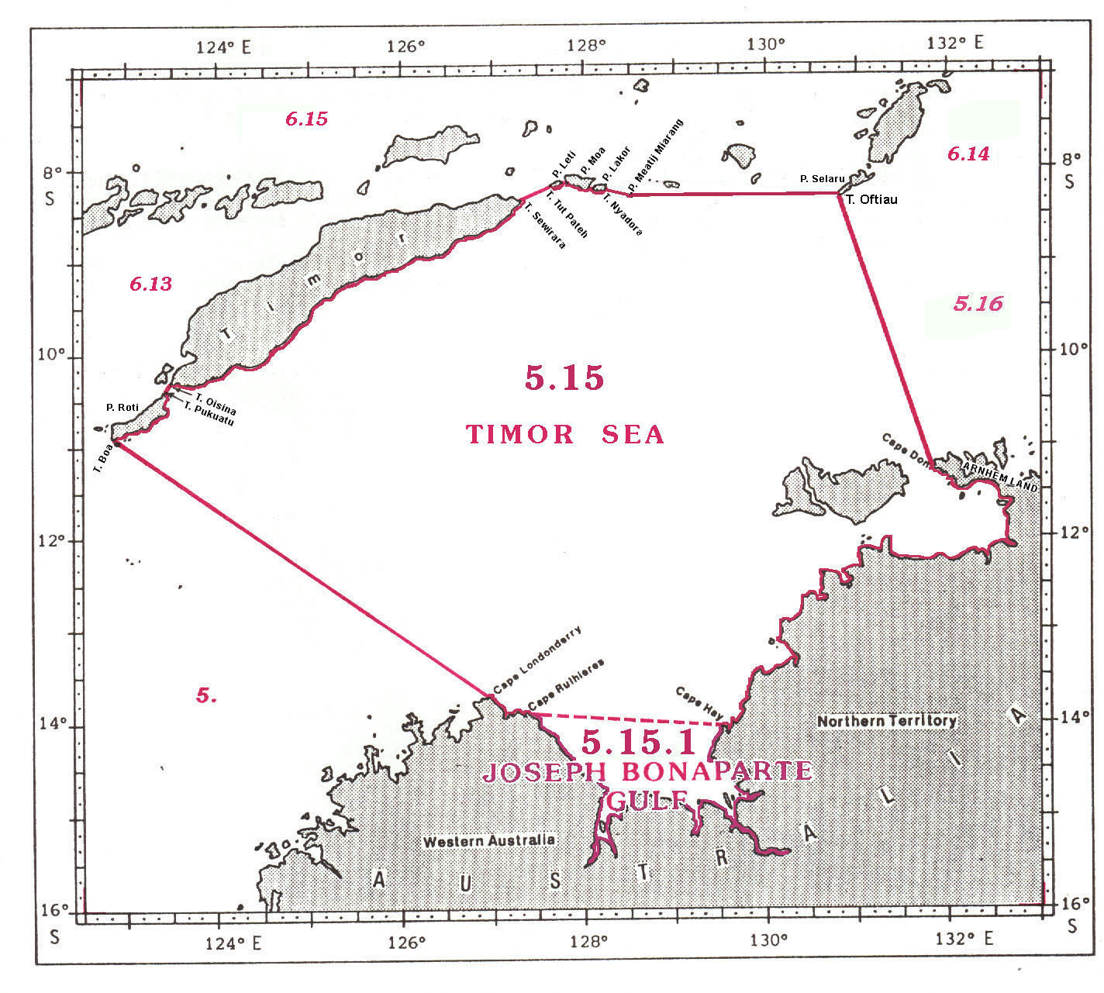

5.15 TIMOR SEA

The limits of the Timor Sea, a component of the Indian Ocean situated between the north west coast of Australia and Timor, are as follows:

On the West:
From the north east part of Cape Londonderry (13°44’S - 126°57’E) on the northwestern coast of Australia, a line northwestward to Tanjung1 Boa (10°56’S - 122°51’E), the southwestern extremity of Pulau2 Roti;

On the North:
From Tanjung Boa northeastward, along the southeastern coast of Roti, to Tanjung Pukuatu (10°25’S - 123°22’E), the northern extremity of this island;
thence from Tanjung Pukuatu northeastward, a line to Tanjung Oisina (10°21’S - 123°27’E), the western extremity of Timor (the common limit with the Sawu Sea, see 6.13);
thence from Tanjung Oisina northeastward, along the southern coast of Timor, to Tanjung Sewirara (8°23’S - 127°17’E), the eastern extremity of this island;

thence from Tanjung Sewirara northeastward, a line to Tanjung Tut Pateh (8°13’S - 127°36’E), the western extremity of Pulau Leti;
thence from Tanjung Tut Pateh eastward, along the northern coast of Leti, to Tanjung Supurmela (8°12’S – 127°45’E), the eastern extremity of this island;
thence from Tanjung Supurmela northward, a line to Tanjung Yaulu (8°07’S – 127°46’E), the western extremity of Pulau Moa;
thence from Tanjung Yaulu eastward, along the northern and eastern coasts of Moa, to Moanga (8°12’S – 128°04’E), the northeastern extremity of this island;
thence from Moanga eastward, a line to the northwestern extremity of Pulau Lakor (8°12’S – 128°06’E);
thence from the northwestern extremity of Lakor eastward, along the northern coast of this island, to Tanjung Nyadora (8°16'S - 128°14'E), the southeastern extremity thereof;
thence from Tanjung Nyadora eastward, a line to the southern extremity of Pulau Meatij Miarang (8°20’S - 128°30’E);
and thence from the southern extremity of Meatij Miarang eastward, a line to Tanjung Oftiau (8°21'S - 130°47'E), the southern extremity of Pulau Selaru (the common limit with the Banda Sea, see 6.15).

On the East:
From Tanjung Oftiau southward, a line to Cape Don (11°18’S - 131°45’E) on the northern coast of Australia, the western extremity of the Arnhem Land coast of north Australia

On the South:
From Cape Don generally southwestward, along part of the northern coast of Australia, to Cape Hay (14°03’S - 129°28’E);
thence from Cape Hay northwestward, a line to Cape Rulhieres (13°55’S - 127°81’E) (the common limit with Joseph Bonaparte Gulf, see 5.15.1);
and thence from Cape Rulhieres northwestward, along the northwest coast of Australia, to Cape Londonderry (13°44’S - 126°57’E).

5.15.1 JOSEPH BONAPARTE GULF

The limits of Joseph Bonaparte Gulf, an indentation of the Timor Sea into the north western coast of Australia, are as follows:

On the North:
From Cape Rulhieres (13°55’S - 127°21’E) southeastward, a line to Cape Hay (14°03’S - 129°29’E).

On the South:
From Cape Hay southwestward, westward and northwestward, along the coast of Australia, including the estuarine waters of Victoria River, other rivers and Cambridge Gulf, to Cape Rulhieres (13°55’S - 127°21’E).
GULF OF CARPENTARIA and ARAFURA SEA

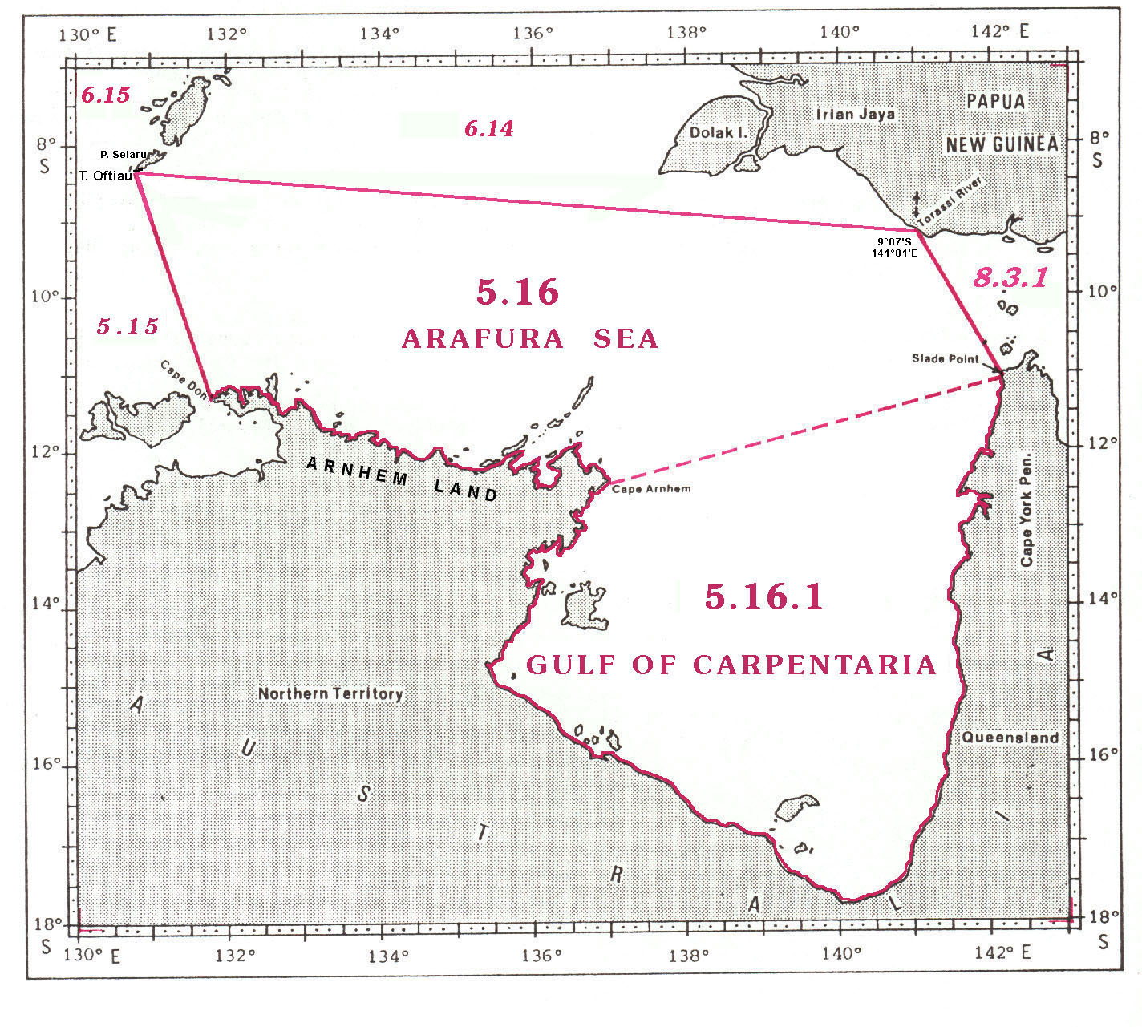
5.16 ARAFURA SEA

The limits of the Arafura Sea, a component of the Indian Ocean lying between the south western part of New Guinea and the northern coast of Australia, are as follows:

On the West:
From Cape Don (11°18’S - 131°45’E), the western extremity of the Arnhem Land coast of north Australia, a line northwestward to Tanjung1 Oftiau (8°21'S - 130°47'E), the southern extremity of Pulau Selaru.

On the North:
From Tanjung Oftiau southeastward, a line to the mouth of the Torassi River (9°08’S - 141°01’E), the frontier between Irian Jaya (Indonesia) and Papua New Guinea, on the southern coast of New Guinea.

On the East:
From the mouth of the Torassi River, on the south coast of New Guinea, a line southeastward to Slade Point (10°59’S - 142°08’E), on the coast of Australia (the common limits with the South Pacific Ocean, see 8.)

On the south:
From Slade Point southwestward, a line to Cape Arnhem (12°21’S - 136°59’E), the eastern extremity of Arnhem Land coast of north Australia;
and thence from Cape Arnhem, along the northern coast of Australia, to Cape Don (11°18’S - 131°45’E).

5.16.1 GULF OF CARPENTARIA

The limits of the Gulf of Carpentaria, a large indentation of the Arafura Sea into the northern coast of Australia are as follows:

On the North:
From Cape Arnhem (12°20’S - 136°58’E), the eastern extremity of Arnhem Land, a line northeastward to Slade Point (10°58’S - 142°07’E), adjacent to the northern extremity of Australia.

On the South:
From Slade Point southward, northwestward and northward, along the north coast of Australia, to Cape Arnhem (12°20’S - 136°58’E).
GREAT AUSTRALIAN BIGHT

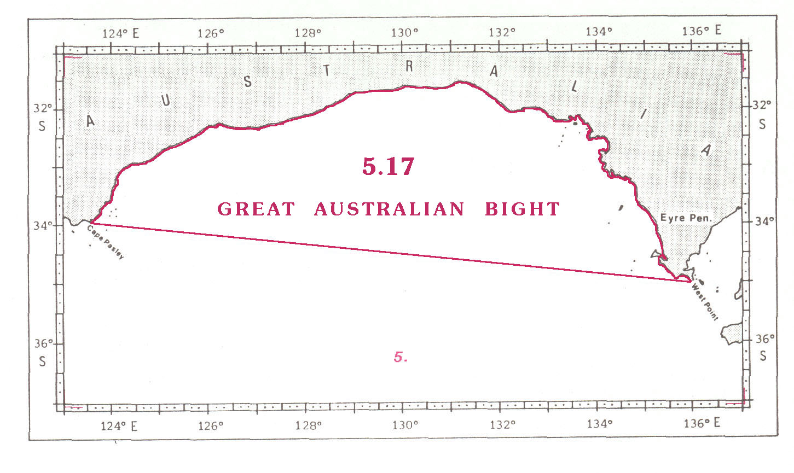

5.17 GREAT AUSTRALIAN BIGHT

The limits of the Great Australian Bight, a component of the Indian Ocean and situated on the southern coast of Australia, are:

On the South:
From Cape Pasley (33°56'S – 123°30'E), on the eastern part of the southwestern coast of Australia, eastward, along the southern coast of Australia, to West Point (35°00'S – 135°56'E), the southeastern extremity of the Eyre Peninsula.

On the North:
From West Point northwestward, a line to Cape Pasley (33°56'S – 123°30'E).

__________

Page intentionally left blank

1 Lem (Thai) = Cape
2 Tanjung (Indonesian) = Cape, Point
1 Tanjung (Indonesian) = Cape, Point
2 Pulau (Malaysian) = Island
1 Cap (French) = Cape
2 Ponta (Portuguese) = Point
1 Ras (Arabic) = Cape
1 Ras (Arabic) = Cape
2 Hisn (Arabic) = Fort
1 Ras (Arabic, Pakistani) = Cape
1 Pulau (Indonesian) = Island
1 Lem (Thai) = Cap
2 Tanjung (Indonesian) = Point, Cape
3 Pulau (Indonesian) = Island
1 Tanjung (Indonesian) = Cape, Point
2 Pulau (Indonesian) = Island
1 Tanjung (Indonesian) = Cape

