INTERNATIONAL HYDROGRAPHIC  ORGANIZATION | INTERGOVERNMENTAL OCEANOGRAPHIC  COMMISSION (of UNESCO)

UNDERSEA FEATURE NAME PROPOSAL
(Sea NOTE overleaf)

Note: The boxes will expand as you fill the form.
Name Proposed: | Jugoya Ridge | Ocean or Sea: | Northwest Pacific Ocean

Geometry that best defines the feature (Yes/No) :
Point | Line | Polygon | Multiple points | Multiple lines* | Multiple polygons* | Combination of geometries*
 |  | Yes
* Geometry should be clearly distinguished when providing the coordinates below.
 | Lat. (e.g. 63°32.6’N) | Long. (e.g. 046°21.3’W)
Coordinates: | 23°10.91’N  23°11.76’N  23°15.70’N  23°18.96’N  23°18.02’N  23°15.02’N  23°12.96’N  23°10.91’N | 136°10.41’E  136°02.11’E  135°59.36’E  136°03.05’E  136°16.32’E  136°20.69’E  136°18.04’E  136°10.41’E

Feature Description: | Maximum Depth : | 5456 m | Steepness :
Feature Description: | Minimum Depth : | 3794 m | Shape :
Feature Description: | Total Relief : | 1482 m | Dimension/Size : | 15 km×44 km

Associated Features:

Chart/Map References: | Shown Named on Map/Chart: | 6722
Chart/Map References: | Shown Unnamed on Map/Chart:
Chart/Map References: | Within Area of Map/Chart:

Reason for Choice of Name (if a person, state how associated with the feature to be named): | Jugoya is the one of the traditional Japanese names of “full moon night”, or “the fitteenth night of lunar month”. This part of the Kyushu-Palau Ridge has several undersea features that have names relevant to moon in Japanese.

Discovery Facts: | Discovery Date: | Feb. and Mar. 2003
Discovery Facts: | Discoverer (Individual, Ship): | The Japanese survey vessel “Takuyo”

Supporting Survey Data, including Track Controls: | Date of Survey: | Feb. and Mar. 2003, May. and Jun. 2004
Supporting Survey Data, including Track Controls: | Survey Ship: | The Japanese survey vessel “Takuyo” and “Shoyo”
Supporting Survey Data, including Track Controls: | Sounding Equipement: | Multibeam echo sounder  Seabeam 2112
Supporting Survey Data, including Track Controls: | Type of Navigation: | GPS without Selective Availability
Supporting Survey Data, including Track Controls: | Estimated Horizontal Accuracy (nm): | 0.014 nm (26 m)
Supporting Survey Data, including Track Controls: | Survey Track Spacing: | 8 nm
Supporting Survey Data, including Track Controls: | Supporting material can be submitted as Annex in analog or digital form.

Proposer(s): | Name(s): | JCUFN
Proposer(s): | Date: | Sep. 10, 2015
Proposer(s): | E-mail: | ico@jodc.go.jp
Proposer(s): | Organization and Address: | Hydrographic and Oceanographic Department, Japan Coast Guard  Aomi 2-5-18,Koto-ku,Tokyo 135-0064, Japan
Proposer(s): | Concurrer (name, e-mail, organization and address):

Remarks: | The undersea features that have names relevant to moon in Japanese are (except Jugoya Ridge):  - Mikazuki Seamount (= “Cresent moon”) (note that the shape of the feature looks like cresent moon)  - Kita-Mikazuki Seamount (= “North” Cresent moon)  - Higashi-Mikzauki Seamout (= “East” Cresent moon)  - Hangetsu Ridge (= “Half moon”)  - Jogen Basin (= “Waxing moon”)  - Kagen Basin (= “Waning moon”)  - Zangetsu Seamount (= “Moon remaining in the sky after sunrise”)  - Izayoi Seamount (= “Sixteenth nigh of lunar month”)  - Mangetsu Basin (“Full moon”)  See Fig. 4 for these names.

NOTE : This form should be forwarded, when completed :

a) If the undersea feature is located inside the external limit of the territorial sea :-
to your "National Authority for Approval of Undersea Feature Names" (see page 2-9) or, if this does not exist or is not known, either to the IHB or to the IOC (see addresses below);

b) If at least 50 % of the undersea feature is located outside the external limits of the territorial sea :-
to the IHB or to the IOC, at the following addresses :

International Hydrographic Bureau (IHB)  4, Quai Antoine 1er  B.P. 445  MC 98011 MONACO CEDEX  Principality of MONACO  Fax: +377 93 10 81 40  E-mail: info@ihb.mc | Intergovernmental Oceanographic Commission (IOC)  UNESCO  Place de Fontenoy  75700 PARIS  France  Fax: +33 1 45 68 58 12  E-mail: info@unesco.org

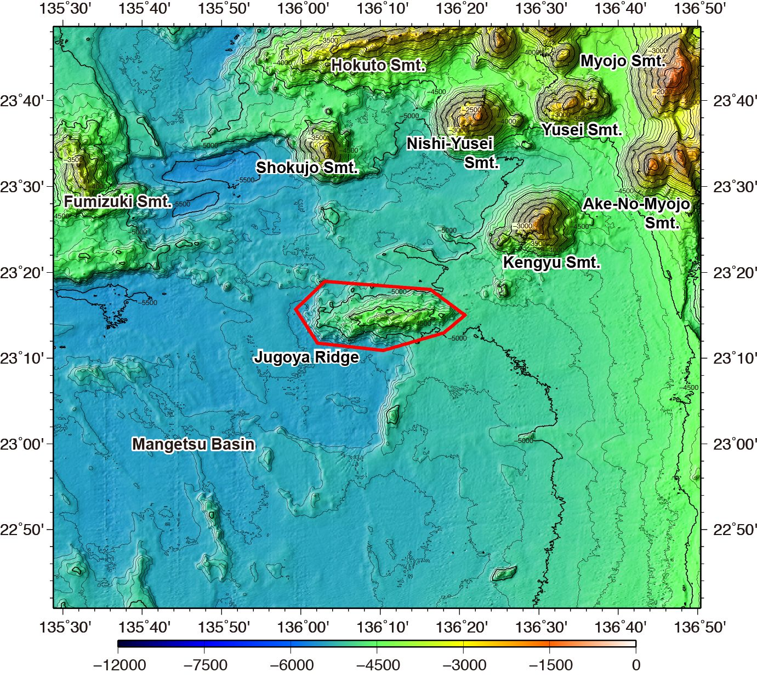

Fig. 1. Bathymetric map of the Jugoya Ridge. Contours are in 100 m.
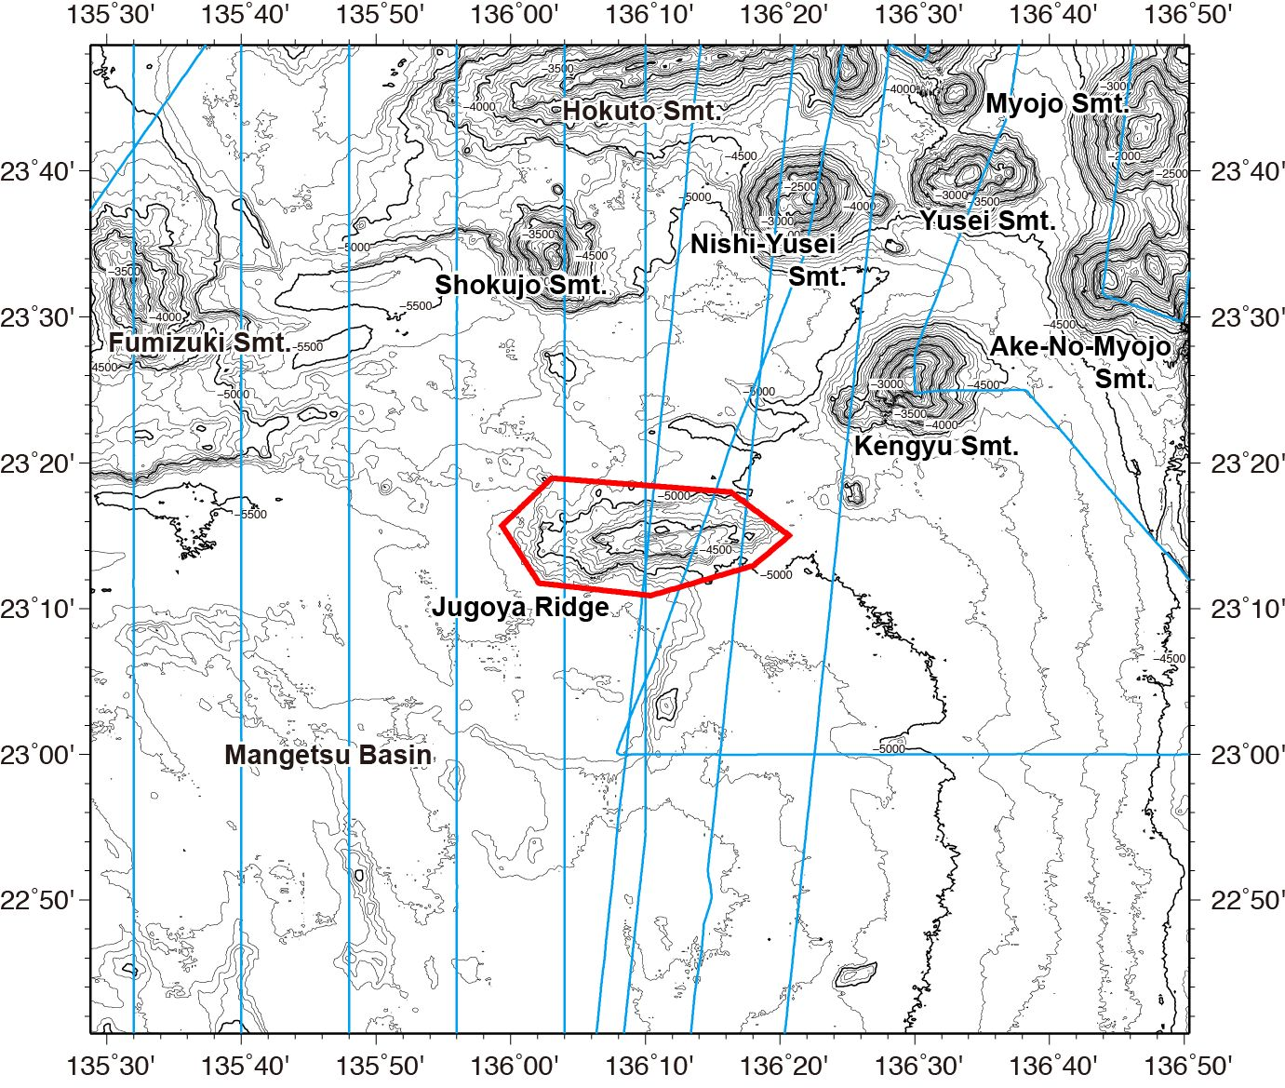

Fig. 2. Bathymetric map of the Jugoya Ridge, showing with track lines. Contours are in 100 m.
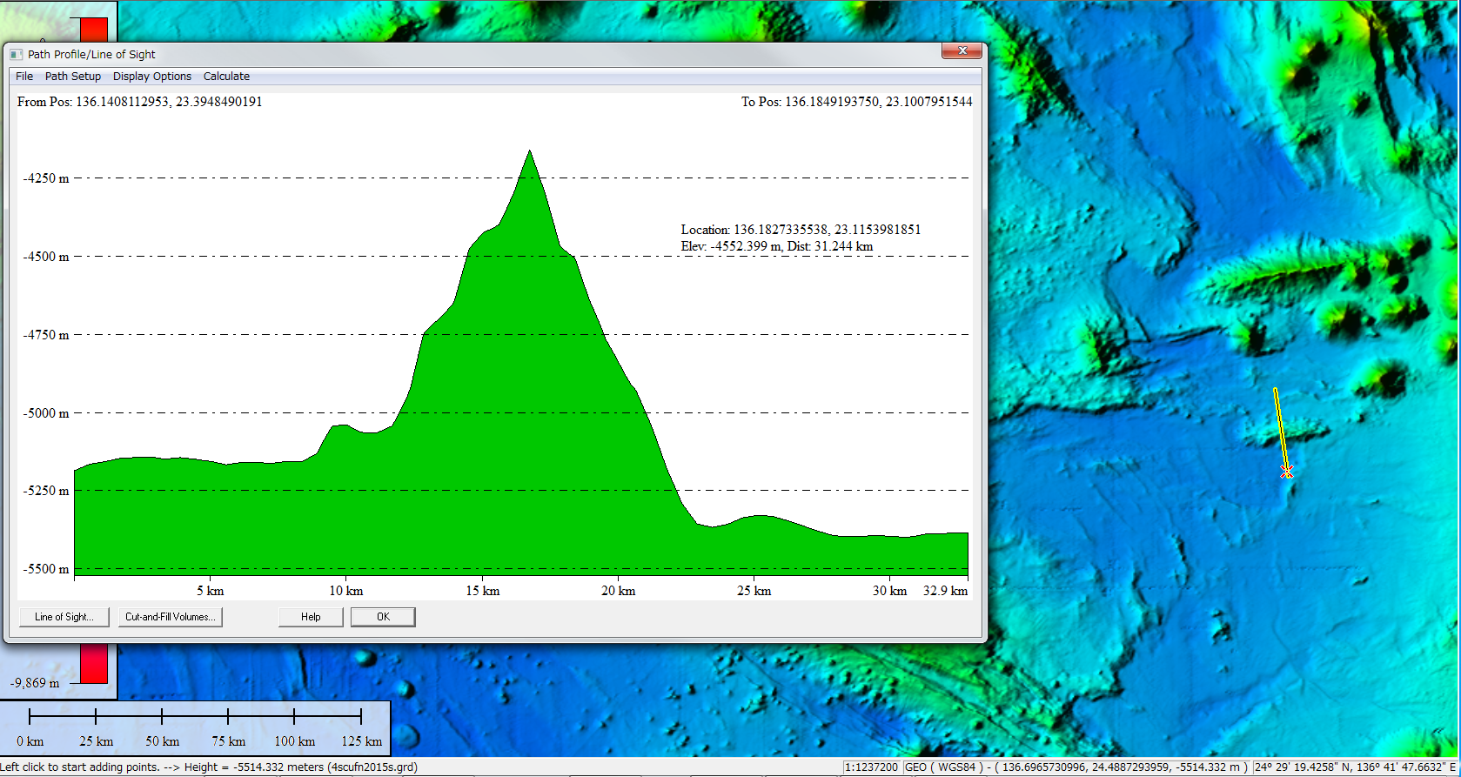

Fig. 3. Bathymetric profile across the Jugoya Ridge.

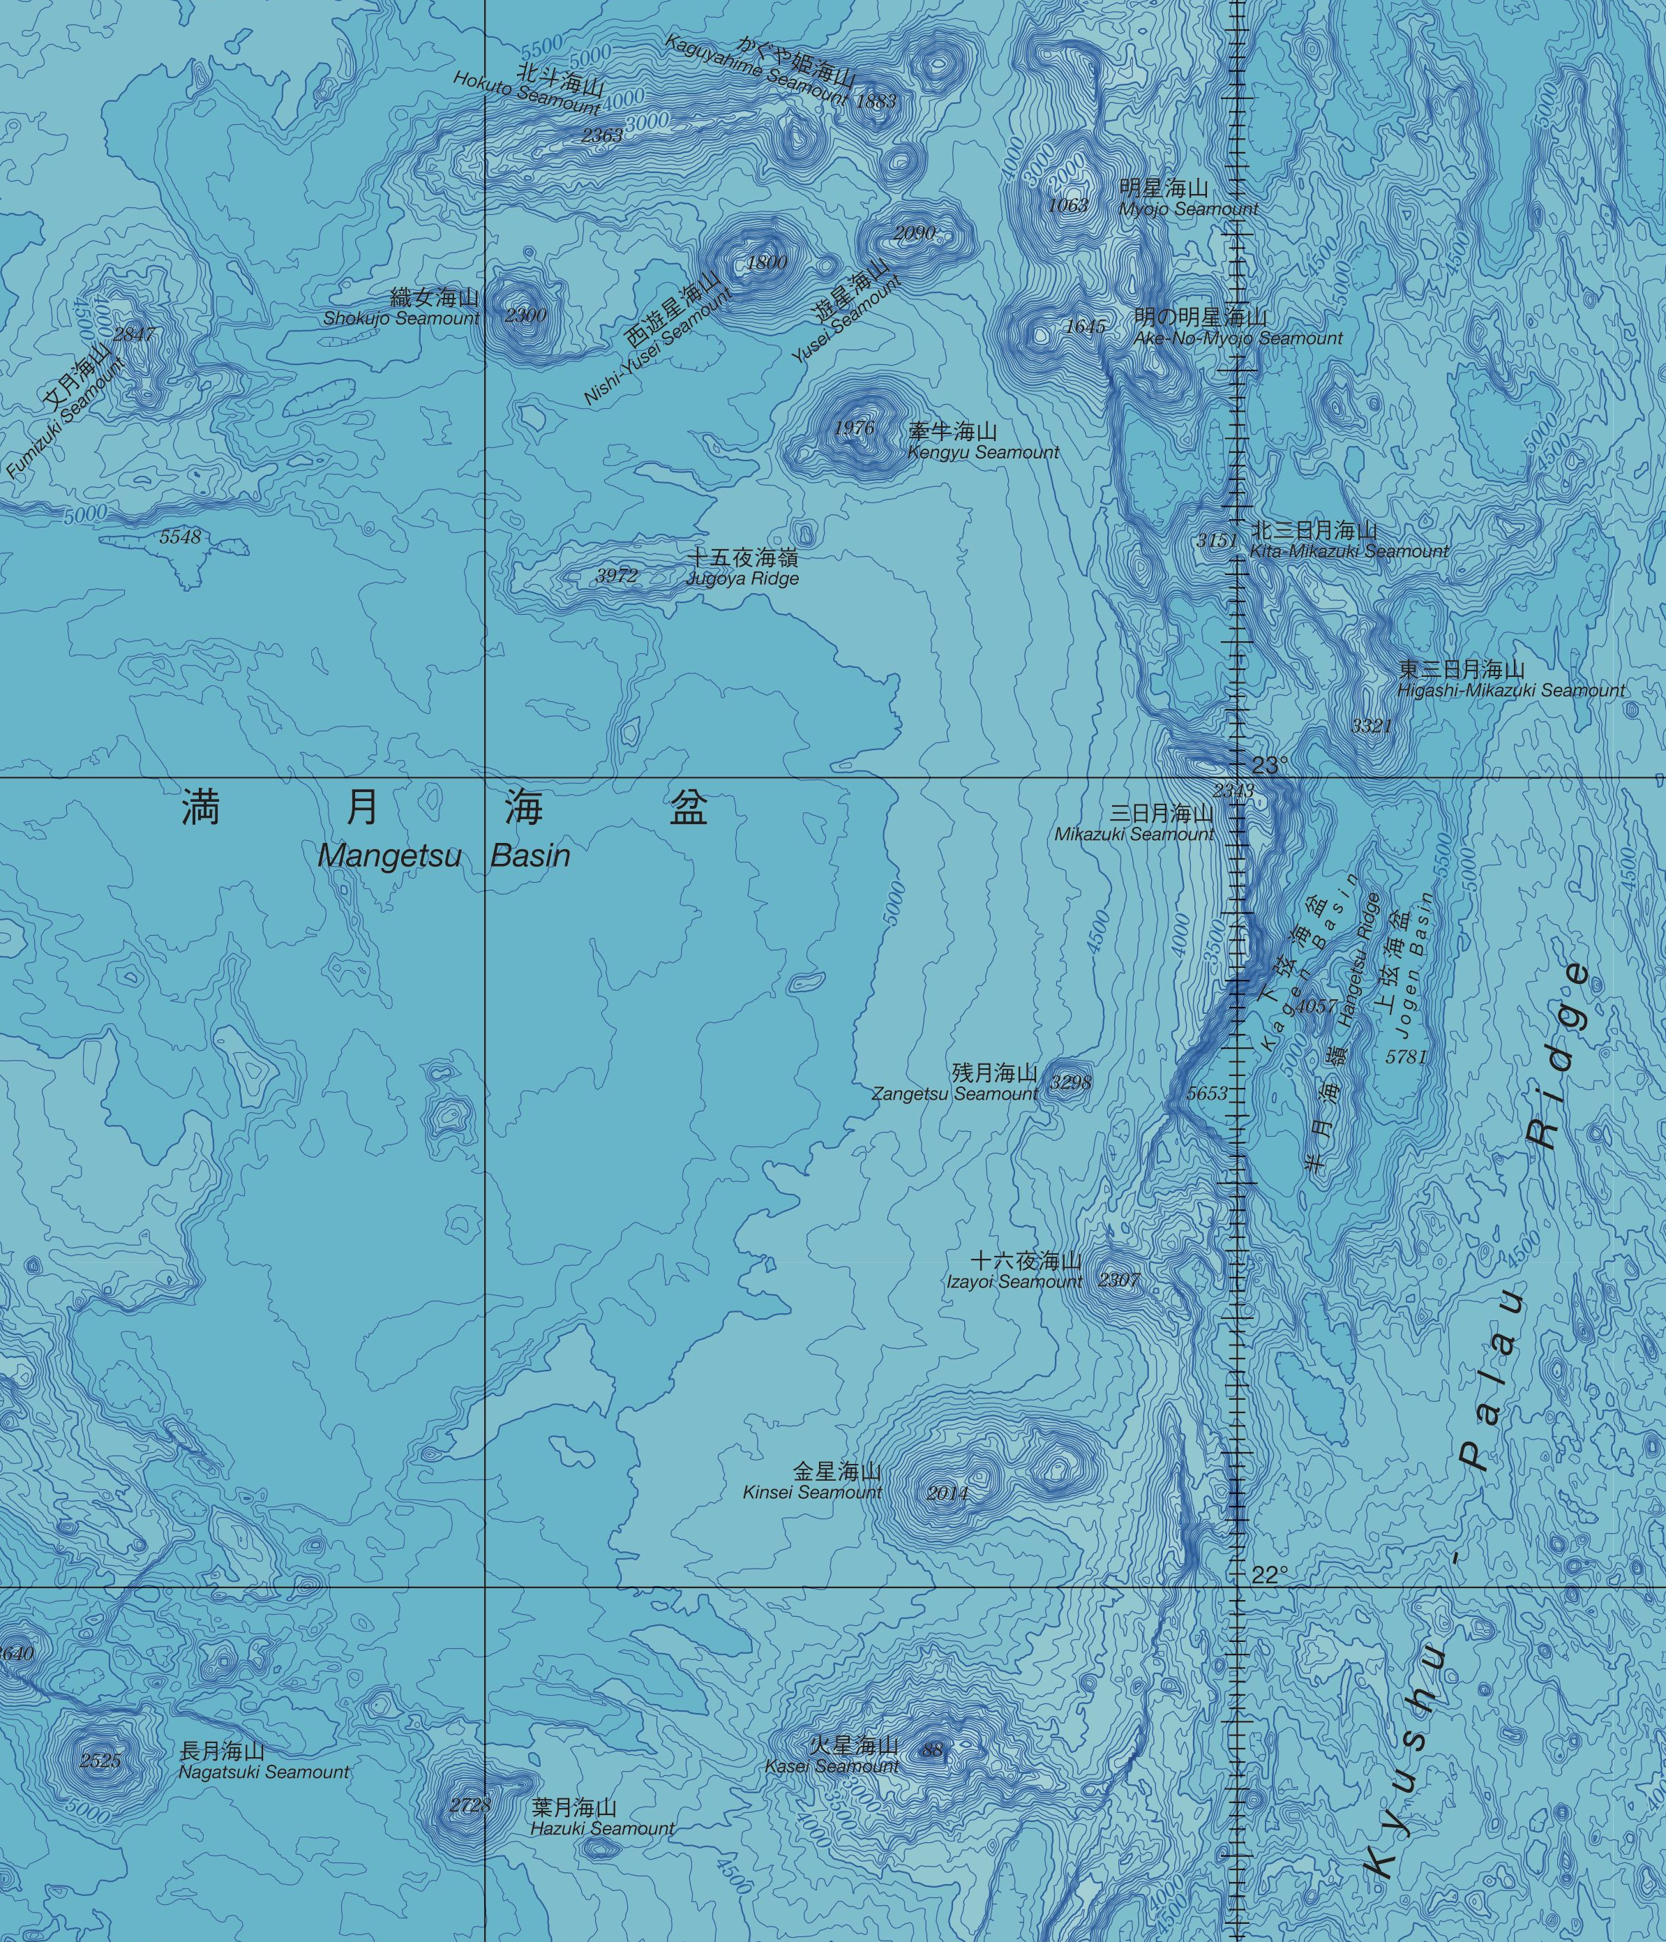

Fig. 4. Blow-up of the Japanese bathymetric map #6722, showing the undersea features with names relevant to moon in Japanese.

