INTERNATIONAL HYDROGRAPHIC  ORGANIZATION | INTERGOVERNMENTAL OCEANOGRAPHIC  COMMISSION (of UNESCO)

UNDERSEA FEATURE NAME PROPOSAL
(See IHO-IOC Publication B-6 and NOTE overleaf)

Note: The boxes will expand as you fill the form.
Name Proposed: | Magamo Seamount | Ocean or Sea: | N/A

Geometry that best defines the feature (Yes/No) :
Point | Line | Polygon | Multiple points | Multiple lines* | Multiple polygons* | Combination of geometries*
 |  | Yes
* Geometry should be clearly distinguished when providing the coordinates below.
 | Lat. (e.g. 63°32.6’N) | Long. (e.g. 046°21.3’W)
Coordinates: | 21°13.90’N  21°11.35’N  21°04.08’N  21°03.23’N  21°06.38’N  21°09.90’N  21°13.90’N | 148°57.89’E  149°06.50’E  148°59.83’E  148°53.40’E  148°51.22’E  148°51.46’E  148°57.89’E

Feature Description: | Maximum Depth: | 5,300 m | Steepness : | N/A
Feature Description: | Minimum Depth : | 3,375 m | Shape : | Distorted
Feature Description: | Total Relief : | 1,925 m | Dimension/Size : | 25 km × 15 km

Associated Features: | Hishikui Seamount, Yoshigamo Seamount, and Suzugamo Seamount

Chart/Map References: | Shown Named on Map/Chart:
Chart/Map References: | Shown Unnamed on Map/Chart:
Chart/Map References: | Within Area of Map/Chart:

Reason for Choice of Name (if a person, state how associated with the feature to be named): | The closest land to this feature is the Minami-Tori Shima Island. The Island, also known as Marcus Island, is an isolated Japanese coral atoll in the Northwest Pacific Ocean, and the easternmost land territory of Japan. The meaning of its Japanese name is literally "Southern Bird Island".  Therefore, JCUFN gave names after bird to a series of Seamount and Guyot around the Minami-Tori Shima Island.  For this feature, “Magamo” is the Japanese for a mallard duck.

Discovery Facts: | Discovery Date: | Nov. 2001
Discovery Facts: | Discoverer (Individual, Ship): | Japanese survey vessel "Shoyo"

Supporting Survey Data, including Track Controls: | Date of Survey: | Nov. - Dec. 2001
Supporting Survey Data, including Track Controls: | Survey Ship: | Japanese survey vessel "Shoyo"
Supporting Survey Data, including Track Controls: | Sounding Equipement: | Multibeam echo sounder  Seabeam 2112
Supporting Survey Data, including Track Controls: | Type of Navigation: | GPS without Selective Availability
Supporting Survey Data, including Track Controls: | Estimated Horizontal Accuracy, in nautical miles (M): | 0.014 nm (26 m)
Supporting Survey Data, including Track Controls: | Survey Track Spacing: | 9 nm
Supporting Survey Data, including Track Controls: | Supporting material can be submitted as Annex in analog or digital form.

Proposer(s): | Name(s): | JCUFN
Proposer(s): | Date: | August 20, 2018
Proposer(s): | E-mail: | ico@jodc.go.jp
Proposer(s): | Organization and Address: | Hydrographic and Oceanographic Department, Japan Coast Guard Kasumigaseki 3-1-1, Chiyoda-ku, Tokyo 100-8932, Japan
Proposer(s): | Concurrer (name, e-mail, organization and address):

Remarks: | The position of the summit is located in (21°06.37’N, 148°56.64’E).

NOTE: This form should be forwarded, when completed:

a) If the undersea feature is located inside the external limit of the territorial sea:
- to your "National Authority for Approval of Undersea Feature Names" (see Publication B-6) or, if this does not exist or is not known, either to the IHO or to the IOC (see addresses below);

b) If at least 50 % of the undersea feature is located outside the external limits of the territorial sea:
- to the IHO or to the IOC, at the following addresses :

International Hydrographic Organization (IHO)  4b, Quai Antoine 1er  B.P. 445  MC 98011 MONACO CEDEX  Principality of MONACO  Fax: +377 93 10 81 40  E-mail: info@iho.int  Web: www.iho.int | Intergovernmental Oceanographic Commission (IOC)  UNESCO  Place de Fontenoy  75700 PARIS  France  Fax: +33 1 45 68 58 12  E-mail: info@unesco.org  Web: http://ioc-unesco.org/

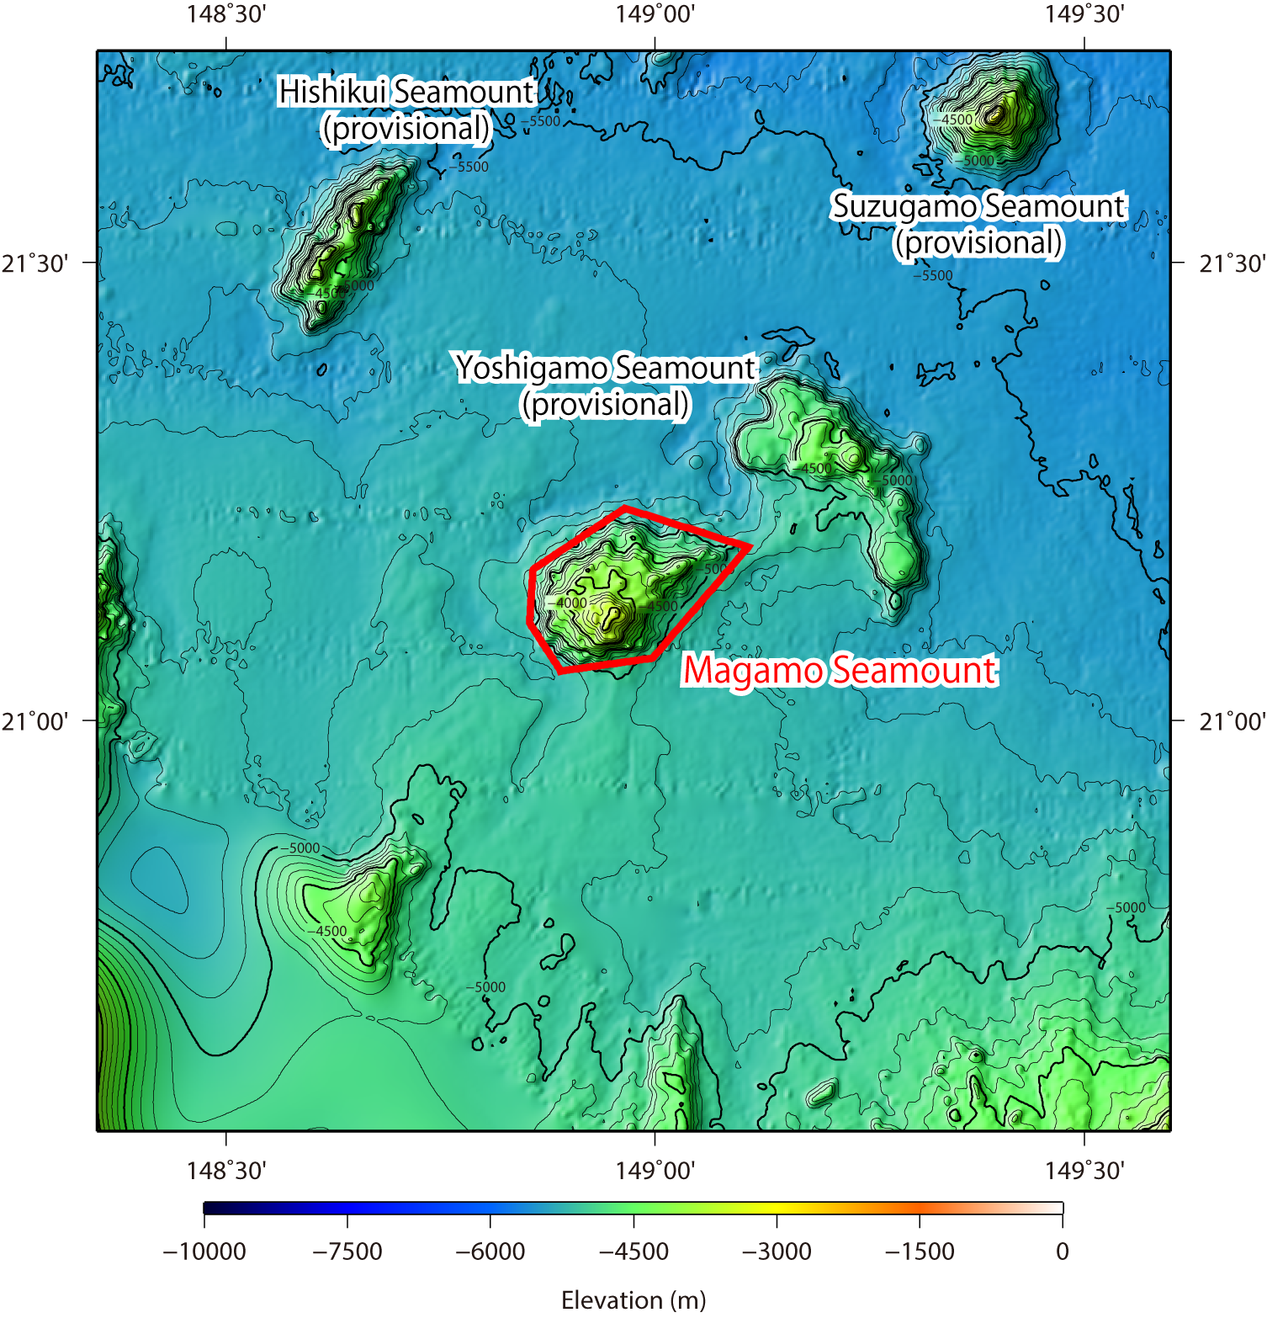

Fig. 1. Bathymetric map of the Magamo Seamount. Contours are in 100 m.

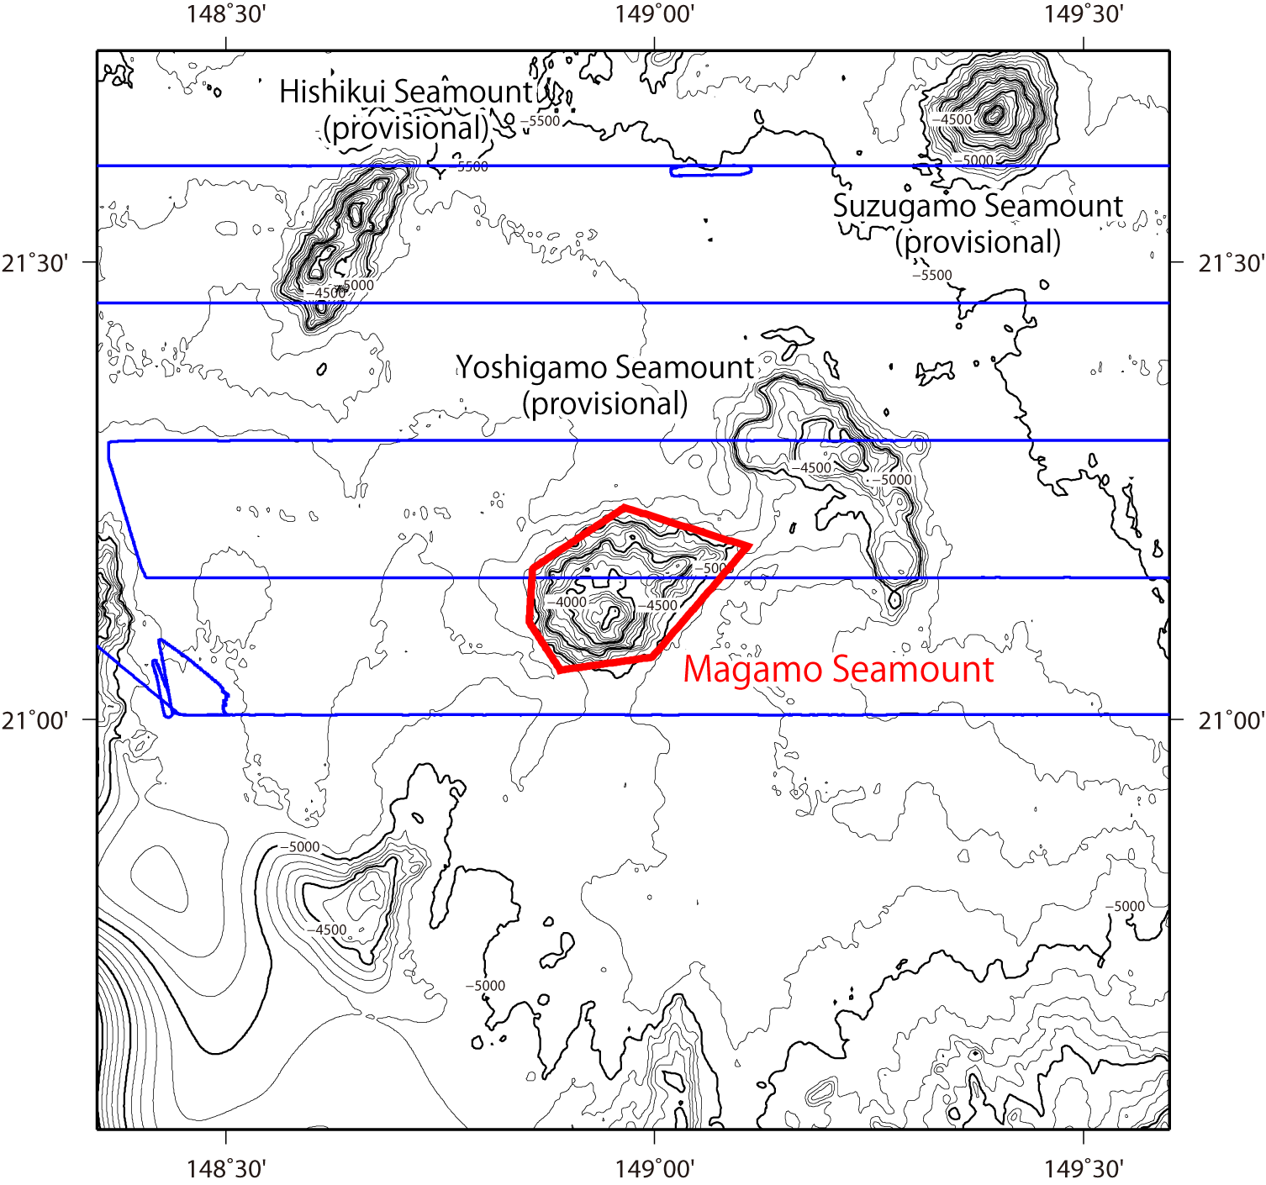

Fig. 2. Bathymetric map of the Magamo Seamount, shown with track lines. Contours are in 100 m.

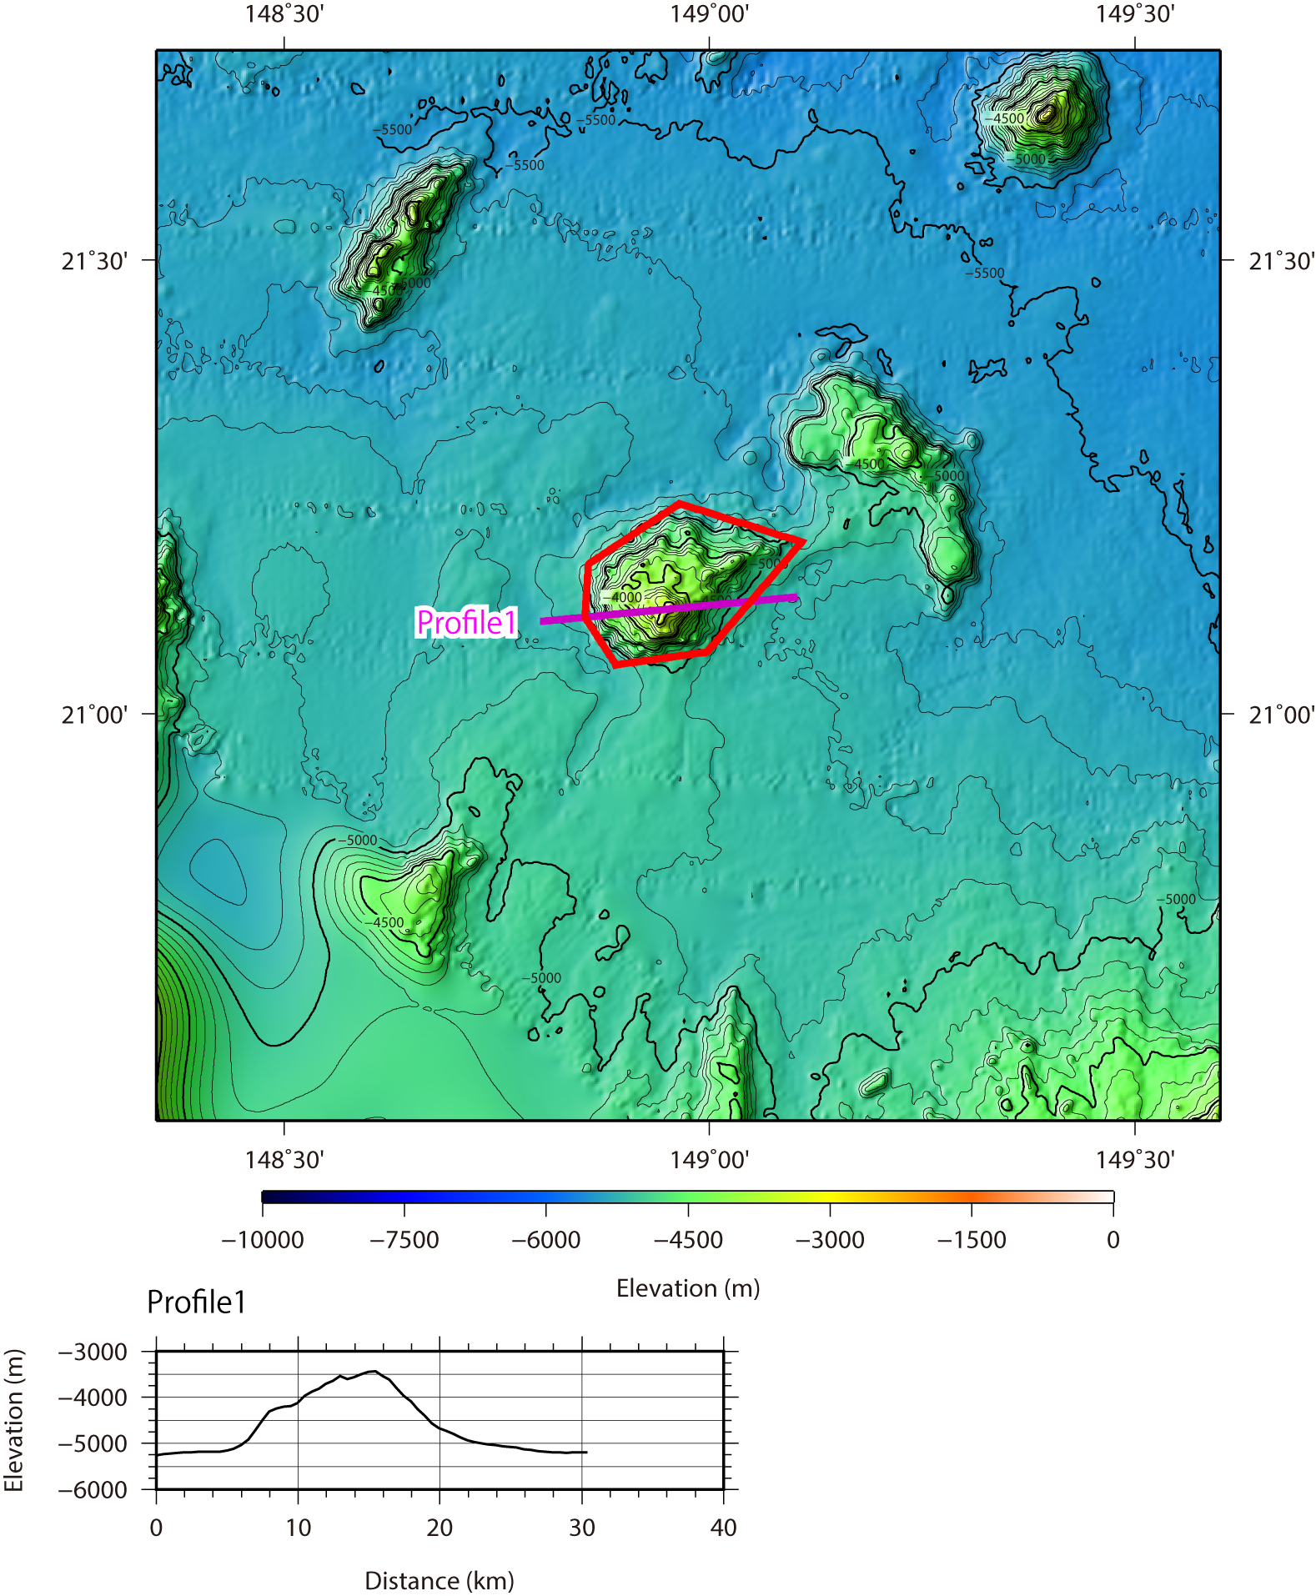

Fig. 3. Bathymetric profile across the Magamo Seamount.

