INTERNATIONAL HYDROGRAPHIC ORGANIZATION



IHO GEOSPATIAL STANDARD

FOR HYDROGRAPHIC DATA

Draft 0.0.1 – October 2009

Special Publication No. 101

Electronic Navigational Chart Product Specification

Published by the

International Hydrographic Bureau

MONACO

Contents Page
1 Overview 1
1.1 Introduction 1
1.2 References 1
1.3 Terms, definitions and abbreviations 1
1.3.1 Terms and Definitions 1
1.3.2 Abbreviations 1
1.4 S-101 General Data Product Description 1
1.5 Data product specification metadata 2
2 Specification Scopes 3
3 Data Product Identification 3
4 Data Content and structure 5
4.1 Application Schema 5
4.2 Feature Catalogue 7
4.3 Feature Types 8
4.3.1 Meta Feature Types (S-57 PS 3.4) 8
4.3.2 Geographic Feature Types 8
4.3.3 Theme Feature Types 8
4.3.4 Aggregated Feature Types (S-57 PS 3.9) 9
4.4 Time Varying Features (S-57 PS 3.7) 9
4.5 Feature integrity (S-57 PS 5.9) 9
4.5.1 ENC data integrity measures 9
4.5.2 Feature level CRC values 10
4.5.3 Implementation 10
4.5.4 Processing 10
4.6 Attributes 10
4.6.1 Numeric Attribute Values (S-57 PS 3.5.4) 10
4.6.2 Text Attribute Values (S-57 PS 3.5.5) 11
4.6.3 Mandatory Attribute Values (S-57 PS 3.5.2) 11
4.7 ENC Data Set 11
4.8 Cells (S-57 PS 2.2) 11
4.9 Unique Universal Identifier (S-57 PS 3.1) 12
4.10 Display Scales 12
4.11 Geometry (S-57 PS 2.3 and 3.8) 13
4.11.1 Level 3a 14
5 Coordinate Reference Systems (CRS) 14
5.1 Introduction (S-57 PS 4.1) 14
5.2 Horizontal Geodetic Datum (S-57 PS 4.1) 15
5.3 Vertical and Sounding Datum (S-57 PS 4.2) 15
5.3.1 Vertical Datum (S-57 UOC) 15
5.3.2 Sounding Datum (S-57 UOC) 15
5.4 Projection (S-57 PS 4.3) 16
5.5 Units of Measure (S-57 PS 4.4) 16
5.5.1 Positions (S-57 PS 4.4) 16
5.5.2 Depths (S-57 PS 4.4) 16
6 Data Quality (S-57 UOC) 16
6.1 Quality, Reliability and Accuracy of Bathymetric Data 17
6.1.1 Quality of bathymetric data 17
6.1.2 Survey reliability 17
6.1.3 Quality of sounding 17
6.1.4 Sounding accuracy 17
6.1.5 Technique of sounding measurement 18
6.2 Accuracy of non-bathymetric data 18
6.2.1 Quality of positions 18
6.2.2 Horizontal accuracy 18
6.2.3 Vertical accuracy 18
6.2.4 Source of bathymetric data 18
6.2.5 Source of other data 18
7 Data Capture and Classification 19
8 Data Maintenance 19
8.1 Introduction 19
8.2 S-101 Product Specification Maintenance 19
8.2.1 Maintenance Procedures 19
8.2.2 Clarification 19
8.2.3 Correction 19
8.2.4 Extension 19
8.2.5 Version Control 20
8.3 Clarification Version Control 20
8.4 Correction Version Control 20
8.5 Extension Version Control 21
8.6 Data Maintenance 21
9 Portrayal 21
10 Data Product format (encoding) 22
11 Data Product Delivery (S-57 PS 5.8? and 2.2) 22
11.1 Implementation (S-57 PS 5.1) 22
11.2 Feature and Portrayal Catalogue Delivery 23
11.3 The standard encoding 23
11.3.1 Data Sets (S-57 PS 5.5) 23
11.3.2 Cell naming (S-57 PS 5.6.1) 23
11.3.3 ENC Cell files (S-57 PS 5.6.1) 23
11.3.4 Updating (S-57 PS 5.7) 24
12 Metadata 25
12.1 Navigation Purpose (S-57 PS 2.1) 27
12.2 Language (S-57 PS 3.11) 27
12.2.1 Use of lexical level 2 27
ANNEX A Data Product format (encoding) (S-57 PS 6) 28
1 Introduction 28
1.1 Data set files 29
1.2 Records 30
1.3 Fields 30
1.4 Subfields 30
1.5 Base cell and update file structure 30
1.5.1 Data Set Identification field structure 33
1.5.2 Data Set Structure Information field structure 33
1.5.3 Attribute field structure 34
1.5.4 Data Set Coordinate Reference System record structure 35
1.5.5 37
1.5.6 Information Type Identifier field structure 37
1.5.7 Coordinate Control field structure 39
1.5.8 2-D Integer Coordinate field structure 39
1.5.9 3-D Integer Coordinate field structure 39
1.5.10 2-D Floating Point Coordinate field structure 40
1.5.11 3-D Floating Point Coordinate field structure 40
1.5.12 Feature Type Record Identifier field structure 46
1.5.13 Feature Object Identifier field structure 46
1.5.14 Spatial Association field structure 46
1.5.15 Feature Association field 47
1.5.16 Theme Association field 47
1.5.17 Masked Spatial Type field structure 48
2 ANNEX B (informative) 49

Overview

Introduction

References

Terms, definitions and abbreviations

Terms and Definitions
Cell
A cell is a geographical area containing ENC data.
ENC
The latest version of official data carried by a vessel for the intended voyage.

ENC Product Specification
The set of specifications intended to enable Hydrographic Offices to produce a consistent ENC, and manufacturers to use that data efficiently in an ECDIS that satisfies the IMO Performance Standards for ECDIS. An ENC must be produced in accordance with the rules defined in this Specification and must be encoded using the rules described in the Data Capture and Classification Guide.
point
0-dimensional geometric primitive, representing a position

curve
1-dimensional geometric primitive, representing the continuous image of a line

NOTE: The boundary of a curve is the set of points at either end of the curve. If the curve is a cycle, the two ends are identical, and the curve (if topologically closed) is considered to not have a boundary. The first point is called the start point, and the last is the end point. Connectivity of the curve is guaranteed by the “continuous image of a line”

curve segment
1-dimensional geometric object used to represent a continuous component of a curve using homogeneous interpolation and definition methods

NOTE: The geometric set represented by a single curve segment is equivalent to a curve

Abbreviations
IHO International Hydrographic Organization
ENC Electronic Navigational Chart
SENC System Electronic Navigational Chart

S-101 General Data Product Description
Note: This information contains general information about the data product.
Title: Electronic Navigational Chart

Abstract: An Electronic Navigational Chart (ENC) is a vector chart produced on the authority of a government authorized Hydrographic Office. Its primary function is for use within an Electronic Chart Display and Information Systems (ECDIS) to meet International Maritime Organisation (IMO) and Safety Of Life At Sea (SOLAS) chart carriage requirements. The ENC contains an extraction of real world information necessary for the safe navigation of vessels.

Content: This product specification is a complete description of all the appropriate features, attributes and their relationships necessary to define an ENC data product. The precise content is documented within the Feature Catalogue and the relationships defined the Application Schema. Details of how these features should be symbolised are contained in the associated portrayal catalogue.
Spatial Extent:
Description: Areas specific to marine navigation.
East Bounding Longitude: 180
West Bounding Longitude: -180
North Bounding Latitude: 90
South Bounding Latitude -90

Temporal Extent:

Purpose: The purpose of an ENC data set is to provide official navigational data to an Electronic Chart Display and Information System (ECDIS) for the safe passage of vessels between destinations.

Data product specification metadata
Note: This information uniquely identifies this product specification and provides information about its creation and maintenance.
Title: The International Hydrographic Organization Electronic Navigational Chart Product Specification
S-100 Version: 0.0.1
S-101 Version: 0.0.1
Date: September 25, 2009
Language: English
Classification: Unclassified
Contact: International Hydrographic Bureau (IHB)
4 Quai Antoine 1er
B.P. 445
MC 98011 MONACO CEDEX
Telephone: +377 93 10 81 00
Fax: + 377 93 10 81 40
URL: www.iho.int
Identifier: S-101
Maintenance: Changes to the product specification S-101 are coordinated by Transfer Standards Maintenance and Applications Development Working Group (TSMAD) of the IHO and shall be made available via the IHO web site. For further details see annex ?

Specification Scopes
Scope ID: Root scope
Level: Dataset
Level name: ENC Dataset
Spatial Extent:
Description: Areas specific to marine navigation.
eastBoundLongitude: 180
westBoundLongitude: -180
northBoundLatitude: 90
southBoundLatitude -90

Vertical Extent:
minimumValue:
maximumValue:
unitOfMeasure: meters
Temporal Extent:
TM_Primitive:

Data Product Identification
A data set that conforms to this product specification will be identifiable by the discovery metadata that supports it.
Title: Electronic Navigation Chart
Alternate Title: ENC
Abstract: When an S-101 ENC is produced it must be in accordance with the rules defined in the S-101 product specification. S-101 details specifications intended to enable Hydrographic Offices to produce a consistent ENC, and manufacturers to use that data efficiently in an ECDIS to satisfy IMO Performance Standards for ECDIS.
Topic Category: Transportation
Geographic Description: Areas specific to marine navigation.
Spatial Resolution: Display Scale
Purpose: Electronic Navigational Chart for use in Electronic Chart Display Systems
Language: English
Classification: Unclassified
Spatial Representation Type: Vector
Point of Contact: Producing Hydrographic Office
Use Limitation: Not to be used for navigation on land.

Data Content and structure
An S-101 ENC is a feature-based product. This section contains the product application schema expressed in UML and an associated feature catalogue. The feature catalogue provides a full description of each feature type including its attributes, attribute values and relationships in the data product.

Application Schema
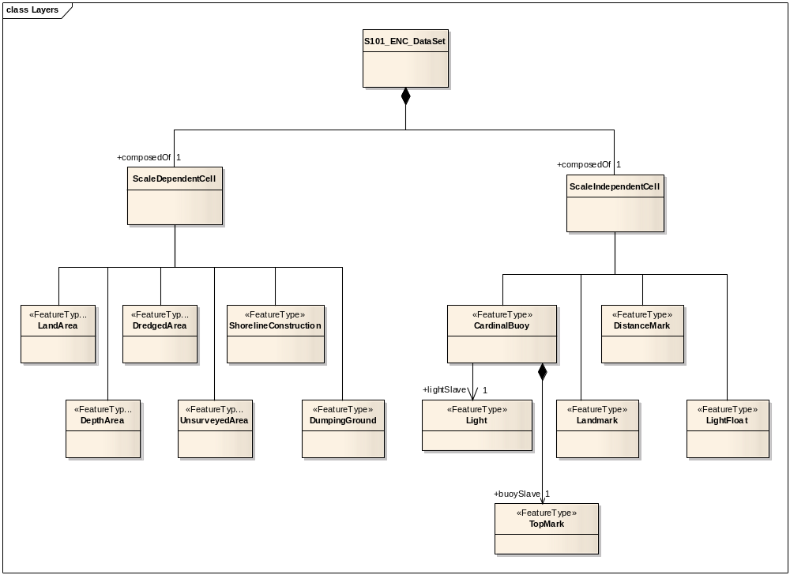
Figure ?? Datasets

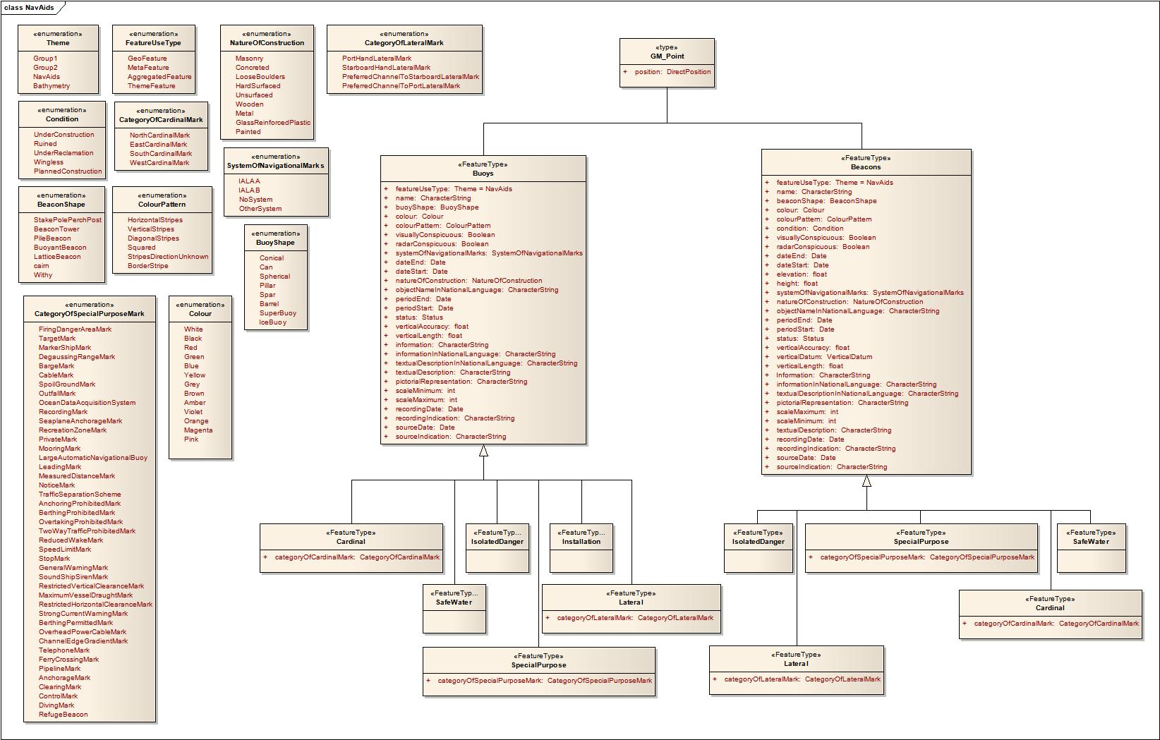
Figure ?? Navigational Aids Feature Theme
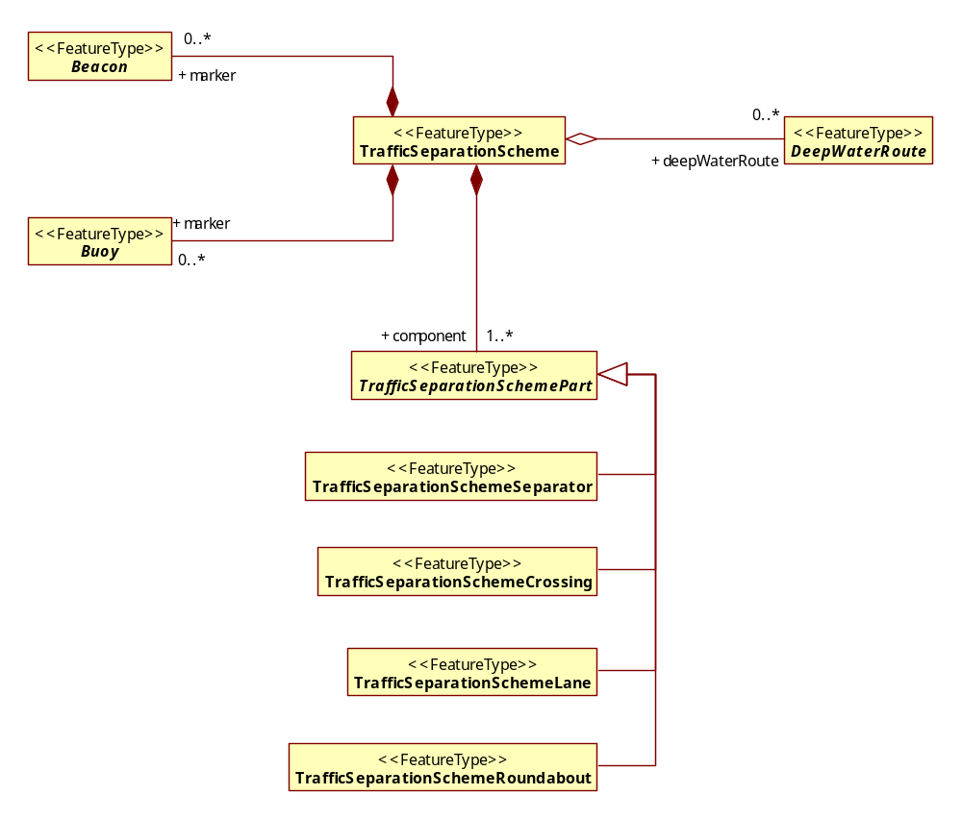
Figure ?? Feature Aggregation

Note: UML diagrams detailing all new S-101 concepts, the application schema will form the backbone of the document. This is just a start it is not the complete application schema. The next section of this chapter will discuss each of the parts of the application schema in detail. It will be generic and will not tie us down to a specific encoding. The content of this section needs some work….

Feature Catalogue
Only feature types, information types, attributes, attribute values, associations and roles which are defined in the IHO Feature Catalogue may be used in an ENC.
The feature catalogue will only be available in XML format with an accompanying style sheet.

Feature Types

Meta Feature Types (S-57 PS 3.4)
Meta features contain information about other features within a data set. Information defined by meta features override the default metadata values defined by the data set descriptive records. All meta objects are defined in the S-101 Feature Catalogue.

The maximum use must be made of meta objects to reduce the attribution on individual objects.
In a base data set (EN Application profile), some meta objects are mandatory.
M_COVR M_QUAL M_NSYS
Meta object M_COVR provide an exhaustive, non-overlapping coverage of the whole cell.
Meta objects M_QUAL must cover any part of the cell containing depth or bathymetry. They must not overlap.
The meta object M_NSYS with the attribute MARSYS (to indicate the system of navigational marks) must also provide an exhaustive non-overlapping coverage of the part of the cell containing data. However, other M_NSYS objects with the attribute ORIENT (to indicate a local direction of buoyage) may overlap these objects.

Geographic Feature Types
Geo feature types form the principle content of the navigational product and are fully defined by their associated attributes and information types.

Theme Feature Types
Theme features are a special kind of collection object. They do not define a feature itself but group other features together. The reasons for the grouping are mostly thematic, other reasons are possible. Each feature object may belong to more than one theme. Themes are therefore not mutually exclusive. Since the kind of association from a theme object to its members (and vice versa) is not variable, the encoding of this type of association is different from the other feature associations.
The theme number is indicated in the “Group” [GRUP] subfield of the “Feature Record Identifier” [FRID] field.

Skin of the Earth Theme (S-57 PS 3.10.1)
Themes are normally defined in the feature catalogue however in this case there are constraints which have to be observed. Skin of the Earth features are a set of geo features of geometric type area that do not overlap each other and form a continuous surface named “skin of the earth”. The geometry of coincident boundaries between Skin of the Earth features must not be duplicated. The features listed below represent the only allowable features in this theme.
DEPARE DRGARE LNDARE UNSARE FLODOC HULKES PONTON
Each area covered by a meta object M_COVR with CATCOV = 1 must be totally covered by a set of geo objects of type area that do not overlap each other (the skin of the earth). The geometry of coincident boundaries between skin of the earth features must not be duplicated.

Aggregated Feature Types (S-57 PS 3.9)
Feature with a use type of aggregated can have multiple associations to other feature types.
There are two ways to define relationships between objects :
- nominated master feature record,
- collection objects of classes “aggregation” (C_AGGR), or “association” (C_ASSO).
The use of the Catalogue Cross Reference record is prohibited.
The use of the collection object class C_STAC is prohibited.
All hierarchical relationships (master to slave) must be encoded by using a nominated “master” feature record carrying the pointers to the “slave” objects in the “Relationship Indicator” [RIND] subfield in the “Feature Record to Feature Object Pointer” [FFPT] field with the value {2} = slave.
All association or aggregation relationships using collection objects are assumed to be peer to peer. The “Relationship Indicator” [RIND] subfield of these collection feature records must be {3} = peer.
The use of these relationships is described in the Data Capture and Classification Guide.

Associations
Associations between features are established and carried in the feature catalogue.
EXAMPLE A light is associated with a landmark

Roles
Roles between features are established and carried in the feature catalogue.
EXAMPLE A light is a slave to a buoy; buoy is the master of the light. Where master and slave are the role between the light and the buoy.

Time Varying Features (S-57 PS 3.7)
The ENC may contain information about magnetic variation, tides, tidal streams and currents.

Feature integrity (S-57 PS 5.9)

ENC data integrity measures
Where there is a high impact of data corruption such as ENC data there is a need for a mechanism within the ENC data itself to ensure it has not changed. The mechanism chosen for this assurance is a cyclic redundancy check. File integrity checks are based on the CRC-32 algorithm (a 32 bit Cyclic Redundancy Check algorithm) as defined in ANSI/IEEE Standard 802.3, the reference for which is given in clause 1.3.

Feature level CRC values
Each Feature record may have a CRC value associated with it. This encapsulates the entire state of that feature and is calculated on the entire cell data associated with that feature. It is defined as a CRC-32 value calculated from an XML rendering of a feature’s state at the time of publication. These feature level CRC values are described further in Appendix XX. Encodings may additionally define other data integrity mechanisms at a file level as well as stronger data authentication mechanisms such as digital signatures but the standard encoding defined in the standard contains only feature and file level CRC-32 values.

Implementation
The checksums for each data set are held in the “CRC” [CRCS] subfield of the “Catalogue Directory” [CATD] field. They allow the integrity of each file in the exchange set to be checked on receipt. The CRC value computed on the received file must the same as the CRC value transmitted.
The CRC values are recorded in ASCII as a hexadecimal numbers

Processing

G(x) = x ³² + x ²⁶ + x ²³ + x ²² + x ¹⁶ + x ¹² + x ¹¹ + x ¹⁰ + x ⁸ + x ⁷ + x ⁵ + x ⁴ + x ² + x + 1
Encoding is defined by the following generating polynomial:
Processing is applied to relevant files as they appear in the exchange set.
The CRC value of the file is defined by the following process:
1. The first 32 bits of the data are complemented.
2. The n bits of the data are then considered to be the coefficients of a polynomial M(x) of degree n-1.
3. M(x) is multiplied by x³² and divided by G(x), producing a remainder R(x) of degree <31.
4. The coefficients of R(x) are considered to be a 32-bit sequence.
5. The bit sequence is complemented and the result is the CRC.
The hexadecimal format of CRCs are converted to ASCII characters and stored in the Catalogue Directory [CATD] field.
An example of coding in C language is given in Annex.

Attributes

Numeric Attribute Values (S-57 PS 3.5.4)
Floating point or integer attribute values must not be padded by non-significant zeroes.

Text Attribute Values (S-57 PS 3.5.5)
Character strings must be encoded using the character set specified in Unicode Transformation Format-8 (UTF-8).
The lexical level used for the “Feature Record Attribute” [ATTF] field must be 0 (ISO/IEC 646 IRV) or 1 (ISO 8859-1). Lexical level 0, 1 or 2 may be used for the “Feature Record National Attribute” [NATF] field. Format effecting (C0) characters as defined in S-57 Part 3, Annex B are prohibited. The delete character is only used in the update mechanism.

Mandatory Attribute Values (S-57 PS 3.5.2)
There are four reasons why attribute values may be considered mandatory:
- They determine whether a feature is in the display base,
- Certain features make no logical sense without specific attributes,
- Some attributes are necessary to determine which symbol is to be displayed,
- Some attributes are required for safety of navigation.
All mandatory attributes are identified in the feature catalogue.

Unknown Mandatory Attribute Values (S-57 PS 3.5.1)
In a base data set, when an attribute code is present but the attribute value is missing, it means that the producer wishes to indicate that this attribute value is unknown.

In a revision data set, when an attribute code is present but the attribute value is missing it means:

- that the value of this attribute is to be replaced by an unknown value if it was present in the original data set,
- that an unknown value is to be inserted if the attribute was not present in the original data set.

ENC Data Set
An ENC data set is a collection of geo-referenced cells containing geographic features that are used to fully describe the physical marine environment for the safe passage of vessels.

Cells (S-57 PS 2.2)
A cell is a grouping of features, attributes, geometry and metadata which form a data surface with a specific coverage.
Cells must be rectangular (i.e. defined by 2 meridians and 2 parallels). However the data contained within a cell does not have to be equal to the cell boundary.
Features with the geometric properties of point or line coincident with the border of two cells within the same layer and with the same display scale must be part of only one cell.
When a feature extends across cells at the same display scale its geometry must be split at the cell boundaries and its complete attribute description must be repeated in each cell.
In order to facilitate the efficient processing of ENC data the geographic coverage of a given usage must be split into cells. Each cell of data must be contained in a physically separate, uniquely identified file on the transfer medium, known as a data set file.

.
The coordinates of the borders of the cell are encoded in decimal degrees in the “Catalogue Directory” [CATD] field.
Each cell must be completely covered by meta features of class M_COVR. The areas that contains data must be indicated by M_COVR features with CATCOV = 1. Any other areas that do not contain data must covered by M_COVR features with CATCOV = 2.
Cells with the same navigational purpose may overlap. However, data within the cells must not overlap. Therefore, in the area of overlap only one cell may contain data, all other cells must have a meta object M_COVR with CATCOV = 2 covering the overlap area. This rule applies even if several producers are involved.

Unique Universal Identifier (S-57 PS 3.1)
Each feature and Information type within an ENC must have a unique universal identifier [UUID].
For ENC the UUID may be used to identify multiple instances of the same feature. For example, the same feature may appear in different display scales, or a feature may be split by the cell structure. In these circumstances each instance of this feature may have the same identifier.
UUIDs must not be reused, even when a feature has been deleted.

Display Scales
Display scale will be the optimum viewing scale of the data within a cell. The display scale must be one of the scales listed in the table below. In addition to the optimum display scale the producer will encode the maximum and minimum display scales an ENC can be viewed at.
The display scales for ENC have been aligned with standard RADAR ranges and are as follows:
Standard RADAR Ranges | Display Scale | Navigation Purpose
 | >1:3, 000,000 | Ocean Passage
200 NM | 1:3, 000,000 | Ocean Passage
96 NM | 1:1,500,000 | Ocean Passage
48 NM | 1:700,000 | Ocean Passage
24NM | 1:350,000 | Coastal
12 NM | 1:180,000 | Coastal
6 NM | 1:90,000 | Coastal
3 NM | 1:45,000 | Coastal
1.5 NM | 1:22,000 | Port entry
0.75 NM | 1:12,000 | Port entry
0.5 NM | 1:8000 | Port entry
0.25 NM | 1:4000 | Port entry
 | <=1:2000 | Port entry

Table 1: Standard Display Scales

Geometry (S-57 PS 2.3 and 3.8)
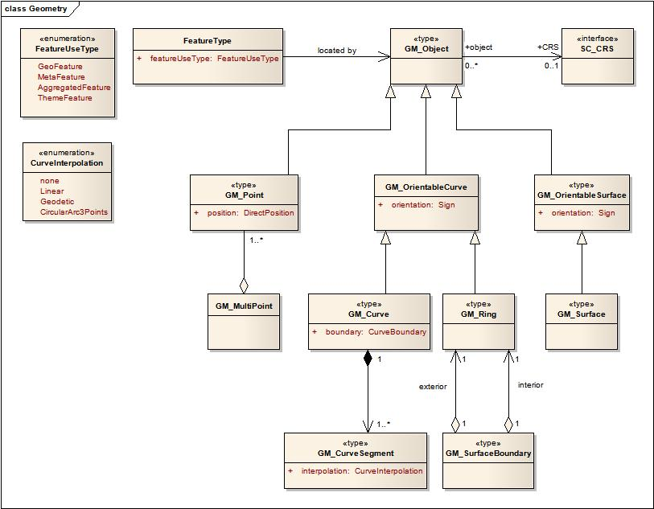

Figure ? S-100 Level 3A

Features contain descriptive attributes and do not contain any geometry (i.e. information about the shape and position of a real world entity). Spatial objects may have descriptive attributes and must contain geometry. A feature is located by a relationship to one or more spatial objects. Features may exist without referencing a spatial object, but each spatial object must be referenced by a feature.

The underlying geometry of an ENC will be constrained to S-100 level 3a which supports 0, 1 and 2 dimensional objects, points, curves and surfaces. The third dimension is expressed as an attribute of an object.

ENC data must be encoded using chain-node topology.
If there is a logical topological relationship between objects, coincident linear geometry must not be duplicated.
Edges must be encoded using SG2D fields only.
Despite the saving in data volume offered by the use of arcs/curves, the disadvantages are such (e.g. during updating, generating warnings/alarms) that they must not be used for ENC.
It is recommended that Linear features should not be encoded at a point density greater than 0.3 mm at compilation scale.
Linear geometry between two explicit coordinates is defined as a loxodromic line on WGS84. Long lines may need to have additional explicit coordinates to cater for the effects of projection change".
The presentation of symbolised lines may be affected by line length. Therefore, the encoder must be aware that splitting a line into numerous small edges may result in poor symbolisation.
In certain circumstances, the symbolisation of an edge may need to be suppressed. This is done using the value {1} in the “Masking Indicator” [MASK] subfield of the “Feature Record to Spatial Record Pointer” [FSPT] field. If the value in the “Usage Indicator” [USAG] subfield is set to {3} (exterior boundary truncated by the data limit), the MASK subfield must be set to {255} (null).

Level 3a

A set of point, curve and surface primitives with the following constraints:

- Each curve must reference a start and end point (they may be the same).
- Curves must not self intersect.
- Areas are represented by a closed loop of curves beginning and ending at a common point.
- In the case of areas with holes, all internal boundaries must be completely contained within the external boundary and the internal boundaries must not intersect each other or the external boundary. Internal boundaries may touch tangentially (i.e. at one point).
- The outer boundary of a surface must be in a clockwise direction (surface to the right of the curve) and the curve orientation positive. The inner boundary of a surface must be in a counter-clockwise direction (surface to the right of the curve) and the curve orientation negative.
- Coincident linear geometry must be avoided when there is a dependency between features.

For a complete description of the geometry in Figure ?? see S-100 part 6 – 1D and 2D Spatial.

Coordinate Reference Systems (CRS)

Introduction (S-57 PS 4.1)

Due to the nature of hydrography it is common practice to separate the horizontal and vertical part of a position. This leads to 2D coordinate reference systems for the horizontal positions and 1D coordinate reference systems for the vertical positions. To describe 3D coordinates those coordinate reference systems must be combined to produce a compound reference system. An ENC data set must define at least one compound CRS. An ENC compound CRS is composed of a 2D geodetic CRS (WGS84) and a vertical CRS.

Horizontal Geodetic Datum (S-57 PS 4.1)
For ENC the geodetic datum of the horizontal CRS must be WGS 84. If the CRS WGS84 is not defined in the encoding by referencing then it must be fully defined, encoding all parameters.

Vertical and Sounding Datum (S-57 PS 4.2)
Although all coordinates in a data set must refer to the same horizontal CRS different Vertical Datums can be used for the height or depth component of a coordinate tuple. Therefore the vertical CRS can be repeated. For each Vertical CRS a unique identifier is defined. Those identifiers will be used to indicate which Vertical CRS is used.
No restriction is placed on the vertical or sounding CRSs that can be used to define height and depth reference systems within ENC.
The various levels which are used on paper charts for elevations and soundings will be used. The default values are encoded in the “Vertical Datum” [VDAT] subfield and the “Sounding Datum” [SDAT] subfield in the “Data Set Parameter” [DSPM] field.

Vertical Datum (S-57 UOC)
Vertical datum information is encoded using the meta feature M_VDAT, or the attribute VERDAT on individual features. The values encoded in the attributes ELEVAT, HEIGHT, VERCCL, VERCLR, VERCOP and VERCSA are referenced to the specified datum(s). VERDAT must not be encoded on an feature unless at least one of the above attributes is also encoded on that feature.
The default value for the entire data set must be given in the metadata.
If the vertical datum for an area is different to the value given in the data set, it must be encoded using M_VDAT. The areas covered by these meta features must not overlap.
Height contours, going across areas having different values of vertical datum, must be split at the border of these areas.
Various datums are used on paper charts and these datums are used in the same way for ENC. For example, different datums may be used for the following:
- altitude of spot heights, height contours, landmarks,
- elevation of lights,
- vertical clearance.

Where different vertical datums are used for the various vertical measurements, the default value given by the VDAT subfield or M_VDAT applies to the first group of the above list. The attribute VERDAT on an individual feature applies to the elevation of lights and vertical clearances and must only be populated if different to the value given by VDAT or M_VDAT.

Sounding Datum (S-57 UOC)
Sounding datum information is encoded using the subfield VDAT or the meta feature M_SDAT, and must be constant over large areas. The values encoded in the attributes VALSOU, DRVAL1, DRVAL2 and VALDCO, and the sounding values encoded in SOUNDG features, are referenced to this datum.
If the sounding datum for an area is different to the value given in the data set, it must be encoded using M_SDAT. The areas covered by these meta features must not overlap.
The use of the attribute VERDAT on individual features related to depth is prohibited see the feature catalogue for full list.

Depth contours and depth areas going across areas having different values of sounding datum must be split at the border of those areas.

Projection (S-57 PS 4.3)
No projection is to be used within the ENC. Coordinates must be encoded as geographical positions (latitude, longitude).

Units of Measure (S-57 PS 4.4)
Units to be used in an ENC

- Position: latitude and longitude in decimal degrees (converted into integer values).
- Depth: metres.
- Height: metres.
- Positional accuracy: metres.
- Distance: nautical miles and decimal miles, or metres.

Positions (S-57 PS 4.4)
Latitude and longitude values are converted from decimal degrees to integers by means of the Coordinate Multiplication Factor. The number of decimal digits is chosen by the data producer and is valid through out the data set.
Coordinates must be held in ENC production systems at a resolution of 0.0000001 (10⁻⁷) and the coordinate multiplication factor value should be set to 10000000 (10⁷) for all cells.
EXAMPLE A longitude = 34.5678E is converted into X = longitude * COMF = 34.5678 * 10000000 = 345678000.

Depths (S-57 PS 4.4)
Depths are converted from decimal meters to integers by means of the 3-D (Sounding) Multiplication Factor. Soundings are never encoded with a resolution greater than one decimetre, so the value of sounding multiplication factor must be 10.
For update cells, ‘Coordinate Multiplication Factor’ [X], [Y] and the ‘3-D (Sounding) Multiplication Factor’ [Z] will not be present. In this case, the values from the original base cell should be used.

Data Quality (S-57 UOC)
Data quality comprises the following:
- source of data;
- accuracy of data;
- Up-to-datedness of data.

Data quality is considered to be meta information. As such, it can be encoded at three different levels
Data quality information is considered to be application specific. Therefore, rules for encoding data quality must be defined by the relevant product specification.

Quality, Reliability and Accuracy of Bathymetric Data
Information about quality, reliability and accuracy of bathymetric data is given using:
- the meta feature M_QUAL for an assessment of the quality of bathymetric data,
- the meta feature M_SREL for additional information about the survey,
- the attributes QUASOU, SOUACC and TECSOU on groups of soundings or individual features,
- the attributes POSACC and QUAPOS on the spatial features.

For the mariner, M_QUAL provides the most useful information. Therefore, the use of M_QUAL is mandatory for areas containing depth data or bathymetry.
More detailed information about a survey may be given using M_SREL. For example, in incompletely surveyed areas, lines of passage soundings may be indicated as such using a linear M_SREL feature. This information is more difficult for the mariner to interpret. Therefore, the use of M_SREL is optional.
For individual objects (wrecks, obstructions etc), or small groups of soundings, QUASOU, SOUACC and TECSOU may be used to provide additional information about quality and accuracy.

Quality of bathymetric data
The meta feature M_QUAL defines areas within which uniform assessment exists for the quality of bathymetric data, and must be used to provide an assessment of the overall quality of bathymetric data to the mariner. Areas of a cell containing depth data or bathymetry must be covered by one or more M_QUAL, which must not overlap.

Survey reliability
The survey reliability may be encoded using the meta feature M_SREL.

Quality of sounding
If it is required to encode the quality of sounding, it must be done using the attribute QUASOU on either the meta feature M_SREL or on individual geo features (e.g. SOUNDG).

The quality of sounding must not be encoded using QUASOU on the depth geo feature, unless it is different to the value of QUASOU encoded on M_SREL

Sounding accuracy
Sounding accuracy is encoded using the attribute CATZOC on the meta feature M_QUAL. If it is required to encode additional sounding accuracy information, it must be done using the attribute SOUACC on either the meta feature M_QUAL or on individual geo features (e.g. SOUNDG).

The accuracy of sounding must not be encoded using SOUACC on the depth geo feature, unless it is different to the value of SOUACC encoded on M_QUAL.

Technique of sounding measurement
If it is required to encode the technique of sounding measurement, it must be done using the attribute TECSOU on either the meta feature M_QUAL or on individual geo features (e.g. SOUNDG).
The technique of sounding measurement must not be encoded using TECSOU on the depth geo feature, unless it is different to the value of TECSOU encoded on M_QUAL.

Accuracy of non-bathymetric data

Quality of positions
The meta feature M_ACCY may be used to provide an overall accuracy of position for all non-bathymetric features. It must not be used to provide the accuracy of bathymetric information.
The attributes QUAPOS and POSACC may be applied to any spatial object, in order to qualify the location of an feature.
QUAPOS and POSACC must not be applied to the spatial object of any geo feature if they are identical to the QUAPOS and POSACC values of the underlying meta feature.
QUAPOS gives qualitative information, whereas POSACC gives quantitative information. POSACC on the M_ACCY applies to non bathymetric data situated within the area, while QUAPOS or POSACC on the associated spatial objects, qualifies the location of the M_ACCY object itself. Meta objects M_ACCY and M_QUAL should not overlap.

Horizontal accuracy
If it is required to encode the accuracy of a horizontal clearance (attribute HORCLR), it must be done using the attribute HORACC.
HORACC applies only to HORCLR. There is no attribute to express the accuracy of the attributes HORLEN and HORWID.

Vertical accuracy
If it is required to encode the accuracy of a vertical clearance (attributes VERCLR, VERCOP, VERCSA, VERCCL), it must be done using the attribute VERACC.
If several vertical clearances are given for one object, the accuracy given must be that of the least accurate.

Source of bathymetric data
Details of the source surveys used in compilation may be encoded using the meta object M_SREL.

Source of other data
The source of non-bathymetric information should be encoded using both the attributes SORIND and SORDAT on the individual objects, but only if this information is considered to be useful to the mariner.

Data Capture and Classification
The S-101 Data Capture and Classification guide shall provide the information to map real world objects into the data set. This Guide is located in Appendix A. Data collected as S-101 shall conform to the data classification and capture guide.

Data Maintenance

Introduction
Maintenance shall be defined in two parts for S-101, maintenance of the product specification and maintenance of the data.

S-101 Product Specification Maintenance
This section specifies the procedures followed in maintaining and publishing the various parts of S-101.

Maintenance Procedures
Changes to S-101 are coordinated by the "Transfer Standard Maintenance and Application Development Working Group" (TSMAD) of the IHO and shall be made available via the IHO web site. Organizations that wish to make changes to S-1001, must address their comments to the International Hydrographic Bureau.
There are three change proposal types to S-101: clarification, correction and extension. Any change proposal must be one of these types.
All proposed changes shall be technically and commercially assessed before approval. All proposals shall be submitted using the S-101 maintenance proposal form in Annex ???.

Clarification
Clarifications are defined as non-substantive changes to S-101. Clarifications remove ambiguity and errors in spelling, punctuation and grammar. A clarification shall not cause any substantive semantic change. A clarification shall not also be classified as a correction. All clarifications shall be available for immediate use when approved by TSMAD.

Correction
Corrections are defined as substantive semantic changes to S-101, used to correct factual errors. A correction shall not also be classified as a clarification. One correction may result in multiple related actions. All cumulative clarifications shall be included with the release of approved corrections. After approval the correction shall be available for use at a date specified by TSMAD.

Extension
Extensions are significant changes to S-101. For example new regulations mandated by IMO can result in S-101 extensions. One extension may result in multiple related actions. All cumulative clarifications and corrections shall be included with the release of approved extensions. After approval the extension shall be available for use at a date specified by TSMAD.

Version Control
The IHO shall release new versions of S-101 as necessary. New versions may include clarifications, corrections and extensions. Each version shall contain a change list that identifies the changes between versions of S-101.

Clarification Version Control
Clarifications shall be denoted as 0.0.x. Each clarification or set of clarifications approved at a single point in time shall increment x by 1. Figure 1 shows the S-101 Clarification Version Control.
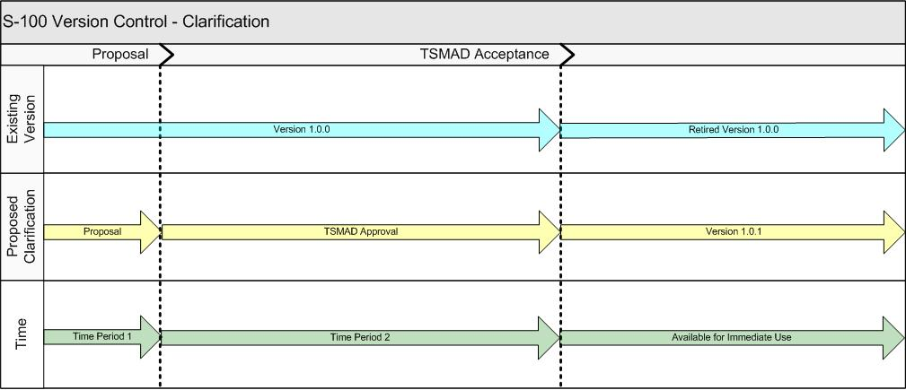
Figure 1 — Clarification Version Control

Correction Version Control
Corrections shall be denoted as 0.x.0. Each correction or set of corrections approved at a single point in time shall increment x by 1. Correction version control shall set clarification version control to 0. Figure 2 shows the S-101 Correction Version Control.
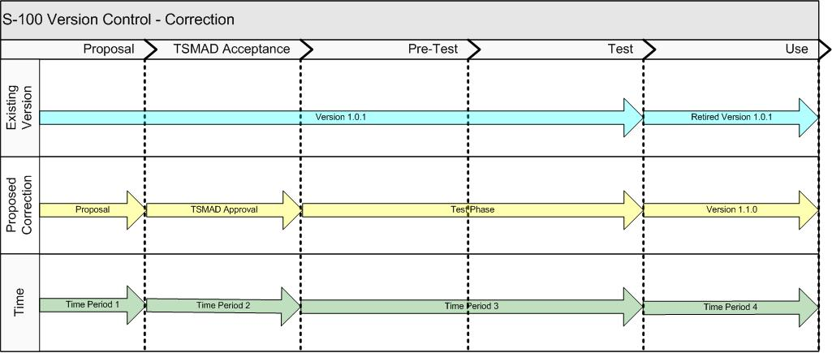
Figure 2 — Correction Version Control

Extension Version Control
Extensions shall be denoted as x.0.0. Each extension or set of extensions approved at a single point in time shall increment x by 1. Extension version control shall set the clarification and correction version control to 0. Figure 3 shows the S-101 Extension Version Control.
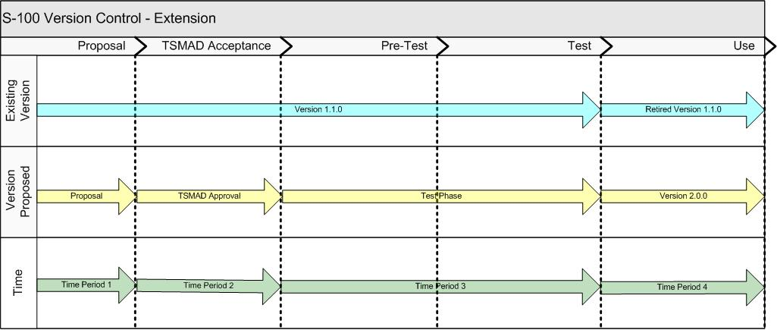
Figure 3 — Extension Version Control

Data Maintenance
Item Name | Description | M/O | Card | type
maintenanceAndUpdateFrequency | Frequency with which changes and additions are made to the data product (per update scope) | M | 1..* | MD_MaintenanceInformation  (ISO 19115)
dataSource | Identification of the kinds of data sources usable to produce data sets | M | 1..* | LI_Source (ISO 19115)
productionProcess | Textual description of the production process applicable to the data sets (per scope or data source) | M | 1..* | LI_ProcessStep (ISO 19115)

Portrayal
ECDIS pick reports will display only set A attributes in full, no abbreviations, acronyms or enumeration code numbers should be displayed.
Attribute_A =: Attributes in this subset define the individual characteristics of an object;
Attribute_B =: Attributes in this subset provide information relevant to the use of the
data, e.g. for presentation or for an information system;
Attribute_C=: Attributes in this subset provide administrative information about the
object and the data describing it;
It will be possible to identify where updates to a base cells have occurred.
S-101 shall include a portrayal catalogue.
Item Name | Description | M/O | Card | type
portrayalLibraryCitation | Bibliographic reference to the portrayal library | O | 0..1 | CI_Citation (ISO 19115)

Data Product format (encoding)
formatName | ISO 8211
version | 2nd Edition
characterSet | UTF-8
specification | Information Technology – Specification for a data descriptive file for information interchange.

See Annex A for a complete description of the data records, fields and subfields.

Data Product Delivery (S-57 PS 5.8? and 2.2)
Item Name | Description
unitsOfDelivery | Cells - In order to facilitate the efficient processing of ENC data the geographic coverage of a given usage must be split into cells.
transferSize | 5mb
mediumName
otherDeliveryInformation

Implementation (S-57 PS 5.1)
The binary implementation of S-57 must be used for ENC. Therefore, the “Implementation” [IMPL] subfield of the “Catalogue Directory” [CATD] field must be set to “BIN” for the data set files.

Feature and Portrayal Catalogue Delivery

The standard encoding
The S-101 product specification defines an encoding which can be used as a default for transmission of data between parties. It is not suitable for commercial distribution of data and further encodings, which may draw on the standard encoding, will be defined for commercial distribution of data. It is mainly file based and has a strong resemblance to the S57 ENC 3.1.1 exchange set specification.
The encoding encapsulates exchange set elements as follows:
- ENC cells – ISO 8211 binary encoding of features/attributes and their associated geometry and metadata. Defined further in XXXX
- Exchange Catalogue – ISO 8211 encoded representation of exchange set catalogue features [discovery metadata]. Includes an additional file level CRC check per cell in addition to the standard feature level CRC32 values.
- Useful information about the ENC dataset. This is contained within a README.TXT file.
- Supplementary files – These are contained within the exchange set as files and the map from the name included within the cell and the physical location on the media is defined within the Exchange Catalogue.

Data Sets (S-57 PS 5.5)

Three kinds of ENC data set may be produced and contained within an exchange set.

- new data set : no ENC data has previously been produced for this area and for the same navigational purpose.
- update: changing some information in an existing data set.
- new edition of a data set : including new information which has not been previously distributed by updates.

Each new data set or new edition is called a base cell file. A data set containing updates to at least one base cell file is called an update cell file.

Cell naming (S-57 PS 5.6.1)
Within this encoding all cells are encapsulated as files as is the Exchange catalogue. The entire exchange set is encapsulated therefore as a set of files which can be written to hard media and transmitted as required across network links.

ENC Cell files (S-57 PS 5.6.1)
In this encoding the ENC cells files are named according to the specifications given below:
CCSXXXXX.EEE
| | | |
| | | |----- EEE = update number – this is a ‘0’ padded 3 digit number identical to the cell’s UPDN.
| | |-------------- XXXXXXXX = individual cell code, up to eight characters
| |------------------- S = 1. Scale Independent - 2. Scale Dependant – 3. Complete
|----------------------- CC = producer code

The main part forms an identifier where:
- the first two characters identify the issuing agency.
- the third character indicates the cell type
- the fourth to * characters are used for the cell code. This code can be used in any way by the producer to provide the unique file name. If characters other than numbers are used only uppercase letters are allowed the use of the underscore character in cell names is prohibited.

.

Updating (S-57 PS 5.7)
This section describes how the standard encoding defines updating methodologies for ENC cells. In order to ensure that feature type updates are incorporated into an ECDIS in the correct sequence without any omission, the file extension and a number of other parameters encoded in the data are used in the following way:
file extension every new data set, re-issue or new edition must have a .000 extension as per the translation from EDTN to the file extension. For update cell files the extension is the value of the UPDN field, ranging from .001 to .999. These numbers must be used sequentially, without omission. Number .001 is the first update after a new data set or a new edition, but not after a re-issue. The update sequence is not interrupted by a re-issue. After a re-issue, subsequent updates may be incorporated into the SENC created from this re-issue or to the SENC created from the original data and kept continuously updated.
edition number when a data set is initially created, the edition number 1 is assigned to it. The edition number is increased by 1 at each new edition. Where a cell is cancelled and its name is re-used at a later date, the edition number of the new cell must be one higher than the final edition number of the cell that it has replaced. Edition number remains the same for a re-issue.

update number update number 0 is assigned to a new data set. The first update cell file associated with this new data set must have update number 1. The update number must be increased by one for each consecutive update, until a new edition is released. The new edition must have update number 0. A re-issue of a data set must have the update number of the last update applied to the data set. In the case of an update cell file the file extension is the same as the update number.
update application this date is only used for the base cell files (i.e. new data sets, re-issue and new edition), not update cell files. All updates dated on or before this date must have been applied by the producer.
issue date date on which the data can be used.

- The update information encoded in each individual cell file is called a sequential update.
- The collection of the update information encoded in the update cell files which have been issued since the last new data set, the last re-issue of a data set or since the last update was applied to the SENC is called a cumulative update. In the example, the cumulative update for the new data set starts with update number 1. The cumulative update for the re-issue of a data set starts with update number 32. The cumulative update for a data set to which update number n has been applied starts with update number n+1.
- The update information which has been incorporated in a re-issue of a data set is called a compilation update.

Each re-issue or new edition of a data set must have the same name as the base cell file which it replaces.

In order to delete a data set, an update cell file is created the edition number must be set to 0. This message is only used to cancel a base cell file.

In order to modify a support file the attribute purpose of the support file metadata provides the mechanism.

When a feature pointing to a text, picture or application file is deleted or updated so that it no longer references the file, the ECDIS software should check to see whether any other feature referenced the same file, before that file is deleted.

An exchange set may contain base cell files and update cell files for the same cells. Under these circumstances the update cell files must follow on in the correct sequential order from the last update applied to the base cell file.

Metadata
Discovery meta data elements required for scale dependent and scale independent ENC cells.
Name | Cardinality | Value | Type | Remarks
DataSetDiscoveryMeta data | - |  | - | -
metadataFileIdentifier | 1 |  | CharacterString
metadataPointOfContact | 1 |  | CI_ResponsibleParty
metadataDateStamp | 1 |  | Date
metadataLanguage | 1 | English | CharacterString | All data sets conforming to S-101 PS must use English language
fileName | 1 |  | CharacterString | Dataset file name
filePath |  |  | CharacterString | Full path from the exchange set root directory
abstract | 1 |  | CharacterString | Short description of the area covered by dataset harbour or port name, between two named locations etc.
dataProtection | 1 | {1} to {2} | CharacterString | 1. Encrypted  2. Unprotected
purpose | 1 | {1} to {4} | CharacterString | 1. New  2. New Edition  3. Update  4.Cancellation
specificUsage | 1 | {1} to {3} | CharacterString | 1.Port Entry  2.  3.
editionNumber | 1 |  | CharacterString | when a data set is initially created, the edition number 1 is assigned to it. The edition number is increased by 1 at each new edition. Edition number remains  the same for a re-issue.
updateNumber | 1 |  | CharacterString | Update number 0 is assigned to a new data set.
updateApplicationDate | 0..1 |  | Date
issueDate | 1 |  | Date
productSpecification | 1 |  | S-100_  ProductSpecification | This must be encoded as S-101
producingAgency | 1 |  | CI_ResponsibleParty
displayScale | 1 | {1} to {12} | double | Display scale must be one of the 12 predefined scales detailed in Table 1.
horizontalDatum | 1 |  | CharacterString
verticalDatum | 1 |  | CharacterString
soundingDatum | 1 |  | CharacterString
dataType | 1 |  | S-100_DataFormat
otherDataTypeDescription | 0..1 |  | CharacterString
boundingBox | 1 |  | EX_GeographicBoundingBox
boundingPolygon | 1 |  | EX_BoundingPolygon
comment | 0..1 |  | CharacterString
cyclicRedundancyCheck | 1 |  | CharacterString  NonNegativeInteger
layerId | 1..* |  | Double | Identifies the relationship to other layers that are required to view the complete data set.

Navigation Purpose (S-57 PS 2.1)
The navigational purpose for which an individual ENC has been compiled is indicated in the data set discovery meta data and, in the default encoding is specified in the cell filename. The following codes are used to identify the navigational purpose:

Code | Navigation Purpose
1 | Ocean Passage
2 | Coastal
3 | Port entry

Language (S-57 PS 3.11)
The exchange language must be English. Other languages may be used as a supplementary option.
In general this means that when a national language is used in textual national attributes the English translation must exist in the international attributes. However, national geographic names do not need to be translated in the international attributes they may be left in their original national language form or may be transliterated or transcribed.

Use of lexical level 2
If the national language cannot be expressed in lexical levels 0 or 1, the following rules apply:
- the exact spelling in the national language is encoded in the “National Attributes” [NATF] field using lexical level 2.
- translated text, including transliterated or transcribed national geographic names is encoded in the “International Attributes” [ATTF] field using lexical level 0 or 1.

Where possible international standards should be used for the transliteration of non-Latin alphabets.

ANNEX A Data Product format (encoding) (S-57 PS 6)
formatName | ISO 8211 | M | 1..* | CharacterString
version | Version of the format (date, number, etc.) | O | 0..1 | CharacterString
characterSet | Character coding standard used for the data set (western European requirement, Greek, Turkish, Cyrillic) | M | 1 | MD_CharacterSetCode (ISO 19115)
specification | Name of a subset, profile, or product specification of the format | O | 0..1 | CharacterString
fileStructure | Structure of delivery file | O | 0..1 | CharacterString

Introduction
This chapter define the structure and content of the catalogue file and data set file in an exchange set.
The catalogue file is defined in XML schema language and the data set files are encoded as ISO/IEC 8211 data records, fields, and subfields.

Catalogue File (see associated S-101 Catalogue.xsd)

Name | Cardinality | Value | Type | Remarks
metadataFileIdentifier | 1 |  | CharacterString | Should this be changed from a mandatory in S-100 part 3
metadataPointOfContact | 1 |  | CI_ResponsibleParty
metadataDateStamp | 1 |  | Date
metadataLanguage | 1 | English | CharacterString | All data sets conforming to S-101 PS must use English language
fileName | 1 |  | CharacterString
filePath |  |  | CharacterString
abstract | 1 |  | CharacterString | E.g. a harbour or port name, between two named locations etc.
purpose | 1 | {1} to {3} | CharacterString | 1. New, 2. New Edition, 3. Update
specificUsage | 1 | {1} to {3} | CharacterString | Navigation purpose  1. Ocean Passage, 2. Costal, 3. Port Entry
editionNumber | 1 |  | CharacterString | when a data set is initially created, the edition number 1 is assigned to it. The edition number is increased by 1 at each new edition. Edition number remains  the same for a re-issue.
updateNumber | 1 |  | CharacterString | Update number 0 is assigned to a new data set.
updateApplicationDate | 0..1 |  | Date
issueDate | 1 |  | Date
productSpecificationEditionNumber | 1
editionNumberS-100 | 1
producingAgency | 1 |  | CI_ResponsibleParty
displayScale | 1 |  | double | Display scale must be one of the 12 predefined scales detailed in Clause 4.1
  {1} to {12}
horizontalGeodeticDatum | 1 |  | CharacterString
verticalDatum | 1 |  | CharacterString
soundingDatum | 1 |  | CharacterString
boundingBox | 1 |  | EX_GeographicBoundingBox
boundingPolygon | 1 |  | EX_BoundingPolygon
comment | 0..1 |  | CharacterString
cyclicRedundancyCheck | 1 |  | NonNegativeInteger
layerId | 1..* |  | Double | Identifies the relationship to other layers that are required to view the complete data set.

Data set files

The order of data in each base or update cell file is described below:

Data set file
Data set general information record
Data set structure information field structure
Data set co-ordinate reference system record structure
Information records
Information
Vector records
Point
Multi point
Curve
Composite Curve
Surface
Feature records
Meta features
Geo features (ordered from slave to master)
Aggregated features
Theme features

This order of records will enable the import software to check that the child record exists each time the parent record references it (i.e. it will already have read the child record so it will know if it exists or not).

Records
Records and fields that do not appear in the following tree structure diagrams are prohibited. The order of records in the files must be the same as that described in these tree structure diagrams.
The combination of the file name and the “Name” of the record must provide a unique world-wide identifier of the record.

Fields
For base cell files, some fields may be repeated (indicated by <R>) and all of their content may be repeated (indicated by *). In order to reduce the volume of data, the encoder should repeat the sequence of subfields, in preference to creating several fields.

Subfields
Mandatory subfields must be filled by a non-null value.
Prohibited subfields must be encoded as missing subfields values. The exact meaning of missing attribute values is defined in clause ???

In the tables following the tree structure diagrams, mandatory subfields are shown by “M” in the “use” column and prohibited subfields by “P” in the same column. If there is nothing in this column, it means that the use of this subfield is optional. When a subfield value is prescribed, it is indicated in the “value” column. The “comment” column contains general comments and an indication of whether the subfield is ASCII or binary coded.

When encoding new base data sets the record update instruction (RUIN) is always set to insert. When encoding updates it can be set to insert, modify or delete.

Base cell and update file structure

Base cell file
|
|--<1>--Data Set General Information record
| |
| |--0001 - ISO/IEC 8211 Record Identifier
| |
| |--<1>--DSID - Data Set Identification field
| |
| |--<1>--DSSI - Data Set Structure Information field
| |
| |--<R>-- ATTR – Attribute Field (Metadata)
|
|--<1>--Data Set Coordinate Reference System record
| |
| |--0001 - ISO/IEC 8211 Record Identifier
| |
| |--<1>--CRID - Coordinate Reference System Record Identifier field
| |
| |--<1..2>--CRSH - Coordinate Reference System Header field
| |
| |--<1>--CSAX - Coordinate System Axes field
| |
| |--<1>-- PROJ - Projection field
| |
| *--GDAT - Geodetic Datum field
| |
| *--<R>--VDAT - Vertical Datum field

|--<R>--Information record
| |
| |--0001 - ISO/IEC 8211 Record Identifier
| |
| |--<R>-- ATTR – Attribute field
| |
| |--<R>-- INAS – Information Association field
|
|--<R>-- Point record
| |
| |--0001 - ISO/IEC 8211 Record Identifier
| |
| |--<1>--PRID – Point Record Identifier field
| |
| |--<R>--ATTR - Attribute field
| |
| |--<R>--INAS - Vector Record Pointer field
| |
| | alternate coordinate representations
| |
| *--C2DI (2): 2-D Integer Coordinate field
| |
| *--C3DI (4): 3-D Integer Coordinate field
| |
| *--C2DF (2): 2-D Floating Point Coordinate field
| |
| *--C3DF (4): 3-D Floating Point Coordinate field
|
|--<R>--Multi Point record
| |
| |--0001 - ISO/IEC 8211 Record Identifier
| |
| |--<1>--MRID - Multi Point Record Identifier field
| |
| |--<R>--ATTR - Attribute field
| |
| |--<R>--INAS - Information Association field
| |
| |--<1>--COCC - Coordinate Control field
| |
| *--<R>--C2DI - 2-D Integer Coordinate field
| |
| *--<R>--C3DI - 3-D Integer Coordinate field
| |
| *--<R>--C2DF - 2-D Floating Point Coordinate field
| |
| *--<R>--C3DF - 3-D Floating Point Coordinate field
|
|--<R>-- Curve record
| |
| |--0001 - ISO/IEC 8211 Record Identifier
| |
| |--<1>--CRID - Curve Record Identifier field
| |
| |--<R>--ATTR - Attribute field
| |
| |--<R>--INAS - Information Association field
| |
| |--PTAS – Point Association field
| |
| |--SECC – Segment Header field
| |
| |--COCC - Coordinate Control field
| |
| | alternate coordinate representation
| |
| *--<R>--C2DI - 2-D Integer Coordinate field
| |
| *--<R>--C3DI - 3-D Integer Coordinate field
| |
| *--<R>--C2DF - 2-D Floating Point Coordinate field
| |
| *--<R>--C3DF - 3-D Floating Point Coordinate field
|
|--<R>-- Composite Curve record
| |
| |--0001 - ISO/IEC 8211 Record Identifier
| |
| |--<1>--CCID – Composite Curve Record Identifier field
| |
| |--<R>--ATTR - Attribute field
| |
| |--<R>--INAS - Information Association field
| |
| |--CCOC – Curve Component Control field
| |
| |--<R>--CUCO – Curve Component field
|
|--<R>-- Surface record
| |
| |--0001 - ISO/IEC 8211 Record Identifier
| |
| |--<1>--SRID – Surface Record Identifier field
| |
| |--<R>--ATTR - Attribute field
| |
| |--<R>--INAS - Information Association field
| |
| |--<R>--RIAS – Ring Association Field’
|
|--<R>-- Feature Type record
| |
| |--0001 - ISO/IEC 8211 Record Identifier
| |
| |--<1>--FRID - Feature Type Record Identifier field
| |
| |--FOID - Feature Object Identifier field
| |
| |--<R>--ATTR - Attribute field
| |
| |--<R>--INAS - Information Association field
| |
| |--<R>--SPAS - Spatial Association field
| |
| |--<R>--FEAS - Feature Association field
| |
| |--<R>--THAS - Theme Association field
| |
| |-<R>-MASK (*3): Masked Spatial Type field

Field Content

Data Set Identification field structure

Field Tag: DSID | Field Name: Data Set Identification

Subfield name | Label | Format | Subfield content and specification
Record name | RCNM | b11 | {10} - Data Set Identification
Record identification number | RCID | b14 | Range: 1 to 2³²-2
Encoding specification | ENSP | A() | Encoding specification that defines the encoding
Encoding specification edition | ENED | A() | Edition of the encoding specification
Product identifier | PRSP | A() | Unique identifier for the data product as specified in the product specification
Product edition | PRED | A() | Edition of the product specification
Application profile | PROF | A() | Identifier that specifies a profile within the data product
Dataset file identifier | DSNM | A() | The file identifier of the dataset
Dataset title | DSTL | A() | The title of the dataset
Dataset reference date | DSRD | A(8) | The reference date of the dataset  Format: YYYYMMDD according to ISO 8601
Dataset language | DSLG | A() | The (primary) language used in this dataset
Dataset abstract | DSAB | A() | The abstract of the dataset
Dataset edition | DSED | A() | The edition of the dataset
Dataset topic category | *DSTC | b11 | A set of topic categories

Data Descriptive Field
3600;&%/GData□Set□Identification▲RCNM!RCID!STRD!ENED!PRSP!PRED!PROF!DSNM!DSTL!DSRD!DSLG!DSAB!DSED\\*DSTC▲(b11,b14,7A,A(8),3A,b11)▼

Data Set Structure Information field structure
Field Tag: DSSI | Field Name: Data Set Structure Information

Subfield name | Label | Format | Subfield content and specification
Dataset Coordinate Origin X | DCOX | b48 | Shift used to adjust x-coordinate before encoding
Dataset Coordinate Origin Y | DCOY | b48 | Shift used to adjust y-coordinate before encoding
Dataset Coordinate Origin Z | DCOZ | b48 | Shift used to adjust z-coordinate before encoding
Coordinate multiplication factor for x-coordinate | CMFX | b14 | Floating point to integer multiplication factor for the x-coordinate or longitude
Coordinate multiplication factor for y-coordinate | CMFY | b14 | Floating point to integer multiplication factor for the y-coordinate or latitude
Coordinate multiplication factor for z-coordinate | CMFZ | b14 | Floating point to integer multiplication factor for the z-coordinate or depths or height
Number of Information Type records | NOIR | b14 | Number of information records in the data set
Number of Point records | NOPN | b14 | Number of point records in the data set
Number of Multi Point records | NOMN | b14 | Number of multi point records in the data set
Number of Curve records | NOCN | b14 | Number of curve records in the data set
Number of Composite Curve records | NOXN | b14 | Number of composite curve records in the data set
Number of Surface records | NOSN | b14 | Number of surface records in the data set
Number of Feature Type records | NOFR | b14 | Number of feature records in the data set

Data Descriptive Field
1600;&□□□Data□Set□Structure□Information▲DCOX!DCOY!DCOZ!CMFX!CMFY!CMFZ!NOIR!NOPM!NOMN!NOCN!NOXN!NOSN!NOFR▲(3b48,10b14)▼

Attribute field structure
Field Tag: ATTR | Field Name: Attribute

Subfield name | Label | Format | Subfield content and specification
Attribute label/code | *ATLB | b12 | A valid attribute code
Attribute index | ATIX | b12 | Index (position) of the attribute in the sequence of attributes with the same code and the same parent (starting with 1).
Parent index | PAIX | b12 | Index (position) of the parent complex attribute within this ATTR field (starting with 1). If the attribute has no parent (top level attribute) the value is 0.
Attribute Instruction | ATIN | b11 | {1} - Insert  {2} - Delete  {3} - Modify
Attribute value | ATVL | A() | A string containing a valid value for the domain of the attribute specified by the subfields above.

Layer ID

Data Descriptive Field
2600;&%/GAttribute▲*ATLB!ATIX!PAIX!ATIN!ATVL▲(3b12,b11,A)▼

Data Set Coordinate Reference System record structure

Coordinate Reference System Record Identifier field structure
Field Tag: CRID | Field Name: Coordinate Reference System Record Identifier

Subfield name | Label | Format | Subfield content and specification
Record name | RCNM | b11 | {15} - Coordinate Reference System Identifier
Record identification number | RCID | b14 | Range: 1 to 2³²-2
Number of CRS Components | NCRC | b11 | {1} - Single CRS  {2} - Compound CRS (2 components)

Data Descriptive Field
1100;&□□□Coordinate□Reference□System□Record□Identifier▲RCNM!RCID!NCRC▲(b11,b14,b11)▼

Coordinate Reference System Header field structure
Field Tag: CRSH | Field Name: Coordinate Reference System Header

Subfield name | Label | Format | Subfield content and specification
CRS Type | CRST | b11 | see table
Coordinate System Type | CSTY | b11 | {1} - Ellipsoidal CS  {2} - Cartesian CS  {3} - Vertical CS
CRS Name | CRNM | A() | Name of the Coordinate Reference System
CRS Identifier | CRSI | A() | Identifier of the CRS from an external source.  Empty if not defined by reference
CRS Source | CRSS | b11 | {1} - IHO CRS Register  {2} - EPSG  {254} - Other Source  {255} - Not Applicable
CRS Source Information | SCRI | A() | Information about the CRS source if CRSS = ‘Other Source’

Data Descriptive Field
1600;&%/GCoordinate□Reference□System□Header▲CRST!CSTY!CRNM!CRSI!CRSS!SRCI▲(2b11,2A,b11,A)▼

Coordinate System Axes field structure
Field Tag: CSAX | Field Name: Coordinate System Axes

Subfield name | Label | Format | Subfield content and specification
Axis Type | *AXTY | b11 | see table
Axis Unit of Measure | AXUM | b11 | {1} - Degree  {2} - Grad  {3} - Radian  {4} - Metre  {5} - International foot  {6} - US survey foot

Data Descriptive Field
2100;&□□□Coordinate□System□Axes▲*AXTY!AXUM▲(2b11)▼

Projection field structure
Field Tag: PROJ | Field Name: Projection

Subfield name | Label | Format | Subfield content and specification
Projection Method | PROM | b11 | see table
Projection Parameter 1 | PRP1 | b48 | see table
Projection Parameter 2 | PRP2 | b48 | see table
Projection Parameter 3 | PRP3 | b48 | see table
Projection Parameter 4 | PRP4 | b48 | see table
Projection Parameter 5 | PRO5 | b48 | see table
False Easting | FEAS | b48 | False easting (Units of measurement according to the coordinate axis ‘Easting’
False Northing | FNOR | b48 | False northing (Units of measurement according to the coordinate axis ‘Northing’

Data Descriptive Field
1600;&□□□Projection▲PROM!PRP1!PRP2!PRP3!PRP4!PRP5!FEAS!FNOR!▲(b11,7b48)▼

Geodetic Datum field structure
Field Tag: GDAT | Field Name: Geodetic Datum

Subfield name | Label | Format | Subfield content and specification
Datum Name | DTNM | A() | Name of the geodetic datum
Ellipsoid Name | ELNM | A() | Name of the ellipsoid
Ellipsoid semi major axis | ESMA | b48 | Semi major axis of the ellipsoid in metre
Ellipsoid second parameter type | ESPT | b11 | {1} - Semi minor axis in metres  {2} - Inverse Flattening
Ellipsoid second parameter | ESPM | b48 | The second defining parameter of the ellipsoid
Central Meridian Name | CMNM | A() | Name of the central meridian
Central Meridian Greenwich Longitude | CMGL | b48 | Greenwich longitude of the central meridian in degrees

Data Descriptive Field
1600;&%/GGeodetic□Datum▲DTNM!ELNM!ESMA!ESPT!ESPM!CMNM!CMGL!▲(2A,b48,b11,b48,A,b48)▼

Vertical Datum field structure
Field Tag: VDAT | Field Name: Vertical Datum

Subfield name | Label | Format | Subfield content and specification
Datum Index | DTIX | b11 | Internal identifier of the Vertical Datum
Datum Name | DTNM | A() | Name of the Vertical datum
Datum Identifier | DTID | A() | Identifier of the datum in an external source
Datum Source | DTSR | b11 | {1} - IHO CRS Register  {2} - Feature Catalogue  {3} - EPSG  {254} - Other Source  {255} - Not Applicable
Datum Source Information | SCRI | A() | Information about the CRS source if DTSR = ‘Other Source’

Data Descriptive Field
1600;&%/GVertical□Datum▲DTIX!DTNM!DTID!DTSR!SCRI!▲(b11,2A,b11,A)▼

Information Type Identifier field structure
Field Tag: IRID | Field Name: Information Type Record Identifier

Subfield name | Label | Format | Subfield content and specification
Record name | RCNM | b11 | {150} - Information Type
Record identification number | RCID | b14 | Range: 1 to 2³²-2
Object code | OBJC | b12 | A valid object code
Record version | RVER | b12 | RVER contains the serial number of the record edition
Record update instruction | RUIN | b11 | {1} - Insert  {2} - Delete  {3} - Modify

Data Descriptive Field
1100;&□□□Information□Type□Record□Identifier▲RCNM!RCID!OBJC!RVER!RUIN▲(b11,b14,2b12,b11)▼

Coordinate Control field structure
Field Tag: COCC [Upd] | Field Name: Coordinate Control

Subfield name | Label | Format | Subfield content and specification
Coordinate Update Instruction | COUI | b11 | {1} - Insert  {2} - Delete  {3} - Modify
Coordinate Index | COIX | b12 | Index (position) of the addressed coordinate tuple within the coordinate field(s) of the target record
Number of Coordinates | NCOR | b12 | Number of coordinate tuples in the coordinate field(s) of the update record

Data Descriptive Field
1100;&□□□Coordinate□Control▲COUI!COIX!NCOR▲(b11,2b12)▼

2-D Integer Coordinate field structure
Field Tag: C2DI | Field Name 2-D Integer Coordinate

Subfield name | Label | Format | Subfield content and specification
Coordinate in Y axis | *YCOO | b24 | Y-coordinate or latitude
Coordinate in X axis | XCOO | b24 | X-coordinate or longitude

Data Descriptive Field
2100;&□□□2-D□Integer□Coordinate▲*YCOO!XCOO▲(2b24)▼

3-D Integer Coordinate field structure
Field Tag: C3DI | Field Name: 3-DInteger Coordinate

Subfield name | Label | Format | Subfield content and specification
Vertical Datum Id | VDID | b11 | Internal identifier of the Vertical Datum
Coordinate in Y axis | *YCOO | b24 | Y- coordinate or latitude
Coordinate in X axis | XCOO | b24 | X- coordinate or longitude
Coordinate in Z axis | ZCOO | b24 | Z - coordinate (depth or height)

Data Descriptive Field
3100;&□□□3-D□Integer□Coordinate▲VDID\\*YCOO!XCOO!ZCOO▲(b11,3b24)▼

2-D Floating Point Coordinate field structure
Field Tag: C2DF | Field Name 2-D Floating Point Coordinate

Subfield name | Label | Format | Subfield content and specification
Coordinate in Y axis | *YCOO | b48 | Y-coordinate or latitude
Coordinate in X axis | XCOO | b48 | X-coordinate or longitude

Data Descriptive Field
2200;&□□□2-D□Floating□Point□Coordinate▲*YCOO!XCOO▲(2b48)▼

3-D Floating Point Coordinate field structure
Field Tag: C3DF | Field Name: 3-D Floating Point Coordinate

Subfield name | Label | Format | Subfield content and specification
Vertical Datum Id | VDID | b11 | Internal identifier of the Vertical Datum
Coordinate in Y axis | *YCOO | b48 | Y- coordinate or latitude
Coordinate in X axis | XCOO | b48 | X- coordinate or longitude
Coordinate in Z axis | ZCOO | b48 | Z - coordinate (depth or height)

Data Descriptive Field
3600;&□□□3-D□Floating□Point□Coordinate▲VDID\\*YCOO!XCOO!ZCOO▲(b11,3b48)▼

Point Record Identifier field structure
Field Tag: PRID | Field Name: Point Record Identifier

Subfield name | Label | Format | Subfield content and specification
Record name | RCNM | b11 | {110} - Point
Record identification number | RCID | b14 | Range: 1 to 2³²-2
Record version | RVER | b12 | RVER contains the serial number of the record edition
Record update instruction | RUIN | b11 | {1} - Insert  {2} - Delete  {3} - Modify

Data Descriptive Field
1100;&□□□Point□Record□Identifier▲RCNM!RCID!RVER!RUIN▲(b11,b14,b12,b11)▼

Multi Point Record Identifier field structure
Field Tag: MRID | Field Name: Multi Point Record Identifier

Subfield name | Label | Format | Subfield content and specification
Record name | RCNM | b11 | {115} - Multi Point
Record identification number | RCID | b14 | Range: 1 to 2³²-2
Record version | RVER | b12 | RVER contains the serial number of the record edition
Record update instruction | RUIN | b11 | {1} - Insert  {2} - Delete  {3} - Modify

Data Descriptive Field
1100;&□□□Multi□Point□Record□Identifier▲RCNM!RCID!RVER!RUIN▲(b11,b14,b12,b11)▼

Curve Record Identifier field structure
Field Tag: CRID | Field Name: Curve Record Identifier

Subfield name | Label | Format | Subfield content and specification
Record name | RCNM | b11 | {120} - Curve
Record identification number | RCID | b14 | Range: 1 to 2³²-2
Record version | RVER | b12 | RVER contains the serial number of the record edition
Record update instruction | RUIN | b11 | {1} - Insert  {2} - Delete  {3} - Modify

Data Descriptive Field
1100;&□□□Curve□Record□Identifier▲RCNM!RCID!RVER!RUIN▲(b11,b14,b12,b11)▼

Point Association field structure
Field Tag: PTAS | Field Name: Point Association

Subfield name |  | Label |  | Format |  | Subfield content and specification
Referenced Record name | *RRNM |  | b11 |  | Record name of the referenced record
Referenced Record identifier | RRID |  | b14 |  | Record identifier of the referenced record
Topology indicator |  | TOPI |  | b11 |  | {1} - Beginning point  {2} - End point  {3} - Beginning & End point

Data Descriptive Field
2100;&□□□Point□Association▲*RRNM!RRID!TOPI▲(b11,b14,b11)▼

Segment Control field structure
Field Tag: SECC [Upd] | Field Name: Segment Control

Subfield name | Label | Format | Subfield content and specification
Segment update instruction | SEUI | b11 | {1} - Insert  {2} - Delete  {3} - Modify
Segment index | SEIX | b12 | Index (position) of the addressed segment in the target record
Number of segments | NSEG | b12 | Number of segments in the update record

Data Descriptive Field
1100;&□□□Segment□Control▲SEUI!SEIX!NSEG▲(b11,2b12)▼

Segment Header field structure
Field Tag: SEGH | Field Name: Segment Header

Subfield name | Label | Format | Subfield content and specification
Interpolation | INTP | b11 | {1} - Linear  {2} - Arc3Points  {3} - Geodetic  {4} - Loxodromic

Data Descriptive Field
1100;&□□□Segment□Header▲INTP▲(b11)▼

Composite Curve Record Identifier field structure
Field Tag: CCID | Field Name: Composite Curve Record Identifier

Subfield name | Label | Format | Subfield content and specification
Record name | RCNM | b11 | {125} - Composite Curve
Record identification number | RCID | b14 | Range: 1 to 2³²-2
Record version | RVER | b12 | RVER contains the serial number of the record edition
Record update instruction | RUIN | b11 | {1} - Insert  {2} - Delete  {3} - Modify

Data Descriptive Field
1100;&□□□Composite□Curve□Record□Identifier▲RCNM!RCID!RVER!RUIN▲(b11,b14,b12,b11)▼

Curve Component Control field structure
Field Tag: CRPC [Upd] | Field Name: Curve Component Control

Subfield name | Label | Format | Subfield content and specification
Curve Component update instruction | CCUI | b11 | {1} - Insert  {2} - Delete  {3} - Modify
Curve Component index | CCIX | b12 | Index (position) of the addressed Curve record pointer within the CRPT field(s) of the target record
Number of Curve Components | NCCO | b12 | Number of Curve record pointer in the CRPT field(s) of the update record

Data Descriptive Field
1100;&□□□Curve□Component□Control▲CCUI!CCIX!NCCO▲(b11,2b12)▼

Curve Component field structure
Field Tag: CUCO | Field Name: Curve Component

Subfield name |  | Label |  | Format |  | Subfield content and specification
Referenced Record name | *RRNM |  | b11 |  | Record name of the referenced record
Referenced Record identifier | RRID |  | b14 |  | Record identifier of the referenced record
Orientation |  | ORNT |  | b11 |  | {1} - Forward  {2} - Reverse

Data Descriptive Field
2100;&□□□Curve□Component▲*RRNM!RRID!ORNT▲(b11,b14,b11)▼

Surface Record Identifier field structure
Field Tag: SRID | Field Name: Surface Record Identifier

Subfield name | Label | Format | Subfield content and specification
Record name | RCNM | b11 | {130} - Surface
Record identification number | RCID | b14 | Range: 1 to 2³²-2
Record version | RVER | b12 | RVER contains the serial number of the record edition
Record update instruction | RUIN | b11 | {1} - Insert  {2} - Delete  {3} - Modify

Data Descriptive Field
1100;&□□□Surface□Record□Identifier▲RCNM!RCID!RVER!RUIN▲(b11,b14,b12,b11)▼

Ring Association field structure
Field Tag: RIAS | Field Name: Ring Association

Subfield name |  | Label |  | Format |  | Subfield content and specification
Referenced Record name | *RRNM |  | b11 |  | Record name of the referenced record
Referenced Record identifier | RRID |  | b14 |  | Record identifier of the referenced record
Orientation |  | ORNT |  | b11 |  | {1} - Forward  {2} - Reverse
Usage indicator |  | USAG |  | b11 |  | {1} - Exterior  {2} - Interior
Ring Association update instruction |  | RAUI |  | b11 |  | {1} - Insert  {2} - Delete

Data Descriptive Field
2100;&□□□Ring□Association▲RRNM!RRID!ORNT!USAG!RAUI▲(b11,b14,3b11)▼

Feature Type Record Identifier field structure
Field Tag: FRID | Field Name: Feature Type Record Identifier

Subfield name | Label | Format | Subfield content and specification
Record name | RCNM | b11 | {100} - Feature type
Record identification number | RCID | b14 | Range: 1 to 2³²-2
Object code | OBJC | b12 | A valid object code
Record version | RVER | b12 | RVER contains the serial number of the record edition
Record update instruction | RUIN | b11 | {1} - Insert  {2} - Delete  {3} - Modify

Data Descriptive Field
1100;&□□□Feature□Type□Record□Identifier▲RCNM!RCID!OBJC!RVER!RUIN▲(b11,b14,2b12,b11)▼

Feature Object Identifier field structure

Field Tag: FOID | Field Name: Feature Object Identifier

Subfield name | Label | Format | Subfield content and specification
Producing agency | AGEN | b12 | Agency code
Feature identification number | FIDN | b14 | Range: 1 to 2³²-2
Feature identification subdivision | FIDS | b12 | Range: 1 to 2¹⁶-2

Data Descriptive Field
1100;&□□□Feature□Object□Identifier▲AGEN!FIDN!FIDS▲(b12,b14,b12)▼

Spatial Association field structure
Field Tag: SPAS | Field Name: Spatial Association

Subfield name |  | Label |  | Format |  | Subfield content and specification
Referenced Record name | *RRNM |  | b11 |  | Record name of the referenced record
Referenced Record identifier | RRID |  | b14 |  | Record identifier of the referenced record
Orientation |  | ORNT |  | b11 |  | {1} Forward  {2} Reverse  {255} NULL (Not Applicable)
Scale Minimum |  | SMIN |  | b14 |  | Denominator of the largest scale for which the feature type can be depicted by the referenced spatial object.  If the value is 0 it does not apply.
Scale Maximum |  | SMAX |  | b14 |  | Denominator of the smallest scale for which the feature type can be depicted by the referenced spatial object.  If the value is 2³²-1 it does not apply.
Spatial Association Update Instruction |  | SAUI |  | b11 |  | {1} - Insert  {2} - Delete

Data Descriptive Field
2100;&□□□Spatial□Association▲*RRNM!RRID!ORNT!SMIN!SMAX!SAUI!▲(b11,b14,b11,2b14,b11)▼

Feature Association field
Field Tag: FEAS | Field Name: Feature Association

Subfield name |  | Label |  | Format |  | Subfield content and specification
Referenced Record name | *RRNM |  | b11 |  | Record name of the referenced record
Referenced Record identifier | RRID |  | b14 |  | Record identifier of the referenced record
Association Code |  | ASCD |  | b12 |  | A valid code for the association
Role Code |  | RLCD |  | b12 |  | A valid code for the role
Feature Association Update Instruction |  | FAUI |  | b11 |  | {1} - Insert  {2} - Delete

Data Descriptive Field
2100;&□□□Feature□Association▲*RRNM!RRID!ASCD!RLCD!APUI▲(b11,b14,2b12,b11)▼

Theme Association field
Field Tag: THAS | Field Name: Theme Association

Subfield name |  | Label |  | Format |  | Subfield content and specification
Referenced Record name | *RRNM |  | b11 |  | Record name of the referenced record
Referenced Record identifier | RRID |  | b14 |  | Record identifier of the referenced record
Theme Association Update Instruction |  | TAUI |  | b11 |  | {1} - Insert  {2} - Delete

Data Descriptive Field
2100;&□□□Theme□Association▲*RRNM!RRID!TAUI▲(b11,b14,b11)▼

Masked Spatial Type field structure

Field Tag: MASK | Field Name: Masked Spatial Type

Subfield name |  | Label |  | Format |  | Subfield content and specification
Referenced Record name | *RRNM |  | b11 |  | Record name of the referenced record
Referenced Record identifier | RRID |  | b14 |  | Record identifier of the referenced record
Mask Update Instruction |  | MUIN |  | b11 |  | {1} - Insert  {2} - Delete

Data Descriptive Field
2100;&□□□Masked□Spatial□Record▲*RRNM!RRID!MUIN▲(b11,b14,b11)▼

ANNEX B (informative)
S-101 Maintenance - Change Proposal Form

Organisation |  | Date
Contact |  | Email

Change Proposal Type Select only one option
1.Clarification | 2.Correction | 3.Extension

Location Identify all change proposal locations
S-100 Version No. | Part No. | Section No. | Proposal Summary

Change Proposal
Please provide a detailed change proposal.

Change Proposal Justification
Please provide a suitable explanation for the change and where applicable supporting documentation.

Please send completed forms and supporting documentation to Thomas.Mellor@ukho.gov.uk.

Notes on ISO 8211 by Jonathan Prichard.

I have been thinking about iso8211 and ENC encodings in the context of S-101 for some time. We have been discussing the benefits of multiple encodings and the possibility of reconciling our integrity checks using a canonical form but this has led to a general discussion on the merits (or otherwise) of iso8211 encoding for ENC. iso8211 has been used ever since ENC was invented and is still the bottom layer of encoding within an ENC, i.e the data structures and records are encoded using iso8211's binary format. But how efficient is that format. Since the ENC cell is immutably associated with the file that contains the encoding it's where you should have the least "slack". The encoding of the ENC data has to be transferred via hard media or online transmission to every single customer so any inefficiencies which exist in the way the data is encoded are multiplied massively. I undertook a short survey on the amount of data compared with the amount of non-data within an ENC and the results are presented below:

Iso8211 structure.

The header.
Let's take a look at a typical ENC cell. It is a binary encoding of the ENC. iso8211 is a self describing binary format which uses a header/body structure to deliver its contents. Within a single iso8211 file there is a variable length header which describes all the records within the rest of the file and also their structure. Each record is made up of a number of subfields, each of which has a particular binary representation.

Data records
The header is then followed by a sequence of records. Each record follows the same structure.

1. A 5-byte length indicator for the entire record

2. A 24 byte leader which contains flags about how the record is constructed including an offset to the first byte of data.

3. A catalogue which describes each subfield, its length and offset (from the iso8211 header the reader knows then what sequence the data is in)

4. The data itself. Each record is standalone and contains no CRC values, record counts or other information. The structure of each record is laid down in the Se57 edition 3.1 ENC product specification. So, for example if we look at a simplified ENC update (I have used an update to illustrate the points made as it is a smaller file. A new edition is somewhat larger as we will see...).

Length Offset Name/Length
1. 01894 HEADER
2. 00301 00067 0001 00003 DSID 00195 DSSI 00036
3. 00069 00053 0001 00003 FRID 00013
4. 00069 00053 0001 00003 FRID 00013
5. 00069 00053 0001 00003 FRID 00013
6. 00069 00053 0001 00003 FRID 00013
7. 00069 00053 0001 00003 FRID 00013
8. 00181 00095 0001 00003 FRID 00013 FOID 00009 ATTF 00052 FSPT 00009
9. 00180 00095 0001 00003 FRID 00013 FOID 00009 ATTF 00051 FSPT 00009
10. 00177 00095 0001 00003 FRID 00013 FOID 00009 ATTF 00048 FSPT 00009
11. 00179 00095 0001 00003 FRID 00013 FOID 00009 ATTF 00050 FSPT 00009
12. 00230 00109 0001 00003 FRID 00013 FOID 00009 ATTF 00046 FFPT 00041 FSPT
00009

Finished. 11 records 3482 772

The above table shows a simple ENC update with just the data record and structure left behind. The header is 1894 bytes and then there are 11 data records with varying sizes and data offsets. you can see the update starts with a DSID & DSSI records and then continues with a number of feature related records. What's the point...? The point is the last line where it says "Finished". If you look in record (2) above, the first actual data record you will see that the whole record is 301 bytes long but the data doesn't start until byte 67. This is to allow enough space for the file to encode the DSSI and DSID catalogue entry before describing the data. So there are only 301-67 = 234 bytes of space being used to encode actual data. In fact, over the entire file there are 11 records which make up a file of 3,482 bytes, of which only 772 are used to encode real ENC data. The rest is header (1,894 bytes), record leaders and catalogue descriptors (in fact the "0001" records, of which there are one per record also take up 33 bytes). So, only 22% of the cell contains actual data... The rest is just iso8211 structure.
The point is... iso8211 is very good and very compact at storing data but it works best within a single file. Once you rely on multiple files you duplicate its self-describing overheads.

What does this mean for a base cell?
The example above is an update file. 90% of data which we distribute is actually new editions or new cells. In the case of a base cell the picture is slightly different. The size is not dominated by the 8211 header any more since the cell files are a lot larger. There are a large number of records though and in a lot of these the 8211 overhead of leader + catalogue is much larger than the data which it encompasses. I looked at some GB cells and, sparing the details of the actual records involved, found the following results (I've reproduced just the last line of the output from the previous example:

Cell Name Records Total size Data Size
GB203552.000 269 533152 378010
GB203593.000 1987 327800 214897
GB203596.000 4022 666528 437442

So you can see from the table above that 66-71% of the cell is data, the rest is record overhead!
It would be interesting to see what results could be gleaned from the current world ENC portfolio. I actually had a stab at this and got similar results. Of the 24,424 base and update cells which constituted the last UKHO AVCS base reissue about 8,000 of them were base cells. These on average contain 58% data. The remaining update cells contain about 23% data only. At the very bottom of the pile are updates with only one record. GB5A0052.002, a cancellation cell, contains 3% data only in a file containing 1,887 bytes. There are, however cells with the opposite effect GB200760.001 is 97% data. This is an update which added a small number of features with a high geographical content.

Conclusions:
1. It would seem we compress, encrypt and transport both in hard media and onlinedata but about 40% of it is actual ENC data

2. The rest is specific to the format we have chosen within the product specification to encode the data.

3. Although headers are likely to be highly compressible it does call into question iso8211's use in a world where cell numbers are in the 000s and vessel broadband technology still places a high value on good compression

4. Further analysis of where the choke points are and where the product specification leads to duplication of data could give valuable pointers for S-101 encoding development.

