2nd MEETING
OF THE IHO COUNCIL
London, United Kingdom, 9 – 11 October 2018
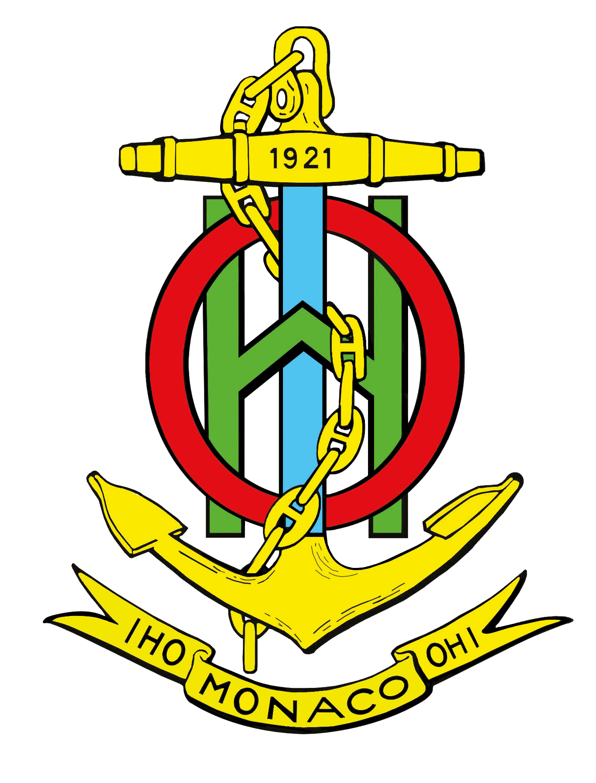

«RED BOOK»

COMPENDIUM OF COMMENTS SUBMITTED BY MEMBER STATES ON PROPOSALS TO BE CONSIDERED BY THE IHO COUNCIL

Reference: IHO Resolution 8/1967 as amended – Procedure for considering proposals submitted by Member States to the Assembly or to the Council

PROPOSALS

PROPOSALS SUBMITTED FOR CONSIDERATION BY
THE 2nd MEETING OF THE IHO COUNCIL

Note: Documents labelled as INFormation papers (e.g. Doc. C2-x.xINF) were submitted after the deadline for submission. Although they have been uploaded in the list of documents for the C-2 meeting, it will be up to the Council Members to decide whether the proposals they may contain, should be considered during the meeting.

Agenda Item | Object of the Proposal | Submitted by | References
4.1 | Report and Proposals from HSSC | HSSC Chair | C2-4.1A
4.1 | Revision process of IHO Resolution 2/2007:  - New Review Cycle for WG/PT Development Phase of Prod Specs  - Guidance on conduction of an Impact Study | HSSC Chair | C2-4.1A  Annex A1  Annex A2
4.1 | Amendments to the HSSC Terms of Reference and Rules of Procedure | HSSC Chair | C2-4.1A  Annex B
4.1 | HSSC key priorities of the IHO Work Programme for 2019-2020 | HSSC Chair | C2-4.1A  Annex C
4.1 | Request for the use of the IHO Fund for Special Projects | HSSC Chair | C2-4.1A  Paragraph 19
4.1 | Top-3 work items of the HSSC Working Groups and Project Teams work plans for 2019-2020 | HSSC Chair | C2-4.1A  Annex D
4.2 | Report and Proposals from IRCC | IRCC Chair | C2-4.2A
4.2 | Amendments to the IRCC Terms of Reference and Rules of Procedure | IRCC Chair | C2-4.2A  Annex A and its Appendix
4.2 | Amendments to the IHO Resolution 2/1997 | IRCC Chair | C2-4.2A  Annex B and its Appendix
4.2 | Amendments to the Capacity Building Sub-Committee Terms of Reference and Rules of Procedure | IRCC Chair | C2-4.2A  Annex C and its Appendix
4.2 | IHO Publication B-12 - IHO Guidelines on Crowd-Sourced Bathymetry | IRCC Chair | C2-4.2A  Annex D
4.2 | Amendments to the IHO Resolution 6/2009 | IRCC Chair | C2-4.2A  Annex E and its Appendix
4.2 | Application of the IHO Resolution 1/2018 (IHO CL 19/2018 refers) | France | C2-4.2B
4.3 | Development and future provision of S-100 based Products | HSSC and IRCC Chairs, Secretary-General | C2-4.3
6.1 | Proposals from the Strategic Plan Review Working Group | SPRWG Chair | C2-6.1
7.1 | Preparations for the triennium of IHO centenary celebrations (IHO-100) | Secretary-General | C2-7.1
7.2 | Overhaul of all IHO communication means and digital revamp of the International Hydrographic Review | Secretary-General | C2-7.2
7.3 | Establishment and future governance of the Nippon Foundation-General Bathymetric Chart of the Oceans (GEBCO) Seabed 2030 Project | Secretary-General | C2-7.3INF
7.4 | Annex C of C-1 Summary Report | United States of America | C2-7.4INF

LIST OF MEMBER STATES’ COMMENTS

General comments for all the proposals
AUSTRALIA:
Australia has reviewed the proposals and looks forward to participate in the deliberations when these are discussed during C-2.

COLOMBIA:
Colombia, as Chair of the South Eastern Pacific Regional Hydrographic Commission, agrees with the continuity of the “Red Book” edition, in the sense that such document is essential for the proposals and positions to be presented to the Council. This document allows to have a general view of the concerned subject and of the respective positions.

Specific comments

Agenda Item | Object of the Proposal | Submitted by | Reference
4.1 | Revision process of IHO Resolution 2/2007:  - New Review Cycle for WG/PT Development Phase of Prod Specs  - Guidance on conduction of an Impact Study | HSSC Chair | C2-4.1A  Annex A1  Annex A2

CANADA:
Annex A1: Canada endorses this proposal. Related comments found in association with Annex A2.
Annex A2: Canada endorses this proposal, with the following comments.
1. General comments:
a. In the Review Cycle document Annex A1, it indicates "Conduct impact assessment" and "Provide Impact Assessment Report" and this document in Annex A2, is about conducting an "impact study". Are the assessment and the study the same concept, if not, could they be clearly compared and contrasted?
b. Is the study 'scalable'? That is, does each change in specification require the same depth of study or investigation? Is there a risk that the time it takes to do the study (starting with getting HSSC endorsement before starting) will outweigh its benefits? The guidelines here may be overly prescriptive in some cases.
c. Could any examples of one of these surveys be provided? Having a basic or generic survey prepared and available to WGs may help speed the study along.
2. Specific comments:
a. Under the "Description…" section:
-"An impact study plan should include ...and a plan to conduct a study". This wording sounds redundant.
-What is meant by the "impacts of the study"?
-Cannot it be assumed that a new version of a standard will have an impact on IHO MS and their stakeholders? Otherwise, why is a new version necessary?
-"market and business procedures" would be included in the impacts on MS and stakeholders.
b. "Suitability …":
-It states that the suitability check is to be conducted by professional survey experts. This implies a cost. Who pays for this?
c. "Specification of requested…"
-Provisions for privacy and security for those filling out the surveys should be part of the IHO protocol for collecting and storing data. In addition, there is a risk that some stakeholders, e.g. s/w or h/w manufacturers, may not want to complete a survey if the results will be made public and/or they can be otherwise identified.

COLOMBIA:
Colombia supports this proposal.

Agenda Item | Object of the Proposal | Submitted by | Reference
4.1 | Amendments to the HSSC Terms of Reference and Rules of Procedure | HSSC Chair | C2-4.1A  Annex B

CANADA:
Canada endorses this proposal.

COLOMBIA:
Colombia supports this proposal.

Agenda Item | Object of the Proposal | Submitted by | Reference
4.1 | HSSC key priorities of the IHO Work Programme for 2019-2020 | HSSC Chair | C2-4.1A  Annex C

CANADA:
Canada endorses this proposal, with the following comment.
- HSSC may want to check that Marine Service Portfolios (MSPs) is still the current term used by the IMO.
Comment by the Secretary-General: The following definition is currently being reviewed: “Maritime Service Portfolio (MSP) is a set of operational Maritime Services and associated technical services provided in digital format.” (See Paragraph 22 of MSC.1/Circ.1595 dated 25 May 2018). Maritime Services is the correct term to be used in the IHO Work Programme. Correction has been made in the Rev1 version of the HSSC key priorities.

COLOMBIA:
Colombia supports this proposal.

FINLAND:
In addition to listed and proposed amendments it is good to consider extend work related to S-101 standard, which is at its final stage.
There is need for guidelines for how S-101 should be implemented i.e. how to produce S-101, how to distribute S-101, what updates are needed to the WEND principles.

Agenda Item | Object of the Proposal | Submitted by | Reference
4.1 | Top-3 work items of the HSSC Working Groups and Project Teams work plans for 2019-2020 | HSSC Chair | C2-4.1A  Annex D

CANADA:
Canada endorses this proposal.

COLOMBIA:
Colombia supports this proposal.

FINLAND:
Generally speaking, high density contour lines can be produced and disseminated with ENC and used in the ECDIS already with current standards and practice.
Tools for automated contour generation are available as well. Beside proposed development of high density contours it would be important to widen development with studying how S-102 bathymetric surface product will interact with ENC in a way that Go/No-Go areas can be determined and visualized in ECDIS for navigator.

Agenda Item | Object of the Proposal | Submitted by | Reference
4.2 | Report and Proposals from IRCC | IRCC Chair | C2-4.2A

UNITED STATES OF AMERICA:
The US supports, noting the WENDWG Terms of Reference change to support the entirety of marine WEND users.

Agenda Item | Object of the Proposal | Submitted by | Reference
4.2 | Amendments to the IRCC Terms of Reference and Rules of Procedure | IRCC Chair | C2-4.2A  Annex A and its Appendix

CANADA:
Canada endorses this proposal.

COLOMBIA:
Colombia supports this proposal.

FRANCE:
The 3rd sentence of §9 of the ROP should read "If prior endorsement by the Council is not deemed necessary by the Committee ..." (and not "by the Chair"), to be consistent with the 2nd sentence "The Committee should appreciate and determine the need to submit recommendations to the Council", and to be aligned with the proposed amendments to § 2.9 of ROP of the HSSC (document C2-4.1B).
Comment by the Secretary-General: Agreed and fixed in the Rev1 version of Appendix to Annex A to C2-4.2

Agenda Item | Object of the Proposal | Submitted by | Reference
4.2 | Amendments to the IHO Resolution 2/1997 | IRCC Chair | C2-4.2A  Annex B and its Appendix

BRAZIL:
In Appendix of Annex B, paragraph 7, 3rd row, replace "IHB" by "IHO Secretariat".
Comment by the Secretary-General: Agreed and fixed in the Rev1 version of Appendix to Annex B to C2-4.2, as well as “Bureau” has been replaced by “Secretariat” in the last sentence.

CANADA:
Canada endorses this proposal.

COLOMBIA:
Colombia supports this proposal.

Agenda Item | Object of the Proposal | Submitted by | Reference
4.2 | Amendments to the Capacity Building Sub-Committee Terms of Reference and Rules of Procedure | IRCC Chair | C2-4.2A  Annex C and its Appendix

CANADA:
Canada endorses this proposal.

COLOMBIA:
Colombia supports this proposal.

FRANCE:
Editorial: red line version of §6 of the TOR should retain "Secretariat" to be in accordance with the cleaned version. The latter should have include "3" after "Work Programme", in accordance with the former.
Comment by the Secretary-General: Agreed and fixed in the Rev1 version of these documents.

Agenda Item | Object of the Proposal | Submitted by | Reference
4.2 | IHO Publication B-12 - IHO Guidelines on Crowd-Sourced Bathymetry | IRCC Chair | C2-4.2A  Annex D

BRAZIL:
Brazil does not support the approval of the B-12 as it is.
Comments:
Brazil wants to stress that the chapter of Legal Considerations was suppressed from the publication, and we strongly suggest that the subject “Legal Considerations” (UNCLOS, for example) shall be considered and taken into account before engaging in CSB activities. Therefore, Brazil suggests to send the publication back to the CSBWG in order to include a Chapter of “Legal Consideration” and afterwards, submit to the State Members for comments and approval.
See our suggestion to the IHO CL 49/2017:
“…Pages 46/47/48
- Legal Considerations
  - Introduction ……………………………………………………………………………………………….
  - Maritime Jurisdiction
1st Paragraph – Under international law, as reflected in the 1982 United Nation Convention on the Law of the Sea (UNCLOS). ….. ….. Coastal States may have differing views on whether collecting bathymetric data on passage and providing it to the IHO DCDB for the common good is considered acceptable within the framework of the restrictions they impose under UNCLOS, with special regards to its Article 40. (suggest to add). In this context….
5.3 Rights and Responsibilities
1st Paragraph - ... in support of global initiatives such as the GEBCO Project... (We don’t think it is usual to produce GEBCO lines in “National Jurisdiction Waters”. Brazil defended position in Intergovernmental Oceanographic Commission of UNESCO (IOC/UNESCO) at its 29th Assembly keeping the rights of coastal states as stated in UNCLOS).
2nd Paragraph – It is important that all parties participating in the IHO CSB programme carefully consider their rights and responsibilities in relation to the various legal jurisdictions under which they are operating. (Great! We strongly support this statement).
3rd Paragraph - …. Data supplied to the IHO DCDB by vessels directly or (we suggest to remove this from the wording) through Trusted Nodes is licensed in accordance in accordance with…(We insist that CSB data is submitted to DCDB through trusted nodes, only).
…”

CANADA:
Canada endorses this proposal, with the following comments.
1. CA would like to acknowledge the work of the CSBWG and the efforts of the c/CSBWG Ms Jennifer Jencks (USA).

COLOMBIA:
Colombia supports this proposal.

ITALY:
Italy takes part in revision of B-12 and has no further comment on its adoption and approval.

Agenda Item | Object of the Proposal | Submitted by | Reference
4.2 | Amendments to the IHO Resolution 6/2009 | IRCC Chair | C2-4.2A  Annex E and its Appendix

CANADA:
Canada endorses the amendments, as presented, with the following comments.
1. The IHR has been a very important publication for the IHB/IHO since 1923.
2. Canada, therefore, finds it encouraging to see the efforts being made to preserve that legacy and to ensure the longer term relevance and sustainability of the IHR (Proposal 7.2).

COLOMBIA:
Colombia supports this proposal.

Agenda Item | Object of the Proposal | Submitted by | Reference
4.2 | Application of the IHO Resolution 1/2018 (IHO CL 19/2018 refers) | France | C2-4.2B

ITALY:
Italy agrees on the principle and on the paragraph Analysis in the Comment by France to IRCC Report on Application of IHO Resolution 1/2018, but its application should be harmonized as much as possible between the different RHCs and the resolution itself should be reviewed to enhance its application as proposed.

UNITED KINGDOM:
UK supports the proposal by France.

Agenda Item | Object of the Proposal | Submitted by | Reference
4.3 | Development and future provision of S-100 based Products | HSSC and IRCC Chairs, Secretary-General | C2-4.3

CANADA:
Canada endorses this proposal, as presented, with the following comments.
1. The manner in which the IHO and MS manage the development and future provision of S-100 must be well planned, coordinated, and communicated.
2. A communication plan (incorporated into the overall communication strategy) will be critical to ensure MS, stakeholder, and the interested public are well informed of IHO actions and intentions. Therefore, Canada suggests that the communication plan on S-100 implementation also be an element of the roadmap. [Related to Proposal 7.2]
3. Canada suggests that WENDWG and the RHCs start considering their roles in helping coordinate the provision of S-100 products and services.
3. The IHO delivery of stable and sound specifications remains the key to forward movement in the areas mentioned, i.e. production tools, training, distribution, and the engagement of ECDIS manufacturers. This must remain one of the main goals of the IHO.
4. CA concurs with the proposal that distribution/dissemination concepts are an important element of the overall implementation plan and is exploring options. In the longer term, it foresees employing multiple options.
5. The document notes the importance of test data (as developed by IHO WGs) in order to facilitate testing. However, the task of developing these test datasets is not evident in any of the “Top 3 work items for 2019-20” document in Proposal 4.1 Annex D or is this considered within one of the tasks listed, or to be considered for future years?

COLOMBIA:
Colombia supports this proposal, outlining that training on the S-100 is required, in which data production should be achieved in a real and practical way, based on this specification. Likewise, we support the HSSC so that this Committee establishes adequate subordinate WGs to develop a whole set of representative test data for the range of data products.

FRANCE:
France welcomes this important proposal, and looks forward to the discussion on the matter at the Council. It is suggested that a strategy for an efficient implementation of S-100 based products consider their assimilation by end users.

JAPAN:
Japan reserves comment for discussions at the 2nd Council meeting.

KOREA (Republic of):
The Republic of Korea agrees with the four suggested subjects listed in Paragraph 7 of the proposal in principle. Since S-100 1.0.0 was published in 2010, we have seen a great deal of efforts on the development of S-100 based Product Specifications (PSs) exerted by the HSSC and its subordinate Working Groups. Next-generation S-101 ENCs as well as S-111, S-122, S-123 and S-102 2.0.0 applicable to S-100 system will be developed by the end of the year to be published in 2019. This timeline is in accordance with the S-100 Master Plan established and maintained by the HSSC which provides mid- to long-term plan for developing and testing S-10X PSs. And the Master Plan enables IHO Member States and stakeholders to predict when S-100 based products will be published.
In this regard, taking into consideration the proposal and SOLAS Chapter V, the ROK believes it is time to initiate the discussion at the Council on the ‘S-100 Transition Plan’ which outlines step-by-step implementation strategies including the four subjects proposed in the proposal.

UNITED KINGDOM:
This paper raises many concerns for the wider hydrographic community that do not represent the full views of HSSC/IRCC. UK looks forward to wider discussion at C2, particularly relating to the relative responsibilities of the IHO and the IMO.

Agenda Item | Object of the Proposal | Submitted by | Reference
7.1 | Preparations for the triennium of IHO centenary celebrations (IHO-100) | Secretary-General | C2-7.1

BRAZIL:
Brazil congratulates the Secretary-General for this initiative and agree with the proposal for the preparation of the celebration of IHO centenary.

CANADA:
Canada endorses this proposal, with the following comments.
1. Canada supports the Secretariat’s plans for IHO-100 and looks forward to participating in, and contributing to, the event to the extent that is practically possible.

COLOMBIA:
We agree in that the IHO and the MS support in a direct or indirect way the three events, both in Monaco and in our countries.

UNITED STATES OF AMERICA:
The US notes the deadline of December 2018 for contributions. The US wishes to note it is evaluating the prospects of utilizing the “Science on a Sphere” in support of the commemoration activities. Information can be found on line at: https://sos.noaa.gov/What_is_SOS/

New data sets highlighting hydrographic matters could potentially be developed.

Agenda Item | Object of the Proposal | Submitted by | Reference
7.2 | Overhaul of all IHO communication means and digital revamp of the International Hydrographic Review | Secretary-General | C2-7.2

BRAZIL:
Brazil agrees with the importance to review and modernize all of IHO communication means, except the design of a new logo for the Organization, as our current logo has been known world-wide for almost one hundred years. Therefore, changing it should be carefully considered, especially on the occasion of the celebration of IHO centenary.

CANADA:
Canada endorses this proposal, with the following comments.
1. Canada supports this ongoing initiative to overhaul the IHO communication means, including establishing a presence in social media and the incorporation of GIS services. [An additional suggestion, is for IHO to investigate the possibility of developing an IHO app.]
2. Canada endorses the use of additional budget for the digital IHR revamp.

COLOMBIA:
We agree. To this respect, we recommend:
1. to maintain the IHO Logo;
2. to study the possibility of classifying the IHR in the “Scientific Journal Ranking” SJR, so that Doctoral students can publish their PHD thesis in the IHR, as it is required by doctorates’ institutions.

JAPAN:
Japan reserves comment for discussions at the 2nd Council meeting.

SPRWG Chair:
Paragraph 18 of Doc. C2-6.1 – Report of the SPRWG to C-2
18. The manner in which the IHO Strategic Plan is integrated into an overall IHO communication strategy requires further consideration. This is outside the SP but, depending on what type of messages the IHO wishes to communicate, and how it does it, it may change some of the high level strategic directions and deliverables.

Agenda Item | Object of the Proposal | Submitted by | Reference
7.3 | Establishment and future governance of the Nippon Foundation-General Bathymetric Chart of the Oceans (GEBCO) Seabed 2030 Project | Secretary-General | C2-7.3INF

NETHERLANDS:
This paper requests the Council to discuss the implementation of Seabed 2030 (Paragraph 13b). Part of the discussion is how the Regional Hydrographic Commissions could support this project. This would be a difficult question for the RHCs that NL is a member of, as it is not clear how Seabed 2030 currently relates to regional initiatives for the combination and publication of gridded bathymetric models (EMODnet, IBCCa, BSBD, etc). We understand how they relate to the GEBCO project in general, but the Seabed 2030 project seems to be run –to some degree– separately. Would it be possible to clarify this point?
Comment by the Secretary-General: the IHO Secretariat is currently investigating the possibility of having a direct intervention by a representative of the Seabed 2030 project at the C-2 meeting as it seems important to get a better understanding of its implementation.

UNITED STATES OF AMERICA:
The US notes the intent of Doc. C2-7.3INF to improve oversight of the GEBCO Seabed 2030 project by the GEBCO GC, IHO and IOC communities and we find considerable value in the paper.

The US looks forward to discussing coordinated support of Seabed 2030 Project across the IHO at the C-2 meeting and the GEBCO GC meetings going forward.

As received in response to IHO CCL03/2018.

