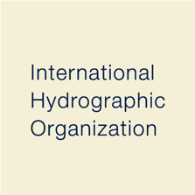

June 2019 (draft) v1.0
Published by the
International Hydrographic Organization
4b quai Antoine 1er
Principauté de Monaco
Tel: (377) 93.10.81.00
Fax: (377) 93.10.81.40
info@iho.int
www.iho.in
Guidebook for HCA-GIS dataset

Hydrography and Charting
--

IHO Hydrographic Commission on Antarctica (HCA)

A guidebook for HCA-GIS dataset;
Hydrography and Charting

International Hydrographic Organization (IHO), Hydrographic Commission on Antarctica (HCA)

Contents

• About IHO and HCA

• Data description

• How to visualize the data on Quantarctica

• How to download the data

• Disclaimer
About IHO and HCA

The International Hydrographic Organization (IHO) is an international organization which has a principal aim to ensure that all the world's seas, oceans and navigable waters are surveyed and charted. It has also encouraged the establishment of Regional Hydrographic Commissions (RHCs) to coordinate hydrographic activity and cooperation at the regional level. The Hydrographic Commission of Antarctica (HCA) is one of the RHCs which consists of Hydrographic Offices from 24 countries*.

The HCA has operated a Web GIS Service called HCA-GIS to visualize various hydrographic data and metadata around the region. In order to achieve higher profile beyond the hydrographic community, the HCA-GIS dataset is now provided as Quantarctica Friendly Dataset.
IHO and HCA strongly believe that the hydrography and charting activities significantly contribute to various research activities in the polar region. Any comment or suggestion for the dataset is highly appreciated and please contact us if appropriate.

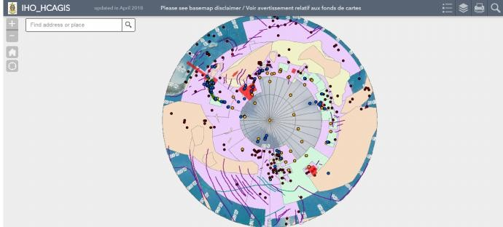

An image of HCA-GIS

* As of 2019, HCA consists of the following members: Argentina, Australia, Brazil, Chile, China, Colombia, Ecuador, France, Germany, Greece, India, Italy, Japan, Korea (Rep. of), New Zealand, Norway, Peru, Russian Federation, South Africa, Spain, Uruguay, United Kingdom, USA, and Venezuela. For further information, please visit our website.
Data description

HCA-GIS dataset contains four types of data as follows:

• Survey Areas
It shows areas in which hydrographic (bathymetric) surveys were historically conducted. The coverage is provided by the HCA Member States. For the actual survey data, please contact to each hydrographic authority.

• Shipping routes
It shows areas of major shipping routes around the Antarctic Peninsula. It is also suggested that those sea areas have been seldom surveyed with the modern survey facilities. Therefore, the survey priority assessed by the Hydrographic Priorities Working Group in the HCA is added to the routes area to encourage Member States accelerate hydrographic survey in the region. For further detail, please refer to the HPWG website.

• Electronic navigational chart (ENC) coverage
An electronic navigational chart is a real-time navigation system that integrates a variety of information that is displayed and interpreted by the Mariner. ENCs are produced and authorized by national hydrographic authorities. ENCs are eventually sold by chart agents and other suppliers. It shows the geographic coverage of ENCs now available in the region. The coverage is updated based on the information provided by the RENCs (Regional ENC Coordination Centers), Member States and distributor organizations. For further information of ENC, please refer to the IHO website.

• Tide records
Observation of tide is indispensable part of hydrographic survey to measure the depth of seabed precisely. The vertical datum is decided based on the observation. Though the observational period of tide depends on hydrographic survey, the location and contact point for the detail is available from the point feature. For tide data itself, please contact to the hydrographic institution.

• Seabed Feature Names
GEBCO (General Bathymetric Chart of the Oceans) is a non-profit
making organization to provide the most authoritative publicly-available bathymetry of the world's oceans. It operates under the joint auspices of the International Hydrographic Organization (IHO) and the Intergovernmental Oceanographic Commission (IOC) (of UNESCO). The GEBCO Sub-Committee on Undersea Feature Names (SCUFN) maintains and makes available a digital gazetteer of the names, generic feature type and geographic position of features on the seafloor. The dataset is derived from the SCUFN Gazetteer as of Aug. 2018. For further detail or the latest information, please visit the website.

How to visualize the data on Quantarctica

Currently, the HCA-GIS dataset is hosted on ArcGIS Online, which is a cloud platform for GIS data. The Quantarctica can easily visualize the data as ArcGIS Feature Service for on-line use (similar to the WFS service). In this section, the User has to have network connection.

First, on your Quantarctica, please proceed to “Layer” -> “Add Layer” -> “Add ArcGIS Feature Server Layer”.

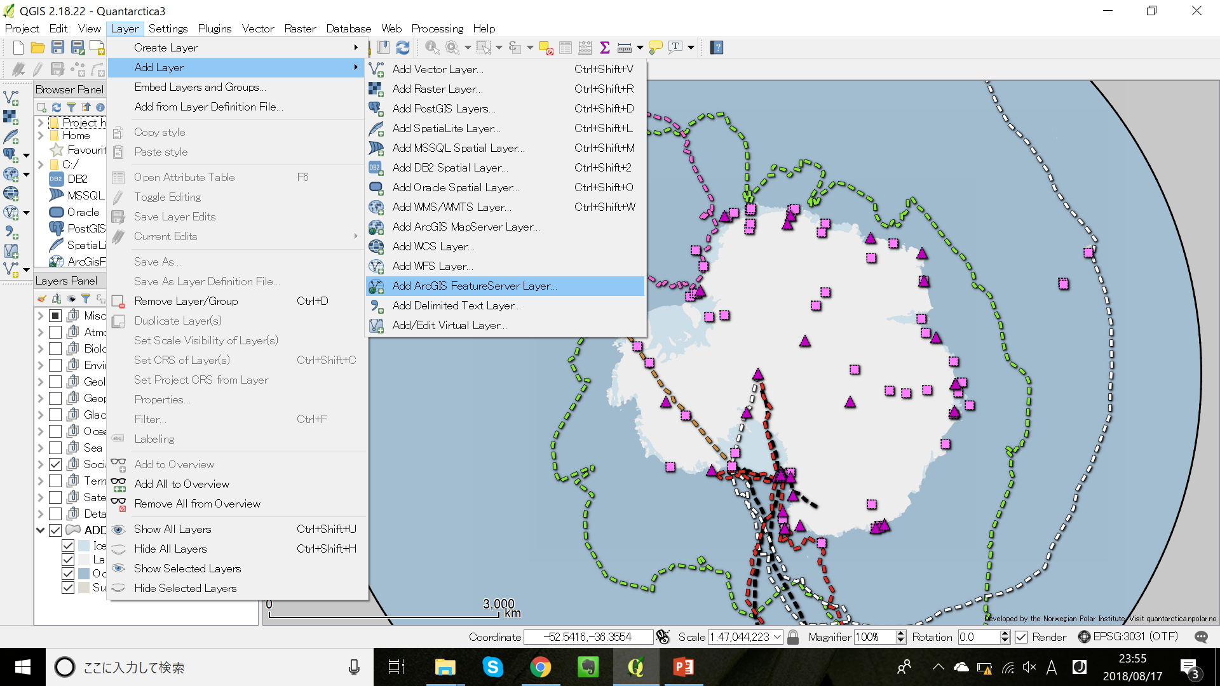

Then, please put “New” button and for the URL, please input the following URL as
<https://services.arcgis.com/CuKhy9lf5rURr3iI/arcgis/rest/
services/IHO_ HCAGIS/FeatureServer>.
Push “OK”, then back to the Server connection page, please put “Connect”.
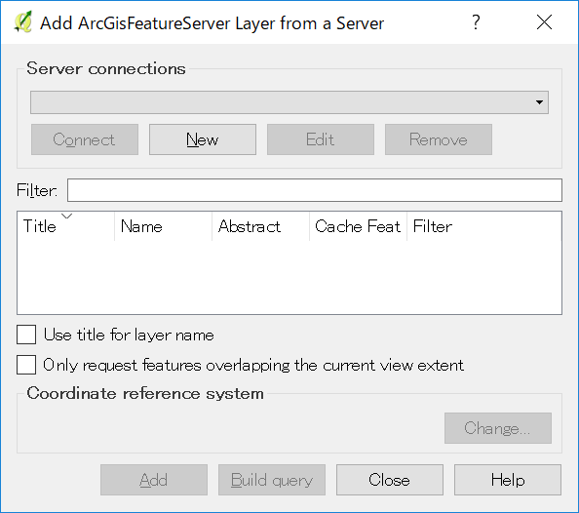

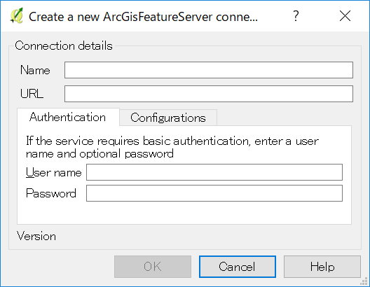

It will be displayed several layers of HCA-GIS dataset. Then, please select layers to be visualized as below, and push “Add”. Then, the layers HCA-GIS dataset will be overlapped in the Quantarctica.

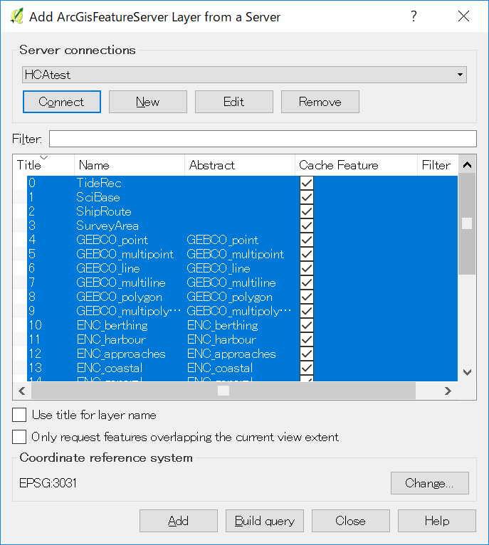

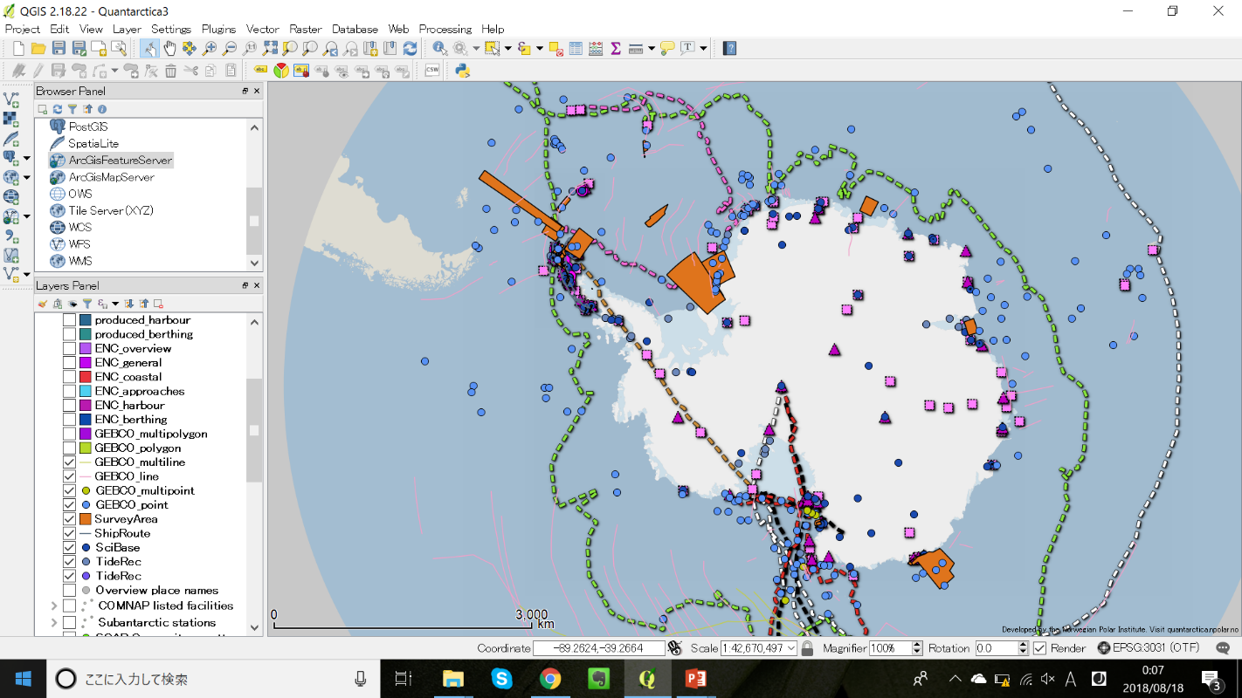

How to download the data
To download the HCA-GIS dataset from ArcGIS Online, please visit the following URL. Then, “HCA GIS” -> choose data and file type (spreadsheet, KML or Shape file)
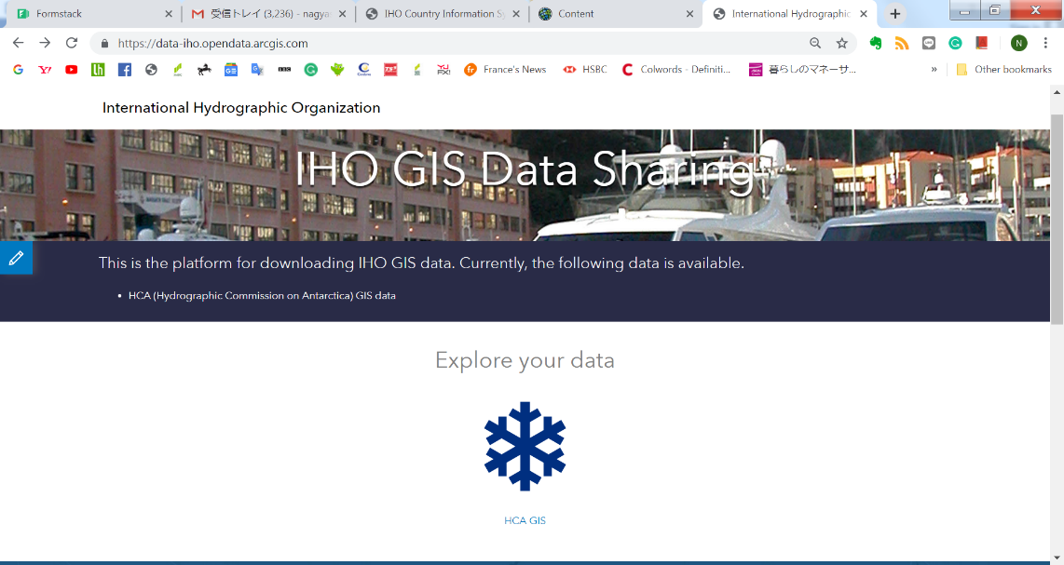

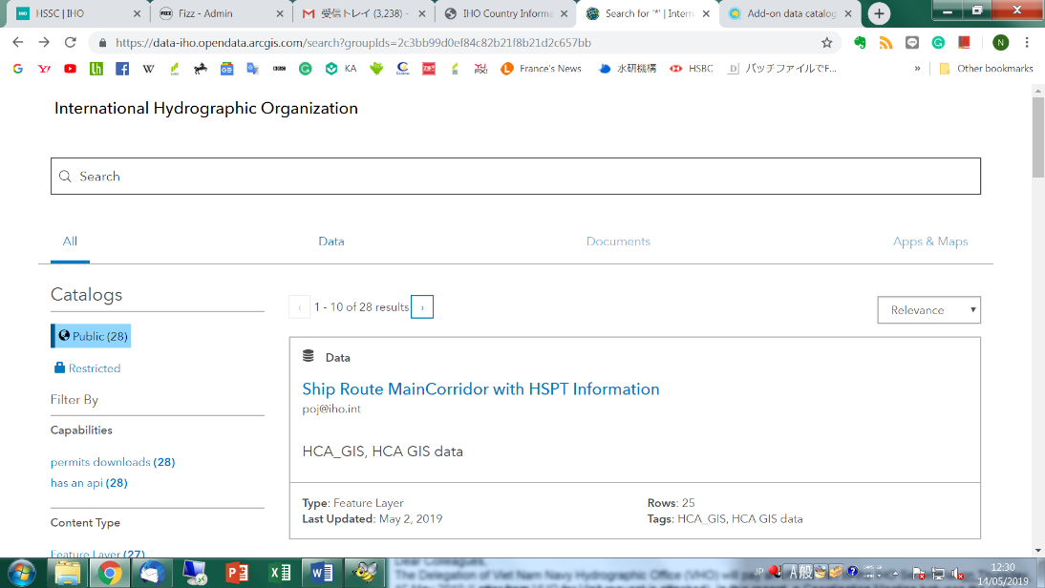

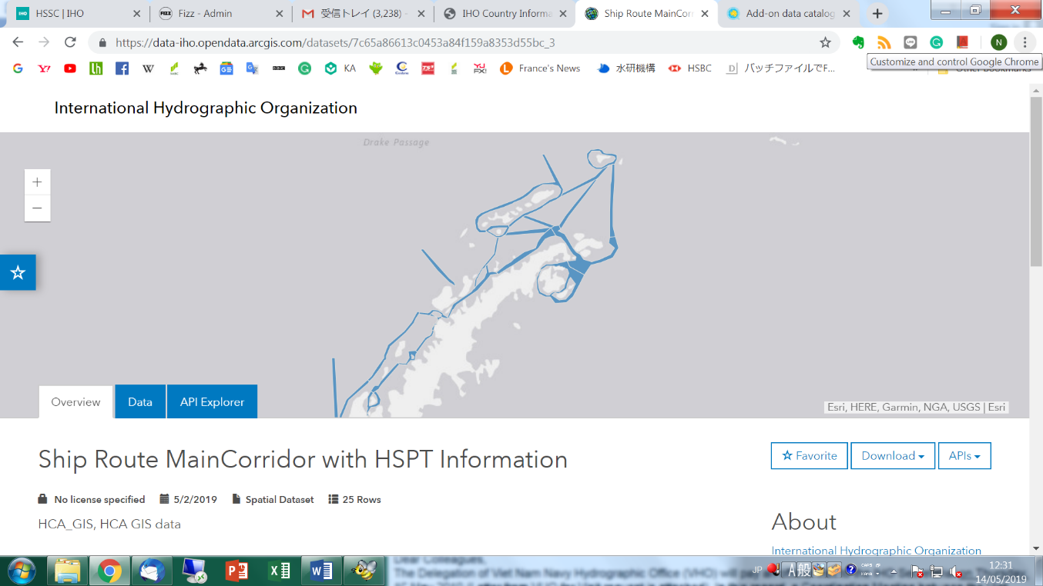

Disclaimer

The HCA-GIS dataset is for informative purposes only. The IHO and HCA grants permission to Users to download and copy the dataset for the User’s personal or non-commercial use without any right to resell or redistribute them or to compile or to create derivative works therefrom.
Please follow the following citation style shown in the website.

International Hydrographic Organization, Hydrographic Commission on Antarctica (2019) HCA-GIS Data; Hydrography and Charting [online] Available at: “https://data-iho.opendata.arcgis.com/”

For the further detail of the disclaimer, privacy and copyright issues, please refer to the IHO website’s disclaimer.

