QUESTIONNAIRE ABOUT THE STATUS UPDATE OF MARINE SPATIAL DATA INFRASTRUCTURE IMPLEMENTATION

Background
During the 20th meeting of the Mediterranean and Black Sea Hydrographic Commission (MBSHC), it was decided that Italy should represent MBSHC into the Marine Spatial Data Infrastructure Working Group (MSDIWG) through an ambassador.
During the last MSDIWG meeting, held in Niteroi in January 2018, the Group discussed a possible way to connect the MSDI (Marine Spatial Data Infrastructure) national level to the MSDI global level through the regional level, which is represented into the IHO government structure by the Regional Hydrographic Commissions (RHCs).
Version 2.0 of the IHO publication C-17, Spatial Data Infrastructures "The Marine Dimension" – Guidance For Hydrographic Offices, was adopted by the IHO CL 16/2018. The publication contains the guidelines to develop MSDI within the national hydrographic bodies.
Further documents, within the national spatial data infrastructure, can be found at a global level in the United Nation Global Geospatial Information Managements (UN GGIM) website (http://ggim.un.org/). This year the eighth session of the Committee of Experts of UN GGIM approved the Overarching Strategic Framework of the Integrated Geospatial Information Framework, which can be found, together with the other meeting documents, at the following link:
http://ggim.un.org/meetings/GGIM-committee/8th-Session/documents/
This year the UN GGIM Working Group on Marine Geospatial Information (UN GGIM MGIWG) has started to work. The next MSDIWG meeting will be held in Korea next March, immediately before the first meeting of the UN GGIM MGIWG. It will be a good opportunity to participate to both face to face meetings of the two working groups.
In order to develop the link between different geographical levels of MSDI (local, national, regional and global), a questionnaire was sent with the MBSHC CL 4/2018.

MSDI concept
The National Hydrographic Offices (HOs) have traditionally produced high quality hydrographic data and published them through safety of navigation products. The two levels, data and products, have been fused together into a common historical path.
A global trend, arisen during last decades, is promoting the perspective to look at data by an independent point of view, as a numerical description of reality.
In order to be used, data cannot be just gathered and stored, but they have to be managed through an infrastructure which facilitates and simplifies their accessibility. This infrastructure is normally defined Spatial Data Infrastructure (SDI). SDI is defined in the Global Spatial Infrastructure Cookbook as "the relevant base collection of technologies, policies and institutional arrangements that facilitate the availability of and access to spatial data".
SDI has its foundation into geographical data. Looking at the Earth as a unique Planet only a Global SDI can be addressed in order to study its physical state and behavior. The global level can be reached by individuals through intermediate levels, closer to a particular situation of a relatively small portion of the Planet. The global level is then divided into different smaller levels, oriented either to geographical position (e.g. regional level, national level, local level) or to environmental position (e.g. land domain, marine domain).
The already mentioned publication IHO C-17 explores SDI of the marine domain (MSDI) and it contains a suggested path to address MSDI from a national perspective. Having an ambassador of MBSHC to MSDIWG is a way to connect MSDI through different geographical levels (from national to global level through the regional one).
Both IHO and UN GGIM have regional bodies. On the one hand IHO RHCs have a marine focused approach (the focal point is the marine domain and the national level expresses its willingness to participate in the Commission around a portion of the sea), on the other hand the UN GGIM regional entities (the UN GGIM Regional Committees) arose around the geographical continents within a land domain perspective. The result is that IHO and UN GGIM regions have different geographical extensions.
The basics of the MSDI concept are explained in the IHO C-17 by two pictures, one about data and their clear separation from information, the other one about the four MSDI pillars.
Reality is explored measuring data, and the level of data is separated from the level of information. Information is extracted from data but it is not considered data. Typical examples of information delivered by HOs are those contained in the Nautical Charts (both paper charts and ENCs).

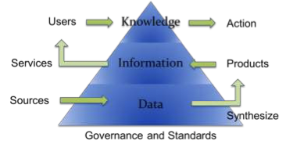
Picture 1 - The Data Information Knowledge triangle (from IHO C-17 page 10)

MSDI is composed of four pillars. Here it is added a word in brackets after every pillar to better explain what it addresses.
Data (WHAT) is only one pillar, because it is managed through standards (HOW), which allow interoperability of data, information and communication technologies (WHERE), which allow sharing of data, policy and governance (WHY), which allow to change MSDI into a value-added activity.
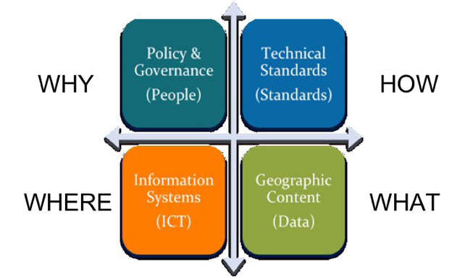
Picture 2 - The Four pillars of MSDI (from IHO C-17 page 7)

Feedback from Questionnaires
MBSHC is composed of twenty-two Members, four Associate Members and seven Observers. With MBSHC CL 4/2018 a Questionnaire on MSDI was distributed to all MBSHC Members.
Four Members and one Associate Member replied to the CL sending back the Questionnaire fully compiled; three Members and one Observer replied via e-mail explaining their position on MSDI.
All replies opened to the application of MSDI to different topics related to the sea, even far away from the traditional safety of navigation aim. Feedback underlines recent developments in the use of the sea, where MSDI can play a leading role. They are, for example, Marine strategy, Marine spatial planning and Ocean governance.
Feedback is mainly focused on Standards. IHO standards, with particular focus on the transition from S-57 to S-100 world, are today complemented by Open Geospatial Consortium (OGC) standards, especially in web-based infrastructures. The Infrastructure for Spatial Information in Europe (INSPIRE), an European Union (EU) initiative, is also used by some of the actors involved.
From a geographical perspective, feedback was received from actors inside and outside the Mediterranean and Black Sea Region.
MSDI initiatives mentioned in the feedback are either internal to the HOs (e.g. the HO has its own MSDI), or referred to National SDI (NSDI), or linked to regional SDI (e.g. the EU initiatives INSPIRE and the European Marine Observation and Data Network - EMODNET), or related to specialized MSDI activities (e.g. RENC MSDI).
Particular attention was focused on copyright policy. HOs data has been traditionally gathered using specific rules. The use of data for safety navigation products is well known, while a different use of data needs to be better regulated. The role of authoritative data is one of the topics of the feedback.
Costs of MSDI activities, especially those connected with web infrastructures and ICT pillar, were particularly stressed. These costs are today covered by HOs internal funding (when the actor is funding its own MSDI), national funding (when there is a framework which defines the NSDI) and regional funding (e.g. EU is funding an MSDI initiative through a project). The difference between the cost to maintain the infrastructure and the cost to ensure the service (e.g. reply to a specific request of data and prepare them) is one of the topics of the feedback. The topic on open and/or free data is also mentioned.
Finally, feedback tends to keep well separated the safety of navigation topic from all the other topics.

Key elements
Feedback, as explained above, can be connected to MSDI pillars, as highlighted in this paragraph.
- Data (WHAT)
Looking at the data-information-knowledge triangle, products (such as ENCs or Paper Charts) are conceptually separated from data, and MSDI activities can be managed on a different level with reference to the products.
Focusing on which kind of data an actor can manage and share, a list of them can be found in the IHO C-17. During the last UN GGIM plenary meeting, a minimum list of global fundamental geospatial data themes was endorsed and it is available on UN GGIM website at the following link:
http://ggim.un.org/meetings/GGIM-committee/8th-Session/documents/E-C20-2018-7-Add_1-Global-fundamental-geospatial-data-themes.pdf
For example, a HO can be involved in Global Geodetic Reference Frame at Sea, Elevation and Depth, Functional Areas at sea, Geographical Names at sea and in the coastal zone, Geology and Soils, Physical Infrastructures at Sea, Transport Networks and Water.
The role of authoritative, open, free data is at the center of a strong debate. There is no doubt that the use of data represents a future opportunity to develop and change the traditional role of HOs.
- Standards (HOW)
The way to share data through a Spatial Data Infrastructure is a key factor for interoperability. As arisen from the feedback, different organizations are involved in creating and proposing standards. These organizations are today connected and they work together, each one in its own field. IHO, ISO and OGC are active at a global level. MSDIWG connects the standards into a unique MSDI framework, as the meeting of the OGC Marine Domain WG is usually held immediately after the MDIWG meeting.
Different documents, shared within all these communities, were prepared to explain the importance of the use of standards. The updated documents are available at the following links:
- A Guide to the Role of Standards in Geospatial Information Management
- Companion document on Standards Recommendations by Tier
- Implementation and adoption of standards for the global geospatial information community
The development of the S-100 framework is the main challenge, and the capability to be inclusive to external stakeholders will be one of the main key drivers for the success of the project.
- Information Systems (WHERE)
The accessibility of data can be realized using technological infrastructures. On the one hand, building up a web-based infrastructure is becoming accessible in many Countries, on the other hand what is focused in the feedback is the cost of realizing and above all maintaining it.
It is necessary to underline that this pillar is not only connected with the information technology, but also with the communication technology, which makes the infrastructure able to link HOs to external stakeholders in an effective way.
- Policy and Governance (WHY)
In the feedback it is well underlined that MSDI is strongly connected to different strategic activities of the actors involved which are, for instance, the way they choose to present their products to external stakeholders, the way to link their activities to the national ones, the way to share data.
Copyright, licensing and pricing are key factors for MSDI policy. A useful compendium on licensing of geospatial information has been prepared by UN GGIM and endorsed during the latest UN GGIM Expert Committee Meeting. The compendium is available at the following link:
http://ggim.un.org/meetings/GGIM-committee/8th-Session/documents/E-C20-2018-9-Add_2%20Legal_and_Policy_Frameworks_rev.pdf

